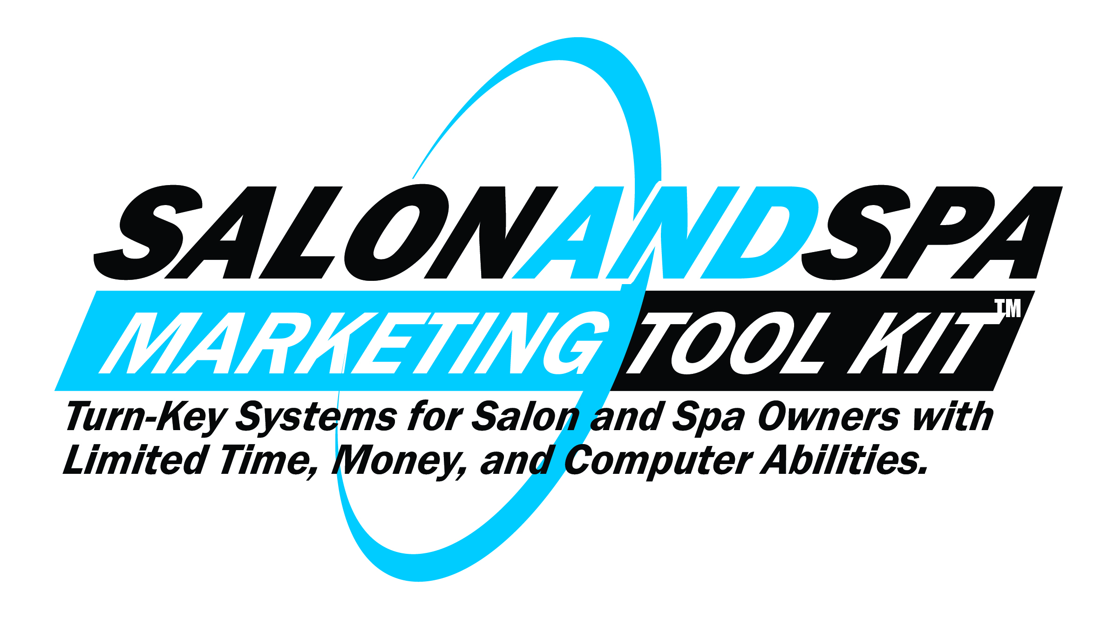
121 Proven Strategies To:

►Position Your Salon/Spa To Dominate Your Market Area

►Get Boatloads Of New High-Paying Clients From
Off-Line & On-Line Methods

►Explode Your Profits

Salon & Spa Marketing Tool Kit™ Contact Information

Address: 1250 Rush Henrietta TWLR, Rush NY 14543

Phone: 1-866-205-2037

Email: Member@SalonAndSpaMarketingToolKit.com

Business hours: Monday –Friday 9am to 4pm (Eastern Standard Time)

IMPORTANT NOTE: As a company we have chosen to offer client service opportunities to “stay at home moms”. So what this means is our phone rings in their home. As a result, sometimes when you call during our normal business hours you may not get a live person because a mom is tending to her child. She may be feeding, changing a diaper, or doing a hundred other things a stay at home mom does. So please just leave a message and someone will get back to you pronto. Thank you for your understanding.

One-On-One Coaching Calls: are set up by email only:

Coaching@SalonAndSpaMarketingToolKit.com

New Mover Client Attraction Program™ - Email the office at: Member@SalonAndSpaMarketingToolKit.com with up-to 5 zip codes from your area. We will email you the address of the “new moves” in those zip codes around the first of every month.

Copyright Notices

ALL RIGHTS RESERVED. No Part of this book may be reproduced or transmitted for resale or use in any party other than the individual purchaser who is the sole authorized user of this information. Purchaser is authorized to use any of the information in this publication for his or her own use only. All other reproduction or transmission, or any form or by any means, electronic or mechanical, including photocopying, recording or by any information storage or retrieval system, is prohibited without express written permission from the publisher.

LEGAL NOTICES: While all attempts have been made to provide effective, verifiable information in this book, neither the Author nor Publisher assumes any responsibility for errors, inaccuracies, or omissions. Any slights of people or organizations are unintentional. If advice concerning tax, legal, compliance, or related matters is needed, the services of a qualified professional should be sought. This Book is not a source of legal, regulatory compliance, or accounting information, and it should not be regarded as such. This publication is designed to provide accurate and authoritative information in regard to the subject matter covered. It is sold with the understanding that the publisher is not engaged in rendering legal, accounting or other personal services. If legal advice or other expert assistance is required, the services of a competent professional person should be sought. Due to the nature of direct response marketing and varying rules regulating business activities in many fields, some practices proposed in this book may be deemed unlawful in certain circumstances and locations. Since federal and local laws differ widely, as do codes of conduct for members of professional organizations and agencies, the reader must accept full responsibility for determining the legality and/or ethical character of any and all business transactions and/or practices adopted and enacted in his or her particular field and geographic location, whether or not those transactions and/or practices are suggested, either directly or indirectly, in this book. As with any business advice, the reader is strongly encouraged to seek professional before taking action. NOTE: guarantees of income or profits are intended by this book. Many variables affect each individual’s results. Your results will vary from the examples given. Salon & Spa Marketing Tool Kit, its employees or agents cannot and will not promise your personal success. Salon & Spa Marketing Tool Kit,, its employees or agents has no control over what you may or may not do with this Salon business program, and therefore cannot accept the responsibility for your results. You are the only one who can initiate the action, in order to reap your own reward! Any and all references to persons or businesses, whether living or dead, existing or defunct, are purely coincidental.

Published by: Salon & Spa Marketing Tool Kit © 2013 and beyond.
Table of Contents
Page
Contact Information 2
Introduction 6
Business Model Flow Chart 10

Section 1 - Positioning & Groundwork Strategies
Strategy #1 Building Your Lucrative, and Autopilot Salon or Spa Business 13

Strategy #2 Your Marketing Plan 15 Strategy #3 Why Call Them Clients- Not Customers 18
Strategy #4 Work On Your Business, Not In Your Business 19
Strategy #5 Simple Market Research 20
Strategy #6 No One Cares Who You Are Until They
Know How You Can Help Them 21
Strategy #7 Lifetime Value Of Your Client (LTV) 22
Strategy #8 You Are Not Your Client 23
Strategy #9 Marketing System 24
Strategy #10 Your Unique Selling Points (USP) 25
Strategy #11 Does Your Message Match Your Market? 27
Strategy #12 The Marketplace Wants To Beat You Down To A Commodity 28
Strategy #13 Why You Must Have A Big, Bold, Solid, Unconditional Guarantee 29
Strategy #14 Why Testimonials Are So Important 31
Strategy #15 Getting Great Testimonials 32
Strategy #16 What Should Your Testimonials Say 34
Strategy #17 Keep A Book Of Testimonials In Your Reception Area 35
Strategy #18 If You Live By Price, Then You Will Die By Price 36
Strategy #19 Increase Your Prices 37
Strategy #20 Have Different Pricing Level Packages 39
Strategy #21 Always Practice The Golden Rule 41
Strategy #22 Accept Credit Cards 42
Strategy #23 Get Effective Business Cards 43
Strategy #24 Always Be A Professional 45
Strategy #25 Answering Your Telephone Properly 46
Strategy #26 Do You Ever Feel Tongue-Tied? 48
Strategy #27 Hold Yourself Accountable 49
Strategy #28 Stay On Top Of Your Marketing 50
Strategy #29 #1 Reason Salon/Spa Owners Don’t Succeed 51
Strategy #30 #2 Reason Salon/Spa Owners Don’t Succeed 52
Strategy #31 #3 Reason Salon/Spa Owners Don’t Succeed 53
Strategy #32 #4 Reason Salon/Spa Owners Don’t Succeed 54
Strategy #33 #5 Reason Salon/Spa Owners Don’t Succeed 55
Strategy #34 Cleansing Mental Brainwashing 56
Strategy #35 Stop Giving “Consultations” & Start Giving “Audits” 58
Strategy #36 Putting It All Together 62

Section 2- Clients Nurturing & Retention Strategies

Strategy #1 Why Nurture Existing Clients 64

Strategy #2 Always Remember LTV 68

Strategy #3 Don’t Ignore Your Clients Like Most Businesses Do 69

Strategy #4 Client Data Base 70
Strategy #5 Newsletter 72
Strategy #6 Thank-You Letters 73
Strategy #7 Email 75
Strategy #8 Voice Broadcast 77
Strategy #9 Postcard 79
Strategy #10 Audio Postcard 80
Strategy #11 Video Message 81
Strategy #12 DVD 82
Strategy #13 Holiday Cards 83
Strategy #14 Free Information Offers 84
Strategy #15 New Client Kit 86
Strategy #16 Client Appreciation 87
Strategy #17 Client Luncheons and Dinners 89
Strategy #18 Constantly Educate Your Clients 92
Strategy #19 Always Make Your Clients Feel They Are #1 93
Strategy #20 Wow Your Clients 94
Strategy #21 Respond To Complaints Immediately 95
Strategy #22 Fire Some Clients 98
Strategy #23 Zombification 99

Section 3 – Off-Line Marketing Strategies

Strategy #1 How to Stop Being Sucked In By

The Advertising “Blind Archery Trap” 103

Strategy #2 Types of Advertising That Work for Small Businesses 106

Strategy #3 Learn Direct Response Marketing 110

Strategy #4 Diversify Your Marketing 112
Strategy #5 Direct Mail 114
Strategy #6 Get Them to Open Your Mail 117

Strategy #7 The 11 Biggest Direct Mail Mistakes Made

By Small Business Owners 119
Strategy #8 Headline Tips Guaranteed To Work 121
Strategy #9 Print Advertising 122
Strategy #10 Yellow Pages 134
Strategy #11 How to Get Your Yellow Page Ad to Your Target
Market Without Paying the Yellow Page Company 135
Strategy #12 Personal Letters Work, Fancy Brochures Don’t 139
Strategy #13 Consumer Awareness Guides & Messages 141
Strategy #14 Referrals 142
Strategy #15 Networking 143
Strategy #16 Never Rely On Walk-ins Again 144
Strategy #17 Hold Workshops 145
Strategy #18 Charity Program 147
Strategy #19 Joint Ventures 149
Strategy #20 How to Get New Clients From Open Houses and Holiday Parties 155
Strategy #21 Learn For Yourself Because You Have The Most At Stake 156
Strategy #22 Learn To Be Sales Pro 157
Strategy #23 Tape Record Yourself 159
Strategy #24 Be Yourself 160
Strategy #25 Don’t Be A Bore 161
Strategy #26 Always Reschedule Next Appointment 162
Strategy #27 Confirm All Appointments 164
Strategy #28 Follow-Up Calls 166
Strategy #29 Add More Services 168
Strategy #30 Beating the ‘Slow Season’ 169
Strategy #31 Always Test Your Marketing 171
Strategy #32 Do Your Math 172
Strategy #33 Track Your Client Lead Sources 173
Strategy #34 Continuity Is King 175

Section 4 – On-Line Marketing Strategies

Strategy #1 Make Sure Your Website Is Direct Response Driven 177
Strategy #2 Get Listed On Google For Free 178

Strategy #3 Email Marketing 180

Strategy #4 Pay Per Click Advertising 182
Strategy #5 SEO Basics- Tips For Small Business Owners 196
Strategy #6 Social Media Marketing 217
Strategy #7 Successful Blog by Using Wordpress 235
Strategy #8 Mobile Marketing 269

Section 5 – Bonus Strategies

Strategy #1 Don’t Be a Human Lobster 275
Strategy #2 Educate Employees 276

Strategy #3 Parkinson’s Law 277

Strategy #4 Zero-Based Thinking 279

Strategy #5 Always Use Exact Numbers 282
Strategy #6 Stay Plugged In 285

Introduction

Salon and Spa Marketing Tool Kit

Congratulations on getting involved with this program. And congratulations on being in business for yourself. The fact that you are reading this right now proves that you are in the top 5% of all people, because most people have dreams but never act on them for various reasons.

So give yourself the credit you deserve. You are not a “yes woman or man” or a “slave” for some big corporation. You are in business for yourself and your family. You DO control your own destiny. You DO control how much money you make. You DO control everything about your life including your salon/spa business. You live your life on your own terms, nobody else’s.

The first thing we want you to know is, what you are going to learn on this journey with us in most cases will be the complete opposite of what you have ever heard before. If you keep an open mind and are willing to learn and understand what we are saying IT WILL MAKE SENSE TO YOU.

WE PROMISE.

The second thing we want to let you know is that we have NOT added “filler” to this program. We have done our best to squeeze the best salon and spa marketing strategies out of all the information we have learned from our circle of marketing experts and from continuing to work with our members. So you are only getting the “meat” here.

The third thing we want to explain it that based on our research in developing this program there are approximately 500,000 salons and spas in the United States and Canada. We only plan on having 10,000 members in this program because we just don’t want to run a big business. Quality of life is very important to us.

So what that means is 2% of the salons and spas will have access to the information contained here, 98% will not. Said another way 98% of the salons and spas will continue to be in “the dark” when it comes to marketing their services. You won’t be and we can guarantee that when you finish reading these materials you will “get it”. You will have an experience similar to when a cave man saw fire for the first time.

The fourth thing we want to say is that in today’s competitive environment being good at what you do is NOT good enough. There is competition everywhere. The fact that you run a good salon or spa and are a good person is NOT enough.

You MUST to be a good MARKETER.

The fact that you may not be a good marketer right now, you shouldn’t be concerned about, because IT’S NOT YOUR FAULT.

They don’t teach marketing that works in high school or any college. 99% of the population does NOT understand marketing or how to make it work.

It is never the one with the best product or service that wins, it is the one with the best marketing that wins. This is not to say that you don’t have to offer a good product or level of service, you do. That is expected of you.

The fifth thing we want to explain is that throughout this manual and on the CD’s we say “she” or “her” most of the time because 90% of all the salon and spa owners are women. So if you are a man reading this please don’t be offended. It is just the nature of the beast.

In fact we have found over the years that women are much better communicators, much better at follow up, and much better at getting marketing stuff done. So if you are a woman great. If you are a man and your wife is involved in the business or she is your boss and running the business, great. If you are a man and running your business all by yourself – no problem, just follow our system.

The sixth thing we want to tell you is that everything we will share with you in our materials will be things that have proven to work for me or my close circle of marketing experts and our current members. Nothing is theory.

And we will do my very best to keep things simple (the way we like them) and give you tools that are all set up for you so all you have to do is plug them into your salon or spa business. We like things handed to us on a silver platter and we think you do to because you don’t have the time to figure out all this marketing stuff and that’s what you are paying us for anyway.

And the last thing we want to do in this introduction is “tell you Mike’s story” so you know how all this came about and to prove to you that we do know what we am talking about. We are not like college professor’s teaching business or marketing who never did anything that he/she teaches.

Mike speaking now…

I have been flat broke, I have rolled up my sleeves for years and have been in the trenched and managed to dig myself out.

I am telling this for YOU. Because if I can “make it”, anyone can. I have no desire to be famous; I don’t need praise or recognition. My passion in life is to help others who have walked or are currently walking the same path that I have walked.

I am a salon/spa owner just like you.

So here is my story and I hope to get to hear your story someday perhaps sharing a lunch or dinner.

I was born in Rochester NY in 1960. I have 3 brothers and one sister. I am the youngest of the boys.

I made it out of high school by the skin of my teeth. Nothing in school interested me, I never studied, and I got mostly C’s and D’s.

After high school I went to a community college, same thing as high school, nothing interested me so I dropped out.

I had moved out of my parent’s home and was working at a local grocery store, earning minimum wage, going nowhere fast.

My father owned a hair salon for many years and was looking for one of his children to join the family business, I didn’t have anything going on, and so I figured, why not!

I went to work for him directly out of beauty school, and I was married the same year. My wife and I started cranking out children right away, five in all.

After working for my dad for 7 years it was time to buy the business from him, it started out good. I was growing the business steady year after year. I really didn’t know what I was doing, but it was growing slowly every year.

Then all the sudden my family was growing faster than my business, the crap was about to hit the fan. I spent the next twelve years struggling to make payroll and pay my bills. I was going further and further into debt every year, I was depressed and had no clue how to get things fixed.

I finally got to the point where I had to do something, close the salon or figure out a way to make more cash.

Fast forward a few years, I’m out of debt completely, except for my house, which has been remodeled and made larger, now my family of 7 live comfortably.

I no longer work behind the chair.

People ask me if I work any longer, I tell them “only when I want too!”

I never miss a golf match or basketball game my kids play in, never!

We have a family membership at a country club, and my wife and I play golf all the time.

None of this would have been possible if I did not learn
UNCONVENTIONAL marketing, the exact marketing I am going to teach you.

You cannot learn this from any college or university.

You will hear me talk about how I learned all this marketing stuff from my multimillionaire brother and his close circle of marketing geniuses. They have told me that most of the marketing stuff they learned in college DOES NOT WORK.

So you are much better off if you were never taught anything about marketing.

It took me the last four years to learn what I am going to teach you here. I did not invent any of this (only tweaked it and applied it to the salon/spa industry) I got it from my brother Mark and his circle of marketing geniuses he relies on for his business ventures. And I continue to learn from my fast growing members, just like you!

That’s it!

So let’s get started, OK?

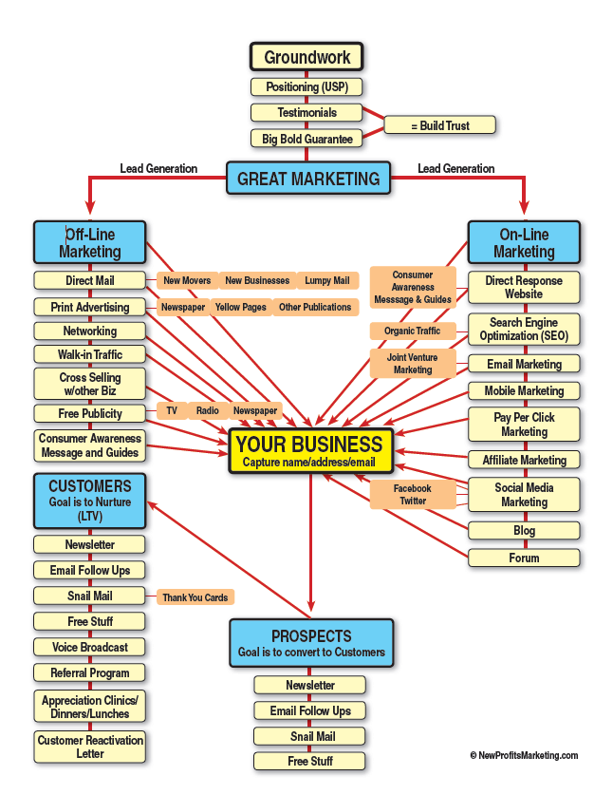

A Little About How This Program Is Organized

There are FIVE sections to this program and they are:

- Positioning & Groundwork Strategies
- Client Nurturing & Retention Strategies
- Off-Line Marketing Strategies
- On-Line Marketing Strategies
- Bonus Strategies

VERY IMPORTANT

If you are a brand new business WITHOUT any clients yet, please go through the program as it is laid out from start to finish. Don’t skip around because when you start getting your first clients you need to know how to treat them.

I intentionally put the “Nurturing Clients” section before “Getting New Clients” because when running a business you always want to do the things first that are the easiest and give you the biggest bang for your time and efforts. Because your current clients already TRUST you, they will be the easiest to sell more products and services too. And, they will refer others to you. We call this ‘Picking the Low Hanging Fruit”

Please note: All the forms, letters, and ads found in this manual are also found in your Marketing Tool Kit. They are both in printed form and on CD so that you can use, modify, and print for your business.

Section 1 - Positioning & Groundwork Strategies

Page

Strategy #1 Building Your Lucrative, and Autopilot Salon or Spa Business 13

Strategy #2 Your Marketing Plan 15 Strategy #3 Why Call Them Clients- Not Customers 18
Strategy #4 Work On Your Business, Not In Your Business 19
Strategy #5 Simple Market Research 20
Strategy #6 No One Cares Who You Are Until They
Know How You Can Help Them 21
Strategy #7 Lifetime Value Of Your Client (LTV) 22
Strategy #8 You Are Not Your Client 23
Strategy #9 Marketing System 24
Strategy #10 Your Unique Selling Points (USP) 25
Strategy #11 Does Your Message Match Your Market? 27
Strategy #12 The Marketplace Wants To Beat You Down To A Commodity 28
Strategy #13 Why You Must Have A Big, Bold, Solid, Unconditional Guarantee 29
Strategy #14 Why Testimonials Are So Important 31
Strategy #15 Getting Great Testimonials 32
Strategy #16 What Should Your Testimonials Say 34
Strategy #17 Keep A Book Of Testimonials In Your Reception Area 35
Strategy #18 If You Live By Price, Then You Will Die By Price 36
Strategy #19 Increase Your Prices 37
Strategy #20 Have Different Pricing Level Packages 39
Strategy #21 Always Practice The Golden Rule 41
Strategy #22 Accept Credit Cards 42
Strategy #23 Get Effective Business Cards 43
Strategy #24 Always Be A Professional 45
Strategy #25 Answering Your Telephone Properly 46
Strategy #26 Do You Ever Feel Tongue-Tied? 48
Strategy #27 Hold Yourself Accountable 49
Strategy #28 Stay On Top Of Your Marketing 50
Strategy #29 #1 Reason Salon/Spa Owners Don’t Succeed 51
Strategy #30 #2 Reason Salon/Spa Owners Don’t Succeed 52
Strategy #31 #3 Reason Salon/Spa Owners Don’t Succeed 53
Strategy #32 #4 Reason Salon/Spa Owners Don’t Succeed 54
Strategy #33 #5 Reason Salon/Spa Owners Don’t Succeed 55
Strategy #34 Cleansing Mental Brainwashing 56
Strategy #35 Stop Giving “Consultations” & Start Giving “Audits” 58
Strategy #36 Putting It All Together 62

Positioning & Groundwork Strategy #1

Building Your Lucrative & Autopilot

Salon or Spa Business

Would you rather succeed the hard way or the easy way? You’ve been told all your life that success takes hard work—that’s probably how you got where you are today.

Hard work is a great way to build your business, and it can certainly make you a lot of money if you’re willing to put in the time and effort—but do you really want to spend your whole life working?

What if there was a way to build your business that was easier and more enjoyable?

Most people work the hard way, and that probably what you would learn in other business programs. This program will give you the advantage by showing you how to get more results with less effort. You’ll see higher profits while working less and having more fun!

The key to your success will be unconventional marketing systems that will give you the edge. You’ll be earning more, and doing it more easily and quickly. So you’ll have much more time and energy to focus on all the things you want out of life.

Using great unconventional marketing makes selling easy and
most of the time unnecessary.

Right now you’re probably doing way too much selling and not enough marketing. Many people even treat them as the same thing, but that’s a big mistake. Marketing helps you get the right prospects lined up, and you need to do it before you sell. Then when you sell, in person or over the phone, you’ll know you’re taking to the right people.

If you correctly use the unconventional marketing techniques in this program, you’ll get clients who are pre-qualified, pre-interested, and pre-motivated to do business with you. This marketing system will screen out people who would only waste your time and deliver you the prospects who have the most interest in your products and service.

Focusing your time and energy on the right people brings you greater success with less work. If you follow the unconventional marketing strategies we’re going to show you, selling will become much easier and more enjoyable. How? The marketing process will be doing most of the work for you.

Unconventional marketing, done correctly, is the best strategy you can implement to grow your business.

We’ll show you how to do it easily, quickly, and of course completely ethically.
Businesses who have the biggest profits are not necessarily the
hardest workers…

They are the smartest workers.

Why work hard when there’s a better way? There’s always a limit to how hard you can work. But with the right smart strategies, you can watch your profits continue to grow and grow, yet still have time to enjoy with your family or you’re other interests.

Positioning & Groundwork Strategy #2
Your Marketing Plan

Please be sure to read this section before continuing. This is something that every business owner should be doing, but less than 1% actually do! It may seem simple, but it can dramatically improve your business.

The key to effective marketing is creating a:

Marketing Plan

Every business needs specific plans and goals. Success comes from knowing what you want to achieve and having a detailed plan to achieve it.
.
We used the words “specific” and “detailed” for a reason: vague plans won’t help you. Just saying, “I want to make more money than I can ever spend,” or “I want to make $10,000 a month” is not a good plan. It doesn’t give you enough to focus on or tell you how to get there.

Be specific. As you read through the marketing techniques in this manual, pick three to start with that work for you. Write them down. Include how much money you want to earn from each idea this week and this month. Create a 3-month plan, then a 6-month plan and a yearly plan. Start small, and keep adding.

When the first three ideas are in place, add three more. Continue adding until you’re using most of the money-making marketing ideas in this program. (There may be a couple of ideas that just don’t seem right for you—that’s fine. Start with the ones you’re most interested in, and keep building from there).

Always include money goals in your plan. You should try to use net (take-home) income, not gross. Even if you’re used to thinking in terms of gross, net is a better measure of your actual profits. Think of a business owner who does $350,000 in gross—sounds like a lot, right? But at the end of the day, what if she only takes home $35,000? Not so impressive after all.

Make sure you know where you’re starting from. Over 80% of businesses don’t even know how many clients they have each month. Don’t be one of them! You must know how you are currently doing.

Make sure you know the number of new clients you get each month, how much you make from each one, how much each one costs you to acquire, and which marketing strategy they came from.

Here’s an example:

Jackie is a salon owner who has been in business for two years. (She and the numbers shown below were created for illustration purposes only.) She gets most of her clients from walk-in business or her ad in the Yellow Pages.
She grosses $5,750 a month. Her average ticket is $35.94

Therefore she sees 40 clients a week. Or, 8 clients a day, 5 days a week.

Her net is 35% of gross or $503 a week.

Jackie wants to double her net income in two months, triple in four months. (We don’t blame her.)

Considering that Jackie doesn’t know any of our marketing secrets (like how to charge more for her services), she will have to get twice as many clients to double her business.

Goal: 80 clients a week. Or, 16 clients a day 5 days a week.

Currently, “walk-ins” account for 18 clients a week, while her Yellow Pages ad brings 22 a week.

But she also gets 10 “walk-ins” each week who just ask questions but don’t make an appointment and 11 calls from her ad who never schedule. That means she only books around 65% of her prospects.

Without the strategies I’m going to show you to improve her booking rate, Jackie would have to get 123 prospects to reach her goal of 80 clients.

Her plan to get 123 prospects:

18 from her walk-ins
10 from her Yellow Page Ad
30 from her website
22 from her new-mover letters
26 from her 3-step letter
19 from her referral program =
128 Prospects

Wow that’s 5 more than her goal!

Make a weekly plan, and make it a part of your routine. Schedule a half hour in one day each week to create your plan and check whether you met your goals for the last week. Treat this as an important appointment, and make it a priority to keep it every week. If you just follow this one strategy, your income can double in only 12 months.

Of course, Jackie didn’t know any of our secrets to double the profit from all her clients.

If she did both: double her profits from each client, and double the number of clients, she’d quadruple her business in less than 2 months.

Your weekly plan should include the following:

- Goal for total net income.
- Goal for number of new clients.
- Goal for number of repeat clients.
- Goal for number of referrals.
- Average net income from each client.
- The number of prospects you’ll have to generate to reach your goal.
- A detailed plan to generate the number of prospects you need.

You don’t need to print out your plan or write it in any special format. You can simply
write it on plain paper, if you want. What matters is making a plan for every week and keeping track of your progress.

Positioning & Groundwork Strategy #3
Why Call Them Clients – Not Customers

You might think there’s not much difference between a “client” and a “customer”, but the words you use in your business can have a huge impact. We’re going to tell you why using the word “client” is the better choice. Even if you already call your customers “clients,” you need to read this chapter to understand the reasons why. If you’re still calling them “customers,” you definitely need to read this chapter!

Why?

A “customer” is just someone who buys something from you (and may or may not ever come back). But a “client” is someone who has a close business relationship with you, who counts on you to make sure their needs are met.

Can you see how this changes the way you look at your clients? You respect them more. You don’t just see them as a “sale,” but as a person who you care about helping. You recognize them as your most valuable asset in business. After all, without them, you wouldn’t even have a business!

“Client” is a word you should use all the time – not only when you’re actually working with clients, but also when you’re speaking with your employees. Make sure everyone in your business knows the right word to use – and why.

Why Did We Put This Strategy At The Beginning?

This strategy helps you understand the power of small changes. It shows you the approach of this program, which shows you how to make subtle changes in what you say and do and explains why they’re so effective. Once you realize that something as simple as using a different word is actually a marketing strategy (and you know the reasoning behind it), you’ve got the right mindset to get through the whole manual.

We’ve noticed that most businesspeople tend to think of “customers” as nuisances.

But “clients” are important and deserve to be treated that way.

When you know why you call them “clients,” you change how you think about your business—and your “clients” will probably like it too!

Positioning & Groundwork Strategy #4
Work On Your Business, Not In Your Business

What the heck does this mean? Let me explain.

Working in your business includes providing services, selling products, scheduling appointments, managing employees, general upkeep, and so on. All the things that have to be done every day to keep your business running.

Working on your business includes planning how you want to expand your services and products, how you’re going to target a new niche, how many new marketing strategies you’re going to try. These things don’t just keep your business running, they help it grow.

Get the difference?

Working in your business is fine. Everyone does it. But you also need to work on your business. You need to plan to be successful.

As your business grows, you should work less and less in your business. You can hire other people for that. But if you don’t work on your business, no one else will!

This is a very powerful strategy.

It’s how Walt Disney built the enormous Disney empire, which started from just a few cartoons and grew to include Disney World, Disneyland, all the Disney characters, movie studios, and a huge media business. He didn’t just draw Mickey Mouse all day; he worked on expanding his business into one of the most successful companies in America. One of the reasons it’s still so successful is that the people at the top work on the business, not in it.

This same strategy will work for you too.

Work less and less in, and more and more on your business. You’ll see great results!

Positioning & Groundwork Strategy # 5
Simple Market Research

This simple strategy will help you turn your business around and get it heading in a profitable direction almost overnight.
It requires a little extra effort on your part, but if you take action on it, you will uncover marketing opportunities and rewards that you never knew existed.

- Take a few of your best clients to lunch or a coffee shop and ask them what they like and dislike about your business. Make sure they know that you want the honest truth because you value their opinion, you want to keep them as a client, and you want more clients just like them.
After the meeting send a thank you letter. Make sure it’s personal. Anything less will weaken your sincerity.

- Call up some of the clients that have not been to your business in a while and take them to coffee or lunch. If they don’t want to do lunch, get information from them on the phone. Ask them why they haven’t been to your business, what you can do better, and what you do well. Then ask them if it’s OK for you to send them a “special thank you for your help gift”. Send a special offer, just for them. And make sure it has real value.

If you talk with ten current and former clients and take good notes, you can use this information to improve your business, and create marketing messages that target your potential clients more effectively.
You’ll uncover many strengths and weaknesses. Some of them may shock you. Improve on your strengths, and fix your weaknesses.
We guarantee you will get very valuable and useful information from this tip, and you will get a lot of satisfaction from the smart work you will accomplish. You might even get a few unexpected referrals, or win over a disgruntled client.
Positioning & Groundwork Strategy #6
No One Cares Who You Are Until They Know
How You Can Help Them

This simple idea changed our lives and it can change yours too.
If you want to get people’s attention -- in a few words tell them how you can help them -- then they’ll want to talk with you.
Once people know how you can help them, they’ll be hungry to hear from you, eager to talk with you. Getting the conversation started is the most important step to being successful.
Without an easy way to get that initial conversation going, you’ll always be frustrated, no matter how smart or capable you are. That applies to everything from getting a response to emails, web marketing, direct marketing, and any other way you reach out and try to stimulate a response.
WIIFM

What is WIIFM?
Every human being is tuned into their own little radio station in their head and when confronted with a decision to make, that little voice asks “What’s In It For Me”.
So all your marketing and advertising MUST be geared to WIIFM because they don’t care about anything else.
Pretty selfish, huh?
It’s human nature, don’t fight it – use it to your advantage.

Positioning & Groundwork Strategy #7
Lifetime Value Of Your Client

The name says it all, and once you see how this simple concept can help you achieve your goals, you’ll wonder why so few business owners ever consider it.

Here’s what it’s all about.

The Lifetime Value Of Your Client (LTV) is the total profit produced by an average client over his/her lifetime association with you. How does this number help you plan better? By knowing a client’s total value to your business, you can figure out how much you can afford to spend to convert a prospect to a client.

Let’s see how this works. Your average new client:
- spends $75.00 the first time she does business with you ($45.00 for a haircut and $30.00 for a product)
- comes back every 6 weeks for a haircut
- maintains her color every 12 weeks
- buys a product about every 2 months

In the course of a year, she is potentially worth $750.00 to you.

She is going to be your client for 5 years (then she’ll move to Florida or get a divorce). In 5 years, she will have spent a minimum of $3,750.00 with you.

Next, figure out how much of that is profit to you. For this example, we’ll say 50%. This means you will make $1,875.00 profit on your average client over the next 5 years.

Hopefully, you’re starting to see how this can help you plan your marketing expenses. In fact, you could pay up to $1,875.00 (in this example) for each new client and still break even in 4 years. We don’t suggest that. But would you spend up to $50.00 to get $1,875.00 in 5 years? In fact, you don’t have to wait that long—you get a return on your investment with the first sale, enough to recover the $50.00 you spent.

Referrals add even more profit to the value of your clients. If your average client refers one new client to you, the profit from the original client doubles ($1,875.00 for the original client and $1,875.00 from the person they referred). And you didn’t have to do any advertising to get that new client.

Start calculating the lifetime value of your average client. Make increasing this value one of your goals. Some ways to do this include getting your clients to refer more often, increasing the average ticket, making repeat clients more frequent, and selling more product and services.

Positioning & Groundwork Strategy #8
You Are Not Your Client

It sounds obvious, but too many business owners never learn this crucial concept. They think their clients all have the same wants, needs, and opinions as them.

You do not know what your clients will want or how they will react.

Don’t judge something before you try it. I hear from many business owners who say, “My clients won’t like that or respond to it.” How do they know until they give it a chance to work?

The truth is, you don’t know what will or won’t work with your clients. The marketing strategies I’m sharing with you have been tested all over the country.

They work.

Period.

If you can’t get something to work, email us and we’ll help you get it to work.

Don’t assume a strategy won’t work just because you tried it once and didn’t see results. That’s like questioning the laws of aerodynamics every time a plane crashes. When an accident happens, the authorities figure out what caused the problem and work to fix it. Contact us and we’ll help you do the same thing with your marketing strategy. Don’t miss out on potentially huge profits because you gave up on a strategy!

There are some methods you can use to try new things in your business. For a new product or service, it could be as simple as asking your clients whether they would be interested in it. See what they want and what they don’t want. Then give them what they want.

You can also start with a small test of a new offering. For example, if you find a product that you think is fantastic and you think your clients will buy two apiece, don’t buy 100 cases of it and then find out that your clients hate it. Buy a small amount of inventory and see if it sells. If it does, buy a little more.

Always remember that you aren’t your own client!

Positioning & Groundwork Strategy #9
Marketing System

A marketing system is a system used to get new clients.

All of the off-line and on-line marketing strategies explained later in this manual are systems. They are strategic ways of getting new clients.

But, they are systems.

You can’t just do part of one and expect to get results. It just doesn’t happen that way. You have to do all parts of the system to get it to work.

For example, when you do the Three Letter Sequence Strategy that goes to new movers, you can’t just give out the first letter. You have to do all three. And they need to be ten days apart. And it has to be the letter we provide, (or a slightly tweaked version.) And, it has to be delivered in a Direct Response manner.

Then it’ll work.

You will get results.

But you have to do every part of the system, not just the first step. This is true of any system.

Think of making coffee. The first step is to put in a new filter and add coffee. But if you stop there, you’ll never get coffee. You need to follow the rest of the steps in the system to get coffee. That is; you have to add water, turn it on, and put the pot under the drip. Then you’ll have coffee. Stopping after the first few steps in a marketing strategy will give you the same results as with your coffee maker. NONE.

So follow through on everything. Put the systems in place and they will automatically generate revenue for you every month.

Complete the system and you’ll soon be taking home the HIGH PROFITS you deserve!

Positioning & Groundwork Strategy #10
Your Unique Selling Points (USP)

The first step in establishing your unconventional marketing is to determine your “Unique Selling Points” (USP). This is what makes your small business special or different from everyone one else.

It answers the question of, “Why should I do business with you over all your competitors?”

Knowing your USP is crucial to the success of your goals. This is what makes you stand out. I’m going to help you figure out what your USP will be.

First, your USP is what makes you different. It’s not the same things all your competitors say about themselves. So, “I have better prices than everyone else,” or “I have 20 years of experience,” or “I am an honest, ethical business owner,” are not your USP. Everyone says those things.

Let’s determine what your USP is. OK?

List the things that make you different on the lines below. Remember not to include the things every other business owner says. Some examples might be: your location, your employees, your hours of operation, how you do things, expertise in a particular service, unique products or services you provide, etc.

1.________________________________________________

2._________________________________________________

3._________________________________________________

4._________________________________________________

5._________________________________________________

Now read some examples of USPs to get the idea, then create your own.

This is the USP for our company Salon& Spa Marketing Tool Kit™:

“Turn-Key Marketing Systems for Salon and Spa Owners with
Limited Time, Money, and Computer Skills™”

Here’s one for Mike’s hair salon:

“The Exact Hair Color You Want Or Your Money Back!™”

Here’s one for a pizza shop:

“Fresh, Hot Pizza Delivered To Your Doorstep In Less Than
30-Minutes, Or It’s FREE™”

Another for an insurance agent:

“The Exact Complete Coverage You Need With The
Most Responsive Customer Service Ever™”

How about for an auto repair shop:

“The Same Honest and Friendly Service As A Dealer
Without The High Cost™”

Here’s one for a TV repair shop:

“Guaranteed to FIX Your TV in 48 Hours or It Costs You Nothing™”

Why is having a good USP so important?

Because if people don’t see what makes you different and better than your competition, they will assume you are all the same and have no other option but to compare solely on price. That’s a situation any business owner should try to avoid. Once you start lowering your price to compete, your profits will go down, eventually you’ll have to lower your quality, and then you’ll be stuck in a downward spiral.

Never compete on price, compete on value.

Warning! We see Salons and Spas trying to be “all things to all people” instead of being specific on what they offer. They’re usually afraid that the market isn’t big enough for the one, two, or three things they do very well, so they add a bunch of other things. This is a mistake, because you won’t be able to create a good, specific marketing message. People won’t know what you really do, and your marketing will lose all its power.

You are most likely very good at the services you offer; now all you have to do is get very good at marketing them. There are plenty of potential clients who are in your specific market.

Write your USP here:

_______________________________________________

Positioning & Groundwork Strategy #11
Does Your Message Match Your Market?

In the strategy before this one we talked about how important and critical to your success it is to have Unique Selling Points (USP). Your USP is your specific message.

Now we will talk about how important it is to make sure your message (your USP) matches your market. What we mean about this is that the greatest message in the world is useless if it goes to people who don’t care because they will not “hear it”. You have to be communicating to the right people. This is called “Message to Market Match.”

If your market is women say 50 to 70 years old, you would NOT want a message like “Our Hair Styles Make You Look More Mature”. That may be OK for teenagers but not for woman who want to look younger not older.

Who is your ideal client?_______________________________

What is their age?____________________________________

What is their income?__________________________________

Where do they live?___________________________________

What else do you know about them?______________________________

So you have to have a strong message and a good market match to be right on target in your marketing.

Now you have the two things that MOST small business owners never even think about and that’s one of the reason they are struggling.

A USP
Your Message Matches your Market

Positioning & Groundwork Strategy #12
“The Marketplace Is Trying To Beat You Down
To A Commodity. Don’t Let That Happen.”

When we go to the grocery store and there is nothing to differentiate one onion from another onion, the ONLY thing that we can differentiate it with is PRICE.

Why?

Because it’s a commodity.

Price then becomes the only deciding factor.

Competitors who are less astute will try to sell only on price, so they will try to beat you down and beat your competitors down by simply pooh-poohing anything they do that is different because they are trying to compete on price.

That’s also true for the marketplace; if you are NOT giving them criteria for what makes you different, what makes you special, what makes you premium. Then the only thing they can come back to is price, turning you back into a commodity.

Remember, the services you deliver in your business are not the same as your competitor.

You MUST create the buying criteria for what sets you apart from anyone else. It is pretty powerful to develop this mindset that everyone is trying to make you into an ordinary commodity and your job is to make sure that you stand out as extraordinary.

Positioning & Groundwork Strategy #13
Why You Must Have A Big, Bold, Solid
Unconditional Guarantee

You should guarantee all your work and services, 100%. We know this sounds like a big risk, and you might be thinking, “I can’t afford to do that. I’ll get people calling me all the time to do corrective work. If I do that, everyone will want their money back and rip me off.”

This is a natural reaction, but it’s completely untrue.

Your guarantee will show, in writing, your commitment to your client’s total happiness with your work. And I’ll explain why it’s not risky like you might think.

Hundreds of our members are using a version of the below guarantee with NO negative effect:

100% No-Risk Guarantee

As the owner, we want our clients to be super-pleased – in fact, absolutely delighted – with everything we do. So all of our services comes with our ironclad, risk-free guarantee. What does that mean? Simply this: If you aren’t happy with our work, we’ll do it over for free. If you’re still not thrilled you can have your money back. No questions asked. No hard feelings. It’s your choice. We stand behind our work 100%. If you ever have any questions or concerns about our work, please call us right away.

Mike’s offered this bold guarantee in his salon for over 4 years, and do you know how many times he’s been taken up on it? Twice. Out of thousands of clients serviced each year. In both cases, they were clients he wanted to “fire” anyway. For 99.9% of potential clients, your risk-free guarantee simply gives them the security of knowing you stand behind your work. Most will not take advantage of you. And if the occasional one does, they are usually the type of person who would have been difficult and demanded their money back whether or not you offered a bold guarantee.

Remember, nothing is more important than your client’s complete and total happiness.

Is this bold? Yes.

Is it strong? Yes.

Is it risky? Not at all. Think about it this way:

If you offer a bold guarantee, how many clients will come back to ask for corrective service? One per month? (And remember, chances are no one will ask for their money back). On the other hand, how many people who might have otherwise have been hesitant will now have the confidence to go ahead with you? Tons. This guarantee is incredibly powerful for attracting clients because it takes all the risk out of doing business with you. Such a strong guarantee shows you are completely confident in your work, which lets people develop trust in you.

Besides, none of your competitors will have a guarantee like this. This gives you a huge competitive advantage.

By the way, “Satisfaction Guaranteed” is not a big, bold guarantee. That gives you no competitive advantage. Lots of people put that wimpy phrase on their stuff. What does it mean anyway? It’s not clear – “Satisfaction Guaranteed”, or what?

Our guarantee makes it clear that doing business with you is risk free by offering 100% money back. Besides, you don’t want clients to be just satisfied – you want them to be thrilled so they become lifelong clients who give you tons of referrals.

We don’t think anyone should be in business if they don’t guarantee their work. If you aren’t confident in what you do, do something you can be confident about.

The numbers work in your favor to offer a solid guarantee. It’s very rare that anyone will take you up on it BUT lots of people will be convinced to use you because of it.

Once you develop a guarantee, use it. Use it all in your marketing and advertising. Tell all your clients. If you’ve got it, flaunt it!

Positioning & Groundwork Strategy #14
Why Testimonials Are So Important

Testimonials are what your current clients have to say about you. They are a tremendous benefit to your business because:

What Others Say About You Is Infinitely More Believable
Than What You Say About You

Think about it. Would you be more likely to try a new restaurant if your neighbor told you how wonderful it is or if you saw an ad in the newspaper for it?

Of course you’d be more likely to try it if your neighbor couldn’t stop raving about it. Opinions and experiences from “real people” are always more credible. (Making people so thrilled with your service that they can’t help telling others about you is another strategy that you can read about in “Wow Your Clients” in Section 2.)

Testimonials make your business more believable.

Question: How many testimonials should you use?

Answer: You can never have too many testimonials.

Sure, maybe your prospects won’t read every one but they will read enough to be convinced. They’ll assume that the others are just as good.

To show you the power of testimonials, let me tell you about a public speaker:

The public speaking business is fiercely competitive. There are many speakers competing for relatively few opportunities. Only the best succeed.

One public speaker doesn’t write any letters or any marketing materials to send to prospects. This is all he does:

When someone calls in to his office and asks for information about a speaking engagement, he gets their name and address. Then he sends them a box (a big box) full of what past clients have had to say. That’s all he does. No letter, nothing else.

He closes 82% of all his prospects and is booked full. Testimonials are truly powerful.

Use as many testimonials as you have.

Positioning & Groundwork Strategy #15
Getting Great Testimonials

What if you don’t have any testimonials?

Don’t worry. Here’s how to get exceptional, glowing testimonials that will tell the world how great you are.

Start by identifying your most devoted clients—the ones who think you’re the best thing since hairspray. Ask them if they’d be willing to share how they feel about your business.

You don’t want to let them just write their comments from scratch. Give them a sheet with questions to respond to. This will be easier for them, since most people don’t like to write, and it will give you more focused, useful, compelling quotes to use. Make sure to ask for permission to use their answers as testimonials in your marketing materials.

Following this section you’ll find an example you can use for clients to fill out.

Then, turn their answers into sentences. Make them compelling.

Don’t forget to get their permission to use their name, otherwise you could be sued. We like to include a box they can check if they don’t want their name used in promotional material.

Start giving these forms to every client. Ask them to please take a few minutes to fill it out. The best time to do this is usually right after you’ve serviced the client, and he/she is standing there beaming. This is when your client is happiest and your service is fresh in his/her mind. Most will be happy to do this for you. If there isn’t time, send it with the thank you letter, referral letter, newsletter, etc. and be sure to include a self addressed, stamped envelope.

Just because you don’t have testimonials, don’t put off doing something. Do it. You can always add in testimonials. But, if you have them use them.

The following method is a very effective form for capturing testimonials.
“Your Words Are Worth Their
Weight In Gold!”

Dear Friend,

You have been selected because you are part of the top 20% of [business Name’s] clients. To qualify in the top 20% you have met these criteria:

*You were a delight to work with
*You are responsible in keeping and being on time for your appointments
*You have a great attitude!

In other words, I love having you come into my business. And, because you are in the top 20% I would be honored if you would do me a favor. Please take a few minutes and jot down some feelings you have about your experiences in my business. Your thought and words are worth their weight in gold to me because I want to attract more clients like you. If 100% of my clients were like you, my life would be pure joy.

Your Name___________________________________________________
Your Address_________________________________________________
State, City, Zip________________________________________________
Occupation___________________________________________________
How many times have you visited my business?________________________
What is your overall feeling about my business?________________________
Describe in detail a specific experience with us that you were happy with____________

_______________________________________________________________________

_______________________________________________________________________

Describe the one or two benefits that you have gotten from us that you value the most.
Explain specifically what you’ve gotten out of them. _____________________________

________________________________________________________________________

Thank you very much. We really appreciate all of your honest comments.

____ Yes, feel free to use my name in any or all of your promotional material(s).

________________________________________________________________________
Signature/Date

Positioning & Groundwork Strategy #16
What Should Your Testimonials Say

As a rule of thumb, you should have at least one testimonial for each benefit.

For example, if one of your benefits is a charming personality, one of your testimonials should be about how great you are at conversation and putting clients at ease.

If another point is that you create amazing hairstyles, you should have a testimonial raving about how talented and creative you are. If it’s hair coloring services, there should be a testimonial covering that.

You get the picture … for every benefit, you should have at least one testimonial. Two is better. Remember what I said: You can never have too many testimonials.

How to Sign the Testimonials

The purpose of testimonials is to create credibility so prospects believe that what you are saying about you is true. The best way to do that is to give the person’s name, occupation, city and state.

For example:

Jane Friday
Nurse
Aurora, Colorado

Positioning & Groundwork Strategy #17
Keep A Book Of Testimonials In Your Reception Area

Every time you get a testimonial put it in your Book of Testimonials.

This can be a 3-ring binder or a nice leather-bound book. It doesn’t matter, as long as you have one.

Keep your testimonial book out in the waiting area where anyone can see it. Make sure that people look at it when they come into your business. Encourage clients to look at it. Especially encourage prospects to look at it.

When a prospect sees how many clients are thrilled with your services, they will want to do business with you.

What other people say about you is infinitely more believable
than what you say about you.

Your prospect may even recognize people they know in your testimonials. They may be neighbors, friends, members of the same association, co-workers, etc. Those testimonials are like personal recommendations from someone they trust. Think of how powerful that is!

Having all of those testimonials together is like having lots and lots of referrals saying how wonderful you and your business are, all in one place.

This is very easy to do and you’ll get great results!

Positioning & Groundwork Strategy #18
If You Live By Price, Then You Will Die By Price

Everyone is too concerned with price. Frankly, I think it’s ridiculous.

People aren’t price shoppers if you educate them. You can charge anything you want to as long as you can convince them you are worth it.

But if you live by price, you’ll die by price.

If you try to be the cheapest in town, you’ll never be able to sustain quality service. You’ll be in a constant price war with your competitors. You’ll probably go out of business.

We would never want to be the cheapest in town. That terrifies us. We would much rather explain price once than apologize for inferior service forever. We would also much rather see three clients and make $300.00 than ten clients to make the same amount! Remember what we said before, lower price leads to lower profits and eventually lower quality. Then your best clients go somewhere else.

Quality. Not quantity.

Don’t think you can compete on price with the big national chains that live on low prices by having huge turnover. As a small business, there’s no way you can match their quantity. There just aren’t enough hours in the day! You need to explain to the market why your services are worth more.

Cheap prices lead to inferior work.

Inferior work leads to unhappy clients.

Unhappy clients lead to no repeat business and no referrals.

It’s only a matter of time before the cheapest Salon or Spa goes out of business.

Like we’ve said: live by price, die by price.

Positioning & Groundwork Strategy #19
Increase Your Prices

Everyone would raise their prices if they could get away with it. But most are too scared. Let me tell you why you shouldn’t be.

A person only buys on price when they think all other aspects are equal or nearly equal.

Think about it: if people thought there was no difference between a Timex and a Rolex except for price, no one would by a Rolex.

Unfortunately, that’s how a lot of people see Salons and Spas. They think we all do the same things and offer basically the same products and level of service. So naturally, they price shop. Why would they pay more for the same thing?

Your job is to convince them you’re not the same. You need to educate them so they realize what they are getting with you that makes your price worth it.

Once you do this, your worries are over.

Let me explain the different between price and value.

Price is what you pay.

Value is what you get.

Everyone wants a good value. They don’t want a low price if they get crummy service and inferior products. They want value.

Give them value. And charge them for it.

We never succeeded in our businesses until we raised our prices and became the most expensive in my area. After we raised prices, our businesses exploded and we had more clients than ever before. Why? Because we were able to convince them that they get a great value from us… And they do! In an industry built on low prices, we charged double what most of our competitors did. But was offered the most service and highest quality in town, and we could do this because:

We charged enough so we could afford to be the best.

Make sure your clients understand your value right from the start. Don’t wait for them to say you are too expensive or out of their budget. It’s almost always too late at this point.

Educate them from the beginning. Help them see you’re not just offering the same thing as other businesses. Your clients are used to thinking this way with other products: They live in nice houses. They have nice cars. They wear nice clothes. They don’t buy the cheapest when it comes to those products.

Why?

Because they know the difference between price and value. You just have to make them look at your business the same way that they look at other things. This is easy when you have middle class and above clients.

Raise your prices. Get paid for what you do. You deserve it.

Think how much more you could do than your competitors:

- You offer a solid guarantee
- You live up to your promises
- You do a great job
- You strive for quality
- You educate your clients
- You offer free services and information to prospects

You are superior, so you should get paid for it.

If you are convinced that you are worth it, your clients will be convinced too.

Positioning & Groundwork Strategy #20
Have Different Pricing Level Packages

When you are selling, it is a big mistake to only have one choice.

Having one choice leaves your prospects nothing to compare with except the competition. You don’t want this.

You want to give people the chance to choose between you, you, and you. Not between you and the competition. People like to have options to pick from. If you convince them that they can find an option that fits their needs with you, they’ll never even think about the competition.

We suggest having at least two options, preferably three. Call them “service packages,” and give them names that reflect their value. For example:

Basic Service Package:

Gold Service Package:

Platinum Service Package:

Once the prospect sees you offer three different options, most likely (90% of the time) he/she will choose one of them.

Option #1 is going to be the lower-priced choice for those clients who aren’t quite used to paying more. Once they experience your service and see your value, many will become loyal customers who will be glad to spend more the next time.

Option #2 will be your most popular choice—make sure you mention this to prospects. About 70% of your clients will go for this option.

Option #3 will be the deluxe package for those who want the best you offer.

When you present your choices, you should have a detailed description of the services included with each package. Show the client what they are getting, and make sure to include your money-back guarantee and other benefits like free product with purchase. Even if you think something is not worth describing because every other business does the same thing—do it. Not every business tells the client everything involved in their services and how the client benefits. You want your client to see how much they are getting for their money.

The key to getting more money for your services is building perceived value. Packaging your services and describing them in detail does just that.

If you have other services, you can easily add them in, but it’s best to limit your choices to between three and five options. More than that will only confuse your clients. Personally, we think 3 is the perfect number. Of course, if they want part of one service and part of another, you can create that “special” one for them.

Positioning & Groundwork Strategy #21
Always Practice The Golden Rule

The golden rule- TREAT OTHERS THE WAY YOU LIKE TO BE TREATED

You can’t possibly build a big, strong business if you are not ethical.

This should go without saying. But some people still think they can get away with being unethical, so let me may it clear: Being unethical is business suicide.

Unethical businesses think they can save money by not doing “the right thing.” This is ridiculous! In the long run, they are shooting themselves in the foot.

Why?

An unhappy client will tell the world how you were unfair and unethical. They will gripe to everyone they know, even to people they don’t know. A few clients who are unhappy can easily destroy a business.

So, make them happy.

If you have a truly difficult client who you just can’t do business with, give them their money back. It doesn’t matter if you’ve already done the work.

Believe us, it’s much cheaper to give them their money back than to let them tell the world how “you ripped them off”.

Live Up To Your Promises

Don’t make promises you can’t keep, and keep the promises you make.

It’s sad to see how many Salons and Spas don’t live up to their promises. It hurts their reputation, and its bad business. Never promise something if you’re not positive you can deliver on it.

For the most part, a client isn’t going to decide if she/he is going to do business with you based on one promise. If you can’t deliver something they want, explain why. Educating your client is a million times better than breaking a promise.

Being ethical will not only help you sleep better at night; it just makes good business sense.

Positioning & Groundwork Strategy #22
Accept Credit Cards

Here are 3 reasons why you MUST accept credit cards from your clients.

- It is a much easier decision for your clients to buy one of your services and products using a credit card. They make most of their purchases now using a credit card.

- It makes you more legitimate. YES your potential client will think to themselves: “If they accept, credit cards they must NOT be a fly-by-night operation”. “If a bank trusts them then I should trust them.”

- Your clients get points on their credit cards. A lot of your clients have credit cards where they get merchandise points every time they use the cards.

YES there is a fee for accepting credit cards but the increased sales, time saved, and increased cash flow far outweigh the cost. I’ve never had a business where accepting credit cards ended up costing me money.

Positioning & Groundwork Strategy #23
Get Effective Business Cards

Most business cards say nothing. They don’t do anything to cause someone to call you.

The only reason to spend money is so that you can make more money. Most business cards don’t fall into this category. They are just a waste of money.

Look at the one below. Then look at a “typical” business card.

Big difference. Ours says something important. It tells why your business is different, how it’s better than the competition. It gives someone a reason to call. Yours should do the same.

Business Card

Front fold over of the business card:

“Your USP (i.e. “You Get The Best Service Ever, Or It’s Free!”)
100% Money Back Guarantee
My Personal Guarantee To You:
If you are not totally thrilled with the service you receive then just tell me and I will bend over backwards to make you happy. If you still aren’t thrilled with the service we provide then I will refund your money. Every cent. No hard feelings. No questions asked

X [your signature here]

[business name here]
Print your name
[phone number here]

Back fold over business card:

4 Reasons You Will Love [your business name]
[your business name] differs from ordinary [salons or spas] in four important ways:
- You will be educated by our talented and skilled staff so you can understand exactly what a [business type] can offer to help you maintain optimum [the result of your services]. This is why we publish and make available to you our Free Consumer’s Guide and our Free Consumer Awareness Message.
- You will be dealing with me and my experienced, talented, staff. You can rest easy that you are dealing with breakthroughs, and offer you only the highest quality services and products. We never compromise or “cut” corners for price.
- We’ll do everything possible to make your trip to our [business type] a refreshing experience in your busy life. At [business name] it’s all about you. It’s your time, your [whatever the advantage, looks, etc.] etc.
- You get our 100% money-back guarantee. This means you can visit my business risk free. If you’re not happy, you don’t pay

If you’d like to learn more ways you can benefit from [business name], or if you have any questions, please call me at [phone number here]

This is a fold over business card. The template for the inside of the card is on the following page.

Inside of fold over business card:

How You Can Enjoy The Best [Salon or Spa] In Town

If all you want is cheap and low-quality services, I respectfully ask that you visit another [Salon or Spa].

But, if you want the highest quality services, with a talented and skilled staff who will bend over backward to educate you about [the services you offer here] etc., but will also treat you like you are our only client, then you are invited to call us. We’ll answer all your questions and concerns. We give Free [service] to all our new clients. And we will happily share our beauty secrets with you and help you [end result here].
FREE Booklet: “The 7 Biggest Mistakes People Make When Choosing A [Salon or Spa] & How To Avoid Them”
Helps You Choose The Right [Salon or Spa] For YOU.

Call [phone number] To Have This Valuable Guide Send To You FREE Of Charge.

In this fact-filled booklet you’ll discover:
*Why you shouldn’t pick a [Salon or Spa] only on price!
*All [Salons or Spas] really aren’t the same!
*The importance of value and price.
*[business name] 100% No-risk guarantee!
*BONUS: Beauty Secrets revealed!
A must for everyone’s library.

To receive your free [guide] go to [website address here]
To receive your free copy by mail, call [phone number]

“You Get The Best Service Ever, Or It’s Free”

Positioning & Groundwork Strategy #24
Always Be A Professional

You need to present the best face to the public and your clients. Make people feel comfortable and let them know you run a trustworthy business. Remember the old saying, “You only get one chance to make a first impression.”

Three ways you can do this are:

- Keep your Salons and Spas clean and organized.

- Have everyone dress professionally. (Uniforms are an option that can raise the professionalism of your business.)

- Have everyone look well groomed. (No one wants to do business with a slob.)

Unfortunately, many people have a negative impression of the Salon and Spa industry. They’ve seen businesses that are inexperienced and unprofessional. I’ve seen them too: Salons and Spas where the floors are filthy, the windows are dirty and the work spaces are cluttered. Staff members who look like Cindy Lauper on a bad hair day, or dress like they’re getting ready to hit the clubs in mini-skirts and skimpy tops. Granted, you must have a sense of style and fashion—after all, that is what we are selling—but you must keep it tasteful and appropriate.

It may seem unfair, but you must overcompensate for those other businesses that give our industry a bad reputation. You have to fight people’s negative impressions by being exceptionally professional.

You must look clean and neat, and you must be organized. This earns people’s trust and respect. If you want high-quality clients you should be providing them with an atmosphere of professionalism.

Do you think people will pay top dollar to go into a dirty, cluttered, unorganized place of business? Absolutely not.

Positioning & Groundwork Strategy #25
Answering Your Telephone Properly

We’re almost 100% sure that your employees are not answering the phone properly, and it’s hurting your business.
Let us explain.
The most common “short cut” an employee will make is to answer the phone the following way, “Name of business”, this is Cindy.” And more often than not, and maybe every time, they sound like they either don’t want to be there, are super busy, or they are short with customers.
There are many philosophies on how one should answer the phone, but a proven technique is to smile and say, “Name of business, how can I help you?”
You may be thinking there is little difference. But the beauty is in the details. Saying, “How can I help you?” makes your potential client feel more important. Saying, “...this is Cindy” makes your client feel like the person answering the phone is more important.
You want the client to feel empowered, not the other way around.
It’s a good idea to constantly train and re-train your people on this point because they do have a tendency to fall into the “This is Cindy,” routine. Here’s why:
The First Contact Is The Most Important!
The first contact a potential client makes with your business is the most important because it will create a lasting impression of your business and they will decide right then and there if they want to be a part of it.
Make time for this strategy right away...
Call your business and pretend you are a potential client several times in a one or two week period, and do it once a month. Use a towel or something to disguise your voice. Consider recording the conversation for training purposes (check your states laws on recording conversations if you are not comfortable with it, or you are not sure it’s legal to do so.)
Note how the phone is answered and how friendly your employees sound. See if they handle your questions well. Do they ask for the sale, or ask you to come in to your business and/or an appointment?
If they do not answer the phone in a friendly manner, and if they do not ask for the sale or to book an appointment, fix it right away, especially if they are not sounding friendly and helpful.
If they use the “This is Cindy,” routine, or they sound like they are annoyed or don’t want to be there, you have a major problem to fix.
Train your staff regularly in this crucial area and you will experience surprising results from your efforts.

Positioning & Groundwork Strategy #26
Do You Ever Feel Tongue Tied?

Here are the most important words you can use when dealing with people to BREAK down any resistance they might have in dealing with you.

Are you ready for them?

OK. Then here they are:

- No Problem
- I Understand
- Be Happy To
- Please Allow Me
- I’m Confident
- Easiest Part Of My Job
- Would You Do Me A Small Favor?
- Please Tell Me No
- I’d Love To do that For You

So how can you use these words in your business? Here are some examples.

- Someone calls to reschedule an appointment; you say, “No Problem, I understand, I’d be happy to…”
- You want to ask for a referral or testimonials – you say, “Would you do me a small favor? Please tell me ‘no’ if you’re not comfortable doing this for me.”
- You want to try a new service or product with a client – You say, “Please allow me to (whatever), I’m confident it will be terrific.”

Please make sure you train your employees to use these words as well.

The Better You Communicate With Your Clients –
The More Money Will End Up In Your Bank Account.

Positioning & Groundwork Strategy #27
Hold Yourself Accountable

Everything that happens in your business is the result of your own work, or lack thereof.

It’s natural to want to blame everyone and everything but yourself for your problems. But you’ll never take control of your success until you take full responsibility for your business.

No excuses. No lies.

You have to hold yourself accountable for everything – the good and the bad.

Everything!

Stop blaming the economy, or the season, or whatever. Luck? That’s nonsense. The most successful business owners know you of make your own luck.

With this program you have all the tools you need to be hugely successful.

Start counting on yourself. Make plans and stick to them.

You will be the reason your business succeeds or fails.

Positioning & Groundwork Strategy #28
Stay On Top Of Your Marketing

Investing just a little time into keeping track of your marketing strategies will pay off big. You’ll be able to see what works, what doesn’t, and what you can change to do even better.

The easiest way to stay on top of things is to schedule a specific time each week. Monday morning between 8 and 10am works very well. Make this an appointment with yourself and keep it every week; don’t schedule a client or anything else during this time. This is one of the most important things you can do for your business!

Use this time to see how you are doing and make new goals. Look over your marketing goals for the previous week. How did you do? If you didn’t do as well as you wanted to, then change some things so you’ll do better this week.

If you did better than expected, keep on doing what works.

This review is very important to keep track of how you are doing. You need to measure your results, not just go on gut feeling. Know your numbers.

You should also use this time to decide what new strategies to implement over the next week. Make a specific plan you can stick to.

If you follow this advice, you’ll stay on top of your marketing and continue to improve your strategy each week.

Positioning & Groundwork Strategy #29
#1 Reason Salon/Spa Owners Don’t Succeed

Don’t Start Their Marketing

This is the number one reason why people fail-

They Don’t Do Anything!

This is a killer. How can anyone possibly succeed if they don’t do anything?

They can’t.

You won’t get anywhere if you’re standing still. You need to take action to create success.

But too many people won’t try anything new. Why?

We think it’s because they’re afraid to fail. They worry that if they try something, it might not work. They imagine a lot of scary things that might happen if they don’t succeed. The ironic part is (as I said at the beginning of this chapter) they’re actually much more likely to fail by not doing anything.

Everyone fails. There is nothing to be afraid of.

We’ve have failed many, many times before we learned these marketing strategies. But we didn’t let it hold me back.

Even now, when we try something new, sometimes it doesn’t work. We don’t worry about it; We learn from it. Most of what we do succeeds. We make a lot of money from the successes—but we learn more from the failures.

If you never failed, you would never succeed. It’s that simple.

Don’t be held back by fear. Don’t be a victim of “not doing anything.”

Do something! If you need any help, email our office and we’ll be glad to help you out!

Positioning & Groundwork Strategy #30
#2 Reason Salon/Spa Owners Don’t Succeed

Don’t Finish What They Start

This is another big reason people fail.

They don’t follow through on their plans. A plan isn’t going to work unless you commit to it and work on it.

This usually happens because people bite off more than they can chew. They get excited about all the different marketing strategies and start too many at once. Now their plan is too scattered and they don’t have time to finish each one. They do them all halfway.

Then they wonder why nothing works!

If you have your hand in too many things, none of them will be profitable.

Pick 3 strategies to start with. Concentrate on one marketing strategy at a time. Get that one working and then start another. Once you have all 3 of those going, then pick another 3.

Don’t try to do too much at once. But, what you do choose to do, do it all the way.

Positioning & Groundwork Strategy #31
#3 Reason Salon/Spa Owners Don’t Succeed

Aren’t Consistent With Marketing

The marketing strategies in this program have all been proven to get results when they are applied consistently. The key is to follow all the steps and instructions you learn here.

We do this all the time with other processes, but for some reason people are shocked when they do just the first step of a marketing strategy and it doesn’t work as well as they wanted.

Would you be surprised if you just put a disc in your DVD player and nothing happened? Of course not. You know you have to turn it on, hook it up to the TV, put the TV on the correct channel, and press play. It only works when you follow all the steps.

It’s the same way with these marketing strategies. They are systems. There are several parts that make the systems work, and you need to do every part to get it to run correctly.

They work; you just have to work them.

Positioning & Groundwork Strategy #32
#4 Reason Salon/Spa Owners Don’t Succeed

Don’t Have A Marketing Plan

Success never happens by accident. Not Once. You have to have a plan.

If you don’t know where you’re going, any road will take you there. But you won’t achieve success, that’s for sure.

Your plan will be like a good roadmap to take you to your goals. You don’t need any special skills to make a plan that will work for you, it just takes time and commitment. Sit down and think about how much you want to make. Now what strategies are you going to use to make that much?

We’ve heard some people say that they don’t want to plan because they might change their minds. This is absurd. You can always decide to alter your plan. You might want to make your goals higher or lower, or even pick a completely different goal. But if you have no plan at all, you’ll never get anywhere.

PLAN!

Positioning & Groundwork Strategy #33
#5 Reason Salon/Spa Owners Don’t Succeed

Put Off Their Marketing

Procrastination is a common reason people fail.

“I’ll get around to it tomorrow,” has destroyed more businesses than you can imagine.

Procrastination often comes from fear. If you are afraid of something, you will put it off until later to avoid facing it now. Usually it turns out that most of your fears were only in your mind and you only made things worse by putting it off. Be honest with yourself; don’t come up with a bunch of reasons why you “can’t” do something, when you just don’t want to.

Another mistake is wanting everything to be perfect before you begin something. You might catch yourself making excuses like:

- I don’t have these forms made up so I can’t send out a letter.
- I don’t know which neighborhoods are good to target so I’ll just wait.
- I don’t know exactly how to do this.

So what if everything isn’t perfect? It’s much more important to do something than to wait for everything to be perfect. It won’t happen.

Do your best. Give it a shot even if you do it poorly.

Procrastination is deadly.

Don’t wait.

Do it today!

Positioning & Groundwork Strategy #34
Cleansing Mental Brainwashing

Most of us have lots and lots of mental garbage.

We have lots of ideas and beliefs in our head that we “know” are true, even though there is no evidence for them. We believe them because we’ve heard them over and over from family, teachers, books, and other business owners. But when you really think about them, they’re just not true.

For example:

- If you work hard you will succeed.

This is complete garbage.

Think back to school. Did you know a “smart” kid who never studied but always got A’s? He or she didn’t work hard. How about the kid who studied all the time and only got B’s? He or she worked harder, but didn’t do as well. Working hard does not ensure success.

Let me give you a personal example. Before we started using direct response strategies – when I was broke – we worked hard! Much, much harder than we work now. But all that work didn’t get us very far. We didn’t know the right strategies to use, so we wasted a lot of time and energy on things that didn’t get me any clients.

Now that we know these powerful strategies, we don’t have to work hard.

We work smarter, not harder.

- If you’re good at what you do, you’ll have plenty of clients.

Yeah right! This is another myth. The fact is, we used to be just as good before we were successful. But we had very little business. we didn’t know what to do to get repeat business or referrals or new clients. It doesn’t matter if you’re good if no one knows about you.

- Your sales letters have to be “professional”.

This is ridiculous. Your first concern should be whether your letters appeal to clients. When we use “professional” letters, we don’t get new clients. It’s boring. But when we use creative, down-to-earth, easy to understand language, we get tons of response.

Don’t worry what other business owners will think if they see your marketing. We don’t worry about impressing them—we’d much rather have an impressive bank account!

You need to get rid of mental garbage like this if you want to succeed. Examine your old assumptions and throw out anything that has no basis in reality. It’s only going to hold you back and make you waste your energy on the wrong strategy.

Once you unload it, you’ll be free to make as much money as you want!

Positioning & Groundwork Strategy #35

Stop Giving “Consultations” & Start Giving “Audits”

When someone calls up and asks you for a consultation say “We don’t give consultations we give Free Beauty or Hair Audits.” Then explain exactly what a Free Beauty/Hair Audit is in detail.

Throughout the course we use both “Beauty Audit” and “Hair Audit”. Use just one term or use them both. We use “Beauty Audit” when we are targeting a female audience, and “Hair Audit” to target both genders.

The word “audit” simply means to examine, scrutinize, or inspect something. (You know as in “Tax Audit”.) But, you will give a whole new meaning to this word when you adopt this term and offer this free service to your clients and prospects.

This works beautifully. Prospects become much more interested and they place much more value on Beauty or Hair Audit than they do on a ‘consultation’.

“Consultations” are over used. Everybody gives free consultation’s That doesn’t set your salon apart from the one down the street. The client doesn’t see any value in a “free consultation”, but a Free Beauty Audit or a Free Hair Audit, now that’s another story.

Of course, you are ‘consulting’ with the client with Free Audits, but that prospect gets a lot more.

Prospects that you give Free beauty and Hair Audits to are much more likely first to become clients. And, then they are much more likely to become repeat clients. After the audit they understand the importance of maintaining the health and beauty of their hair by visiting your salon on a regular basis.

A Beauty or Hair Audit is a simple procedure. Someone comes in and you analyze their “beauty”, you inspect their hair. Here’s exactly what to do:

- First cover all the problems your prospective client’s hair may have. Check for split ends, chemical, and environmental damage. Tell her/him whether or not their hair can be fixed and how. Then create a product “profile” to suit her/his needs.

- Determine the best hair color for your prospect. Explain how someone only 35 years old can look 55 with the wrong hair color. Tell her/him how she/he can be “made-over” with the right color. And educate her/him about professional colors and how they can actually improve the look and feel of her/his hair 300% and that you will give her/him a ‘prescription’ to make the color last as long as possible.

- Determine what hair style best suits the shape of her/his face. And together discuss which looks would best transform the client into her/his best looking self.

Yes, a person’s hair style can affect their self image and self-esteem. When your client feels beautiful she/he loves you.

- Give her/him a styling demonstration. Once you’ve determined the best look for the client. Take a few minutes to discuss professional styling “secrets” so they can…

Look Like You Just Stepped Out Of A Salon Everyday

This doesn’t have to be anything monumental. You are the “expert” everything you know is a “secret” to them. Show them a few tricks with blow drying and brushing. These tips are extremely valuable- share them.

- After analyzing the clients beauty needs, give her/him a complete written report of the condition of their hair. Tell the client exactly what their beauty needs are and how your salon can fulfill them.

Following is the form to fill out when doing a Free Beauty or Hair Audit.

Beauty/Hair Audit

Date_________

Name__________________________________________

Address_________________________________________

City______________State________Zip________________

Phone (Home) ______________(Work)________________

Source___________________________________________________________

Referred By_______________________________________________________

Hair Needs/Challenges ________________________________________________________________________________________________________________________________________________

What Hair Products Do You Use? ________________________________________________________________________________________________________________________________________________

What styling products do you use? ________________________________________________________________________________________________________________________________________________

How often do you have your hair cut/trimmed?__________________________________

What is your biggest hair challenge?__________________________________________

Coloring
How often do you have color done? __________________________________________

Bleached Permanent Semi-Permanent Color Line:________________________

Perming
How often do you perm your hair? ___________________________________________

Permline used ___________________ Rod Size______________________________

Are you taking any medications?____________________________________________

Are you pregnant? _______________________________________________________

Have you ever had an allergic reaction to perm solution?__________________________

Hair Length

Short Medium Long

Directional Growth

Hairstream Whorls Cowlicks

Natural Hair Color:______________________________________________________

Follicle Structure: round/straight oval/wavy flat/curly

Hair Texture: coarse medium fine very fine

Hair Density: 140,000/blonde 110,000/Brown 108,000/black 90,000/red

Porosity: good moderate poor extreme porosity

Elasticity good normal poor

Scalp Condition: dry normal oily dandruff

Facial shape: oval pear long square heart round diamond

Skin Color:__________________ Eye Color: _______________________

Comments/recommendations ________________________________________________________________________________________________________________________________________________________________________________________________________________________________________________________________________________________________

Product Profile ________________________________________________________________________________________________________________________________________________________________________________________________________________________________________________________________________________________________

Positioning & Groundwork Strategy #36

Putting It All Together

To Get Massive Results You Have To Take Massive Action

It is important that you get as many of these strategies implemented so that you get all the new clients you want. After you have gained some experience you may find that doing more of one method produces better results for you. And you may drop a method because you are getting more new clients that you can handle.

Ideally you want MORE DEMAND THAN SUPPLY.

You now have over 120 strategies to get you more clients and make you a lot more money.

A good goal for you would be to implement three new strategies every week. Some strategies you most likely are already doing. Some are quick to put in place and other may take more time. But if you commit to doing just three per week and in six months you will have more high paying clients than you can handle.

As we discover other proven methods, We will be sure to share them with you as a member in the program.
Section 2- Clients Nurturing & Retention Strategies

Strategy #1 Why Nurture Existing Clients 64

Strategy #2 Always Remember LTV 68

Strategy #3 Don’t Ignore Your Clients Like Most Businesses Do 69

Strategy #4 Client Data Base 70
Strategy #5 Newsletter 72
Strategy #6 Thank-You Letters 73
Strategy #7 Email 75
Strategy #8 Voice Broadcast 77
Strategy #9 Postcard 79
Strategy #10 Audio Postcard 80
Strategy #11 Video Message 81
Strategy #12 DVD 82
Strategy #13 Holiday Cards 83
Strategy #14 Free Information Offers 84
Strategy #15 New Client Kit 86
Strategy #16 Client Appreciation 87
Strategy #17 Client Luncheons and Dinners 89
Strategy #18 Constantly Educate Your Clients 92
Strategy #19 Always Make Your Clients Feel They Are #1 93
Strategy #20 Wow Your Clients 94
Strategy #21 Respond To Complaints Immediately 95
Strategy #22 Fire Some Clients 98
Strategy #23 Zombification 99
Strategy #23 Zombification 95

Client Nurturing & Retention Strategy #1
Why Nurture Existing Clients

Most Salon and Spas spend 90% of their time trying to get new clients . . . while virtually ignoring their current and past clients.

For each and every month that goes by in which you fail to stay in touch with your clients, you lose 5% of them.

There are two sources of getting new clients. One is from your existing or past clients, the other is attracting brand new clients that have no relationship with you or any of your current or past clients.

We want to start by getting new clients with the help of your existing or past clients, because this is much easier to do. You will find out why very shortly.

We like to call this “Low Hanging Fruit.”

In getting results in marketing you always want do what is easier first, this produces the greatest results the fastest.

We don’t know about you but we don’t want challenges when it comes to advertising, especially when money is concerned. So as great marketers we want to:

“Shoot Fish In A Barrel With No Water In It With A 10-Gauge Shotgun”

We want as much of a sure thing as we can get.

Attention - Brand New Owners: If you are brand new to your business and don’t have any past or current clients don’t skip this. You will want to come back to this section and implement the strategies with the very first new client leads you get.

Referring to the people who do business with you as clients signifies a long term relationship. If you do everything we are telling you here in these sessions your “Clients” will soon become your “Friends”

The thing we want you to grasp is to start treating your Clients as if they were your Friends. We will show you how, and then you will understand why later.

Your Best Source Of New Clients Will Come From Your Happy Clients.

Period!

You Are In the Relationship Business!

So how do you establish relationships with your current and past clients so that they are happy to give you lots of referrals and always say good things about you?

You Have To Keep In Touch With Them Often.
And You Have To Give Them Stuff For FREE

What do we mean by often and how do we keep in touch with them?

Often means about 26 times per year you have to “touch your client”. They are hopefully coming into or calling your business 12 or more times already, so a lot of the contact is already being done.

You are probably saying to yourself right now, “ARE YOU NUTS? We don’t have the time or money to do that. Now I think you have really lost your mind.”

HOLD ON! HOLD ON!

First let me tell you what we mean by touching your client. And then prove to you that what we’re talking about cost peanuts and are automatic systems, so there is very little manual labor on your part. But before I do this we must explain to you WHY you must do this and the psychology behind it.

Most small businesses try to get a sale without establishing a relationship first.

Let me ask you a question.

If you are married woman - Did your husband ask you to marry him on the first date you had with him?

If he did, what do you think you would have said?

You would have said, “NO!”

You would have said, “I like you but I need to get to know you better first before I make a commitment that big.”

Selling a person one of your products and/or services is the same thing. It is a BIG commitment of trust and a commitment of money and time, isn’t it?

Here’s another way to explain this.

When two boxers get in the ring to fight they are not trying to throw one punch and hope to win the fight; they are trying to throw many punches at each other.

The one who throws the most punches (most client contacts) and the most lethal blows (best marketing message) wins the fight (gets a long term client who stays and pays for a long time).
When your client thinks of their beauty needs and the products and services you offer, you want them to only think of:

YOU!

You want to dominate that part of his/her brain so whenever anything involved with what your business does and what you offer comes up, you want him/her to think only about YOU and then recommend YOU.

You do this by keeping in contact with your client (touching) in a variety of ways

So what do we mean by “touching” your clients 26 times per year?

Any one of these, or all of these.

- Sending them a postcard
- Sending them a holiday card
- Sending then a birthday card
- Sending them a text email
- Sending or emailing them a newsletter
- Emailing them one of your consumer awareness guides
- Emailing them a video link you think they may be interested in
- Sending them a voice broadcast
- Sending them an audio postcard
- Sending them a thank you card
- Sending or giving them an inexpensive gift
- Sending or giving them a DVD of a new product or service
- Sending them a text message
- Mailing them a “lumpy” letter.
.
Ideally what you want to do is set up a 12-month schedule so that you are keeping in contact with your clients and your potential clients. Once you get this set up there will be very little manual labor on your part. And it will be very inexpensive to do, but will give you the biggest bang for your buck.

Warning! We realize that some of you may not have a computer, email, web sites, etc., or don’t know how to do some of the stuff like streaming video or audio postcards.

Let’s address this way.

This is one of the things YOU need to hear and there is no way to sugar coat it.

You had better learn how to use a computer (or have someone do your computer work for you) and you had better get a website because your future clients have been brought up using computers and web sites, and that is how they WANT to find information out and that is the way they WANT to communicate with you.

Period!

You have to give people what they want.

Good News! Learning how to use a computer these days is rather simple. If you can use a cell phone, you can use a computer, send emails etc. You just need to “bite the bullet” on this one and learn it. If you refuse to learn these skills, your must have someone do your computer stuff for you. If you don’t it, will end up costing you lost sales and BIG money out of YOUR pocket.

We have stopped doing business with certain small businesses because they have no website or email or fax machine because they are too hard to get a hold of. It was more of a pain than it was worth.

In today’s automated world people want everything done fast and they want it to be easy.

We are often asked, “Is it possible to do all the stuff you talk about without a computer?”

And the answer is, “YES!”

It is just harder, much harder. The more clients you have the more difficult and time consuming it becomes. So if you want to make your life easier. Get a computer.

Technology Is Your Friend!

Technology will allow you to get most of your marketing done automatically, which will free up your time so you can spend it the way you want. This gives you tremendous leverage.
Client Nurturing & Retention Strategy #2
Always Remember LTV

The name gives the concept away, and it’s so simple that we remain dumbfounded that so many people in business never consider it.

Here’s what it’s all about.

By definition, the Lifetime Value Of A Client (LTV) is the total profit produced by an average client over his/her lifetime association with you.

Once you know your average client’s lifetime value you are then in a position to make a judgment on how much you can afford to spend to convert a prospect into a client.

For example, let’s say you are a salon owner and the first time your average new client does business with you she spends $75.00 ($45.00 haircut & $30.00 product) she comes back in every 6 weeks for a haircut, maintains her color every 12 weeks and buys a product about every 2 months. In the course of one year she is potentially worth $750.00 to you. She is going to be your client for 5 years. (Then she moves to Florida or gets a divorce, because “life is a moving parade”) In 5 years, she will have spent a minimum of $3750.00 with you.

Now you have to figure out how much of that is profit to you. Let’s say its 50%. So you (theoretically) will make $1875.00 profit on your average client over the next 5 years.

How much are you willing to pay to get a client? You could spend up to $1875.00 and still break even in 4 years. We don’t suggest that. But up to $50.00 seems reasonable. Wouldn’t you invest $50.00 to get $1875.00 back in 5 years? But you don’t even have to wait the full 5 years to start getting it back. On the first sale you make money, more than enough to recover the $50.00

Let’s say that your average client refers at least one other client to you. Now your profit from that client is $3750.00. $1875.00 from the first client and $1875.00 from the referral. Referrals are even more profitable than clients gotten through advertising.

Start calculating the lifetime value of your average client. One of your goals should be to increase this value by getting your clients to refer more often, increasing the average ticket, making repeat clients more frequent, and selling them more product and services.

Client Nurturing & Retention Strategy #3
Don’t Ignore Your Clients
Like Most Businesses Do

Before you can begin a contact program, your current and past clients need to be in a computer database if they are not already. And, as you add clients and people who have shown an interest in your products and/or services you will add them to your client database.

Your database of people may be small now of current and past clients, but it will grow significantly once you implement the off-line and on-line marketing strategies in this program.

So if you don’t have them in a computer as of yet it is best to start now. It will make your life much easier.

Listed below is the information you need to have in your computer for each current client, past client, or person who has asked for information from you.

- First Name
- Last Name
- Address
- Phone number
- Cell number
- Email address
- Date of birth without year
- A field where you can write specific information about them. Examples would be wife’s name, kid’s name, foods they like, wine they like. Any specific information about them. This can be added to all the time.

If you don’t already have database management and email marketing software here are some resources.

- Infusionsoft.com.
- Constantcontact.com
- Awebber.com

We use Infusionsoft because it the most comprehensive and has everything we need to run our businesses. We highly recommend it but there is a pretty steep learning curve using it and it may be overkill for what you need, at least to start.

Client Nurturing & Retention Strategy #4
Client Data Base

By now we hope you realize that your most valuable asset is:

Your Client Database

Because most of your future business will come directly and indirectly from your database of clients.

And if you ever want to sell your business, the main thing another business owner would be buying is the future revenue stream.

You see, without clients your business is not worth very much. Yes, you may have a building, and equipment but you would get the same amount of money for those items if you just sold them separately.

So for another person to buy your business at a decent price, it has to have existing clients.

So, there are a few things you need to do to save money with your database and protect your database.

You want to make sure your database is keep current and accurate.

What do we mean by this?

When you know about your clients moving you have to change their address in your database. 18% of the US population moves every year.

And if your database gets large, say 5,000 people in it, you will want to have your list “scrubbed”. What we mean by this is there is a BIG database that has all the “changes of address” in it for the entire US and Canada. For the most current companies offering this service, do a Google search under “Database Management”. They will take your list for a small fee and match it up against all the people who changed their address and give you the new address in your database.

Why would we do this?

You would only do this if you are sending regular mail to your entire list because you will save money on postage and printing because all your mail will actually be delivered. If you don’t do this, a percentage of your mail will not get delivered and you just wasted the money it costs to print it and mail it.

Makes sense?

The next thing you must do is backup your database in case your computer crashes or someone steals your computer or it gets burned up in a fire.

How often?

The more changes to your database the more often you need to back it up. I would say at least once each month.

This is easy to do. You just make a copy of your database on a CD and store it in a safe place. It probably would not hurt to print out a hard copy every once in a while.

We don’t do any of this stuff; it is all done for us. And you should have it all done for you.

Remember you have to work SMART, not hard

Next we will be explaining in more detail, and with examples, the many different ways you can keep in contact “touch” your clients. You will not want to use the same method each time. You will want to use different methods to mix things up and you will want to do this at least 26 times each year.
Client Nurturing & Retention Strategy #5
Newsletter

We’re NOT suggesting that YOU write a newsletter to your clients because it takes a lot of time and research. One of the services you get each month as a member is a newsletter already done that you can send to your clients.

The way this works is every month you get an email from us telling you that the nexts month’s newsletter is posted in the members area. All you have to do is go there, download the newsletter, and fill in your specific information in the sections we have set aside for you. Then get it printed and have copies in your salon or spa to give your clients. Or email it to them if they have email.

This is a great way to keep your name and business in front of your clients. It is also a great way to announce information you want them to know. They will think that you personally sat down and wrote the newsletter. They will think you spent a lot of time putting it together. They will thank you for all the cool information.

Contrary to what you may think, your clients are not as interested only about the salon and spa industry. Remember “you are not your own client”. So the topics of the newsletter are general interest topics that your clients WILL be interested in and NOT only about the beauty industry. Yes you can add in a few things about your business, maybe a new product or service, etc. but the newsletter will NOT be read if it’s all about your business only.

For example: Would you read a newsletter from your dentist if it was all about the latest developments in root canals? No you would not. And your clients don’t want to know all about the latest and greatest in your industry either. Just because your business is your life doesn’t mean it’s your clients’ lives.

Make sure and print your newsletter on the SAME bright color stock EACH MONTH like bright green, bright yellow, or bright blue because you will want your clients to get accustomed to the same color. And for goodness sake don’t skip a month, be very consistent doing this each and every month.

Client Nurturing & Retention Strategy #6
Thank-You Letters

Thank you letters are very important and often overlooked by business owners. Thank you letters create a positive feeling about your business.

When was the last time you received a thank-you from anyone you did business with? Most businesses just don’t bother. People will be so “wowed” they will talk highly of your business and return for more.

For under a buck you create a good feeling about your business. This is one of the cheapest ways that you can build loyalty, trust and a chance to get more referrals.

You should use a hand written thank you and send it out the day after a new client visits your business. This is very easy. Simple. Cheap. Easy. And very effective. It has impact because the client feels special.

On the next page is a sample thank you letter that you can use as is or modify it for your specific needs.

Date

Dear [Client Name],

We just wanted to take a moment to thank you. It is our pleasure to have you as a client and provide our services to you. Your confidence in our business and the services we perform is sincerely appreciated. Service and Quality are the foundation on which (business name) is built. We will do everything within our ability to see that all of your needs are fulfilled, always striving to exceed your expectations.

We hope we provided all that you asked and expected of us to do. If for any reason you have any concerns or questions regarding the service you received, please do not hesitate to call me personally at XXX-XXXX.

We look forward to serving you again. When you require any future services or have any related questions please call.

Thank you very much,

(Owner)

P.S. I’ve also enclosed some information about our client dinner, referral program and other services.

[This letter is also on your Marketing Tool Kit CD so you can quickly and easily edit it for your use.]

Client Nurturing & Retention Strategy #7
Email

This is the easiest way to keep in contact with your clients and it doesn’t cost any money to do, just a little time. You can just send them a note saying, “Hi.” You can send them a joke or something funny. You can forward to them something that may interest them. You can send them a newsletter which we talked about a few minutes ago.

Keep your emails short and sweet and make them personal. Use plain text and avoid graphics and logos. Make sure your emails are coming from you, the business owner, not from the company in general.

The content you send them is not as important as the fact that you are keeping in touch with them.

Getting your emails opened by your clients and potential clients is critical because the greatest message is worthless if no one reads it.

So how do you then get your emails open?

You must have SUBJECT LINES that offer a BENEFIT and invoke CURIOSITY.

Using the subject lines below will at least double your “open rate”. So use them often.

Excellent Subject Lines

- Mike, Please open immediately (even if you’re on vacation)

- I almost forgot…

- Don’t take this personally, but…

- FW: I’m Not Surprised

- (open up. MAJOR news affects you)

- Hey.

- What do you think?

- I’m trying to reach you Mike.

- Mike I’ll need your response before tomorrow

- Look at this.

- Hey, Mike Smith

- (reminder)

- For your eyes only, Mike

- RE: Read this ASAP

- You should read this Mike…

- RE: question

- Thought you’d like to see this

- Try this experiment

- Checking up on Mike

- Mark, personal from Mike

- RE: I can help you out

- It’s me, open up…

There is a dry cleaner we use and they send me all kinds of stuff, mainly clean jokes and local interest related material about every week.

Guess how many customers we have referred to them in the last 3 years that have started using them?
19

Once you have your client’s email address you can SAVE MONEY communicating with them. You can remind them of their appointments. You can send them the newsletter you get with our program for FREE. You can announce specials. You can announce open houses and parties you will be having. And on and on and on.

The end result will be you will MAKE MORE MONEY.

Client Nurturing & Retention Strategy #8
Voice Broadcast

Voice broadcast is having YOUR recorded voice send out a message to your entire client base in one day. A service does this for you. You record a message and a computer calls your client’s phone number and if they do not answer the phone and the call goes to a voice mail box or an answering machine the recorded message if left. If they answer the phone live, the call is terminated without them knowing the computer called them. It is best to have the computer call them during the day when they are most likely not home.

The caller thinks you are actually calling them personally. They would have no reason not to believe this. If you have 20 clients or 2000 this all can be accomplished in one day with very little effort on your part. This sure beats calling people yourself day in and day out.

You are now working SMARTER not harder and using tremendous leverage.

So how can this be used in your business?

- You can voice broadcast to your clients around the holidays just to wish them a safe holiday.

- You can voice broadcast to your clients to let them know you are offering a special for any one of their family members.

- You can voice broadcast to your clients letting them know you just mailed them a newsletter or a DVD of a new service you are offering.

- You can voice broadcast your client base and let them know about a “holiday party” or a “thank you client party” you are having at your business and for them to come and bring their friends and family.

Sample voice broadcasts you can uses and modify:

Hi – This is Mike from ABC business. I hope you are having a great summer and wish you a safe Fourth of July holiday. My website has some great grilling tips for all my clients. If you are interested, go to website.com. And if you need anything give me a call at 123-4567. Thanks.

Hi – This is Mike from ABC. I just wanted to let you know we just mailed you a DVD of a new service we are offering. If you need other copies for some of your friends, just email me their names and address and I’ll send them right out. My email address is Mike@ABC Business.com. or you can call me at xxx-7899. Thanks.

Hi – This is Mike from ABC Business…just wanted to call and let you know we are having a holiday party on Friday evening December 14 at 6 pm at my store. Wine and hors d’oeuvres will be served. I would really like to have you come and bring a few friends or family members. Thanks and if you have any questions give me a call at 123-4567. See you soon.

[These scripts also on your Marketing Tool Kit CD so you can quickly and easily edit them for your use.]

Where to get Voice Broadcast?

Do a Google search for “Voice Broadcast” and you will find several companies that offer this service.

Client Nurturing & Retention Strategy #9
Postcard

Mailing a postcard to your clients or prospects is an inexpensive and great way to keep your business name in the forefront of their mind. You can be funny and even outrageous.

Now, you don’t have to write your postcards yourself or even mail them yourself. Do a Google search for the most recent companies offering this type of service.

When should I use sending out a regular postcard to my clients?

- You can send your clients a postcard when you are on vacation.

- You can send them one if you have some information you have that you think they should know.

- You can send them one of just something funny that will cheer them up.

Use your imagination here and don’t be afraid to be funny.

For plain looking postcards we have found the best color to use is PASTEL YELLOW. And using courier new font is the best.
Client Nurturing & Retention Strategy #10
Audio Postcard

An audio postcard is an email that has a picture of you on the email with a message to click a link where there is a recorded message from you. This is a really neat way to keep in contact with your client.

Again the content of the audio postcard can be anything and is not as important as the fact that you are keeping in contact with your client.

The company to do this for you is AudioGenerator.com
Client Nurturing & Retention Strategy #11
Video Message

A video postcard is an email that has a link to a short video from you on it. This is a really neat way to keep in contact with your client.

Again the content of the video postcard can be anything and is not as important as the fact that you are keeping in contact with your client.

You can post a video on YouTube.com and then just include a link to your video in your email.

Client Nurturing & Retention Strategy #12
DVD

One of the best ways for potential clients to get to know more about your services is to create a DVD. This does not have to be fancy. You don’t have to edit this or add graphics or music. This is a “home video”.

You simply record the new service you are now offering or anything you want your clients to know.

Now you have a DVD that you can hand out in your business and mail to potential new clients. DVD duplication is pretty inexpensive. The higher costs come into play with all the fancy packaging. You want to keep it simple with a black only title like “New Services Offered by (your business name)”. And just put it in a white paper sleeve. Remember you are giving these away so you don’t have to get fancy. You can get these duplicated locally or do a Google search for a company that you can use for the duplication and mailing them out to your clients.

When members of my program started doing this they found that their DVD’s were being passed around by their clients to their friends and they secured several new clients because of it.
Client Nurturing & Retention Strategy #13
Holiday Cards

We don’t need to do much explaining here. It’s just a nice gesture to wish your clients a happy holiday when they come. Here is another chance for you to be funny.

Send them a card on some off- beat holiday. No one else does. In the resource section is a list of all the holidays we have here in the US and Canada. Use your imagination. You can send out your own holiday cards or you can use Sendoutcards.com for this as well.

Client Nurturing & Retention Strategy #14
Free Information Offers

Whenever you give something away for free it creates RECIPROCITY. People want to return the favor and do business with you. We’re not talking about some expensive item. We are talking about something that has a high perceived value but costs very little or nothing at all.

Information falls into this category. The newsletter is already something you are giving them for free. There are many other kinds of information you can give them as well. If you have to mail it to them, there will be a small cost but if you can email it to them there is no cost.

As a monthly member we will provide you with informational stuff when we come across it that you can send to your clients.

We’ve mentioned (well we have drilled it into your head) that you must keep in contact with your clients at least 26 times per year. If you mix up the delivery method they will not realize that you are contacting them 26 times a year. They will just know that you care about them more than any other business they have dealt with.

This may seem like you are bugging the heck out of your clients contacting them this much but you need to trust me on this, you are NOT.

It is the right amount of contacts for a business relationship. It is right amount of contact to keep you name in the front of their brain without offending them.

Remember whenever your client thinks about the kind of services and/or products you offer you want them to think of YOU and ONLY YOU.

Not a lot of other businesses in your area contact their clients even once in a while. We never used to either, until we got smart and it has paid off by our clients staying with us, and referring other clients to us. Plus our clients contact us more often and spend more money with us.

By doing this, it makes you different; it makes you stand out from everyone else.

We get contacted by some of my mentors in marketing that we told you about earlier every single day. That is 365 days every year and we are NOT offended.

What do you think will happen if your client is at a party and the subject of the products and services that you offer comes up?

Your client will tell them all about YOU that’s what WILL happen.

We guarantee it.

You have been planting seeds and they are now getting harvested.

Do you see how this works?

When using the contact methods we have told you about, you need to use your imagination. Don’t be afraid to be funny with your content. People like funny stuff. They may be having a bad day and your funny thing is just what they needed to cheer them up.

Another thing people always say to me us, “I can’t be funny with this person or that person because she/he is the president, or CEO, or she’s/he’s rich, or she’s/he’s famous, and on and on”...

It does NOT matter.

People are people, and we all are humans. There was a time (most likely a very happy time) when she/he was not rich or famous, or a president of a big company or whatever.

We all get out of bed in the morning, sit on the commode, brush our teeth and put our dresses/pants on the same way.

Don’t be afraid to treat them the same way everyone else. They will appreciate it because it allows them to put their guard down like they do when they hang out with their close friends and family members.

There is a very good chance that you are getting most of your business right now from past clients but it is happening in kind of a haphazard way and we can guarantee that you could be doing a lot better but because you are NOT controlling it.

A lot of potential business is falling through the cracks.

In summary, please keep in contact with your current and past clients and they will talk about you and generate a lot of business for you. You will be controlling the “word of mouth” advertising from this point forward.

And when you get a new prospect (someone who has asked for information from you) treat them like a current or past client and keep in contact with them the same way you do with your current and past clients.

Client Nurturing & Retention Strategy #15
New Client Kit

What’s a new client kit? A new client kit is a package of information you give to every new client. This package can include your thank you letter, information about your other services, your referral program, your newsletter, and some free product sample.

This new client kit does many things for you:

- It reinforces that your business is extraordinary.

- It makes your client think that he/she is getting a lot more than what your competitors offer.

- It helps create the WOW effect.

- It enables you to get more referrals.

- It enables you to get that client to use your other products and services.

Here the examples again of what you can include in your new client kit:

- Thank you letter
- Newsletter
- Referral Program
- Free sample product
- Information and offer on other services or products

The new client kit is a cheap and easy way to get more business from each client and to get more referrals. This is a money maker.
Client Nurturing & Retention Strategy #16
Client Appreciation

You already know that you need to build a relationship with your clients. One of the most powerful ways to do that is to give them something that shows you appreciate them. Do something special to thank them and let them know they are the most important thing to your business (without them, you’d be out of business).

A special Client Appreciation event is a great idea to make your clients feel valued. It not only builds loyalty but can also bring in new business.

Your event could be an Open House at your place of business or a backyard barbecue at your home. This event will be just for clients and their guests, not for the general public.

Schedule your event around a holiday, like July 4th, Memorial Day, Labor Day, or Thanksgiving. People enjoy holiday themes and will be in the mood to celebrate. However, you probably don’t want to schedule it the day of the holiday, in case they have other plans. Plan ahead and schedule it several months in advance.

When you plan your client appreciation event, invite all your clients. Mention it in your newsletter for several months before. Tell all the clients you see. Invite them to bring guests. Let them know this is a special event just for them and their guests.

You have to get excited about this or it won’t work. Even tell a few newspaper reporters and invite them. Make sure the word gets out.

Have all your clients RSVP. You need to know how many people there are going to be, so you can prepare. Plan ahead and you’ll get great results!

What should you do at your event?

There should be food and beverages, of course. You should also have games and contests and give prizes as awards.

The contests should have something to do with the business you are in. Make it fun but also educational. Try a quiz. This can remind clients of the information you’ve been giving them in other ways.

For prizes: Give away a free dinner for 2 or 4 at a nice restaurant, free movie tickets, free hair cut, free manicure, free massage, etc.

You can get local merchants to donate the gifts in exchange for mentioning them in your promotional material and throughout your event. This is a good way to lower your costs.

How Does This Work?

This works like gangbusters. People love it. They feel like they are getting a lot more than just the products and services your business offers– they are! Think how many of the guests will become your clients – almost all of them!

There is an insurance agent here in Rochester who holds a big party on his birthday every year. This is the only marketing he does. He invites his clients and whoever they want to bring and provides catered food. They all bring a “gag” gift for him. This is all he does, and he has more clients than he can handle! In fact, he’s in the top 5% of all insurance salespeople in the USA.

We told you this was powerful!

You don’t need to spend too much for a great event. Your costs are the food, beverages, and the gifts (if you don’t get local merchants to donate them). The amount of money that you’ll make from it will be enormous!
Client Nurturing & Retention Strategy #17
Client Luncheons & Dinners

A client luncheon or dinner is an event you host for all your current clients and their guests. Your clients will see this as a gift from you. The guests they bring will be high-quality prospects. You can even get someone else to pick all or most of the tab.

A client luncheon or dinner accomplishes two things:

- You get a chance to thank your current clients. When they get to enjoy a free lunch/dinner just for using your services, they’re going to think pretty highly of you.
- All of the guests are your prospects. What are your chances of getting them as new clients when A) They’ve already received a free dinner from you, and B) the person who brought them is already your very happy client?

Think of a room full of satisfied people talking about how wonderful you are. How easy will it be to turn those guests into new clients?

Schedule this dinner at a nice hotel or restaurant. Have at least one a year. I don’t recommend having more than four in a year.

How to get someone else to pick up the tab?

You have a very valuable resource – 50 to 300 upscale clients. Many business people will pay you to get the chance to talk to these people.

What kind of business people?

We suggest ones that have the same prospects as you and who do not compete with you or the other speakers. Some good ones are:

  - Weight Loss Experts
  - Personal Trainers
  - Fashion Experts (dress shop owners, etc)
  - Chiropractors
  - Real Estate Agents
  - Tax Advisors
  - Certified Financial Planners
  - Dentists

Approach these professionals and explain this opportunity to them. Let them know the type of clients you do business with. Tell them why this will be a good investment.

Try to get two or three speakers to come. More than three is too much. Offer them 30 minutes to speak just giving information and then let them give a 10 to 15 minute pitch. You can also offer to supply them with everyone’s names and addresses.
Here is a sample schedule for the evening:

    - 6:00-6:30 Arrival and Conversation
    - 6:30-7:15 Dinner
    - 7:15-7:30 You speak
    - 7:30-8:15 Speaker #1
    - 8:15-9:00 Speaker #2

If you have 3 speakers you will need to shorten up the length of time you give to each speaker.

It’s nice to give away some free gifts at your dinners. It makes things more exciting for the attendees. Again, you don’t have to pay for everything yourself. See if the speakers if will donate something, or buy inexpensive gifts and ask the speakers to help pay for them.

Everyone who attends should fill out an evaluation form before they leave. This provides feedback and also helps you follow up with prospects. Have them fill it out at the end and collect it as they leave. There’s a sample form at the end of this section.

After the client dinner, really play it up in your monthly newsletter. Make all your clients who didn’t come, wish that they had. Report all of the people who won free gifts.

Naturally, you follow up with the guests!

Evaluation Form

Date: _________
Name ________________________________________________________

What did you like most about the information presented? ________________________________________________________
________________________________________________________
What did you like least about the information presented? ________________________________________________________
________________________________________________________
Clients Only:
Are you interested in discussing?
[Topic of speaker #1] Y N
[Topic of speaker #2] Y N
Would you be interested in a free initial consultation with (speaker #1) Y N
Would you be interested in a free initial consultation with (speaker #2) Y N
Comments ________________________________________________________
________________________________________________________________________________________________________________

For Guests Only:
Would you be interested in a Free, No obligation [insert your service here]? Y N
Would you be interested in a free initial consultation with (speaker #1)? Y N
Would you be interested in a free initial consultation with (speaker #2)? Y N
Comments: ______________________________________________________
_______________________________________________________

Name___________________________________
Address_________________________________
City_____________State______Zip__________
Home Phone_______________Work Phone___________________
Email address_________________________________

[This form is also on your Marketing Tool Kit CD so you can quickly and easily edit it for your use.]
Client Nurturing & Retention Strategy #18
Constantly Educate Your Clients

Never assume that your client will remember.

You need to constantly educate them about your business, quality workmanship, professional products, maintenance, etc.

After the first time a client visits a business, the business owner usually never educates their clients anymore. That’s if they do it in the first place.

She assumes the client knows it. This is a big, big mistake.

It takes time to learn. If you saw a client every two months and even if you did a great job at educating them (which is doubtful), they still wouldn’t remember much.

Remember – just because your business category is your life, doesn’t mean it’s everyone else’s.

People forget. It’s natural. You must constantly educate your clients over and over.

And if by chance one of them says, “Yeah, I know that,” and goes on to explain it then say, “Oh, sorry ________, most of my clients don’t have a great memory like you do.” This rarely happens but even when it does, people smile. They feel special, smarter. That’s great.

Your goal should be to get all of your clients to say that. Then you’d be doing a good job. And believe us your bank account would be over-flowing!

A constant flow of information to them from you is best. How do you accomplish this?

Through your:

- Monthly Newsletter
- Sales Letters
- When they come into your business
- Consumer Awareness Reports (which you’ll learn about in the next section)

Every one of your clients should know all the services you offer. It’s silly to get all different clients for each of your services. It’s much cheaper and much more profitable if most of your clients use most of your services. This only happens through constant education.
Client Nurturing & Retention Strategy #19
Always Make Your Clients Feel They Are #1

This is very, very important. You should always, always make all your clients feel like they are your most important client. It doesn’t matter how much money they have or their social status, make every client feel like they are number one.

This strategy will do wonders for your client relationships. You will develop loyal, enthusiastic clients who will support and advocate for your business.

When a client feels important, she/he will:

- Return to do business with you over and over again.
- Never look for a different salon or spa.
- Refer lots of new clients to you.
- Rarely make a complaint. A client who loves your business will let the little mistakes slide. They know no one’s perfect and will give you the benefit of the doubt.

How do you make a client feel important?

- Respond to their calls, questions, whatever immediately. Don’t make people wait, answer their questions that day, or at the latest the next day.
- Always treat your clients with respect.
- Always help them with their problem, even if it’s something they should do themselves. They’ll appreciate it very much and pay you back tenfold.

Never underestimate your client. If you treat every client like your most important client, you’ll have more business than you can handle.
Client Nurturing & Retention Strategy #20
Wow Your Clients

You want your client to be in awe after doing business with you.

Does this sound hard?

It may. But it’s really easy.

It’s easy because most businesses do a lousy job. They don’t even do what they are supposed to do. Of course they don’t do anything “extra”. So it’s easy for you to stand out!

What do you do to WOW your clients?

Let us explain with an example. One of our members is a salon owner who gives all of her clients a free spray bottle with a few drops of lavender essential oil in it. She calls it Lavender Mist, and tells them all about the wonderful stress-relieving aromatherapy benefits of lavender oil. Then she tells them they can have unlimited refills forever! Before you dismiss her as crazy, let’s analyze this:

She gives this gift to new clients after their first visit. She puts a label on the bottle with her salon information, and tells them to bring it back in for a refill if they ever run out. People love it and leave with a very positive first impression of her business. The cost to her is $2.55 per bottle.

Rarely does anyone ever bring it back in for the free refill. So it costs her $2.55 to give her client an extraordinary feeling and “tie” them to her salon forever. That’s pretty cheap!

Of course, you don’t have to offer the exact same thing. If you have a product that you can acquire at a relatively low cost, but would have a high end perceived value to your clients, then offer it.

But, our friend doesn’t stop there.

She also gives her clients a free MEMO board to go on their refrigerator, with her salon name and number on it. On the back she puts 5 beauty tips.

Her clients feel special. The memo board coasts her $1.65.

For a onetime total cost of $4.50 she WOWS her client.

Do you think they would ever go to any other salon/spa?

Not on your life!

They are loyal as can be.
Here’s the proof that her strategies were worth it: 38.4% of her business is repeat business. Once you spread that $4.50 over all those return visits, the cost is tiny, but the profit is huge.

But it gets even better. Not only does the get nearly 40% repeat business, but she gets 29.3% of her business from referrals! If you keep splitting that $4.50 by all the clients it generates, you’ll realize why this is so powerful.

Why Don’t More Businesses Do This?

Most businesses look at it as an expense. This is stupid. It is the cheapest and easiest way to get repeat business and lots of referrals.

Don’t limit yourself with shortsighted thinking. A small investment up front can yield tremendous gains in the long run. If other businesses don’t want to WOW their clients, think how much better you’ll look in comparison!

Client Nurturing & Retention Strategy #21
Respond To Complaints Immediately

The key to keeping and even enhancing client relations is to respond to complaints quickly and effectively. Never leave a client unhappy. One of the worst things for your business is an unsatisfied client walking around telling everyone she/he knows.

Unfortunately, it’s human nature to focus on the negative. Statistics show that a happy client tells an average of 5 people, while an unhappy client tells an average of 30 people. (Nowadays, they can do it online, too.) You want to avoid this at all costs.

Even if they are a bad apple and you want to get rid of them, give them their money back and send them on their way. If you give them their money back, they can’t say bad things about you. If you don’t, they’ll be spreading the word about what a terrible business you are. Think of it as money well spent to save you from bad publicity.

For clients who are good clients and something just went wrong, correct it in a hurry.

A complaint response letter to use as a form-letter follows.

[Complaint Response Letter]

Dear [client],

Thank you for telling us about the problem with your recent [product or service]. I am committed to providing exceptional service to you. Unfortunately, I fell short of my goal this time. I’m glad that you brought this matter to my attention so I can get it corrected right away.

I spoke with the [person type, stylist, technician, employee, etc.] that preformed the service and [he/she] will be more than happy to correct the problem. If you are not completely satisfied, I definitely want to know. Tell me how we are doing and what else we might do to be of service to you.

I truly value you as a client and thank you for taking the time to help us continually improve our service.

Sincerely,

[you]
[your business name]

[This letter is also on your Marketing Tool Kit CD so you can quickly and easily edit it for your use.]
Client Nurturing & Retention Strategy #22
Fire Some Clients

Have you heard of the 80/20 theory? It says that 80% of your business comes from 20% of your clients. You probably won’t be surprised to hear that 80% of your problems also come from 20% of your clients … Hopefully not the same 20%!

Seriously, clients who are problems all the time should be fired. That’s right – Fire your bad clients.

“What do you mean? You are saying to fire bad clients, but you keep preaching about client service and client satisfaction.”

We truly believe in excellent client service that goes above and beyond expectations … for our good clients. Of course you should treat all customers professionally and with respect when you are doing business with them.

But that doesn’t mean you have to continue doing business with all of them. If a client is never satisfied, if they complain and hassle you or your staff, they aren’t worth the headache—no matter how much business they do with you.

Long ago, we decided we wouldn’t give superior service to the bad apples. Why continue to put effort into someone who just won’t be satisfied with anything you do? If we feel we’ve done all we can to help them, even bent over backwards to right a wrong, and they still complain – just fire them. We’ll give them their money back just to get rid of them.

These bad apples have very big mouths. Even if they’re being completely unreasonable, others will only hear their side of the story. Just give them a refund and let them be some other business’s problem.

Life is too short and there are too many good people out there to waste your time on bad apples.
Client Nurturing & Retention Strategy #23
Zombification
We’re going to teach you how to raise the DEAD. It’s called Zombification.

Why are you laughing?

Hey, we ALL have dead clients. Not Dead Dead – we mean clients that don’t come into our business anymore. It happens. Sometimes their needs change; sometimes their financial circumstance change, and sometimes, we change.

BUT the end result is a client who stops coming in and buying from you. Which is awful because we all know the effort it takes to get a client in the first place, don’t we?

Now we don’t want you to feel bad about NOT doing this stuff, but… Guess how many small business owners have an active “Client Reactivation” plan?

1 in 100… maybe…

We’re going to show you exactly what to say to a dead client so you can zombify them. Remember, Zombies are the living dead – Zombification helps them find their wallets again. By-the-way, how’s this analogy working for you?

You might not even KNOW your clients are dead because you haven’t established a standard for dead-ness. So, first things first – we need to make a list of who’s dead and who’s not.

Answer this question – How often do your clients come into your business or do business with you? Is it every 1, 2, 3, 4, 5, or 6 months?

So what is the amount of time you should use to determine if a client is dead?

Well if a typical clients usually does business with you every 2 months as an example and 4 months have gone by without them seeing you then they missed two times. We would then consider them DEAD.

So we have established a “DEAD” client if they have NOT come into your business in say 4 months. Or you may just know they are dead, just make sure that you would consider them DEAD.

Now, to that list of dead customers, we want you to send them a letter that says the following. If you have their email address, send them an email.
I almost forgot – we hope you have the names and addresses of all your clients. If you don’t you can’t do this. So PLEASE, for your own sake, START getting the names, address and email addresses of all your clients when they come in. Just have them fill out a form in your waiting room.

Dear Client Name,

I want to sincerely thank you for all times you have come into our salon or spa and for all the business we’ve done together in the past.

However, (this is important, because “However” sounds grave), I recently noticed that we haven’t seen you in quite a while. I was hoping to find out why.

Perhaps we’ve done something wrong – and if we have, I’d like to know what that is. This way, maybe we can fix it for you, but certainly I can make sure it won’t happen again to anyone else.

(Now this is IMPORTANT)

Also, I wanted to make you aware of a (New product, service, or upgrade) that we’ve just rolled out.

Because you’re an important client, I wanted to extend to you a (some kind of reward, discount, something extra) on this (new product, service, or upgrade).

Sincerely,

Jane Doe
ABC Salon
123 Any Street
Any City, 12345

P.S. Please give me a call anytime at 123-4567 and I hope to see you soon.

[This letter is also on your Marketing Tool Kit CD so you can quickly and easily edit it for your use.]

**NOTE-You MUST make them an offer. Make it as good you’re reasonably able to do.

Now, let me tell you why you probably won’t do this. You’re thinking that you’re going to make them upset. You’re thinking that if YOU got a letter like this that you’d turn on the paper shredder.

Question – there are business owners and there are clients – which are you? Do you think you are normal? Uh HELLO! You RUN A BUSINESS. That makes you ABNORMAL.

Remember, we’re not like most people. We’re different. NEVER assume that you are a model of your client, because you are not, and you never will be. So you CAN’T draw an analogy between your thoughts, behaviors, and choices and theirs.

Please GET this:

Even IF they turn on the paper shredder – they were dead ALREADY, You’re not in danger of ruing a relationship with a dead client.

After you do this, send us an email and tell me how many clients YOU “Zombified”.

Many of our clients have reported back up to a 36% response on the letters they sent. That’s money in the bank without much effort. Please DO THIS.

Section 3 – Off-Line Marketing Strategies

Strategy #1 How to Stop Being Sucked In By

The Advertising “Blind Archery Trap” 103

Strategy #2 Types of Advertising That Work for Small Businesses 106

Strategy #3 Learn Direct Response Marketing 110

Strategy #4 Diversify Your Marketing 112
Strategy #5 Direct Mail 114
Strategy #6 Get Them to Open Your Mail 117

Strategy #7 The 11 Biggest Direct Mail Mistakes Made

By Small Business Owners 119
Strategy #8 Headline Tips Guaranteed To Work 121
Strategy #9 Print Advertising 122
Strategy #10 Yellow Pages 134
Strategy #11 How to Get Your Yellow Page Ad to Your Target
Market Without Paying the Yellow Page Company 135
Strategy #12 Personal Letters Work, Fancy Brochures Don’t 139
Strategy #13 Consumer Awareness Guides & Messages 141
Strategy #14 Referrals 142
Strategy #15 Networking 143
Strategy #16 Never Rely On Walk-ins Again 144
Strategy #17 Hold Workshops 145
Strategy #18 Charity Program 147
Strategy #19 Joint Ventures 149
Strategy #20 How to Get New Clients From Open Houses and Holiday Parties 155
Strategy #21 Learn For Yourself Because You Have The Most At Stake 156
Strategy #22 Learn To Be Sales Pro 157
Strategy #23 Tape Record Yourself 159
Strategy #24 Be Yourself 160
Strategy #25 Don’t Be A Bore 161
Strategy #26 Always Reschedule Next Appointment 162
Strategy #27 Confirm All Appointments 164
Strategy #28 Follow-Up Calls 166
Strategy #29 Add More Services 168
Strategy #30 Beating the ‘Slow Season’ 169
Strategy #31 Always Test Your Marketing 171
Strategy #32 Do Your Math 172
Strategy #33 Track Your Client Lead Sources 173
Strategy #34 Continuity Is King 175

Off-Line Marketing Strategy #1
How To Stop Being Sucked In By The Advertising “Blind Archery Trap”

This strategy is about hitting the “marketing bull’s eye” and the steps you need to take to get away from the “Blind Archery Trap”. Most small business owners run their advertising and marketing as if they were shooting at an archery target with a blindfold on, while trying to hit the bull’s eye.

In order to avoid the blind archery trap (diagram on next page) you have to target your marketing and concentrate only on marketing that is tractable and measurable. And you want to structure your marketing so that you are not running around looking for potential clients. You want them to come to you.

What is Unconventional Marketing?

Unconventional marketing is a series of automatic systems that deliver to your business pre-interested; pre-motivated, and pre-qualified potential clients who want to buy your services and products. It is predictable and dependable and brings you the right amount of potential clients when you want them. All this is done automatically without much manual labor on your part.

What Unconventional Marketing is NOT

Getting your name out there. Building your image. Running ads in magazines that are not trackable. Begging people for referrals, passing out your business card. Taking people out to lunch. Giving coffee mugs away with your logo on them. Giving out your web site address. Handing out your brochure and price list. Hoping and wishing for people to call you.

So how do you actually sell your services and products? How do you communicate it to your potential clients properly? How do you deliver it in a way so that it is enjoyable so people want to do business with you and you don’t come across as a pushy salesman?

You have to change your positioning so that they are coming to you and you are NOT going after them. We will show you how to structure your marketing so that they are coming to you.

Now we have just flipped the positioning and now you have all the leverage.

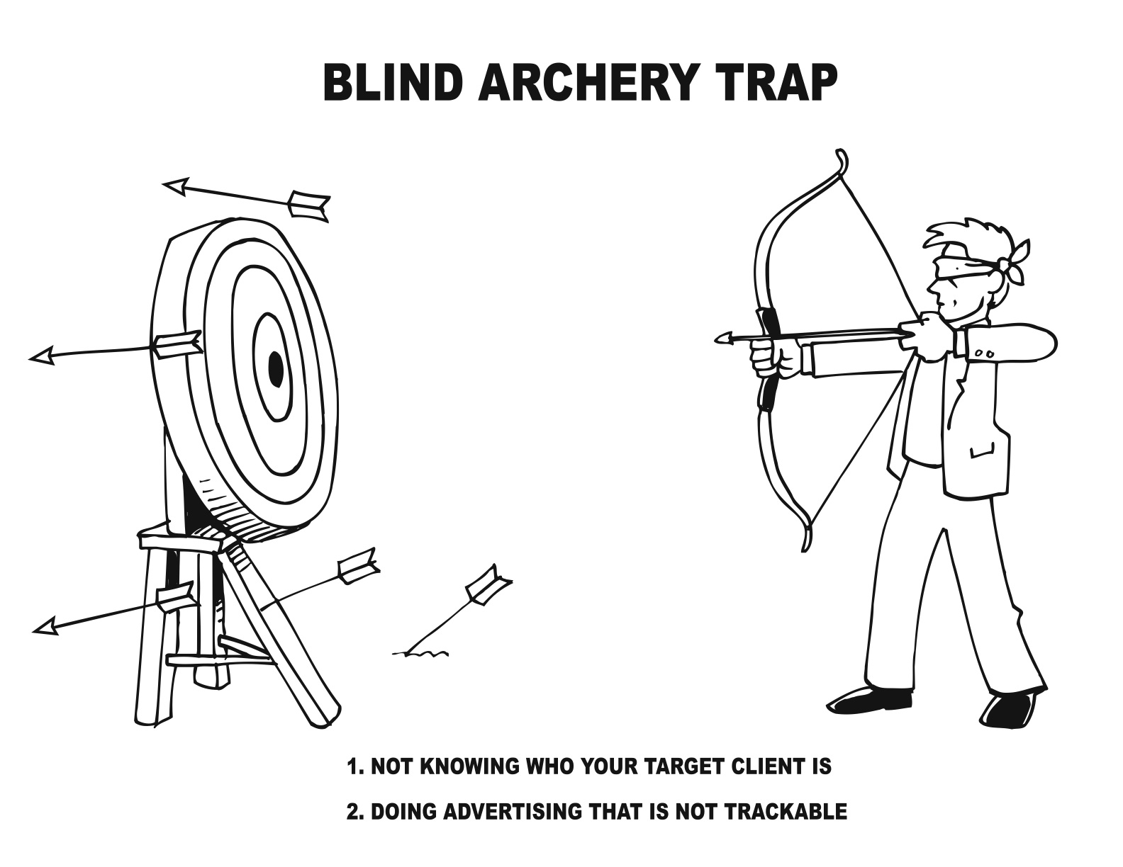
© 2011 Salon & Spa Marketing Tool Kit™

Before we get into the specific unconventional marketing automatic systems, we want you to think of and know where you are right now.

Please answer the following questions:

Do you know how much it cost you to acquire a new client? ____Yes____ No

Do you have a marketing system to generate leads? ____Yes____No
Do you know where your best clients come from? ____Yes____No

Do you know what your return on investment for every marketing dollar you spend?

____Yes____No

Off-Line Marketing Strategy #2

Types Of Advertising That Works For

Salons & Spas

The four things you need to sell your services and products are.

- Your actual services and products – You already have that.

- A marketing message (USP) – Hopefully you have figured that out. If you haven’t please send the office an email for help on this.

- A target market – who is your ideal client, what age are they, what sex are they, what income do they have, where do they live, etc.

- A delivery system.

A delivery system is a method to deliver your marketing message out to your ideal audience information about your small business.

What is a delivery system as it applies to the small business?

Some examples are an ad in a magazine, a letter, an audio postcard, an email, a web site, a recorded message, a voice broadcast, and newsletter. (We intentionally left out brochures because later on we will tell you why you DON’T want to use them.)

Most salon and spa business owners spend money delivering a lousy message, so you must have a great message and it has to match your market.

You can have a great message but not deliver it at all, or deliver it to the wrong people. Or you can have a lousy message and deliver it to the right people.

YOU WANT TO HAVE A GREAT MESSAGE AND DELIVER IT

TO THE RIGHT PEOPLE

This is the only way you even have a chance of getting new clients cost effectively. You WILL waste tons of money and time trying to do otherwise. So if you don’t have your message down (USP) or you are not sure who your market is, send an email to our office for help. OK?

Three Kinds of Advertising

There are three kinds of advertising you can do but after we get done here explaining to you the differences, two of the three you will NOT want to do, if fact you will want to avoid them like the plague.

Image building type advertising – You see this all the time on TV. The company just wants you to know that they exist and that they are a responsible company that cares about you, the environment or whatever.

They are not asking you to do anything like call them or go visit their web site, or store. Most of the commercials you see during the super bowl are image advertising. Advertisers know that you have a certain little space in your brain for the type of product they sell.

They are trying to dominate that space with their product name and image.

What is dominating your brain for cola? Coke, Pepsi, or Dr. Pepper? What is dominating your brain for insurance companies? Allstate, State Farm, Progressive or Geico? How about light beer? Is it Bud Light, or Miller Light. How about cell phones? Is it Verizon, AT&T, or Sprint?.

You get the picture right?

Regular advertising – This could be a TV commercial, an ad in the newspaper, or any type of advertising where the company is asking you to go to the store and buy their specific product. Or a local store having a sale and they are asking you to come to their store.

You see this a lot with the big drug companies asking you to ask your doctor if you need their pill.

The problem with this type of the advertising is you never really know if they bought your product or went to their store or talked to their doctor because of the particular ad you saw.

So this type of advertising cannot be tracked.

Most companies that do this type of advertising know that they are wasting a huge part of their advertising budget on ineffective ads but they just keep doing it because in most cases the companies are huge, have deep pockets, and know they must advertise.

YOU DO NOT WANT TO GET INVOLVED IN THESE
TWO TYPES OF ADVERTISING

The only type of advertising you want to do is:

Direct Response Advertising – which is the only kind of advertising we will show you how to do. And all the direct response advertising we will give you and teach you is UNCONVENTIONAL.

Direct Response Advertising is when you get an immediate response from your prospect which can be tracked back to the specific advertising you did.

It is very track-able and it is measurable. So you know right away if it is working. And you know right away if it is not working so you can STOP it and STOP wasting money on something that is not working.

Make sense?

Here are some examples of direct response advertising.

- A coupon which is redeemed

- An ad that asks the reader to call a free recorded message

- A referral program

- A postcard that asks the reader to go to your web site or call your business.

- An email that asks the caller to visit your store if you have one for a special offer.

- An ad asking the reader to go to your website to get a free special report or newsletter.

- A DVD that informs and then asks the person watching to call for more information on a product or service you offer.

- An outbound recorded message telling the listener about promotions you are offering.

- An audio postcard telling the listener about a special promotion.

- A letter explaining a promotion asking the reader to call you.

Direct Response advertising is the only advertising where you know works or doesn’t work for certain.

What we are giving you and showing you has already proven to work in most cases. we say most cases because things change that we have no control over. If something does not work you will know right away, avoiding spending lots of money.

This is why it is important to be involved in our ongoing monthly membership program because we will give you new stuff that is working and tell you to avoid something else because it has stopped working.

Also this is why we still spend about $20,000 per year on our own marketing education so we can find out about new stuff and then we can share it with you.

OK, now we hope you fully understand that the only kind of advertising you will be doing for your business is Direct Response Advertising the unconventional way (the New Marketing Profits way).

By the way this is the least expensive way to advertise. You will know for every dollar you spend how many dollars in services and products you get in return.

Off-Line Marketing Strategy #3
Learn Direct Response Marketing

You’ve heard us talk about the importance of Direct Response Marketing. But, what is a direct response ad?

A direct response ad meets all of the following criteria:

- Contains a headline
- Creates interest in the service or product
- Creates desire in the prospect
- Has a specific offer
- Has a deadline or cutoff date

Most of the advertising you’re used to seeing does not meet all five points. The difference with direct response is that it’s results oriented.

The ads you usually see and hear, whether in magazines and newspapers or on radio and TV, are known as institutional (or “image”) advertising. With these ads, there is no way of accurately tracking the response since there is no specific offer.

Why Do Advertising Agencies Like Institutional (Image) Advertising?

They can’t be held responsible for zero results. If an ad campaign doesn’t increase sales they blame it on one of the following.

- The economy

- They tell you that you need to run these ads that didn’t work over again and suddenly they will work.

Out of the two, the second is by far the worst. Ad agencies are notorious for this. It should be obvious that the theory is flawed: if an ad doesn’t work once, there’s no reason to think it will bring in tons of business the second time around. Perhaps a very small percentage of your response will come from people who have seen the ad before. But certainly not enough to justify wasting more money.

Advertising agencies are more interested in being creative and “cutesy” than getting results for you. That’s how they win advertising awards. Many of the ads that have won top awards didn’t produce a substantial increase in sales (in fact, some actually decreased sales). We think this is a little ridiculous.

They have forgotten that advertising is meant to do one thing and one thing only:

To Get More Clients

That’s the only reason we advertise. We don’t care about name recognition- we just want more clients.

Massive companies like McDonalds, Levi’s, Budweiser, Nike, and Coca-Cola can afford to do name recognition. Their advertising budgets are so huge that they can waste some of it on ads that don’t get direct results and still survive. (Of course, if they used savvy direct response techniques they’d cut the waste and see better results.)

Small, local businesses do not have that option. We cannot afford to waste marketing dollars on ads that don’t pull in immediate cash.

Direct response is results oriented. You know exactly how much money you made from each direct response method.

Remember the 5 criteria of direct response advertising. To sum them up in a sentence: Emotional direct response marketing gives your prospects something they want and tells them exactly what to do to get it. It creates compelling motivation to do business with you. It drives response, which leads directly to sales.

Follow these rules when marketing:

- Never do anything if you can’t directly track the results.

- Never run an ad a second time if it didn’t work the first time.

- Never fall in love with your ad.

Many business owners starting out in direct marketing break the third rule. It’s fun to see your business’s name in the media or come up with a clever concept. But it’s a mistake to fall in love with any ad until you have tested it and know that it pulls. Remember the purpose of advertising: to get results!

Off-Line Marketing Strategy #4
Diversify Your Marketing

Diversity equals stability.

If you have one marketing strategy that is pulling in $10,000.00 a month (which is entirely possible), it can be tempting to not do anything else.

This is a mistake. This makes you very vulnerable.

It is like putting all your eggs in one basket.

If for some reason that strategy starts only pulling in half as much, only $5,000.00, you’re in trouble.

Yes, yes, we keep telling you that these strategies are systems…that they get consistent results. This is all true but…There could always be some sort of change in one system. Over time these things are bound to happen.

If you have fifteen different strategies to get new clients each month, that’s better than one. The more reliable systems you have bringing in a steady flow of new clients, the more stable you will be.

For example if you have fifteen different strategies bringing in $10,000.00 a month and one stops working, you’ll still be fine.

But if you only have one and it stops working, you have BIG trouble.

We’re telling you this because these strategies are extremely powerful. One strategy could easily bring in $10,000.00 or more a month. It’ll be tempting just to do that one but don’t.

Diversify.

Your business will be bigger, better, and much more stable.

Take a look at the business model on the next page. There are several off-line and on-line ways to get new clients. Use as many as you can.

Off-line Marketing Strategy #5
Direct Mail

Direct mail, when done right, is one of the most powerful ways to market your small business.

That’s why it’s so popular. According to a study by McCann-Erickson, this year there will be $32.4 billion spent on direct mail. In comparison, only $11 billion will be spent on cable TV advertising for the top four TV networks.

There wouldn’t be that much money spent on direct mail if it didn’t work.

So why do most salons and spas think of direct mail as a waste?

- They don’t know how to use it. They’ve never had any instruction on how to use it.
- They send a flier- as you know by now, 99.9% of fliers don’t cut it
- They send it to a ‘bad’ list. The list, the people who you send your letter to, is just as important as the letter itself.

Many people overlook this.

Here’s one small business owner who learned the hard way: she had written a pretty good sales letter. Not great, but pretty good.

But she was getting zero response. Not some, not a little, but zero.

Who was she sending her letter to?

She didn’t know. She had bought a zip code zone.

Finally, she went to check out the area in the zip code zone she purchased.

Let us describe it for you:

Run-down. Tiny houses with peeling paint and broken porches. Junk strewn across the front yard and a car on cement blocks in the driveway. The people who lived there were dressed in stained t-shirts.

Are these the types of people most likely to buy your services?

The List is very important.

To recap, here is why most small business owners fail at direct mail:

- No direct mail expertise.
- Bad sales letter
- Bad list.

How To Do Successful Direct Mail

We’ve made it easy for you to put together a stunning sales letter that will motivate your prospects to read and respond. Use our sample direct mail letters and simply modify them for your business. Make sure you’re using all the techniques in the checklist below, which have been tried and tested to bring the greatest response.

Successful Emotional Direct Response Marketing Formula Checklist

Does the offer you are making closely match the potential new client (target market) or list you are using?
Does your headline:
Appear at the top of the letter or ad?
Invoke curiosity
Promise to deliver a big irresistible benefit?
Specifically apply to the potential new client?
Do you have an irresistible offer that your target market would consider an incredible value they’d be crazy to refuse? And are you giving the reason or a little story as to why you are making the offer?
Do you use down-to-earth language that your potential clients will understand, rather than technical terms or industry lingo? Do you use plain English to describe the problems your services will solve and the results you will deliver in plain English?
Did you write as if you were talking casually, one-on-one, with your prospect? Did you avoid sounding “professional” and “salesy” like a brochure from a big corporation?
Is the copy in your letter/ad clear, clean, and neat and not like a brochure?
Did you avoid using graphics, color, and letterhead?
Do you use short paragraphs and mini-bold headlines?
Do you use easy to read fonts like Times New Roman, Courier New, or Verdana?
In your copy do you bold some words, underline important points and CAPATIALIZE others?
Do have testimonials? And are they specific, impressive, and look convincing? Or do they just say “ABC business did a great job”?
Do they have a photo of the person to the left of the written testimonial?
Do they have a headline?
Do they have the full name of the person, their company, and city/state they are from? Or do they just say “Sally, happy customer”?
If you are offering something for FREE, did you SELL it as though it DOES cost money?
Is it simple and very clear why the prospect should respond to your offer? Are you giving them more than one way to respond? For example: They can call you, fax you, email you, go to a website, come to your place of business, etc.
Did you build URGENCY by stating a limited supply, or deadline to respond by? And did you explain why? For example: “Because of the demand and time limitations I am only offering the FREE (service) to the first 17 people to call me and set up an appointment before April 15, 2011”.
If mailing a letter, does your envelop look like junk mail? Or does it look PERSONAL? Is it hand addressed using BLUE color ink?
It is NOT your company envelope with your logo/address printed on them?
Does it have an actual postage stamp? Not metered or bulk mail.
Does the return address just contain your name and address (not company name) and is it handwritten using BLUE color ink?
Can you make your mailing impossible to ignore? (Lumpy with an object, priority envelope, unusual container, weird size, etc).
Are you prepared and ready with at least 2 more letters or other communications? (email, voice broadcast, fax etc.)
Do you have a plan to immediately follow up on the responses that come in?

[A copy of this checklist is also found in your Marketing Tool Kit]

Now you know why most of the advertising you’ve done before did NOT work. Most of the people who sell advertising don’t follow this formula, and they don’t get results either. But now you’ve learned how to fix your mistakes and create irresistible direct mail marketing, and that gives you the advantage!

Off-Line Marketing Strategy #6
Get Them To Open Your Mail

People will never read your letter if they never open up your letter. So you have to make it “look” like personal mail because…

Most people when they get their mail they divide it into 3 piles.

A-pile is all personal mail

B-pile is their bills

And C-pile is everything else, their junk mail. And you know what happens to their junk mail. Right, it goes in the trash without even being opened.

So if you want your letter to get opened you have to make it look like personal mail. You want to make it look like it is coming from their little old grandmother.

You do this by hand writing the address, using a stamp (not metered) and use colors. If you don’t, you risk your letter getting thrown out along with all the other junk mail without even being opened.

OK?

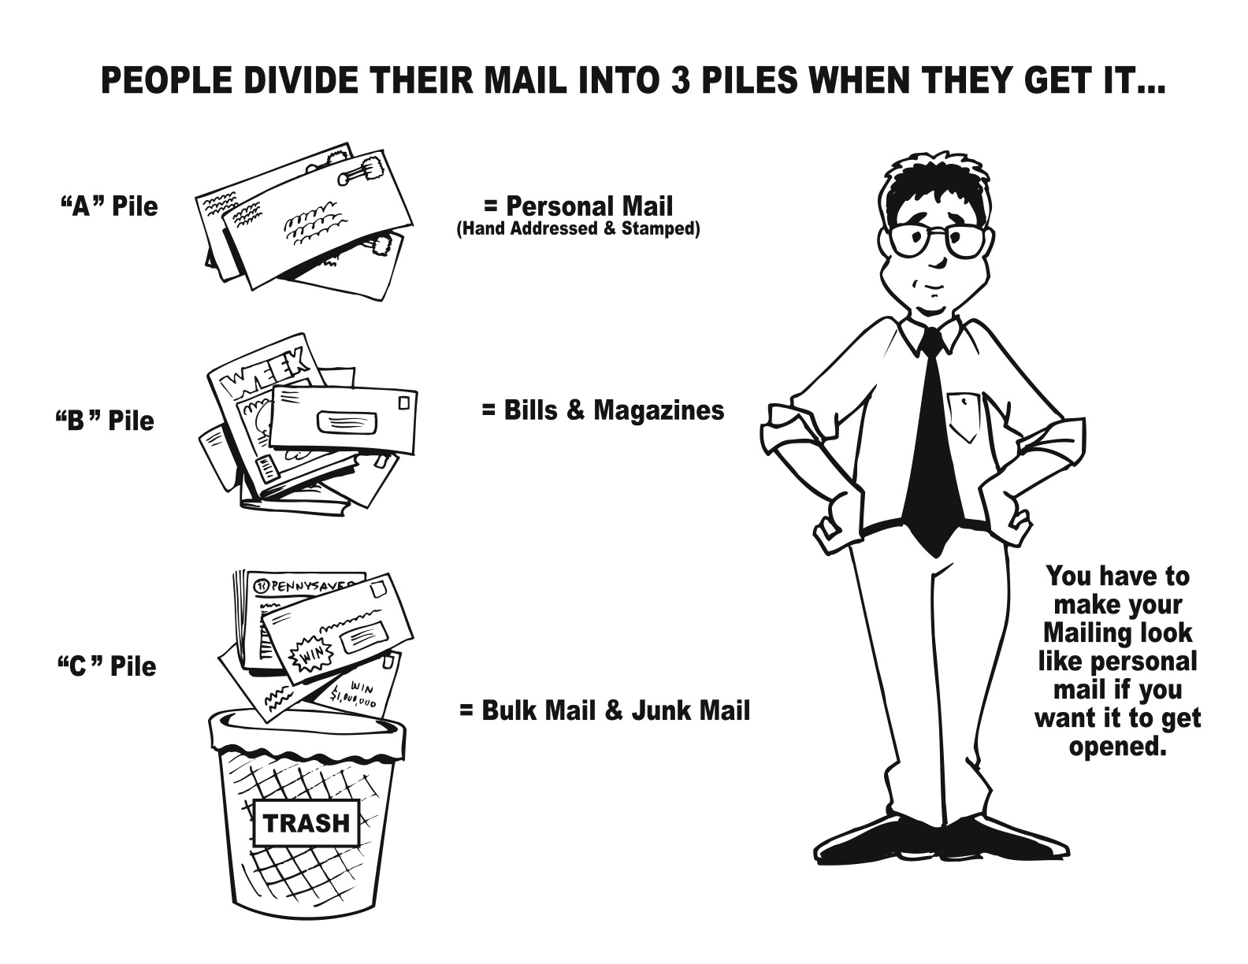
Off-Line Marketing Strategy #7

The 11 Biggest Direct Mail Mistakes

Made By Small Business Owners

This Strategy is about the 11 BIGGEST direct mail mistakes made by small business owners.

Why are these important for you?

Because this is the FOUNDATION to becoming a GREAT marketer. And when YOU become a great marketer there is NO limit as to the amount of money you can make and FREEDOM you can have.

That’s what this ultimately is all about. Isn’t it?

And let me make you a BOLD promise – Once you learn and fully understand the POWER of these marketing principles you WILL know more about “emotional direct response marketing” than 99.9% of all small business.

So here are the 11 biggest mistakes:

#1: Offer Looks Like Junk Mail. The first thing 52% of your prospects do when they come home from work is go through their mail. The mail is usually divided either physically or mentally into three piles. The “A” pile is letters that look important, personal letters, notices, etc. The “C” pile is mail that clearly looks like junk mail. The “B” pile is everything else. The “C” pile mail usually gets tossed unopened, the “A” pile mail gets opened right away and the “B” pile mail may get opened after the “A” pile. You job is to make your envelope look like the “A” pile.

#2: Not Having A Headline Or Having A Lousy Headline: When we write a headline we normally spend half of our time developing the headline. In fact, typically we will write about a dozen headlines before we settle on the one that we think will get the best response. The Headline is the most important part of the direct mail letter. It will grab the readers’ attention and pull them into what you have to say.

#3: Lack Of Testimonials: What your current clients say about you is ten to twenty times more believable than what you say about yourself. Testimonials are a great way to get instant credibility with prospects. How many testimonials should you use? As many as you can – and use them everywhere.

#4: No Offer/Lousy Offer: It is costly to get a new client. What will make someone respond? Well, I’ll tell you one thing – there is no way that someone will respond to a lousy offer or worse yet, no offer. Remember, the real money in getting a new client is in making them a “client for life”.

#5: No Deadline or “Wimpy Deadline: People are natural procrastinators. Unless you motivate them to respond NOW, they never do. A deadline is what makes them respond. Deadlines create fear – fear of losing out on a particular offer or opportunity: One rule that we live by is never to give a prospect more than a 2-week deadline. If you do, you might as well save your hard-earned money and not mail.

#6: Focus On The Business Instead of WIIFM: How many times do you see business advertising and all it says is how wonderful the business is? It talks about how many years they have been business, or the friendly service, or the big selection. But what about what the client really wants? Clients ONLY want one thing – WIIFM (What’s In It For Me).

#7: Trying To Accomplish Multiple Objectives: The business owner or ad agency that created the mail piece tries to accomplish multiple objectives. A mail piece should ONLY have one objective. All you should care about is GETTING A CLIENT. A Client is the only thing that can put money in your bank account. Image can’t do that. Last time I tried, the teller at my local bank wouldn’t allow me to deposit “image”.

#8: Lack Of A Guarantee Or A ‘Wimpy” Guarantee: This is a very simple concept but often scares business owners to death. Study after study has proven that the better the guarantee, the more people will by. Sure, some will take advantage of your guarantee, but they are insignificant to the number that will buy more. If you can’t guarantee your products or services, then find something else to sell.

#9: Failure to Tell Your Story: Clients and prospects like a story. They want to hear why you are making the offer that you are making. It seems to add credibility, and when they believe you, they respond better.

#10: Cute: Why is so much advertising “cute”? Two reason. First of all, cute advertising is the type that wins awards, and ad agencies like to win awards in order to help them “pitch” new clients. Also advertisers like cute advertising because they think it gets remembered. Well, let me ask you a question? Can you give me the names of the advertisers that spent over a million dollars each during the last Super Bowl in order to air their 30-second TV commercial? Bet you can’t name more than one or two. Study after study has proven that the type of advertising that sells is still the emotional, direct response advertising and not the “cute” brand-building type.

#11: Sequence: Just because a prospect did not respond to your first offer does not mean they will never take you up on your offer. Sometimes they intended to respond but got distracted and forgot so they need to be reminded again. From all the mailings that we have done, you can expect the response from your first offer to double (100% more) with your second and third mailings combined. You must follow up at least 3 times.

Off-Line Marketing Strategy #8
Headline Tips Guaranteed To Work

As we discussed in the past, the headline is the most important part of your ad. Without a good headline, you will lose prospective clients instantly and your ads will bomb.
Here are 7 quick headline tips that can double or triple your response rates:
1. “How To” is a tested and proven winning way to begin a headline.
2. Another “Can’t go wrong” headline technique is to use the word FREE somewhere in your headline. It’s still one of the most powerful words in advertising.
3. “New” is yet one more proven response boosting word that you can test in your headlines.
4. Try to use “You” in your headline whenever possible. Tests have shown that it alone can boost response.
5. Another surefire way to create a good headline is to ask a question that evokes a “Yes” answer.
6. Guarantee. Using a guarantee in your headline can double response or more. People don’t want to feel like they’re going to get stuck with a lemon, and they have been ripped off too many times.
7. Everyone wants to know a “Secret”. Use it in your headline and watch response rates soar!
Combine some or all of these like we did in the headline at the top of this page for a very powerful headline, and test different headlines. The difference between an average headline and a good one can be the difference between getting two or three clients and dozens of them driving across town to go to your business.

Off-Line Marketing Strategy #9
Print Advertising

We’ve already warned you not to be like most business owners, who try to accomplish too much with their advertising and end up with something boring that doesn’t connect with anyone. We also told you why direct response advertising will get you better and quicker results for less money.

Now we’re going to show you how to use those techniques to create strong, focused, print ads that demand attention.

Small Direct Response Ads That Produce BIG Results

Remember that one of the keys to successful marketing is to be different. How is anyone going to notice you if you don’t stand out? In print ads, you do this by having an attention-grabbing...

HEADLINE
Why?

Because you have less than one second to catch someone’s attention. And once you get their attention you have to offer them something for free and you have to make it easy for them to get it.

Your headline needs to STOP them dead in their tracks, because once they move past your ad to something else, they’ll never go back. Then you need to make that irresistible FREE offer that will capture them.

Your headline summarizes the one thing you want to do in your ad—and remember, doing too much is deadly.

If you don’t have a great headline your ad will get lost in the clutter of all the other ads.

What does a great headline look like?

On the next few pages I’ve given you over 100 of the greatest headlines ever written. If any of these headlines apply to you, use them to make strong, attention-grabbing ads. Or if you need to, modify them to fit your situation.

And here they are:

- What 99% of All Carpet Cleaners Don’t Know & Will Never Find Out About Marketing Secrets Of A $100,000+ Yearly Income
- To People Who Want To Stop Arthritic Pain --- But Can’t
- Make This 20 Minute Test -- Of An Amazing Arthritic Cream
- Great New Discovery Kills Arthritic Pain -- In A Matter Of Minutes
- Announcing... The New Discovery Of An Arthritic Cream
- Secrets Of Killing Arthritic Pain
- Announcing New Arthritic Pain Killer
- Discover How To Rid Arthritic Pain -- For Good!
- Now For The First Time, A Test Pain Killer For Arthritis
- “How I Got Rid Of My Arthritis Pain In One Day”
- Your Arthritis Pain Is Gone In 24 Hours... Or Your Money Back
- Amazing Breakthrough In Killing Arthritis Pain
- FREE Report Reveals Details On How To STOP Arthritic Pain
- Do You Know How To Kill Arthritic Pain -- FREE Report Reveals Details
- How Much Do You Know About Stopping Arthritic Pain?
- How To Kill Arthritis Pain -- FREE Report Tells All
- How Would You Feel If You Could Stop Your Arthritic Pain?
- I’ve Got To Get This Off My Chest... Or I’ll Explode
- The Truth About Stopping Arthritic Pain
- Amazing Cream Kills Arthritis Pain
- They All Laughed When I Told Them My Arthritis Pain Was Going To Stop -- And When It Did...
- (offer + pain + benefit) “I Like To Be Looked At. Love To Be Admired. But When I Weighed 350 Pounds People Looked At Me Because I Was Fat. And I Felt Horrible. Then A Friend Told Me About Weight Loss. I Took advantage Of Their FREE 15-Day Trial Offer. And Now I Know that When People Look, It’s Because They Like What They See. And At 150 Pounds, They Ought To.”
- (testimonial + pain + offer + benefit) “You Are In Default. Your Home will Be sold At Public Auction In Just 120 Days. That’s Why You Need a FREE One Hour Consultation With Mortgage Specialist Jane Powers. She’ll show You How You Can Keep Your Home -- Or Get Your Equity Out Before Your Home Is Sold At Public Auction.”
- What Everybody Ought To Know About.......
- You’re Probably Going To Be Broke At Age 62... You Deserve It!!
- At Last An Amazing Breakthrough That Stops Arthritis Pain
- Reasons Why It Would Have Paid You To Answer Our Ad A Few Months Ago
- FREE Report -- Tells You Why Your Arthritic Pain Can Be Stopped
- You Can Laugh At Your Arthritic Pain... If You Follow This Simple Plan
- When Doctors Have Arthritis... This Is What They Do
- Thousands Now Have NO Arthritis Pain Who Thought They Had To Live With It Forever
- “How A New Kind Of Arthritis Cream Improved My Pain In 20 Minutes”
- WARNING: Do Not Hire A Home Improvement Contractor Until You Read This Ad (letter, listen to this FREE Recording, etc)
- If You Are A ______________, You Can ______________.
- If You Are A Non-Drinker, You Can Save 20% On Life Insurance
- If Your Firm Uses “Temporaries” You Might Qualify For $1,000 In FREE Services
- Give Me _____________ And I’ll _______________
- Give Me Five Days And I’ll Give You A Magnetic Personality
- Give Me A Chance To Ask You Seven Questions & I’ll Prove You Are Wasting A Small Fortune On Your Advertising
- They Didn’t Think I Could ____________, But I Did
- They Laughed When I Sat Down At The Piano -- But Not When I Started To Play
- Come To Discount Widgets & Pick The Widget You Like, Then Use Our Phone To Call Around & Find The Best Price -- We’ll Beat Their Price By 22%... Guaranteed!
- Thousands (Hundreds) Now ____________ Even Though They _____________
- 55.4%of People Using Eddie’s Arthritic Cream Stop Having Pain Forever!!
- 138,000 Members Of Your Professional Association Receive A Check From Us Every Month -- Even Though They Once Tossed This Letter Into The Waste Basket
- ________ Ways To _________
- 17 Ways to Increase New Patient Flow
- 23 Ways to Slash Your Equipment Maintenance Costs
- WARNING: Your “Corporate Shield” May Be Made Of Tissue Paper -- 9 Ways You Can Be Personally Liable For Your Business Debts, Losses, & Lawsuits.
- Who Else Wants ____________?
- Who Else Needs An Extra Hour Per Day?
- How _________Made Me _____________
- How A “Fool Stunt” Made Me A Star Salesperson
- Are You _______________?
- Are You Ashamed Of The Smells In Your Home?
- How I _______________
- How I Raised Myself From Failure To Success In Selling
- How I Turned A Troubled Company Into A Personal Fortune.
- How To _______________
- How To Win Friends And Influence People
- “Flag” How To ________________
- For Busy Doctors: How To Educate Doctors In Half The Time
- For The Executive With Work Left Over At The End Of The Day: How To Delegate With Out Worry
- Secrets of ______________
- One Time Seminar Reveals How To Double Your Business In 6 Months (Or Less)
- “It’s Just Not Professional”.......
- “They All Laughed When I Ran That Little $40 Ad -- But When I Got 81 Leads...!”
- Read why one of the top horticultural experts in America declared under oath: “This Is The Best Darn Tomato I’ve Ever Tasted!” And it’s absolutely the easiest tomato to grow -----
- Fun And Easy Ways To Earn $500 Next Weekend
- Dead Doctors Don’t Lie
- I Lost My Bulges... And Saved Money Too
- The Little Mistake That Cost A Farmer $3,000 A Year
- Advice To Wives Whose Husbands Don’t Save Money -- By A Wife
- Five Familiar Skin Troubles -- If You Follow This Simple Plan
- Which Of These $2.50 To $5 Best Sellers Do You Want For Only $1 Each?
- Who Ever Heard Of A Woman Losing Weight -- And Enjoying 3 Delicious Meals At The Same Time?
- Guaranteed To Go Through Ice, Mud, Or Snow -- Or We Pay The Tow!
- Today... Add $10,000 To Your Estate -- For The Price Of A New Hat
- To People Who Want To Write -- But Can’t Get Started
- “No More Back-Breaking Garden Chores For Me -- Yet Ours Is Now The Show-Place Of The Neighborhood!”
- Why (Brand Name) Bulbs Give More Light This Year
- How Any Auto Repair Job Can Be “Duck Soup” For You
- It’s A Shame For You Not To Make Good Money -- When These Men Do It So Easily
- For The Woman Who Is Older (Younger) Than She Looks
- If You Were Given $200,000 To Spend -- Isn’t This The Kind Of (type of product, not brand name) You Would Build?
- “Last Friday... Was I Scared! -- My Boss Almost Fired Me!”
- Suppose This Happened On Your Wedding Day
- What Everybody Ought To Know... About This Stock And Bond Business
- Money-Saving Bargains From America’s Oldest Diamond Discount House
- Former Barber Earns $8,000 In Four Months As A Real Estate Specialist
- FREE Book -- Tells You 12 Secrets Of Better Lawn Care
- Greatest Gold-Mine Of Easy “Things-To-Make” Ever Crammed Into One Big Book
- NOW! Own Florida Land This Easy Way... $10 Down and $10 A Month
- Take Any Three Of These Kitchen Appliances -- For Only $8.95 (Values Up To $15.95
- Save Twenty Cents On Two Cans Of Cranberry Sauce -- Limited Offer
- “One Place-Setting FREE For Every Three You Buy!”
- You Must Lose Up To 49 Pounds Or We Pay You $14.00!
- The Fish Lure Guaranteed To Catch Fish
- Earn $180 Per Roll Taking Photographs In Your Own Home
- How To Turn Your Spare Hours Into $1,200 A Week
- They Told Him Salesmen Were “Born” -- But How He Makes $100,000 A Year Thanks To This FREE Report
- “I Want Every Arthritic To Have A FREE Trial Sample”
- Major Arthritis Breakthrough
- “Women Are Breaking Down My Door To Get My Wrinkle Cream”
- Yours FREE From _________________
- “1,001 Home Health Remedies”
- Will You Pay Half The Usual Price For White, Lovely Teeth?
- “If Soap Irritates Your Skin... You Are Using The Wrong Kind”
- Office Headache? -- Here’s The Simple Remedy:
- Join NOW! -- And Get Your First ____________ FREE!!

NEWS HEADLINES: You can add these to any headlines to make them stronger.

- New
- Announcing
- Introducing
- Finally
- Just Released
- Now
- Now Available
- At Last

On the next 2 pages we’re giving you actual complete ads you can use (with simple modifications for your business). Please, don’t modify them so much that they look like everyone else’s ads (that don’t work)! Keep in mind the concepts we’ve talked about in this chapter: have a big bold headline and offer something for free.

These sample ads were written for you salon and spa business owners. Use these as a guide for your specific business.

Salon Owner Swears Under Oath….
“You Get The Best Service Ever, Or It’s Free!”

If you are the kind of person who cares about looking your best and wants to get the most from a professional salon, then call for details (insert phone number).

Now comes the hard part… choosing the best salon for you. But, there are so many salons, and you’ve probably seen your fair share of them – Are you really going to be happy with rushed service and no guarantees? …. How do you find one that best suits your needs, while avoiding getting sloppy or insufficient services? The lowest price salon really isn’t a bargain at all.

Remember This When Choosing a Salon.

3 reasons You Will Love (insert salon name)

1. You Get “The Best Service Ever” – You get the best service through excellent communications coupled with a determination to make you happy. You are always treated like you are our only client.
2. Skilled & Talented Professionals – This means you get the highest quality work performed on you. Our extensive training and education of techniques, products, and skills gives you superior service.
3. 100% Money Back Guarantee – that is exactly what I mean when I tell you “The Best Service Ever, Or It’s Free!” I will bend over backwards to make you happy or you don’t pay!!

Call Today For A
FREE Hair Analysis
More than a consultation, I will address your specific needs, discuss the “look” that suits you best and build a professional product profile for your needs. There is no cost, no obligation and it only takes about 10 minutes, Call (insert salon name) at (insert phone number)

“How To Save Time & Money When Choosing The Best Hair Salon For You”

By: your name
City

There are hundreds of thousands of salons and you’ve been to your fair share of them – how do you choose one? How do you find one that best suits your needs while avoiding getting any sloppy or insufficient services?

Use These Tips To Choose A Salon:

TIP ONE: Choosing a salon solely by price doesn’t work: The truth is, when we invest wisely, we get what we pay for.

Beware of unbelievably low prices. Call the cheapest salon and I’ll wager you get a so-so job with very little service.

It only makes sense that the cheapest salons have to cut costs by using cheap, low-wage, low skilled employees, cheap products, and cheap methods. (After all they have to make up the “quality’ with “quantity”).

Are you really going to be happy with cheap, rushed service and no guarantees? If not, then … the lowest price salon really isn’t a bargain at all.

TIP TWO: What kind of results does the salon get? Many professionals claim to have experience or talent. Often people are upset when they expect their hair to look like a picture they brought into a stylist, but reality sets in about the time they see chunks of hair falling to the floor.

Avoid this tragedy, through excellent communication. Ask to see pictures of the professional’s work. If they don’t have any ask if they have a few clients you can call for a reference or testimonials you can read through. Make sure the salon professional are straight with you. Often times the difference between leaving the salon in tears or with a big smile on your face is simply communication.

TIP THREE: Doing it yourself is a waste of your time and money. Sure you can buy a set of clippers attached to a vacuum cleaner, or buy hair color in a box. But will you really look your best?

If those methods could make you look your best, I would have never spent the time and money to become licensed professional and invested thousands of dollars to open a hair salon.

Furthermore, when you consider the value of your time, you stand to lose more money than you could allegedly save, especially if you botch it up and have to end up visiting the salon anyway.

Are you really going to be totally happy with cheap, rushed service and no guarantee?

If you call today you will receive a FREE Beauty Analysis. More than a consultation, I will address your specific hair needs, discuss the “look” that suits you best and build a professional product profile for you. There is no cost or obligation and it only takes 10 minutes. Call (salon name) today at (number). We specialize in Hair color and style.

Warning! When you submit your ad to a publication
DO NOT LET THEM TYPESET THE AD.

You MUST give them the ad camera ready. They will screw it up if you leave it up to them. This is your ad, your business, and your livelihood… don’t take the chance!

If they insist on typesetting your ad, demand to see a proof before it’s published.

Where should I run my ad?

If your ad isn’t targeted on your ideal client, you’re wasting money. In this program, we’ve asked you to think about where your clients come from, where they live, who they are.

If you know that, it’s simple to decide where to put your ad.

Use the “Birds of the Same Feather Flock Together” strategy. The easiest new clients for you to get are the ones that are like your existing clients. Where is your market and what are they reading? Which newspapers do they subscribe to?

DON’T run your ad in an area you never get clients from.

DON’T run it in a publication your ideal client wouldn’t read.

You can advertise in any publication you think your target market is reading.

Use your imagination.

What Size Ad Should I Place?

Always start with the smallest ad space the publication has and grow in size as your business grows in size and profits. You will get more calls with a larger ad but start small first.

You want your ad to have a great headline and a free offer. You don’t want to be gimmicky or funny.

Let me give you a real-life example of the impact a strong, focused ad can have. On the page after the next, you’ll see two ads that a friend of mine ran in a Penny Saver type newspaper. He’s in the home improvement business.

The ad at the top of the page is the first one he ran, which he wrote himself. It cost $64, and he was getting 2 to 4 calls every time he ran the ad.

On the bottom of the page is the ad we wrote for him. It was the same size and cost the same to run, $64. Guess how many calls he got the first time he ran the ad?

71 calls!

And he has been running the same ad for 28 months now.

The number of calls he gets each time he runs it has settled in at about 40. Because of the high response rate, his $2,000,000 business only spends a total of $3,200 on advertising per year. In an industry where the average business spends $300 on marketing to get an appointment with a customer, he spends under $10.

Because of this he is three to four times more profitable than everyone else in his industry.

One little ad with a great message made all the difference.

And it will make all the difference for you as well in your business.

The only difference between his ad and the one we wrote for him is the message. The message matched the market perfectly.
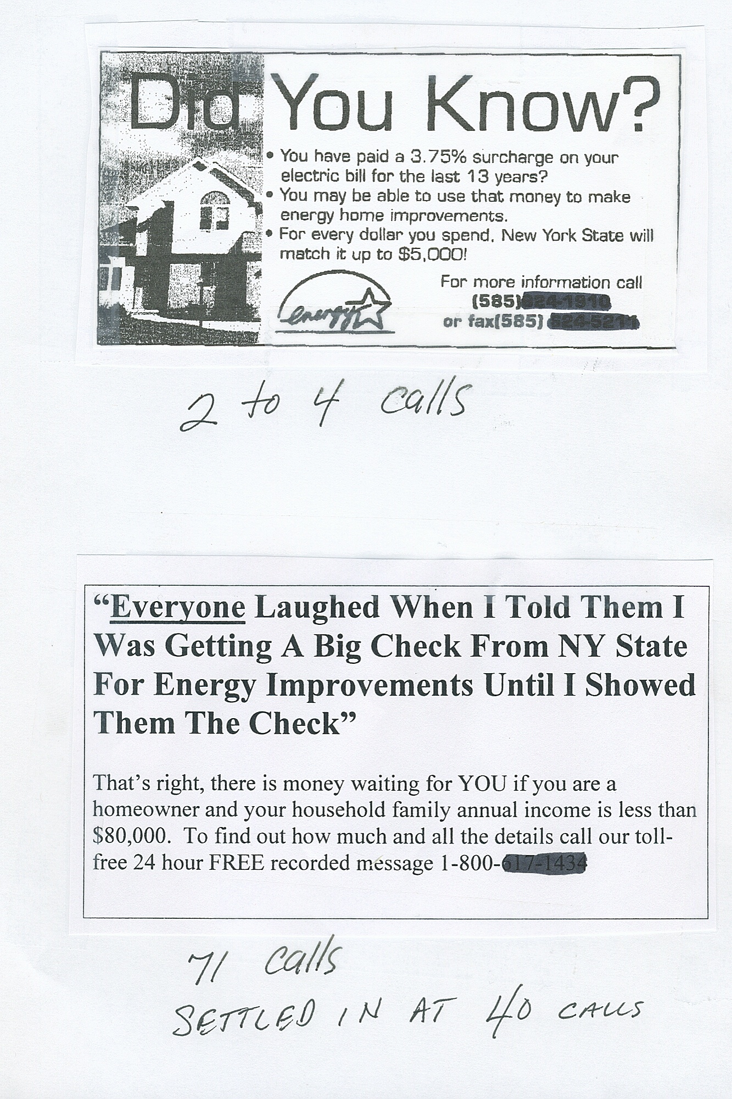
The only difference between a dollar bill and a hundred dollar bill is the MESSAGE.
They are the same size and shape, printed on the same paper, but one is 100 times more valuable. Similarly, your ad can run in the same places as everyone else’s, but get you 5, 10, 15 times the response (or more), if you understand and use the strategies in this program.



It’s all about the message. Don’t fill the ad with visual clutter no one cares about, like logos and pictures. Just black print. If your message is great it will speak loud and clear on its own.

Don’t try to use reverse type (white type on a black background) like the ad below. This has been proven over and over to be less effective than a regular ad.

. 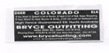

You always have to be thinking of what your potential clients want. And you have to remember every time they see an advertisement of any kind they are immediately looking for…

What’s In It For Me?
(WIIFM)

Off-Line Marketing Strategy #10
Yellow Pages

Advertising in the yellow pages has changed a lot in the past few years. Because of the internet, it is much easier and faster to just do a search on Google, Yahoo, or Bing and find what you are looking for.

Some areas of the country have even stopped automatically delivering the yellow pages in order to conserve resources. They now require you to request a yellow pages book if you want it delivered.

As a result, fewer and fewer people are using the yellow pages. In fact, many younger people don’t even know what the yellow pages are. For you, this means a lower response if you choose to run a yellow pages ad.

With this in mind, is it still worth it to advertise in the yellow pages?

The answer to this question is, “YES, if it makes you money”, and, “NO if it doesn’t.” Remember one of the most important business sayings:

“You cannot manage what you cannot or do not measure”

The only way to figure out if it’s worth it to you is to track the profit your ad brings you versus the cost. If you are just starting out, consider testing a very small ad your first year.

If you decide to advertise in the yellow pages, please follow the separate module in this program for the greatest response possible.
Off-Line Marketing Strategy #11
How To Get Your Yellow Page Ad To Your Target
Market Without Paying The Yellow Page Company

There is a separate module that came with your program that covers all the things you should be doing to MAXIMZE your response to your yellow page advertising.

BUT there is another, very effective way to get your yellow page to your target market WITHOUT giving the yellow page company a ton of money every month.

This strategy to this will SHOCK you.

Are you ready?

DON’T ADVERTISE IN THE YELLOW PAGES

Waite a minute guys, how are local customers supposed to find me? All my competitors are in the yellow pages. Now I think you have totally lost your mind – it must be the heat! Right?

Wrong!

We are going to show you right now how to get in the book without paying. And multiply your response results up to 20 times all for a fraction of the cost of a yellow page ad.

By the way, the last time we looked into yellow page advertising in my town it was $50,000 for a full page ad, FIFTY GRAND, that’s a lot of green backs.

Before we tell you this one little strategy that can transform your bank account we want to clear up some realities about yellow page advertising, OK?

- Most yellow page advertising does NOT work because it is missing all the elements of a successful ad. An ad in the yellow pages is NO different than any type of print ad. The paper it is printed on is yellow, that’s it.
- Yellow page ad reps don’t know squat about advertising. All they want you to do is buy the biggest ad because then their commissions are bigger.
- Most “big” companies have their advertising agencies design their yellow page ad. Advertising reps don’t know squat about effective track-able advertising. The first question an advertising company will ask you is, “What is your advertising budget?” You tell them and they proceed to spent it all with little tangible results.

Here is the strategy.

Design your ad like we show you how in your yellow page module (a full page ad). Get it printed on yellow newspaper just like a full page ad in a yellow page book and MAIL it to your surrounding area (target market) with a letter like the one on the next page.

Change it for your business, town and offer. This letter is also found in your “Marketing Tool Kit”.
“Our Recent Screw Up Saves [your town here] [whatever your target market is, women, men, mothers, etc] Big Money”

Dear Name:

Enclosed please find our yellow page ad that we were going to run in the yellow page directory. My business partner (who is also my husband) had a little disagreement with me about our ad design this year and we missed the submission deadline. So if you wouldn’t mind inserting our ad between page XXX and XXX [tell them where to insert your ad in their yellow page book] in your recently delivered directory we would greatly appreciate it.

We are hoping to save money by mailing you our ad so we want to pass the savings along to you. So for doing this little favor for us we are offering you a FREE [offer them something for free here] (total value $43.00).

Please call us for all the details and to make your appointment. [phone number]

Thank you for your help.

Sincerely
(your name)

P.S. This is a FREE, NO-RISK, NO-OBLIGATION Offer while supplies last. So call us today for an appointment at (phone number).

[This letter is also on your Marketing Tool Kit CD so you can quickly and easily edit it for your use.]

A couple of things you need to know:

- YES the yellow page book company will be ticked off if they find out you did this BUT there is nothing they can do about it.

- YES your competitors will get ticked off if they find out you did this. We hope you don’t care what they think of you.

- Always test a small mailing before you “roll out” to your entire area or target market.

- You can get a list by zip code of people in your area from the company we have listed in the resource section of your manual under “Mailing Lists”.

DO THIS, OK?

Off-Line Marketing Strategy #12
Personal Letters Work, Fancy Brochures Don’t

Fancy, 3-color brochures are very expensive. You have to get at least 1,000 printed at once. Then you have your money tied up in inventory.

Why Brochures Don’t Work

- They scream “sales message!” This is a huge turn-off for prospects, who don’t like feeling they are being “sold to.”

Have you seen the cartoon with General Patton?

Patton is in the middle of a huge battle and a man comes up to him with a box full of guns. Patton says, “I don’t have time for a salesman right now, I’m in the middle of a war.”

You see, even if you have exactly what a prospect needs, if they think you are a “salesman” it will be difficult to get through to them.

It’s the same thing with your sales message. A brochure is immediately recognized as a sales message. It’s fancy but boring.

- You can’t cheaply or easily change your message. When you buy a bunch of brochures, you’re stuck with that message.

The problem is, things change all the time. Maybe you decide to discontinue and offer, or offer something new. Maybe you even stop offering a particular service, like doing nails. Now you’re either giving out a brochure with inaccurate information, or you have to pay a lot of money to get it redone (and who knows when that one will become out-of-date...)

- You can’t cheaply test it. You should always test, test, test.

With brochures, you spend a lot of money on something before you even know if it works. The initial investment is too high. If it doesn’t work, you wasted all that money.

Why Letters Always Get a Better Response:

- Letters look and feel personal. People think of letters as personal and brochures as sales.

- Letters are very inexpensive.

The cost per letter is tiny, but it can easily generate more response than a brochure. Instead of being limited by a print shop’s minimum order, you can get as few or as many done at a time as you need. Instead of tying up your money in inventory, with a pile of brochures sitting in a storage room, you’ll have all your marketing dollars out there working for you.

- Letters are easily changed. If something about your business changed you can quickly, easily and inexpensively change your sales message.

- If your letter didn’t work as well as you’d like, you can easily improve it. Letters have no waste.

Let us drive home this point by asking you a question.

Have you EVER picked up a brochure and read it from beginning to end?

Our guess is NO.

Have you ever read a personal letter from the beginning to the end?

Our guess is you do this all the time.

Your clients and prospects are just like you. STOP using brochures that no one reads and start using letters and consumer awareness guides that have a strong message and show the client how they benefit.

Off-Line Marketing Strategy #13
Consumer Awareness Guides & Messages

Consumer awareness guides and messages are educational marketing pieces that help consumers choose a good business in your category. You use your knowledge as a business owner to offer expert advice on being a savvy consumer. Of course, these are also a great tool to get new clients.
There is a separate module that came with your program on this. Make sure you use these tools.
Some business owners have procrastinated when it comes to using these tools. That is a big mistake. You should be setting this up and using them in all your marketing right away.

Off-Line Marketing Strategy #14
Referrals

Why Referrals?

Referrals are the fastest, easiest way to double your business. What would happen if you could get all your current clients to refer just one new person? You’d have twice the business almost overnight, at little cost to you.

Is it really difficult?

It may seem impossible if you’re someone who hates soliciting for referrals.

But it’s probably a lot easier than you think. You just have to take the initiative—don’t leave it up to your clients to do everything on their own. Reward referrals. Make it a priority. Most businesses rely heavily on referrals, but don’t do anything to encourage them.

You should aim all your efforts at getting referrals.

Why?

Referred Clients are Better Clients:

- They cost less to acquire. This is very important. Anything you can do to get your cost per client down is great.

- They are much less price resistant. Because they were referred by someone they trust, they really want your service.

- They are more likely to refer, since they were referred by someone else.

- They are less likely to complain and are easy to please. Even if something does go wrong, referred clients are more understanding.

For all of those reasons, you should make getting referrals your number one priority.

This won’t just happen overnight. Like anything else, you have to make it happen.

There is a separate module that came with this program called “Referral Magic”. Be sure to follow the plans laid out for you and get this working for you in your business.

Off-Line Marketing Strategy #15
Networking

Do it right or don’t do it.

What we mean by this is:

For some people, networking will be a great opportunity to promote and grow their business. For others, it will just take away time they could be spending on other strategies.

One type of person goes to meetings, parties, and events and interacts with everyone they see. They talk to strangers, get to know them, and enthusiastically discuss their business. Many of the contacts they make become clients.

Another type goes to the same events and only talks to the people they already know. They don’t introduce themselves to strangers. They’re might consider themselves shy, quiet, reserved.

If the first type sounds like you, then network all you can.

If you’re more like the second group, don’t feel bad about it. That’s just the way you are. Figure out where your strengths are and focus your time and energy there.

Can Someone Learn to Network?

Of course. But it takes work. And frankly with all these great strategies you now have, you don’t need to network.

If networking works for you, the rewards can be great. If not, don’t get stressed about it.
There are plenty of other strategies you can use.

Off-Line Marketing Strategy #16
Never Rely On Walk-Ins Again

You’ll never build a highly profitable business by relying on walk-ins. Trying to lure people in off the street by advertising low prices is a game you just can’t win.

And Relying Strictly On Walk-Ins Doesn’t Cut It

Sure, the occasional walk-in can help on a slow day or when a regular client cancels. But they’re not the high-quality clients you need to build the successful business you want. You certainly shouldn’t base your entire business model on walk-ins by renting an expensive location in a mall in hopes of drawing in shoppers. Let me explain:

Offering low, low prices to entice people into your business will get people in the door—but not the people you want. These clients will be coming in solely based on price. You haven’t educated them on the value and benefits of your extraordinary service, so they won’t be willing to pay what it’s really worth. Another problem is that “mall traffic” fluctuates greatly throughout the year. Finally, it’s extremely expensive to rent a space in a mall.

High costs, low profits. That’s not the recipe for success. The walk-in strategy will cost you in the long run and make it harder to build up your business. If you rely on it, you’ll most likely be in the same place in 5 years as you are now.

We’re sure you won’t be surprised to hear the Direct Response Marketing is a much better way to build your high-profit business. With a well-executed direct response plan, you’ll attract high-quality customers who return again and again. Your schedule will be too full to take many walk-ins. Instead, your days will be booked up with qualified clients who are willing to pay the prices you deserve.

Stop relying on walk-ins, and start Direct Response Marketing and join the top 1% of salon and spa owners.

Off-Line Marketing Strategy #17
Hold Workshops

A free workshop is a great way to stir up interest in your business and the products and services you offer. By sharing a little of your expertise, you get a chance to reach potential clients.

We do not recommend just putting an ad in the newspaper and hoping people show up. It’s too expensive, and hardly anyone will come.

So how do you get prospects to attend?

You go through organizations, clubs and associations, diet centers, weight watching meetings. You give a workshop especially designed for them. This gets their members interested in your services and many of the attendees will become clients.

This is very cost-effective for you. The organization will supply the meeting room. They will do most of the advertising for you through their meetings and newsletters.

In return, you provide interesting information, and you can also offer to make a donation to the organization and provide a special deal for its members.

How To Get Into the Organization

Call the organization and ask for the person in charge of educational programs. You need to explain how their organization will benefit, or they won’t be interested. Ask the person if you could come over and discuss a workshop with them. Most people will be more than happy to give you a few minutes of their time.

Explain the whole thing to them. The best way to offer a benefit for their organization is to donate a certain percentage, say 5%, of the work you get because of the workshop to the organization. Then also offer a discount to all their members, such as $15.00 off or 10%.

This way the organization can see that they will be making money and offering something of value to their members. Also tell them exactly what their members will learn even if they don’t use your service. You should tailor each workshop to the specific organization—whatever they are interested in.

Once you set up the workshop, work on promoting it with them. You should give them all the material. Don’t count on them to write effective, direct response marketing. Chances are, people won’t show up. Instead, do it yourself and present it in an interesting, direct response way that will make people want to come. For example, if they are going to put an article in their monthly newsletter, you should write it and give it to them. If they are going to announce it at a meeting, you should write the announcement.

You should ask people to sign up at least one week in advance. Either the organization can take reservations, or you can. Usually the organization is willing to take them—just ask. This allows you to prepare in advance and bring the right number of handouts, etc.

Some of the best organizations to ask include churches and diet centers. Places with a high senior citizen membership are good too. Anywhere you might find people interested in your services. Don’t be afraid to ask!

Off-Line Marketing Strategy #18
Charity Program

Working with charities can help you generate business while improving your visibility and reputation.

However, it’s important not to do this solely for business reasons. You must be truly interested in the charity. People are very sensitive about businesses who want to use the charity for their own benefit. You could end up hurting yourself more than helping. Also, charity events can be a lot of work, so you need to be willing to put in the time.

If you’re really sincere, there are many things you can do for the charity. Some examples are:

- Workshop
- Event
- Promotion

- Workshop

You can hold a workshop and make a donation just like we talked about in the last chapter. In this case, the organization is a charity.

- Event

A charity event can give you a chance to connect with a lot of people, and it doesn’t have to cost much.

For example, you can sponsor a golf tournament with proceeds going to charity. Each golfer donates $50.00 to $100.00 to be in the event.

Ask the charity to advertise and promote it. However, just like with a workshop, you should write the actual ads, letters, announcements, etc. Make sure there is plenty of media coverage both before and after the event. Newspaper, radio, TV, etc. This attracts participants for the event and also gets your name out.

Then you get other local merchants to buy advertising during the golf event. You put up boards with advertisements on each hole or on every other hole. You may make some money from this, but will probably just cover your expenses. Your profits will come from the new clients you’ll be able to reach.

In a short period, your business will get a lot of recognition, and it won’t cost you much at all.

Get every golfer’s name and address, and send them a thank-you letter after the event, telling them how much it raised for the charity and (most importantly) offering them and their spouse/partner a free service from your business.

Of course to all the people who don’t respond to the first letter, send letter number two. And all of those who don’t respond to the first two letters send letter number three.

Also ask the charity for a list of its members and send them a letter too. Tell them how you sponsored the golf tournament, how much money it raised, and what the charity is going to do with that money. They tell them that, since they’ve also supported the charity, you’re going to thank them with a free service and/or a discount if they use your business.

A charity event can be a lot of work, but it can have a big payoff for both the charity and your business.

- Promotion

A promotion is just sending a sales letter to all the charity members (donators). Of course you use a 3-letter sequence.

Call the charity and find the person in charge of promotions and ask to meet with her. Explain that you want send a letter to all their members offering them a free service and/or discount. Tell her that you will donate a percentage of the sales you get from the letter to the organization.

Sometimes you can convince the charity to pay for the postage. Sometimes the charity will split it with you. And once in a while the charity will insist that you pay for all the postage. If they do, you can take that amount out of the amount being donated to charity.

Make sure the letters go on the charity’s letterhead and envelopes. It helps to get the coordinator to write a cover letter endorsing your business.

You can even offer your services to the people at the charity office for free. This definitely helps. That way the charity is confident in your work and they get something out of it right away.

Off-Line Marketing Strategy #19
Joint Ventures

In a joint venture, you partner with another business to get access to their clients. You are the beneficiary and the host is someone with lots of great potential clients in your market.

Needless to say, this can bring in tons of new business. Here’s an example of how it works:

Find a host that targets the same people you do. Let’s say it’s ABC Dry Cleaners, a company with 2,500 clients, mostly women who are homeowners and professionals. These are the same people you’re looking for if you’re a hair salon.

You offer to cut the owner’s hair for FREE, plus you will give a FREE GIFT to all of his clients. This is great for his business, makes him look like a hero to his clients, and helps him personally. Do you think he’s going to say no?

The gift could be a free haircut at your salon and a free beauty audit. He gives you his client list and a sample of his letterhead, and you’re in business. You just got a goldmine of high-quality prospects for the small price of a few discounted services.

When the client comes in for their free beauty audit and haircut, you can “up-sell” her on color, highlights, product, her nails, referrals, testimonials, etc. You’ll make your money back in no time. Work on making her a regular client and it’s all profit from here on out—remember our concept of LTV (lifetime value of the client).

Why is this such a sweet deal?

- First of all, the company that gave her the free gift is a company she knows and trusts. She has already done business with them. They are recommending you.

- You’ve given the client something for free. She now feels obligated to reciprocate. This is the law of reciprocity. It says that whenever you give someone something, she feels obligated to give something back.

The list of businesses you can get to host is almost endless. Some ideas to get you started are decorators, dentists, nail salons, skin salons, carpet cleaners, dress shops, photographers, realtors … anyone with similar clients as you.

On the next page we have some very effective joint venture letters. The first is what you send to the host’s client from the host. The second is a letter that is used to get hosts. Modify them for whoever you get as your host.

A Free Gift For You
For Being Such A Great Client!

Dear Client,

Hi, this is (name) owner of (company). I just wanted to thank you for being a wonderful client. As a way of thanking you I’ve arranged for a free gift for you.

In today’s society it is really hard to find good business. So when I came across an exceptional one, I just wanted to tell the whole world.

The business is [your business] and the owner is [you]. His [salon or spa] is outstanding. I had them [service performed here] and I was very impressed. They treated me with kid gloves. I was pampered; I was treated like I was their only client! They were clean and professional. They even offer a money-back guarantee on their services! This is unheard of in the [your field] industry.

I was so impressed with this [salon or spa] I decided to give you, one of the special clients, a free gift:

One Free [service here]

I wanted a sensational way to thank you for your business and a way to tell others about how wonderful [business name] is. I’ve accomplished both of these at once: I’m giving you a free valuable gift to thank you for your business and also letting you get to know a great business at the same time!

Enclosed is the free certificate for you to use.

Sincerely,

[owner]

[This letter is also on your Marketing Tool Kit CD so you can quickly and easily edit it for your use.]

A Free Gift For You Being Such a Great Client:
One Free [service here]
This is a $57.00 value includes [add in here what the free service includes]
This Gift is Compliments Of: [Host Name Here]
Call and Schedule your appointment today!
123-1234
Call [business name here] & Schedule Your Appointment Today.
You always get “The Best Service Ever, Or it’s Free!”
We’re located at X and X
Not valid with any other offer. Offer expires ______

[Dollar goes here, stapled to top]

How You Can Give A Free Gift Worth
$57.00 To Your Clients
At No Cost To you!

Dear Friend,

As you can see, I have attached a nice, crisp $1.00 bill to the top of this letter. Why have I done this? Actually for three reasons:

- I have something very important to tell you and I needed a powerful way to catch your attention.

- Since my idea can mean enormous profits for both of us, I figured that using the $1.00 bill was superb idea.

- I wanted you to make money from my idea immediately. So here’s your first dollar.

Hi! My name is [your name]. I am the owner of [business name]. I’m looking for ways to expand my business and I’ve come up with a way we can both profit.

I need your help.

I’m sorry to admit this but there are many [business type you are] out there that are less than satisfactory. These are the ones that are more interested in quantity then quality and don’t give clients the service they deserve. They bait people with low prices and then botch up their [type of service] and put the fear of [business type you are] in them. You may have had a similar experience with a [business type you are]. I never, ever bring my clients to tears. I spend the time needed to make my client’s [benefits you offer here]. That’s why I need your help.

Here’s how you can help me make money too:

I’ve just created [name of your dollars] bucks. They’re my own private currency. And I’ll give these dollars to you whenever you refer business to me. For every $100.00 worth of [type of services] services you send me, I’ll pay you $10.00 in [name of your dollars] bucks. And every time your [name of your dollars] bucks total $100.00 or more, I’ll redeem those dollars for CASH.

Or, if you prefer, you can use them toward a service for you or your spouse, or for a good customer. So you risk nothing- and you have everything to gain! And to get started I’ve enclosed your first $10.00 in [name of your dollars] bucks on the house.

Naturally you want to know more about me. So here it goes…

I’ve been in the [your field] industry for [number] years. I’m the [put your credentials here or leave out this sentence.]. [Explain credentials or leave out.] I only use highly trained and talented [type of employees, like, technicians, stylists, etc. ] in my business. I make sure everyone is more than just “book smart”; they have lots of training, talent, and experience. And, our clients are always given special treatment, as if they were our only client.

You may not know this, but not all [type of business you are] are the same. Not only because some of them are more interested in quantity than quality, but there is a big difference in how they perform. I only let the best people work in my [type of business], and we make sure to keep up with the latest [styles, trends, technology, whatever it is here].

If you’d like more information about [type of business you are in] please listen to my consumer awareness message on my website at [website address here]. It’s a free recording that I offer to the public so that they can learn more about choosing a [your business type here]. Find out the 7 Biggest Mistakes People Make When Choosing a [your business type here] and how to avoid them. My website again is [website address here]

In order for you to see how good we are I’m going to make you an unbelievable offer:

I’ll [provide some service here]For Free

As a business owner I know I would never endorse another business to my clients if I were not completely 100% sure of their service. I’m sure you’re the same way. The only way I know how to prove to you that my business is wonderful, is for you to come in and experience it yourself. It’s free. If you’re happy with the results you will start recommending my services to your clients. If you’re not happy, I won’t bother you again. Either way you’ll get [the service here] for free- not a bad deal!

You may be wondering what will happen after [the service you provided]. That’s a fair question.

If you are happy with my extraordinary [name of services here] this is what I propose:

- You’ll be able to give all your clients a free gift. This gift is from you. It is one free [service here]. They will come to me and get [the service here] absolutely free. If they are thrilled with my services, if they want us to, we’ll do more for them right then, or schedule them to come back later, but only if they choose. If they don’t want to, that’s fine. There is no cost and absolutely no obligation. Plus, I back all my work with a 100% Money-Back Guarantee! Yes, that’s right, if, after providing a service, someone’s not completely delighted, I’ll do my best to make it right, or correct it. If they still aren’t thrilled I’ll refund every cent. If someone is not happy, they don’t pay.

How Can I Offer Such An Amazing Guarantee?

I could easily only offer this super amazing guarantee if I were completely sure of my services. I am. You will be too.

If you ask any other [type of business you are] for a money-back guarantee, they’d laugh at you and tell you how that would be absolutely impossible.

The next thing for you to do is call me and schedule your free [service here]. You are welcome to come to my [place of business] and I will [provide service] just to prove to you that I have the best [business type]. My number is [your number]. I’ll be expecting your call. If by chance I’m not available, please leave a message and I’ll call you right back.

You clients are going to love you for giving them such a valuable free gift! This alone will create more business for you by making your clients so happy that they refer other business to you.

Every way you look at it – you benefit. Call (your number) now before it’s too late.

Sincerely,

[your name]

P.S. This offer expires [date (only 15 days away)] so hurry up and call me!

[This letter is also on your Marketing Tool Kit CD so you can quickly and easily edit it for your use.]

Off-Line Marketing Strategy #20

How To Get New Clients From

Open Houses & Holiday Parties

If you think business should be all work and no play, here’s why you’re wrong. We are going to tell you why open houses and holiday parties are very good for your business.

Parties create a great positive impression of your business. It goes without saying that most people love to get together and socialize, whether they’re singles hoping to meet someone special or married people getting out of the house and making new friends. Hosting a party makes them see your business as a fun, positive place that cares about them as people.

For current clients, knowing that you have one or several parties each year gives them another reason to keep coming back for your services. They see it as an extra “perk” of doing business with you and they want to keep getting invited. Plus, when you give them something free like this, they feel like they have to do something in return (law of reciprocity that we mentioned earlier). Having parties helps you keep the clients you have.

But the largest benefit to you is all the guests who show up. The key to successful parties is telling your clients to bring their family and friends. When these people see you and your clients having fun, they will want to be a part of it. You can turn many of them into new clients. Although you can’t get them all, you can expect to get 10% or a little more.

Your parties do NOT have to be fancy, elaborate, or expensive. Any reason to get together is a good enough reason. Although holiday parties are one possibility, we like to hold our parties when there are no holidays to compete with so people are not partied out. So we hold them in February, or March, or Early May, or June.

Off-line Marketing Strategy #21
Learn For Yourself because You Have The Most At Stake

You need to learn how to do great effective marketing on your own; you can’t depend on anyone else. Investing in this course was the best decision you ever made for your business.

There are a lot of people out there who will claim to be experts who will generate tons of business for you. Most of them don’t have a clue about how to get new clients. And you’ll spend a lot of money on some of them before you find out. Marketing is something you have to learn for yourself.

You can’t trust website reps, or any other advertising reps. You can’t even trust advertising agencies.

Let me give you an example from my own salon business.

In our humble beginnings our business was failing. We were flat broke. We got desperate and hired an advertising agency.

We couldn’t really afford it, but I thought this would be the ticket to success. The ad agency was great—great at designing pretty ads and promoting an “image,” but not at getting us clients.

After 3 months, we were losing so much money we thought about getting out of business. Finally, we realized that the advertising agency was getting us nowhere. We had fallen for the theory that “If you just run your ad again, this time people will respond.” It dawned on us that:

If An Ad Doesn’t Work Once,
It Won’t Work the Second
Or Third Time Either!

There’s a grain of truth to the idea that the more times people see an ad, the more they’ll respond. But if an ad loses money the first time, it’s not suddenly going to make a ton of money the second or third time.

Finally, we started using emotional direct response marketing.

So you have to do it yourself. You’ve made a great start with this manual, but keep on learning for yourself. Don’t trust any of those “image” building types.

When you do try something new, track your numbers carefully so you know whether it’s working or not.

Off-Line Marketing Strategy #22
Learn To Be A Sales Pro

Don’t hate “selling”.

We all sell every day of our lives. Not just at work but at home.

You sell your spouse on all sorts of things- going out to dinner where you want to go, rubbing your back, etc.

You sell to your spouse, friends, and employees to convince them that your way is the best.

Everyone sells every day of their life.

Maybe you never thought of it that way but it’s true. Your spouse may be harder to sell than any of your clients! But you aren’t ‘afraid’ of doing it. You aren’t shy.

So why would you be with your clients?

Some people confuse selling with pressuring. Of course pressuring someone is uncomfortable—no one likes it, and they will resist you. But selling doesn’t have to be difficult.

You sell by educating.

Don’t just ask, “Do you want to buy this product or service?”

The answer – if it’s not “No, thank you” – will most likely be “How much is it?” They don’t realize yet what this product can do for them and what it’s worth to them.

Instead, start out by describing all the features and benefits of the product or service. Tell them what it does and, most importantly, how it will help them. Show them why it’s important.

Then you get ready to close the sale.

Again, don’t give them a yes or no question. Instead, give them several different options and ask, “Which do you want?”

Do you see the difference? When you directly ask if a client wants to buy something, it seems like just an optional, extra expense.

But when you explain it and present options, the client realizes what you can do for them, why they need it, and how to choose an option that works for them.

Rather than pressuring, you are educating the client and helping them make a choice that will improve their life in some way. Try to think of possible objections ahead of time and handle them before they come up, to make the client’s choice even easier.

We hope understand the difference between selling and pressuring, because it means doubling your average ticket and therefore doubling your profits!

Off-Line Marketing Strategy #23
Tape Record Yourself

If you think you can’t write emotional direct response copy then begin by tape recording yourself.

When most people start writing emotional direct response copy, they feel a little overwhelmed. This is natural.

You have to “unlearn” years and years of learning. What we mean by this is all through school we were taught to write in this terribly boring, grammatically correct method. Although it may have worked to please your teachers, it doesn’t work here.

What we’ve found is most people do a pretty good job of selling their service face to face. You’ve closed many, many sales in your small business when you have the client in front of you. You know what to say to make people want your services and products.

Instead of trying to painstakingly write a letter from scratch, tape record yourself in action. (Remember to get the permission of the person you are tape recording.) Do this several times so you get used to it and forget it’s even there.

Then write exactly what you have recorded. Leave in all one word sentences. That’s fine for writing. Don’t worry about grammar or all those other rules. They don’t make one bit of difference when you’re selling.

That’s what a sales letter is- salesmanship in print.

By tape recording yourself, then putting it on paper, you will make the whole process of writing much, much easier.

Off-Line Marketing Strategy #24
Be Yourself

Some people think being professional means being formal, or sounding like a letter from an attorney’s office. But people want to do business with other people. Talk to them like your normal self, not like a big, stuffy corporation.

The “down to earth strategy” greatly increases business. It lets people get to know you. And when they know you, they can trust you. When they develop that trust, they’ll be much more likely to stay loyal to you and refer others.

Don’t be afraid to let people in on your personal side. The connection they feel will carry over to your business relationship.

Another side of being “down-to-earth” is being honest and straightforward. Don’t exaggerate how great something is, or try to sugarcoat anything. Sooner or later, your client will find out the truth. Never promise more than you can deliver.

Carry this through in all of your marketing. Be down-to-earth and honest whether it’s in a sales letter or face to face with a client. Forget formal, (boring) “professional” sounding sales letters. When someone reads one of your sales letters, they should feel like they know you too. This is all part of the down to earth approach.

Off-Line Marketing Strategy #25
Don’t Be A Bore

Being boring is the cardinal sin in marketing.

Don’t assume that longer copy is less interesting. The issue isn’t length, it’s whether the copy is engaging, compelling, and attention-grabbing. Longer copy always out-pulls shorter copy as long as it is not boring.

How to find out if your copy is boring or not?

You could mail out a couple hundred letters and see what kind of response you get. Actually, this is what a lot of people do – they make up some copy and just hope for the best. Unfortunately, this can get expensive – especially if it’s boring.

A better strategy is to test out your copy before you send it.

When you write a new ad, letter, or whatever, ask 10 people you know (who aren’t your clients) to read it.

If they say, “Yeah, that was good,” – it’s not good enough. Back to the drawing board.

When it’s really good, they’ll start asking you more questions about how they can get what you are offering. When at least 5 show real interest, you know it’s good enough to mail. If less do – back to the drawing board. If it’s more – you’ve got a winner this time!

Off-Line Marketing Strategy #26
Always Reschedule The Next Appointment

Don’t count on your clients to schedule their next appointment with you. They’ll forget, or lose your phone number, or even decide to try some other salon or spa. You need to reschedule the next appointment with your client.

Like anything else, this works if you make it work. One salon owner we know thinks it’s ridiculous to have someone schedule in advance. Of course, his attitude comes through to customers and then say no. On the other hand, we know many salons and spas that really believe in this practice and it works like a charm for them.

You can easily double your business with this one technique.

Here’s how you do it:

When the client is done, you (or your front desk person) ask the client if they are happy with the services you performed. If he/she is, then explain to her how important it is to come in regularly to maintain whatever the service was for.

Tell the client that although you fit her/him into your schedule this time, normally your clients make appointments [number of weeks] in advance. Offer to schedule her next appointment right now. Explain that you will send a reminder 2 weeks (or whatever it is in your business) before the appointment. If she/he needs to reschedule then, that’s fine. Make sure you explain there is no obligation. Tell her/him that she/he can cancel the appointment at any time.

This technique is so amazingly effective, we don’t know why everyone doesn’t use it. Some of the ways it increases your profits are:

- You will get a lot more repeat business. Since you don’t leave it up to the client to remember who you are and to call in to schedule an appointment, you get many more clients coming back.

- You’ll encourage procrastinators to come in more often. I’m sure you have clients who enjoy your services, but wait twice as long between appointments as your average client. If you could shave a few weeks off of the time between each appointment, you could end up seeing these clients 5 to 15 more times over 5 years. Think how much extra profit that adds up to!

This technique is easy. You can start today. You should start seeing the profits roll in within one and a half to three months.

Don’t forget to send a “reminder” email or letter letting your client know they have an appointment. A sample reminder letter is at the end of this section. You can use it as-is or modify it.

You also need to call 3 days in advance to remind them again. Why? No-shows are very expensive. We recommend doing this even if you have to hire a part-timer to get all the calls in. The amount that you will save by avoiding no-shows is definitely worth it.

Dear [client],

Hello. This is [your name] with [business name]. I just wanted to remind you of your upcoming appointment. We scheduled this several weeks ago and I just wanted to make sure you remembered.

You’re scheduled to come in:

[fill in date and time]

If for some reason you cannot make this appointment, please call our office at [your number] to reschedule.

Thank you.

Sincerely,

[your name]

[This letter is also on your Marketing Tool Kit CD so you can quickly and easily edit it for your use.]

Off-Line Marketing Strategy #27
Confirm All Appointments

Confirming all your appointments is very important. Let us tell you why.

The next few paragraphs are a story of a good day gone bad. If you’re in the personal services business, I bet you’ve had days like this. Afterwards, we’re going to tell you how you can never have days like this again.

Does this sound familiar?

You come in first thing in the morning and check your schedule book for the day—it’s almost full, with just a few holes here and there. Maybe you can fill the holes with walk-ins. You think about all the sales you’re going to make that day.

You or one of your employees takes the first client. She’s scheduled for a cut and color, but when she arrives she decides to cancel the color. Then after the cut, she keeps saying that “it wasn’t exactly what she had in mind.” You’re a little disappointed, but you still have the rest of the day.

But, your next appointment is a no-show. You try calling her at one of her numbers but she can’t be located. You’ve been stood up.

You take a nice long lunch and then come back for the afternoon. The first appointment is for a haircut, and the woman complains about the price (even though you’re not even charging enough in the first place). You never filled those open slots in your schedule, because mall traffic is slow this time of year. Then to top it all off, the appointment you booked three hours of your afternoon for “the works” doesn’t show up either. You call her at work and she says, “Oh sorry, I completely forgot. I’m not sure when I’ll have time; I’ll get back to you.” Now, you’re really fed up. Who does she think she is? She has no respect for your time. You wonder if she’ll ever call back. Probably not.

That good day just went down the drain. Maybe things will turn around tomorrow.

We hope this story shows you the damage that no-shows do. Nobody wants to have a day like that. Between wasted hours and wasted money (you could have put someone else in those slots) we figured out that when days like the above occur you lose more money than you make.

No More No Shows

Out of pure frustration we developed a strategy to eliminate no-shows. Since we’ve implemented this system, we’ve never had a no-show.

It’s easy, and even obvious, but less than 17% of personal service businesses bother to do it.

All you have to do is call your client one to three days before their scheduled appointment. Tell them you’re calling just to make sure they remembered, and remind them of the time they need to be there. We also recommend checking the directions with the client to make sure they know how to get there. When clients get lost and come in late, it pushes your whole day back and makes it hard to give everyone else the best service.

When you start doing this, you will hear over and over again, “Gee, I completely forgot, thanks for calling.” Think how many no-shows and late appointments you save just by taking a few minutes to call!

What to do if you can’t reach the clients:

First, call in the afternoon. If she can’t be reached then call in the evening between 5:30 and 7:30. If you still can’t reach her, leave a message on the machine and send an email.

Using this technique will virtually eliminate no-shows. It also helps your clients build trust and confidence in you. Few businesses make the effort to confirm appointments, so you will seem very professional, organized, and courteous in comparison.

[Confirmation Email]

Dear [Client],

Hello there! It’s (your name). I’ve tried to reach you a couple of times on the phone but I’ve been unsuccessful. I was just reminding you of the appointment you made to visit our [business] on:

[Day] at [time]

You should plan on being here for at least [amount of time]. Remember we are located _____________.

If you have any questions regarding this appointment, please call us at (number.)

Thanks. See you soon.

Sincerely,

[caller name]
[business name]
[This email is also on your Marketing Tool Kit CD so you can quickly and easily edit it for your use.]

Off-Line Marketing Strategy #28
Follow-Up Calls

The follow-up call is one of the best ways to make your clients feel important and keep them happy. Take a few minutes to call your clients one to three days after they have visited your business and check up on their satisfaction. They’ll appreciate the personal attention.

This strategy is very effective.

The number one reason businesses lose clients is because the client doesn’t feel wanted. They think the business doesn’t care about them. More clients leave for this reason than those who move or die. Many times it’s because of a relatively small problem that could have been solved if the business owner took the initiative.

With just a few minutes on the phone, you can keep many of these clients from leaving. We’ve seen many clients who were unhappy over something very minor become happy because of the follow-up call.

Unhappy clients usually aren’t going to call you. But chances are, they’re going to tell someone. If you can intercept them before that happens and satisfy their complaint, you can prevent them from badmouthing you all over town.

Even if your client is perfectly happy, they’ll appreciate seeing that you really care about their satisfaction. This will make them more likely to refer others to you.

Because it is more and more difficult to catch people at home, here is the sequence to take for follow-up calls:

- Call in afternoon

- If no answer, call in evening

- If still no answer, leave a message. [A script is included at the end if this section.]

- Also send a letter if you left a message. (optional)

It is much cheaper to keep an existing client happy than it is to get a new client. That’s why client service is so important. (For other ways to keep your clients happy see Client Appreciation, New Client Kit, and Client Dinner strategies.)

[Script For Answering Machine or Voicemail]

Hello [client name], This is [caller’s name] from [business name]. Last [day of service] you visited us and I’ve tried to reach you but have been unable to do so. I was checking to see if everything was OK. If for any reason at all you aren’t thrilled, please call us at [your number] right away.

I’ll also be sending you a letter.

Thanks for using our services.

[Letter/Email If Couldn’t Reach For Follow-up Call]

Dear [client name]

This is [caller name] from [business name]. Last [day of service], you visited us and I’ve tried to reach you by phone but I haven’t been able to catch you.

I was just checking to see if everything was OK. If for any reason at all you aren’t thrilled, please call us back at [your number] right away. Remember all of our work is backed by our 100%, MONEY BACK GUARANTEE.

Thanks for using our services!

Sincerely,

[caller name]
[business name]

[These are also on your Marketing Tool Kit CD so you can quickly and easily edit it for your use.]

Off-Line Marketing Strategy #29
Add More Services

Adding more services is definitely a way to increase your profits.

Keep in mind, there are some down sides to each of them. If you are a salon and add nail services, there is quite an investment, plus having another employee or independent contractor to worry about.

All of them have their ups and downs. Think about this before you expand.

Other services can be profitable because you can “piggy-back” them on to your current services. The additional service doesn’t have to be advertised to get new clients.

Of course you can advertise them, but it could easily survive or grow based on the clients you get from your core business.

That means that this extra service gets clients without the expense of advertising. That’s why this can be very profitable.

Off-Line Marketing Strategy #30
Beating The “Slow Season”

Every business says they have a slow season. Maybe you do, too—but you don’t have to.

For most businesses it’s between January and March. After the holidays and before tax season, people tend to want to sit on their money. In other areas, “slow seasons” are weather induced. Where I live, in Rochester NY, a lot people leave (at least the smart ones do) for at least some time during the winter, usually January and February.

Maybe it seems like this is outside your control. That you have no choice but to struggle through until things pick up.

Wrong.

We found ways to overcome the slow season.

Now, for those of you who live in an area where a large number of your clients leave for the summer or winter, you may have no choice but to do the same. But most of you won’t be in that situation, and you can use these strategies to continue thriving all year long.

First, you need to start planning two months before your normal “slow season” starts. This is critical. The strategies you need will take some time, and you don’t want to wait until you’re in the depths of the slow season.

Yes, we realize this means you’re going to be working on these strategies during your busy season. You’ll have to take extra time to plan for the future when you’re already busy. Believe us, it’s worth it.

We’ve seen too many people who were too busy to plan. Next thing you know, they have more than enough time to plan and they are in big trouble.

The key to beating slow season is to “beef up” your regular marketing and advertising to compensate. Here are the top strategies:

- Double whatever method is making you the most money. However, if your most successful method is something you can’t double, like a yellow pages ad, go on to the second most successful.

If you’re making the most (or the next most) money from your 3-letter sequence that you give to cold prospects, then double the amount you give out.

For example: If you’re making $500.00 from 100 letters per week then step it up to 200 letters per week.

- Emphasize referrals even more. Try to increase the value if someone sends you a referral.

For example, if you normally pay $10.00 for every referral who becomes a client, you can start offering $20.00 for a limited time. You could also try a one-time contest: the client who sends the most referrals that become clients wins a $150.00 shopping spree at Macy’s.

Promote these referral bonuses in your newsletter. You could even send out a special letter to all your clients. Tell them that they can help you avoid having a slow season by giving you referrals. If they help you out, you’ll help them with increased referral rewards for a limited time.

- Send out a letter to all your clients who haven’t seen you in a while. Make sure not to send this to people who have already pre-booked their future appointments.

When you do all these things, your slow season isn’t slow at all! Of course, your cost per client raises slightly but it is still very, very profitable. And 20 times better than having a slow season.

Remember – start planning two months before your slow season starts. Take the proper steps and you can laugh at your slow season!
Off-Line Marketing Strategy #31
Always Test Your Marketing

Always, always test your marketing methods small. Then if they work, and only if they work, test a little bigger. Keep getting bigger and bigger if it works.

No matter how great, innovative, or fool-proof you think your idea is, don’t trust your instincts until you have proof. Don’t take a risk until you know for sure. Test small, and let the response tell you how good it really is.

We’ve known many people who have lost their shirts by not following this rule.

Let us tell you about one of them. A guy we know bought 500 names from a mailing list broker. He mailed the 500 names and got a tremendous response. It was unbelievable.

Then he made a critical error. He decided to mail to the rest of the list – which was 125,000 names. He got overconfident. He didn’t get bigger slowly, he went all in.

The cost for the list was $12,500.00 (10 cents a name), and he spent $36,250.00 on postage (42 cents a stamp). Guess what his results were? $2,158.00 in sales.

Mailing brokers always give you the best part of the list first. The most responsive buyers.

This guy lost $46,592.00. This is a common mistake. Many, many people have made it.

Remember, test, test, test.

Test small, get bigger slowly.

Off-Line Marketing Strategy #32
Do Your Math

This is crucial to making you tons of money.

If you don’t know your numbers, you have no idea what’s working and what’s not.

We’ve said it before in this manual, but it’s worth repeating:

“You cannot manage what you cannot or do not measure”

Every business owner should memorize this saying. It’s not enough just to have a “good idea” or a “hunch” about how you’re doing. You need to measure every strategy and its results and compare each one.

It sounds simple, but you must do more of what’s working and less of what isn’t. The problem is, you can’t possibly do that if you don’t even know what’s working.

You can’t always trust your instincts. Time and time again, we’ve seen business owners who thought something was working, and it turned out it was barely breaking even. Or they stopped doing something they thought was a total flop, when in reality it was doing 5 to 1 against cost. In both cases they lost tons of money!

You need to know the following to calculate your numbers:

- The cost of the ad or mailing
- The number of leads generated from it
- How many of the leads turned into clients
- The average job of clients – dollar amount
- The average number of referrals per client

Once you calculate these numbers you compare it to your average numbers. That way you can see which methods are working better for you.

This is the only way to get ahead. Know your numbers or it’s not worth doing.

Off-Line Marketing Strategy #33
Track Your Client Lead Sources

You should know where every client comes from. This is critical to the success of your marketing plan.

Tracking client sources is essential to calculating your numbers as we talked about in the last chapter. By tracking your sources you see what’s working and what’s not.

Clients don’t always come from the source you think. You need to confirm this information with the clients themselves. We recommend you have the receptionist check this when the client first calls in. However, if this doesn’t happen, you can get the information when the client comes in for the appointment.

On the following page is the form to have your clients fill out before their appointment. You can tailor this form to your marketing methods. If they don’t have time, let them do it while they are being serviced. And, be sure you get the form back.

Tracking Form

Name _____________________________________________________

I heard about you from the following: Please check the box that applies.

□ I am a previous client
□ Found your website
□ Saw the ad in the newspaper
□ Was referred by a friend
Name of Friend _______________________________________
□ Saw the ad in the yellow pages
□ Received a letter
□ Other ________________________________________________

[This form is also on your Marketing Tool Kit CD so you can quickly and easily edit it for your use.]

Off-Line Marketing Strategy #34
Continuity Is King

What is continuity and why is it so important that you have it in your business?

Continuity is a term used whenever automatic recurring billing is used to pay for services.

For example, your cell phone bill, internet access, cable bill, electric bill are all considered continuity because you get billed on a continuous basis each and every month.

Whenever you can, you want to build automatic continuity billing into your business.

You may be thinking, “I don’t offer service where continuity applies.”

Don’t be discouraged because there is a way to build continuity into just about every business category.

For example:
- We know a plumber who has a bi-yearly automatic billing for a cleaning/repairing program he developed.
- Another for an auto repair shop where clients pay a monthly fee to be used on future repairs so they don’t get shocked with a big repair bill.
- Another for a dentist where he charges a quarterly fee which gets you two check-up a year and other services.
- Or a computer repair business where they have a managed service agreement with clients where they pay a monthly fee depending on how many computers they have.

The reason this is so important for your business is because it is guaranteed money coming in each and every month which really helps out your cash flow.

So start to think how you introduce automatic continuity into your business and if you are having a challenge coming up with something email the office for help.

Section 4 – On-Line Marketing Strategies

Strategy #1 Make Sure Your Website Is Direct Response Driven 177
Strategy #2 Get Listed On Google For Free 178

Strategy #3 Email Marketing 180

Strategy #4 Pay Per Click Advertising 182
Strategy #5 SEO Basics- Tips For Small Business Owners 196
Strategy #6 Social Media Marketing 217
Strategy #7 Successful Blog by Using Wordpress 235
Strategy #8 Mobile Marketing 269
On-Line Marketing Strategy #1
Make Sure Your Website Is
Direct Response Driven

By now you know the big differences between direct response marketing and conventional marketing. And your website is just a delivery system to deliver your marketing message to your target market. So make sure it is built in a direct response way.

There is a separate module that came with this program called “How To Create A Website That Will Drive To You Pre-Qualified, Pre-Motivated High Profit Clients, Day And Night Automatically”.

This module goes into great detail on how set up your website in a direct response way for the greatest response possible. Make sure and follow it to the letter.

On-Line Marketing Strategy #2
Get Listed On Google For FREE!

Here are the instructions for you to follow to get your business a FREE listing on Google.

So…take 10 minutes and get-it-done!

Here it is…

A simple way to get highly targeted relevant Google traffic for F*R*E*E

You know how when you search for Kansas City Hair Salon in Google and there are always those first few results next to a map?

Would you like your business to show up there?

You can and it’s F*R*E*E

Here’s how:

First go to: http://www.google.com/local/add

If you already have a Google Account, sign in with your email and password.

If you don’t have a Google Account, click Sign up for an account now.
Follow the instructions to create a listing.

Please remember these points:

The street address you enter will be shown in the Google Maps search results.

If you already have an AdWords or Gmail login address and password, you can use it to log in to the Local Business Center.

Once you’ve submitted your business information, you’ll need to verify the listing before it goes live. You can verify using a touch-tone phone, SMS, or a PIN that will be sent via regular mail to your business address. Once the listing is verified, your information will normally appear in the results within six weeks.

You must be able to receive regular mail at your business address if you are unable to verify by phone or SMS. A post office box can be used to register. The address you enter in the Google Local Business Center will be the address to which your PIN mailer is sent, and it will also be the address displayed in Google Maps results.

Couple of tips:

When you enter your business information, try using the big city you live near if your business is in a small suburb or township, you will get more searches.

When describing your business, use terms that your customers use to find you. It doesn’t have to be in complete sentences.

Google lets you choose three (3) categories to be found under; so use ALL THREE!

Google will then ask for a validation procedure when you are done. Choose the “phone” procedure and their automated system will call you immediately.

That’s it!

Now, when people look you locally, they’ll find a map with your location right in Google!

On-Line Marketing Strategy #3
Email Marketing

We do not advocate sending emails to people who are not your customers already for the following reasons:

- It is considered SPAM and will most likely end up in the recipients’ SPAM in-box and they will never see it.
- Because your email is unsolicited, the chances of the recipients reading it and responding are very slim.
- Good, clean, and accurate emails lists are hard to come by and are expensive.
- It is much better for you to build your own list by offering some free information with a high perceived value.

Keep your emails short and sweet and make them personal. Use plain text and avoid graphics and logos. Make sure your emails are coming from you the business owner not from the company in general.

Make sure you follow the same guidelines outlined in the “Successful Direct Response Marketing Checklist” when making offers to your email list.

Getting your emails opened by your clients and potential clients is critical because the greatest message is worthless if no one reads it.

So how do you then get your emails open?

You must have SUBJECT LINES that offer a BENEFIT and invoke CURISITY.

Using the below subject lines will at least double your “open rate”. So use them often.

Excellent Subject Lines

- Mark, Please open immediately (even if you’re on vacation)
- I almost forgot…
- Don’t take this personally, but…
- FW: I’m Not Surprised
- (Open up. MAJOR news affects you)
- Hey.
- What do you think?
- I’m trying to reach you Mark
- Mark, I’ll need your response before tomorrow
- Look at this.
- Hey Mark Smith
- (reminder)
- For your eyes only, mark
- RE: Read this ASAP
- You should read this Mark…
- RE: Question
- Thought you’d like to see this
- Try this experiment
- Checking up on Mark
- Mark, personal from Mike
- Re: I can help you out
- It’s me, open up

On-Line Marketing Strategy #4
Pay-Per Click Advertising

PPC stands for Pay-Per-Click - a popular advertising technique on the Internet. Found on websites, advertising networks, and especially on search engines, PPC advertising involves sponsored links that are typically in the form of text ads. These are usually placed close to search results, where an advertiser pays a particular amount to visitors who click on these links or banners and land on the advertiser’s web page.

In essence, PPC advertising is all about bidding for the top or leading position on search engine results and listings. Advertisers do this by buying or bidding on keyword phrases that are relevant to their products or services - the higher the bid, the higher the spot on the search results, the more the people will find the ad (and click on it) to go to their websites (this is why some people call it “keyword auctioning”). Advertisers would then pay the bidding price every time a visitor clicks through the website.

PPC advertising is also known under the following names/variations:

- Pay per placement
- Pay per performance
- Pay per ranking
- Pay per position
- Cost per click (CPC)

PPC advertising is usually done with the following standard procedures:

- Setting up an account and/or deposit funds.
- Creating a keyword list.
- Choosing (and setting up) an account with a PPC search engine.
- Bidding on the ad placement, including the search result words or phrases.
- Writing out an ad copy.
- Setting up the ‘landing pages’ for your ads.
- Placing the advertisement in the search engine.

There are many benefits to Pay Per Click advertising, making it an effective way of promoting a business “online”. Some of them are listed below:

- Get launched immediately. PPC advertisements are implemented very quickly - they can go ‘online’ within an hour after winning the bid and paying for it.

- Obtain specific, pre-qualified, and quality traffic. PPC provides you with a quality or a well-targeted traffic. Visitors are narrowed down into ‘qualified’ people who are actually looking for specific products and/or services that you offer - those who are more likely to become a ‘lead’ (a convert) and complete a transaction (either by buying your product or subscribing to the service that you are offering.

- Widen your reach. PPC advertising provides additional traffic to your site, aside from the natural or “organic” search engines.

- Track your investment. PPC advertising makes use of a tracking system that will determine exactly who comes to the website and what they do once they arrive - the length of their stay on the site and the number of pages (including the actual pages) that they view. These are valuable tools in determining statistics such as return on investment (ROI), acquisition cost-per-visitor, and conversion rates (the percentage of visitors who are converted into customers or leads).

Below are some important things to consider when planning on a pay per click campaign:

Know your product.

Take an inventory of the product and/or services that you have to offer (before anything else).

Stay within the budget.

Determine your daily or monthly budget; and stay with it. This means keeping your budget in mind, avoiding bidding wars if possible.

Bid just right.

Know how to bid right - a bid that is too high can exhaust all of your money, while a bid that is too low can make you lose that spot.

Watch the bottom line.

Measure your profit margin against your spending or expenses. Know when to stop and terminate your PPC program - if you spend more on advertising but have little or no sales at all.

Find the right keywords.

Decide which keyword phrases to opt and bid for. Do some keyword research, either by actually looking at existing search terms or with the use of online keyword suggestion tools, to know which terms are mostly used when searching for items that are related to your business. Focus on specific keywords, not on general ones.

Write effective ads.

A good PPC ad is that which can persuade and move a searcher.

There are several approaches to this:

  - Discount offers

  - Testimonials

  - Celebrity/famous endorsers

  - Money-back guarantees

  - Free trials or sample offers

  - Freebies

  - Reverse psychology

  - Major benefits (“Lose weight”)

  - Direct instructions (“Click here”)

Maintain a professional-looking site.

Your web content should be regularly updated and checked for spelling and grammatical errors. There should be no broken links or images. The website should be simple - designed in such a way that it will be easy for visitors to navigate and load. Include contact details to create a good impression among potential customers.

Maximum Web Promotion with PPC

Engaging in pay-per-click (PPC) advertising has its own benefits and drawbacks.

Business nowadays is doing different kinds of austerity measures when it comes to advertising their products and services. This is because of high rates of placing ads on print and on television. But there is a fast growing approach that businessmen can utilize to bring their services closer to the people and that is through Internet Marketing.

One tool that is causing Internet marketing popularity is PPC advertising. This is a technique used in search engine marketing that requires one to pay a fee every time someone clicks an ad on your website. Usually this placement is done through a bidding process. If you are a top bidder for your keywords/phrases, you are sure to be on the number one spot on all search engines. Just be sure of the effectiveness of your ad copy to get the most number of clicks you need for your business.

PPC – The Pros

- You need not be a genius in computer and technology to be able to run this ad campaign.

- Immediate results are seen after a few days.

- No need to make a website conform to the SEO rules.

- Nothing to lose even if you do not top the pages of different search engines. You can still always choose PPC advertising.

- You can make use any search engine available.

- You can type in any keyword you like.

PPC – The Cons

- Fixed payments every month to the search engine you choose.

- Pay for each click received by your website. At times, visitors are just competitors or people playing pranks on search engines. This hassle wastes money you put in to this advertising.

- Inability to pay for the fees next month would mean removal of your website on the paid listings.

- This advertising can only be used temporarily because it is difficult to handle in the long run.

- Pay-per-click pricing can be costly for long periods of time; therefore, this should be stopped after an ad campaign.

But how exactly PPC advertising can increase traffic, leads and sales?

PRE-QUALIFIED TRAFFIC. All visitors of your website are already considered as a qualified consumer or buyer of your product. PPC advertising leads your customers to you for a lesser cost.

INSTANT EXPOSURE, IMMEDIATE PROFITS. PPC search engines enable you to get your desired results fast. They will have your website live within just a few hours which means immediate increase in sale.

CONSISTENT TOP LISTINGS. This is to get your website on top of the sponsored search results for free. You just have to choose the keywords related to your site and business and place them within your web pages. After this, you are done.

PPC advertising enables advertisers to control their advertising campaigns. Advertisers have effectively targeted their audience and set their own price per click. PPC advertising networks provide the platform to identify the desired audience by geographic setting, topic and industry. These networks have a list of websites of the publishers where the ads will be placed.

Tools are provided by the networks to check how the pay per click limit is working for a certain advertiser. If it’s still competitive, would it be even listed among the paid search lists or does it generate sales? Of course, if the advertiser made the highest bid, the better chances the ad will be seen in the search engine. These networks too provide protection for the advertisers against click fraud. This advertising set-up allows advertisers to set a daily budget for his ads, thus, less spending for unnecessary clicks. Advertiser will never go over his budget.

In PPC advertising, what are important are the keywords and phrases. You have to select at least 10 “very specific” keywords that would give you the best traffic in the search. Then, write the ad creatively but straightforward.

Tell the truth about your product or service and do not lie. Good thing if your product or service will not disappoint those that are relying on your ad’s promise - but what if it did otherwise? Important too is the clarity of the ad. Do not use very vague languages. Include important details like the price.

Important! You should also remember to budget your bids. Do not go overbidding because you will only lose your money and do not go so low that your ads will never get the chance to show up. Check your profit against your spending. If you see no progress then most likely you have to drop your ad campaign.

More and more advertisers have been using PPC advertising and it will continue to grow faster than any online advertising techniques. From revenues of $2.6 billion in 2004 to $7.5 billion in 2010, cost per click will dramatically go up as well from $0.29 to $0.36.

PPC advertising is new in online marketing and it is going to continue in the years to come. For advertisers, this means increase revenues with fewer advertising expenses, savings, more sales, good return of investment (ROI) and effective ad campaigns in the days to come.

How to Create a Profitable PPC
Campaign Management

Certain keywords or phrases that people type into a search engine lead to hundreds and hundreds of search results that pertain to that specific keyword. Businesses that want to advertise on the net using a PPC campaign have to come up with a plethora of keywords that is associated to the business that they are running; so when potential customers type in these keywords, it will lead them to their business site.

This is pretty much the whole concept that operates behind PPC. This is how a PPC campaign brings in traffic to your site, with the selection of the right keywords that people can search through the net.

Some keywords tend to be more expensive than others, especially popular ones. It is vital to select the right keywords, in order to get your money’s worth. This is why it is important to manage you PPC campaign wisely. Sometimes you are better off opting for the less popular keywords that are not so expensive, especially if you have a limited budget. Some businesses even hire the help of a consultant to manage their PPC campaigns.

There are a lot of experts that specialize in PPC campaign management. They come with strategic plans, and assess the need of their clients. They then come up with a PPC campaign that caters to their client’s specification.

This is why big online businesses seek the expertise of a professional to run their PPC ad campaign, because the right set of plans, can potentially bring in a large amount of profits. The more keywords you have, the more you increase the chances of customers clicking these keywords that would lead them to your website. There are also some software you can purchase, such as GoToast, or Bid Rank. These software programs track down your keywords listing.

If you are running a business online, and are planning to run a PPC campaign, it is advisable to purchase keywords that are extremely related to the theme of your business. This way, people know what they are getting, and don’t get confused about the content of your website. The secret is to use keywords or phrases that are searched frequently, but cost very little.

The chances are, the longer people stay in your site, the likelihood of these potential customers making a transaction.

But first things first: you must lure them into your turf.

This is why a lot of entrepreneurs spend a large amount of their budget on advertising, because they know that the right advertising campaign can start the ball rolling.

Also, you should do some research before you start your PPC campaign. There are a lot of PPC search engines to choose from. Those who are less renowned charge less for the same keywords that you’d find in the bigger PPC search engines.

The great thing about PPC campaigns is that you can reach a worldwide audience. Advertising online means global marketing.

Most PPC search engines require a monthly payment in exchange for their services. But if you fail to make payments, they will automatically take your listings out of their search engines. So make sure that you pay your monthly bills, so all the efforts that you put into your PPC campaign don’t go to waste.

The potential earnings that can be generated by starting a pay per click campaign is significant. That’s why a lot of online businesses now are trying to get in on the act. Now, with the right set of keywords, and a smart PPC campaign management plan, more than ever, online businesses are bringing in the big bucks.

PPC Bid Management

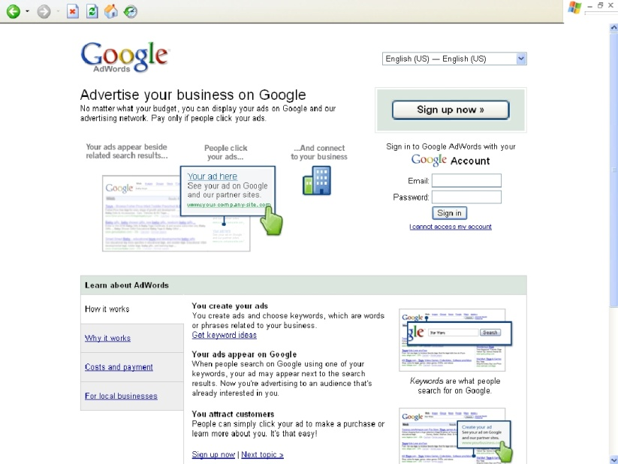

Search engines such as MS Adcenter, Bing, Google Adwords, Yahoo and Miva,(just to name a few) offer top positions among the sponsored listings for particular keywords/phrases you choose. The idea for bidding is you have to buy/bid on keywords/phrases relevant to your business. The highest bidder gets to be on the top of the search result listing and the second highest bidder, of course, gets the next top listing and so on. Every time a visitor clicks on your website, you will have to pay the same amount that you bid on that particular keyword.

PPC can be very costly, time consuming and sometimes not worthy. But if you know how to go about the step-by-step procedures, PPC is a welcome change to traditional advertising.

If you do your searches for products, articles and auctions in the net, you usually type in a keyword or a set of phrase to guide you in your search. Either you use Google or Yahoo Search depending on where you are most comfortable at and where you usually get the best results. As soon as you key in the search button, immediately a long list of keywords or phrase will be displayed containing the keywords you key in. The first or the top link that you saw is most likely the one who bids the highest for that keyword you type. In this way, businessmen will produce the desired results; they get to be advertised, at the same time, saving and spending only for the clicks they need that might translate to potential sales.

The way to start PPC bid management is to identify first the maximum cost per click (CPC) you are willing to pay for a given keyword or phrase. CPC varies from time and even search engine to search engine too. Maximum CPC can be measured by averaging the current costs of bids (bids range from $0.25 to $5). Average of these bids is to be used as the maximum CPC to begin with. As your ad campaign progresses, the actual conversion rate (visitors turning to potential buyers/sales) will be determined and you may have to adjust your CPC (bidding rate) accordingly.

When you start to bid, see to it that you adopt different bidding strategies for various search engines. Search engines have their own PPC systems that require different approaches. It is also worthy to identify different bids for the same keyword phrases in various search engines.

Another thing, it is wiser not to bid for the top spot for two reasons: 1) It is very expensive and impractical, and 2) Surfers usually try different search queries in various search engines before they settle on the right one that fits to what they are looking for. This hardly results to conversion. Try to bid for the fifth spot instead and work your way up.

If you are now going steady on your PPC biddings, it is time for you to develop your own bidding strategy accordingly. It is important for you to track down which sites bring the bulk of your traffic and identify the ranking of your paid ads. This will help your bidding strategy to be effective and you should also decide where you want your ad to be positioned. Usually your maximum CPC will limit your choices.

Bid gaps (e.g. $ 0.40, 0.39, bid gap, 0.20, 0.19, 0.18) occur when there is a significant price increase to move up one spot in the PPC rankings. It is best if you take advantage of the bid gaps by filling them in so you can save up your cents to other bidding opportunities. Often there are keywords worthy of lesser bids to get the appropriate ranking on the list and produce a good number of clicks and higher conversion rate rather than bidding higher but having a poor conversion rate. You have to put in mind that overbidding too is not good but rather the best position for the most effective bid.

Using pay-per-click bid management in promoting your website will only be successful if you take time building many lists across many engines and studying the performance of every listing. In this way, you can make the most value from what you spend in the bidding process. The key is to use the necessary precautions to stay ahead of the competition.

Bid Management Tools

In ensuring best results, you may use bid management tools. There are accepted and approved management tools that will help you in your bidding. They are categorized in two different types:

- Web based (services by monthly subscription) or,

- PC based (a purchased software)

Monitoring tools too may help in the tracking down of your keywords/phrases and search engines as to which among them often generate sales, overall and in relation to your cost per click. This is what you call return of investment (ROI) monitoring.

These bid management tools may include additional functions that may not get from online marketing tools that are readily available. Other tools can monitor competitor’s bids, produce reports for different parties and offer the ability to interface with multiple PPC engines. This is particularly helpful to those who manage more than a hundred keywords across several PPC engines to boost productivity and save time

On-Line Marketing Strategy #5
SEO Basics
Tips For Small Business Owners

Whether you’ve created a website already or are planning to create one in the near future, you know that’s only half the battle. The other half is getting your website found in the search engines in hopes of attracting those interested in the type of products or services you offer.

Although there are a variety of ways to get your website found, this report focuses on Search Engine Optimization (SEO). Through effective SEO tactics, you can improve your search engine rankings for important terms, gain more traffic and do more business.

As I’m routinely asked to give SEO advice/tips, I decided to put my thoughts to paper. The resulting articles have been compiled to create this report. Because of this, you may see some “overlap” in the information presented.

Before I dive into the SEO tips, I’ll give you my definition of both SEO and SEM. I’ll also cover some of the most common SEO terms and give you explanations in plain English. This knowledge will help set the stage for everything that follows.

What Is Search Engine Optimization?

Search Engine Optimization

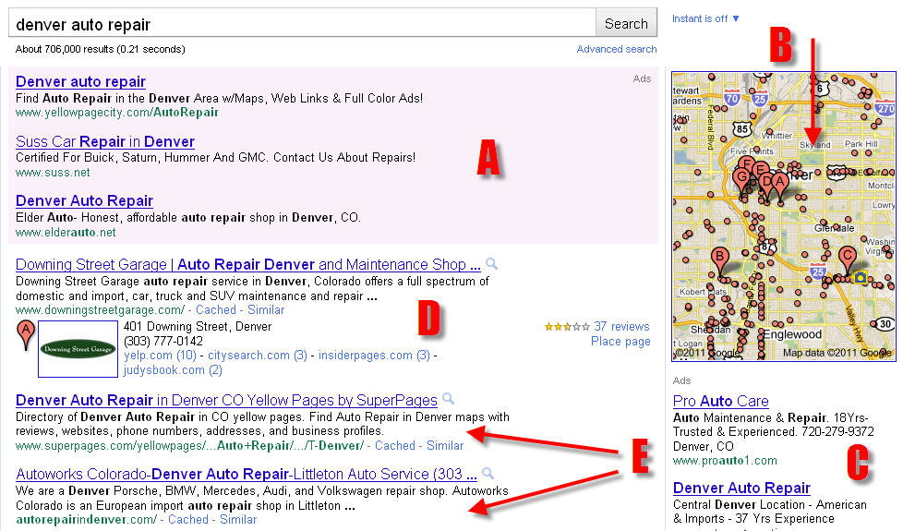

(Screenshot of Google.com for the keyword phrase, “denver auto repair.”
A - The top three ads in the shaded area are paid ads. They have been created through Google’s Adwords program and are Pay-Per-Click (PPC) ads. B - As I conducted a “local search,” Google is showing me a Google Map relevant to my search. The red drops, lettered “A-G,” represent the businesses that have claimed their Google Places listings. C - These ads are also paid ads created through Adwords. D - This is an “organic” listing that can be manipulated through SEO. You can see that this business has created/claimed their Google Places listing as the “A” tear drop appears in their listing. E - These two listings are standard “organic” listings… the kind most are familiar with)

Search engine optimization, aka SEO, is the term that refers to the things you can do to improve your website’s visibility in the search engines. Search engine optimization techniques focus on increasing the organic, or natural, traffic that you receive based on your ranking within the search engines.

The goal of search engine optimization is to ensure your website appeals to search engine crawlers, or bots. The search engines will take note of your site and its content, categorizing it in a way that will allow it to show up in the SERPs (search engine results pages) when certain keywords are typed.

Search engine optimization is achieved through a wide variety of methods. Many webmasters or SEO professionals will focus on proper keyword research, clarity in the setup of your website’s headers, tags, file names and descriptions, external back linking, internal cross linking, and quality content creation.

While each search engine uses its own algorithm for determining the ranking of every page that is indexed, it is possible to increase your rankings by making your site informative and visible via both on-page and off-page techniques. Sites that are designed with ease-of-use and quality information in mind tend to do better than those built sloppily and without a solid plan.

Search Engine Marketing

Search engine marketing, or SEM, is similar to search engine optimization but focuses less on natural rankings and more on the actual promotion of a website. SEM techniques generally include natural SEO but almost always branches out to include contextual or paid search advertising.

Paid search advertising models became more prominent in the late 1990’s, after the search engines themselves became more popular. SEM focuses more on business-oriented websites and their overall online marketing strategies. Because many of the paid advertisements appear at the top of the search engines, the FTC in 2002 responded to complaints by clarifying that paid advertisements and website listings must be clearly denoted so that consumers do not confuse them with websites that have obtained high rankings naturally.

It really doesn’t matter what type of website you have, whether it’s personal or geared towards your business. Incorporating search engine optimization techniques into the creation and ongoing upkeep of your site will ensure you receive higher levels of traffic and, ultimately, greater success.

SEO Terminology - 5 Terms You Should Know

One of the reasons Search Engine Optimization seems so complex is that it there are so many foreign terms used. In this short article, I’ll list some of the most common terms and will try my best to give you “geek free” definitions.

1. SEO

SEO stands for “Search Engine Optimization.” This is a set of techniques and processes used by a SEO Specialist to improve your website’s rankings in the search engines for a particular set of keywords, or keyword phrases.

Of course, the real goal is to increase targeted website traffic in hopes of generating new business. It’s just that this is achieved through better search engine rankings. Studies have proven that the top 1-4 listings get far more traffic than the others found on the page.

2. SEM

SEM stands for “Search Engine Marketing.” Defining SEM is a bit tricky as many authorities have varying ideas as to what the term means.

However, as a general rule, SEM Specialists use three distinct practices to promote their clients’ websites:

- Traditional SEO techniques including both on-page and off-page search engine optimization strategies.
- Buying paid ads from the search engines that offer this type of service... primarily Google, Yahoo and Bing.
- Buying paid “inclusions” from the search engines. This is paying a search engine company for a guarantee that the website will be included in the search.

3. SERPs

SERP stands for “Search Engine Results Pages.” Basically, it’s the page that is returned to you whenever you use a search engine.
The goal of SEO is to improve your web page’s ranking amongst the other “organic” listings in the SERPs.

4. Keyword Phrase

A keyword phrase is any set of words that is searched upon by internet “surfers.” It is the goal of the SEO Consultant to determine which keyword phrases are most relevant to your website/business and are likely to bring you targeted website traffic.

These keyword phrases are then used in the optimization process with the intent of getting your web page’s strong rankings for the chosen terms (aka keyword phrases).

5. Backlinks

Defining backlinks is a challenge only because there are a variety of other terms that mean basically the same thing. You may also hear them referred to as text links, anchor text links, hypertext links, one-way links or contextual links.

A backlink occurs whenever another site links to yours. The link could come from an image or banner type graphic or it could be a linked piece of text.

For SEO purposes, the text links are of primary importance with the goal being to get links that include the keyword phrases you are optimizing for.

While there are hundreds of other SEO terms to learn, these will give you a good framework to build upon. Whether you are learning more so you can improve your own site or just want to be able to communicate better with your SEO Specialist, I encourage you to keep studying.

Don’t Most Web Designers Know SEO?

The world of web design is complex and fraught with misinformation. Chief among them is the belief that most web designers have a solid understanding of Search Engine Optimization (aka SEO).

In truth, the exact opposite is true. Most web designers know very little about SEO and this includes those with college degrees in Website Design.

A friend of mine received a Bachelor’s Degree in Web Design from a reputable University. When I asked her what she was taught concerning SEO she replied... “Not much.”

They gave her their definition and spent a little time explaining the basic concepts. However, they weren’t actually trained in the art and science we call SEO. They were told that work should be performed by an individual/company that specialized in Search Engine Optimization.

I agree with this as web designers are “artsy” by nature and not best suited to things that are highly technical. That’s not to say that there aren’t some who are good at both, just that it’s probably the exception rather than the rule.

The real problem is that most clients know little about the web design process and mistakenly believe that their web designer has optimized their site for the search engines. As many web designers forget to discuss the topic with their clients, the site is put live without being optimized.

To improve your chances of getting a beautiful website that is well-optimized for the search engines, it’s important you understand these three factors:

- Web Design

In this phase, your web designer will work with you to create a nice looking website according to your project specifications. This part is primarily graphic in nature but it does form the foundation of the entire project.

- Website Coding

After the website graphics are finished, the design will be coded such that it can be understood and displayed by browsers like Firefox, Internet Explorer, etc. Some web designers will use a program like Adobe’s Dreamweaver to code the design while others will hire a web coder to do the process manually.

As a general rule, designs that are “hand coded” by a code specialist are more likely to follow the standards set by the Worldwide Web Consortium (aka W3C). They are also more likely to be “lighter” in their design, which is beneficial to SEO.

- Search Engine Optimization

After the site has been designed and coded, the work can begin to optimize the website for the search engines. This is best performed by a SEO Specialist.

The SEO Specialist’s job is to work closely with the client in an effort to understand their business and what outcome(s) they are looking to produce. With this information, the will begin the process of keyword selection and set about optimizing each page of the site.

In addition to the work performed to the site itself, the SEO Specialist will perform a variety of “off page” tasks. These tasks may include link building, social bookmarking, the creation of citations, as well as many others.

As you can see, successful web design is a rather complex topic and frequently requires the work of several specialists. Armed with this information, you’ll know what questions to ask to ensure your project is completed to your satisfaction.

After all, a beautiful website that receives little visitors won’t help you achieve much in the way of new business.

Keyword Selection For Search Engine Optimization

Search Engine Optimization really isn’t rocket science but there is a lot to know and consider when optimizing one’s website.

At the forefront is the understanding of keywords/keyword phrases and what affect they have on your ability to get targeted website traffic.

What is a keyword/keyword phrase anyway?

It’s the word, or words, that internet users are typing in when they conduct an internet search. Fortunately for us, there are a variety of tools that keep track of this incredibly valuable data.

With that understood, here are some tips to help you choose the right keywords for your website... keywords that will draw the specific type of visitors you are looking for.

Keyword tools

There are a variety of keyword tools, both free and paid. Unless you are an SEO professional, you’ll probably want to use the free tool provided by Google.

To find it, simply conduct a search on Google for the term (aka keyword phrase), “Google Keyword Tool.” As Google has done its job to optimize for this keyword phrase, you’ll find it to be the first “organic” listing on page one of the results.

Search Volume

Search volume is an indicator that tells you how many times a particular keyword phrase is searched upon. The data is “search engine specific” so you will find that the numbers differ depending on which search engine’s data you are looking at.

It’s important to note that Google now tracks “local” and “global” search volume separately and can even tell you how frequently someone is searching the term with a mobile device.

Most SEO Consultants disagree as to the accuracy of the data so you should consider the data to be more “comparative” than accurate. For example, if “keyword phrase #1” is said to get 3,000 searches per month and “keyword phrase #2” is said to get 500, it’s safe to say that keyword phrase #1 is more searched upon.

Competition

It’s vital to remember that most search engines only show ten “organic” listings on any page of the SERPs (Search Engine Results Pages). Because of this, you are competing with the websites/web pages that are already ranked for the keyword phrase(s) you have chosen.

In order to get your web page listed on “page one” for a particular keyword phrase, you are going to have to outperform one of your competitors.

There are many factors to consider when gauging competition but the main ones include:

- On-page Optimization - In other words, how well have they optimized their page around the keyword phrase(s) they are ranking for?
- Age of the domain - Generally speaking, the older the domain, the better.
- Domain extension - Although you can improve the SEO of any website, those with a .com, .org, .net, .edu, .gov or a country specific domain tend to rank better than those with other extensions.
- Inbound links - The amount of links the page has from other websites as well as those coming from other pages of the site itself.

Intent

Before finalizing your keyword list, it’s best to see if you can get into the mind of the person conducting the search. While your keyword research will tell you what keyword phrases are being searched upon, do you really know what they are looking for?

Here’s a real-world example:

Let’s say I wrote a book on emergency first aid and CPR and am looking for keyword phrases to promote my book. During my keyword research I find that the keyword phrase, “how to save a life,” is searched more than 40,000 times per month. I get excited because this phrase seems perfect for promoting my new book. But is it?

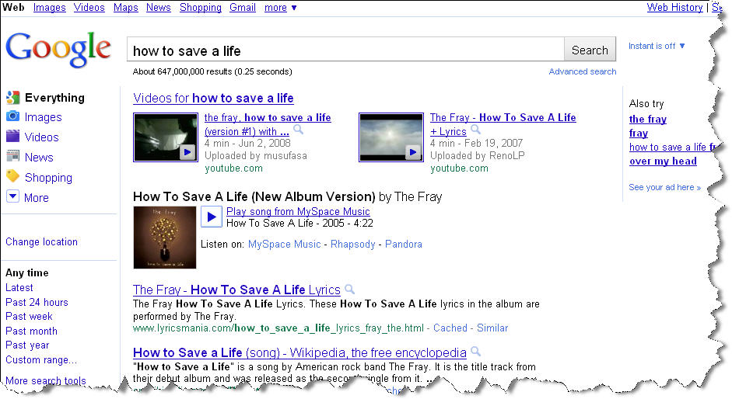

I dig a little deeper and find that this phrase will be meaningless for me. Why? It’s because the average searcher isn’t looking to actually save a life, they’re looking for information (lyrics, the music itself) for the song, “How To Save A Life” by The Fray!

The search volume is great, but the intentionality of the search is different than what it appears on the surface.

Keyword research is paramount to Search Engine Optimization and the ability to increase targeted website traffic. It’s best to avoid rushing in as this is the foundation for which all other SEO tactics will be built upon.

Website Factors That Affect SEO

Search Engine Optimization is generally comprised of two distinctly different activities...optimizing the website itself, referred to as “on page” optimization, and increasing the authority of the website in the eyes of the search engines, referred to as “off page” optimization.

While both strategies must be employed for best effect, most SEO Consultants begin with the on page optimization work before beginning their off page optimization efforts.

In this article, I’ll cover some of the things that can be performed to your website in order to increase its ability to achieve better rankings. First, however, you must understand that each and every page of your website needs to be SEO’d. This will not pose too much difficulty if your website is rather small but if you have dozens (or hundreds) of pages, the work to be done will be substantial.

Here are eleven website factors that may affect your SEO:

Meta Title

Your “meta title” information is added to the page source (i.e. your website
coding). This may be done manually by your web designer or added through a
WYSIWYG editor if your site uses some form of Content Management System (aka CMS). On some dynamic platforms, the meta title is created automatically as soon as the page is published.

Generally speaking, your meta title should be kept relatively short (no more than 60-80 characters) and should include the two-to-three keyword phrases you are specifically trying to optimize the page for.

Meta Page Description

Some may argue how much this affects SEO but there are other benefits to
writing a good meta page description as well. Google will only display the
first 156 characters (including spaces) of your page description so it’s best
to use that as your maximum length.

Your page description text should read well, include your primary keyword
phrase at minimum and be somewhat exciting. The page description will generally be shown to searchers just beneath the clickable title. If your description tells of a benefit or evokes curiosity in the reader, you will enhance your ability to get visitors.

Meta Keywords

Most will tell you that meta keywords are worthless when it comes to SEO and I would tend to agree. However, if you are going to add meta keyword information I would recommend that you keep the amount to no more than about five terms in total.

It’s bad practice to add dozens of meta keywords to each page and you may
actually get penalized for doing so.

On Page Content

Your on page content should be unique to your website if at all possible and
should also include the keyword phrases you are targeting. You don’t need to
worry about the specific “keyword density” anymore as that is mostly a thing of the past but it does help to include the terms you are specifically targeting
at least once.

Your Web Page URL

If your website architecture allows you to control the name of each page, it’s
best to see that it includes your primary keyword phrase.

If you were targeting the term, “search engine optimization,” for example, you
might cause the url to be: domain.com/search-engine-optimization or even
domain.com/search-engine-optimization.html

Both examples work quite well so use whatever version is easiest for you to
achieve.

Your Web Design

You may be surprised to see “web design” included in this list but it can
affect your SEO in a variety of ways:

- Your design should be attractive and professional so as to keep your
visitors on your site as long as possible .
- Your coding should be as “clean” as possible and should validate with
the “W3C validation tool” whenever possible.
- Your images and coding should be optimized so as to maximize the speed of your site. This is good for both SEO and human visitors... no one likes to needlessly wait.

On Page Link Text

As you can control your on page link text, you can increase your optimization
for a term by using the term in the text link that points to your other page.
The gain is generally considered minimal so this should only be done sparingly and only when the keyword phrase is relatively short.

Links Pointing To Other Sites

This topic may surprise you but most SEO Consultants agree... the search engines believe that no one website is the “be all, end all” authority on a topic and therefore expect a website to link to others on the same topic.

Of course, there is a downside to this practice… you may find that the visitor leaves and never comes back. An intelligent strategy is to link to informational only sites, like Wikipedia, that do not provide competitive products or services.

Visit Duration

Many search engines now track how long your visitors remain on your site. The longer the average is, the more apt the search engines are to believe your site is relevant to the keyword phrase that brought them to your web page in the first place.

Visit Depth

In addition to visit duration, they can also track how many pages of your site the visitor looked at before leaving and which specific page they exited from.

You can see this data for yourself when viewing your web stats and can use the data to help you improve your visitor’s experience.

Page Load Speed

I touched on this when I spoke about web design but your page load speed is also affected by the speed of your web hosting. It may not be a major factor, but the search engines are paying attention to how long your pages take to load.

It makes sense, really. The search engines do their best to deliver the best possible visitor experience and if your pages take forever to load, it’s easy to conclude that many are probably irritated as a direct result.

If you address the majority of the topics contained in this article, you’ll be
on your way to well-optimized pages. With a strong SEO framework, you’ll find that your off page optimization efforts yield better, and quicker results
.
The Importance Of Building Quality Backlinks

If you’ve studied SEO for any length of time, you know that there are things you must do to your webpages themselves, called “on page optimization,” and things external to your website, called “off page optimization.”

While there are a number of tactics that fall into the off page optimization category, the most important is the building of quality backlinks. A backlink occurs whenever an image, a piece of text, or your full website url is linked “back” to your site from some other.

The best links are those that are “one-way,” meaning that a site links to you but you do not link back to them. It can be beneficial to “trade links” (called reciprocal linking) with another webmaster for the purpose of gaining website traffic but it’s not a strategy that will improve your search engine rankings or SEO.

As each page of your website should be optimized for 1-3 keyword phrases, it’s best to build “anchor text links” (aka text links, hypertext links, hyper links, contextual links) that include the keyword phrases you are targeting. The more links you build, the better your ranking will be for the terms contained in the links.

Here’s a perfect example of this in real life:

If you search Google.com for the term, “click here,” you will find a page that gives access to the free Adobe Reader (a page off of Adobe.com) ranked in the first position.

This is an interesting/valuable observation as their page is not optimized for this keyword phrase at all. You won’t find it in their Page Title, their Meta Page Description, or anywhere on the actual page itself.

Then how is this page ranked in the top spot for this term?

It’s happening for one reason, and one reason only… a huge amount of backlinks have been built by webmasters from around the world, that link to this page. Want to guess what keyword phrase they’ve used when creating their links? That’s right... they’re linking the term, “Click Here,” to the specific page that is ranking in the first position!

As I write this, Yahoo reports that 2,927,761 links are pointing to this page.

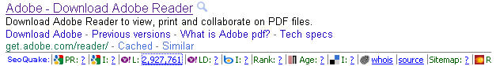

This shouldn’t be taken to mean that you should abandon your on page optimization efforts, but it does reveal the power of anchor text backlinks.

The more links you build to your pages that include your targeted keyword phrases, the more likely your pages are to rank well for the terms... it’s just that simple
.
SEO Tips For Small Business Owners

While there are a variety of ways to increase targeted website traffic, every business owner should consider optimizing their website for the search engines.

Instead of putting all of your eggs in one basket, it’s best to drive website traffic through several sources. This way, you can cast a wider net, resulting in more traffic, and track the efficacy of each source.

Before you begin, you should understand the core concepts of Search Engine Optimization (and Search Engine Marketing). In order to increase your website traffic and attract qualified prospects, you need to understand three things:

- Everything related to SEO starts with an understanding of what a “keyword phrase” is.

Anytime someone conducts a search on Google, or another search engine, they enter some text to start their search. In SEO terms, the entered text is called a “keyword” or “keyword phrase.”

If you know what keyword phrases your prospects are entering when looking for the type of information, products or services you offer, you will know what phrases to optimize your web pages for.

- Websites are not indexed or ranked by the search engines... each web page is indexed and ranked independent of any other.

This is commonly misunderstood but so vital to understand! Just because you have one web page that ranks really well in the search engines, that doesn’t mean that your others will also rank well.

Each page of your website must be uniquely optimized for a handful of keyword phrases… keyword phrases that are searched upon and those likely to attract your targeted audience.

If you pay close attention to the optimization of each page, you should see a dramatic improvement in terms of search engine placement.

- Like it or not, you’re competing against others!

Some have a harder time with this concept than others but the truth remains the truth... in order to get your web page listed on page one of Google, you have to kick one of the currently listed web pages off!

This is valuable information because it will help you understand what you must do to achieve the ranking you’re after.

Thorough analysis of the web pages currently listed for a particular keyword phrase will tell you how hard it will be to overtake one of them. You need to pay close attention to a number of elements including:

- How well is their page optimized for the keyword phrase?

- How old is their domain (the older the better)?

- How many links can be found that point to the page (the more the better)?

While there are other elements involved, these three are of primary concern. If you find you can outdo your competitor’s web page in at least two of the three areas mentioned, you can probably kick them off the page and take their place.

After ensuring you are optimizing for a keyword phrase (or phrases) that are likely to bring you the kind of traffic you want, you’ll often find it is the quantity of backlinks that make the real difference.

Of course, the quality of the backlinks is important too but if you are going to concentrate on one objective, it should be the building of links. Ensure your text links use the keyword phrases you are optimizing for and you’ll find you quickly climb the ranks of the search engines.
Common SEO Mistakes To Avoid (Part One)

Effective Search Engine Optimization is really not that difficult but it does take a bit of knowledge and a keen attention to detail.

Here are three common SEO mistakes to avoid:

1. Choosing the wrong keywords.

Each page of your website should be optimized for a handful of keyword phrases. This helps your page get found whenever someone uses a search engine to search for a keyword phrase you’ve optimized for.

If you optimize for intelligent keywords, you’ll likely get an increase in website traffic from those looking for the types of products and services you offer. However, if you optimize for the “wrong” keywords, you may not get an increase in traffic or may be found by the wrong audience altogether.

Using a keyword research tool, you can determine how many times per month a particular keyword phrase is searched for. This is important because it won’t benefit you to optimize your web page for a term that no one cares about.

Also, you should type each keyword phrase into Google (or your search engine of choice) to see what results you find. If the results show you pages that are related to your own, you are on the right track.

If the results are completely unrelated, you should avoid optimizing for the keyword phrase and look for more targeted terms.

2. Forgetting to include a page title.

Each page of your website should have an intelligent page title... also called the “meta page title.” This information is added to the html code itself and can be found at the top of the page.

The page title serves a few different purposes. First, it is displayed at the top of the browser window to let the visitor know what kind of information to expect on the page. It also helps the search engines know what kind of content to expect.

This is why it is crucial that your page title include the keyword phrases you are optimizing for.

The page title also appears whenever someone finds your page through the use of the search engine. The page title information is used for the blue, clickable link that will take the searcher to your page.

Forgetting to include a page title may cause the search engines to add the term, “Untitled Document,” to your page. This looks quite unprofessional and can hamper your ability to be found for important keyword phrases as well.

3. Using the same page title on all pages.

While effective SEO needn’t be difficult, it does take work. All too often, I see webmasters using the exact same page title on every page of a site and this is cause for concern.

Remember that the search engines index pages of your site, not your website as a whole. Your “meta page title” should include the keyword phrases you want to optimize a particular page for, and each page should be optimized for a unique set of terms.

While there is more to effective search engine optimization, avoiding these three common mistakes will help you outrank the many sites that employ them.

If you are careful to do thorough keyword research, you should find a set of keyword phrases likely to bring you targeted traffic and new business.

Common SEO Mistakes To Avoid (Part Two)

While there are a variety of SEO mistakes to avoid, these three can be the difference between a nice surge in website traffic and having your website trapped in a virtual “black hole.”

1. Keyword stuffing

So, you’ve done your keyword research and have found three really great keyword phrases to optimize a page of your site for. You’ve added the phrases to your “meta page title” and plan to add them to your “meta keywords” list too.

While it can be tempting to add 1,001 keywords into this list, it’s the wrong thing to do. Generally, we think that “more is better” but it’s certainly not in this case.

You see, the search engines are trying to index your web pages for terms relevant to your “on page” content. The better they do this, the more likely it is that the “internet surfer” will continue to use their search engine.

As a result, they will usually index your pages to appear for a handful of keyword phrases but they’re not going to index it for hundreds or thousands.

While there’s no exact value, the practice of using many “meta keywords” or repeating your keyword phrases many times in your “on page” content is considered “keyword stuffing.”

Keyword stuffing is frowned upon by the search engines as it appears you are trying to “game” the system. Instead of getting more traffic, you may actually find that your page gets de-indexed and removed from the search engines altogether.

2. Forgetting to add a “meta page description”

Often times, inexperienced webmasters forget to add appropriate “meta data” to each page. As most of this information is not displayed to human visitors, it’s easy to overlook.

It is vital, however, to add a unique “meta page description” to each page of your site and here’s why...

Google, and the other search engines, generally display the “meta page description” content (unless you have an Open Directory listing) as part of your search engine listing. It appears beneath the clickable link to your website.

If you forget to add a page description, the search engines will automatically grab a portion of text from your page and use it instead. This may not sound like a big deal, but it is.

Your page description text can help to improve your “on page” optimization, but only if it includes the 1-3 keyword phrases you are optimizing around.
It also acts as a mini advertisement and should do its best to entice a web “surfer” to click the link to visit YOUR site!

As there are generally ten “organic” search engine listings on any search results page, you must compete with the others and do your best to see that your listing stands out from the crowd.

Your page description content should be interesting to read and tell the reader what benefit(s) they’ll receive by visiting your site. If you accomplish this, you’ll likely get an increase in traffic and start to “steal” clicks from the other listings.

3. Forgetting to build any “anchor text” links

It’s important to optimize each page of your site around a handful of keyword phrases but the work doesn’t stop there!

While the search engines use many factors to determine where to “rank” each page in their indexes, none are more important than the presence of “anchor text” links pointing to your site.

Anchor text links (also called “text links,” “hypertext links,” “backlinks” etc.) are simply pieces of text that are linked to a particular page on your website. Each link is seen as a “vote” by the search engines and they use them to determine where to rank your page for the “linked” terms.

If the search engines don’t find any links, they make the assumption that no one really cares about the content found on your page. Of course, this assumption really isn’t fair as it takes some time for a brand new page to acquire links naturally but that is the assumption they make.

So in order to speed the process up and help the search engines index your pages for the keyword phrases you’ve chosen during research, you have to build some anchor text links yourself.

This can be accomplished a variety of ways but buying links, or building them through article marketing, video marketing or online press release submission are some of the fastest methods.

No one can guarantee your exact results but by avoiding these three “SEO mistakes,” you’ll set yourself apart from the masses. Doing so will give you a much better chance of getting your pages ranked on the first page for the terms you’re targeting.

10 SEO Myths Debunked

The internet may be called the “Information Superhighway” but that doesn’t always mean the information is correct!

This is especially true when it comes to Search Engine Optimization. Sometimes, the information may have been valid in the past but is no longer valid and sometimes… it was never valid to begin with.

Here are ten SEO myths and their corresponding “truths” -

1. It’s impossible to outrank a web page with a Google PageRank higher than your own.

While Google’s PageRank indicator may play a minor role in determining search engine placement, it’s not a critical factor.

If you conduct a few searches on Google you will find this to be true. It shouldn’t take more than a few minutes to find a page, with a lower Google PR, outranking a page with a higher one.

2. Having an XML Sitemap will boost your rankings in the SERPs.

It is wise to create an XML Sitemap but don’t expect to see any rank improvements. The sitemap is useful to the search engines and will help them crawl your site more efficiently but it won’t help you “leap frog” your competitors. It’s primarily intended to help the bots find, and index your pages.

3. Including “meta keywords” will improve your SEO.

Most search engines disregard the “meta keyword” information altogether. While it can’t hurt to include a handful of relevant terms, don’t expect this to improve your rankings at all.

4. It’s imperative to update your homepage frequently.

If changing your homepage content is good for your visitors and business model, then have at it. Otherwise, just leave it as is.

That’s not to say that your entire site should be stagnant but that there’s no evidence to conclude the necessity to update your homepage’s content on a regular basis.

5. Trading links with other webmasters is just as good as building quality “one way” links.

Trading links (aka Reciprocal linking) was something that worked a long time ago but it is no longer effective for improving one’s rankings.

The only time that the trading of links makes any sense, is when both webmasters may benefit from the traffic that may come from the partner’s site.

6. SEO is a “set and forget” activity.

Most webmasters (and business owners) wished this were true but it’s simply not the case. Effective Search Engine Optimization is an ongoing activity and if you’re not going forward, you’ll find your rankings slip over time.

This is especially true as it pertains to link building. The search engines monitor your inbound links and if they find they find they are dwindling over time, they assume your page is losing its relevance.

7. Using Heading Tags is crucial to your SEO.

The use of Heading Tags (i.e. H1, H2, etc.) is useful to define your site’s content but don’t expect them to make marked improvements in your rankings.

8. Hiding a bunch of links on your pages is a good idea.

Google, and the other search engines, are incredibly smart and can spot the occurrence of “spammy links” quite easily.

Whether you’re using a teeny-tiny font size to display them, coloring them the same as your page background or using CSS to move them so far off the page they can’t be seen by visitors... the search engines know!

This practice is foolish and trust me on this -- no good will come from it!

9. There is an optimum keyword density for your on-page content.

This may have been true in the past but it’s no longer relevant. It’s wise to ensure that your targeted keyword phrases appear somewhere on your page but don’t bother calculating the density percentages.

It’s much better to write content that will be found valuable by the humans reading your content than to spend your time writing for the robots.

10. Paying a firm to “register” your site with “hundreds of search engines” is a wise investment.

This type of offer may sound appealing, but it will do little, if anything, to improve your search engine rankings or generate meaningful website traffic.

As knowledge is power, this information will help you waste less time and money on outdated SEO tactics or those that never worked in the first place.

On-Line Marketing Strategy #6
Social Media Marketing

Part I: Introduction

Small business owners are discovering that social media marketing is quickly becoming an important method for driving business growth. While the idea of using “free tools” to drive marketing can be exciting, this excitement is often followed with the realization that these tools take time and commitment. At the end of the day, the million-dollar question is: can social media help small business owners make more money?

Through interviews with small business owners, HubSpot has examined best practices for small business owners who want to use social media to help grow business revenues.

Questions We Will Answer:

- How does social media drive business revenue?
- How do small business owners resource the time needed for social media?
- How can blogs drive small business leads?
- How does the B2B application of social media for small businesses work?
- How can social media support offline marketing activities?
- How do small businesses get started using social media and keep generating content?
- How is the cost of customer acquisition lower when using social media compared to outbound methods like direct mail and print advertisements?

Part II: Small Business Marketing Obstacles

Before we dive into the details of social media for small business, let us first frame the problem that small business owners are working to solve using social media. Traditionally, large businesses have had an advantage over small business owners because they’ve had larger marketing budgets and could spend more money on outbound marketing techniques like print advertising and direct mail.

Budgets dictated success.

Successful small businesses have long thrived on word-of-mouth to help promote their products or services. With social media, small businesses are now able to use free tools to help increase word-of-mouth while decreasing the need for outbound advertising platforms like the yellow pages, cable television ads, newspaper ads, etc.

Part III: 10 Elements of Small Business Social Media Success

The following 10 common traits were shared by small business owners successfully using social media.

Small Business Owners Who Successfully Use Social Media:

- Commit weekly resources to creating content and engaging in social media.
- Have some methods of understanding how social media activity had an impact on business results.
- Regularly generate content using blogs, Twitter, Facebook or other social platforms.
- Don’t try to use every platform, instead focusing time and resources on the social media channels that drive the best results for their business.
- Use social media to drive participation in offline events.
- Set clear expectations for customers regarding frequency and types of social media interactions their company is willing to provide.
- Leverage social media to position their company as a thought leader within their industry.
- Provide clear calls-to-action and opportunities to generate leads and new customers using social media.
- Use information and data from social media to drive business strategy.
- Balance paid and organic search engine traffic.

Part IV: Small Business Case Studies

Triumvirate Environmental: Generating $1.2 Million in Revenue Using Social Media

Triumvirate Environmental works with clients to ensure compliance, efficiency and the safest possible work environment. The company helps its clients develop solutions for dealing with hazardous waste and other programs related to environmental issues.
Company Details:
Name: Triumvirate Environmental
Employees: 300
Website: http://www.triumvirate.com/
Twitter: http://www.twitter.com/triumvirate
Twitter Followers: 340

Mark Campanale, marketing manager and new media trainer at Triumvirate Environmental, shared insight into the evolution of their online and social media marketing program. Triumvirate indicated they have attributed $1.2 million in revenue to search engine optimization, blogs and LinkedIn.

Campanale explained that they began doing online marketing in 2006 by using Google AdWords. This initial step into digital marketing didn’t go as well as the company had hoped. Because Google AdWords can be complex, the company spent too much money in the early days of their pay-per-click marketing efforts. Campanale indicated that when they got started, they weren’t well educated about AdWords and the PPC money they spent was not tied to specific lead generation and marketing efforts.

Following their initial experiments with AdWords, Triumvirate began using a variety of inbound and social media marketing techniques to support lead generation efforts. Now included in the Triumvirate content marketing mix is blogging, search engine optimization, whitepapers, LinkedIn, Twitter, Facebook, email marketing and pay-per-click advertising.

Building a Blog Network for Small Business Success

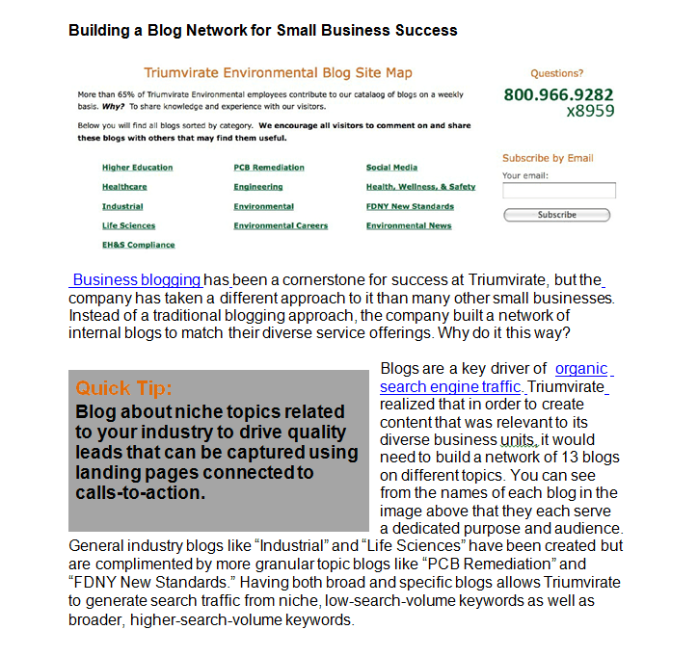

Business blogging has been a cornerstone for success at Triumvirate, but the company has taken a different approach to it than many other small businesses. Instead of a traditional blogging approach, the company built a network of internal blogs to match their diverse service offerings. Why do it this way?

Blogs are a key driver of organic search engine traffic. Triumvirate realized that in order to create content that was relevant to its diverse business units, it would need to build a network of 13 blogs on different topics. You can see from the names of each blog in the image below that they each serve a dedicated purpose and audience. General industry blogs like “Industrial” and “Life Sciences” have been created but are complemented by more granular topic blogs like “PCB Remediation” and “FDNY New Standards.” Having both broad and specific blogs allows Triumvirate to generate search traffic from niche, low-search-volume keywords as well as broader, higher-search-volume keywords.
Quick Tip:
Blog about niche topics related to your industry to drive quality leads that can be captured using landing pages connected to calls-to-action.

Generating Leads With a Small Business Blog

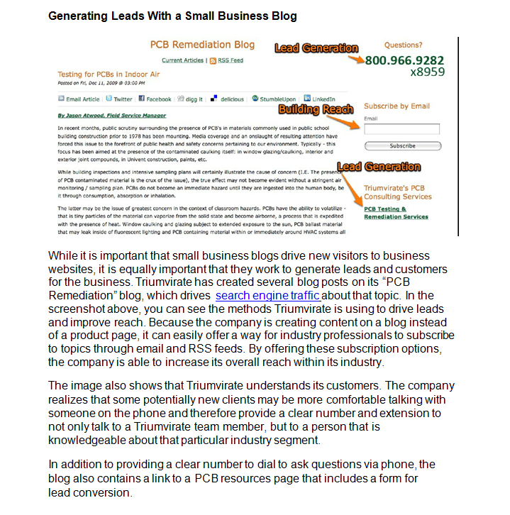
While it is important that small business blogs drive new visitors to business websites, it is equally important that they work to generate leads and customers for the business. Triumvirate has created several blog posts on its “PCB Remediation” blog, which drives search engine traffic about that topic. In the screenshot above, you can see the methods Triumvirate is using to drive leads and improve reach. Because the company is creating content on a blog instead of a product page, it can easily offer a way for industry professionals to subscribe to topics through email and RSS feeds. By offering these subscription options, the company is able to increase its overall reach within its industry.

The image also shows that Triumvirate understands its customers. The company realizes that some potentially new clients may be more comfortable talking with someone on the phone and therefore provide a clear number and extension to not only talk to a Triumvirate team member, but to a person that is knowledgeable about that particular industry segment.

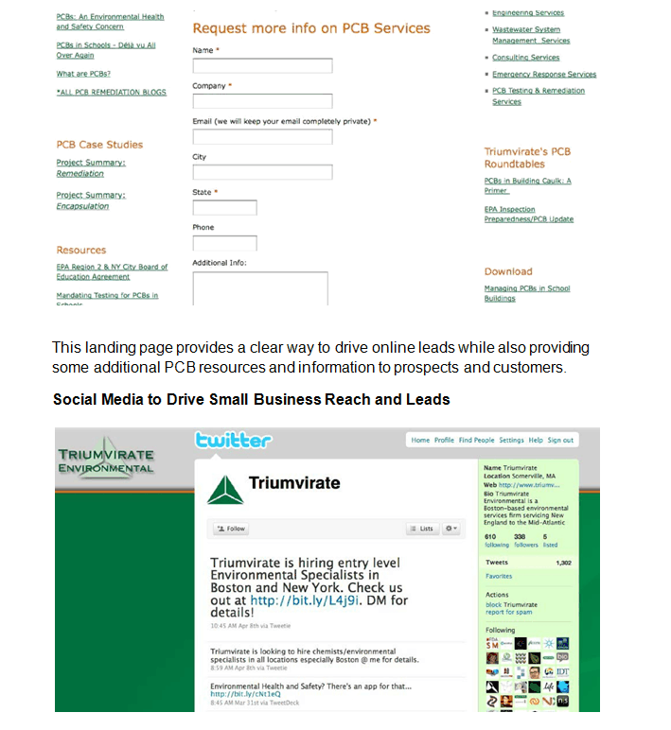
In addition to providing a clear number to dial to ask questions via phone, the blog also contains a link to a PCB resources page that includes a form for lead conversion.

This landing page provides a clear way to drive online leads while also providing some additional PCB resources and information to prospects and customers.

Social Media to Drive Small Business Reach and Leads

Search engines like Google are important in distributing small business content and helping companies get found online. In addition, social networks such as Twitter and Facebook serve as important platforms to drive blog and website traffic while improving customer engagement. Triumvirate uses Twitter to share industry news as well as employment opportunities and content available from the company.

Quick Tip:
Use social networks like Twitter and Facebook to drive prospects back to compelling content on your blog and website.

Resourcing Social Media as a Small Business

While results like $1.2 million in revenue sound like a compelling reason to adopt social media marketing, one of the hurdles small business owners quickly encounter is the issue of time. While many social media and blogging tools are free or low cost for small business owners, they still require a major time commitment to work properly. Triumvirate has two marketing staff members and also relies on interns to help manage the work involved with an active social media marketing strategy. They have also found success by leveraging employees outside of the marketing department to participate in social media. For example, account managers use LinkedIn for personal branding and also blog on a monthly basis.

Advice to Small Business Owners

Campanale explains that consistency has been an important key to success at Triumvirate. He suggests dedicating time to social media marketing efforts. Initially the time investments can seem immense, but the revenue rewards make the investment worth it.

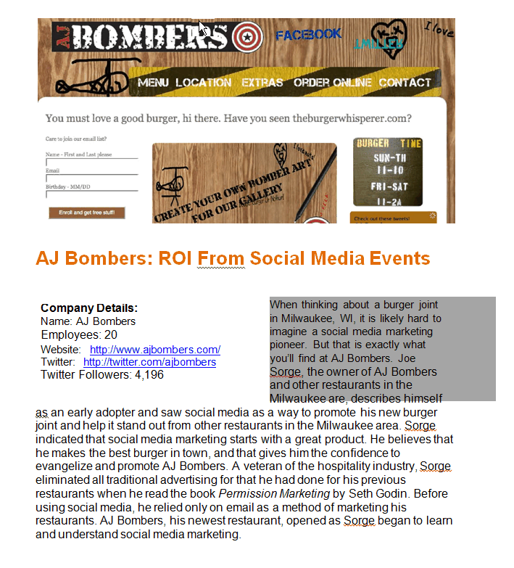

AJ Bombers: ROI From Social Media Events

When thinking about a burger joint in Milwaukee, WI, it is likely hard to imagine a social media marketing pioneer. But that is exactly what you’ll find at AJ Bombers. Joe Sorge, the owner of AJ Bombers and other restaurants in the Milwaukee area, describes himself as an early adopter and saw social media as a way to promote his new burger joint and help it stand out from other restaurants in the Milwaukee area. Sorge indicated that social media marketing starts with a great product. He believes that he makes the best burger in town, and that gives him the confidence to evangelize and promote AJ Bombers. A veteran of the hospitality industry, Sorge eliminated all traditional advertising that he had done for his previous restaurants when he read the book Permission Marketing by Seth Godin. Before using social media, he relied only on email as a method of marketing his restaurants. AJ Bombers, his newest restaurant, opened as Sorge began to learn and understand social media marketing.
Company Details:
Name: AJ Bombers
Employees: 20
Website: http://www.ajbombers.com/
Twitter: http://twitter.com/ajbombers
Twitter Followers: 4,196

Getting Started as a Small Business in Social Media

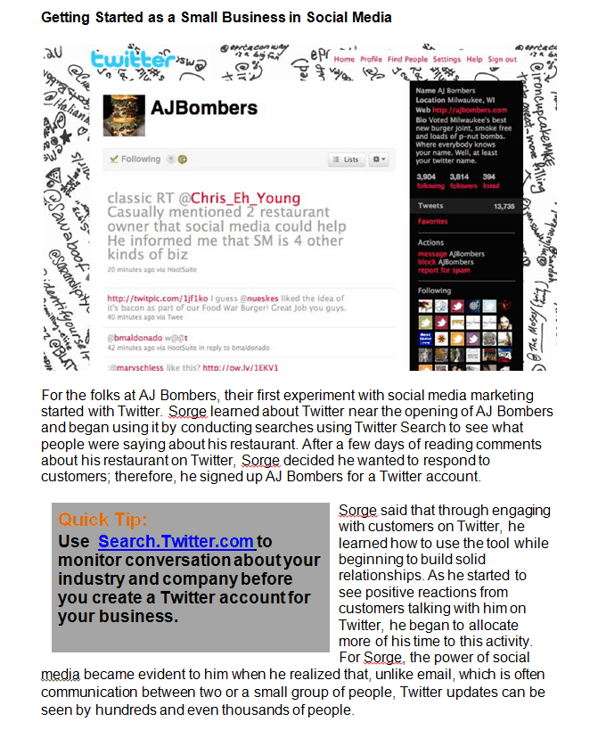

For the folks at AJ Bombers, their first experiment with social media marketing started with Twitter. Sorge learned about Twitter near the opening of AJ Bombers and began using it by conducting searches using Twitter Search to see what people were saying about his restaurant. After a few days of reading comments about his restaurant on Twitter, Sorge decided he wanted to respond to customers; therefore, he signed up AJ Bombers for a Twitter account.

Sorge said that through engaging with customers on Twitter, he learned how to use the tool while beginning to build solid relationships. As he started to see positive reactions from customers talking with him on Twitter, he began to allocate more of his time to this activity. For Sorge, the power of social media became evident to him when he realized that, unlike email, which is often communication between two or a small group of people, Twitter updates can be seen by hundreds and even thousands of people.
Quick Tip:
Use Search.Twitter.com to monitor conversation about your industry and company before you create a Twitter account for your business.

The Difference Between a Social Media Event and a Marketing Stunt
Quick Tip:
Use online communities to generate support and attendance for offline business events.
Some marketers may argue that event marketing is nothing new and that using a location-based service like Foursquare is just adding a new wrinkle. This is the wrong assumption. In interviewing Sorge, my biggest takeaway wasn’t that Friday was his biggest sales day ever; it was that Saturday was his 5th biggest sales day ever and that Sunday was one of his best as well. He explained that during the weekend, nothing special had happened to cause this burst in sales, especially considering professional sports teams were playing out of town and the weather wasn’t particularly good. Sorge believes that the word-of-mouth buzz created by Friday’s event and the speed in which it traveled online generated his best weekend ever.

Marketing stunts can drive a single day of traffic, but social media events can build sustainable and real-time word-of-mouth results that can have an impact on long-terms sales.

Resourcing Social Media Engagement and Events

From organizing events to talking with customers on Twitter, it seems like these activities would take a lot of time. They do. Sorge has two solutions for small business owners. The first is to set the right expectations. When using Twitter, Sorge has set the expectation that he will respond back to questions extremely quickly because he enjoys interacting with customers online. He says that if you are the type of business owner who only wants to spend 10-15 minutes in the morning on Twitter, then do that and customers will learn not to expect responses as quickly. Sorge also explains that he has put systems in place to allow him to spend some time away from the day-to-day operations of the business to spend some of his time communicating with customers through social media.
Quick Tip:
Plan how often you will engage with customers online beforehand as an effort to set expectations for online customer service and engagement.

ROI of Social Media Events and Community Building

Sorge explained that in its first 6 months, sales for the new restaurant were relatively flat. About 6 months in, AJ Bombers began to reach a critical mass in its online community and used its new-found community to help promote events. Through this growth, the restaurant experienced 60-80 percent revenue growth that Sorge has tied directly to social media marketing.

Advice for Small Business Owners

Sorge says to make sure your business and your product are ready for attention before you start social media marketing. He explains that social media will only amplify the failures of a bad product. Once your business is ready, he suggests using tools like Twitter Search and Google Alerts to see what people are saying about your business online. Once you have an understanding of what people are saying, then find common interests and begin some conversations with them on social networks.
Quick Tip:
Use free tools like Google Alerts to monitor mentions of your business online.

Echo Partners: Driving B2B Small Business Leads

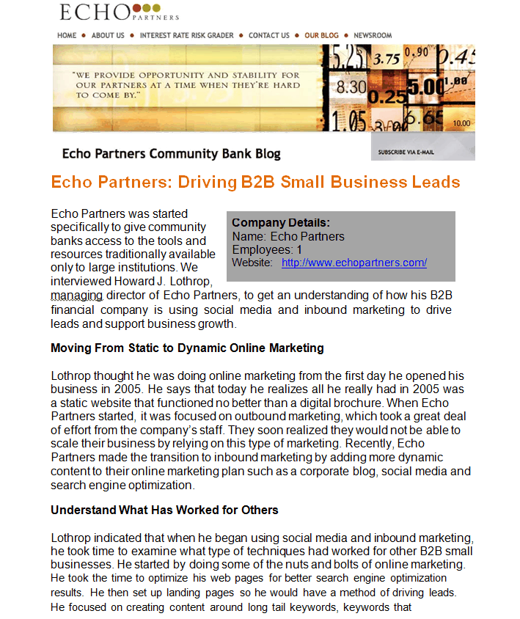

Echo Partners was started specifically to give community banks access to the tools and resources traditionally available only to large institutions. We interviewed Howard J. Lothrop, managing director of Echo Partners, to get an understanding of how his B2B financial company is using social media and inbound marketing to drive leads and support business growth.
Company Details:
Name: Echo Partners
Employees: 1
Website: http://www.echopartners.com/

Moving from Static to Dynamic Online Marketing

Lothrop thought he was doing online marketing from the first day he opened his business in 2005 He says that today he realizes all he really had in 2005 was a static website that functioned no better than a digital brochure. When Echo Partners started, it was focused on outbound marketing, which took a great deal of effort from the company’s staff. They soon realized they would not be able to scale their business by relying on this type of marketing. Recently, Echo Partners made the transition to inbound marketing by adding more dynamic content to their online marketing plan such as a corporate blog, social media and search engine optimization.

Understand What Has Worked for Others

Lothrop indicated that when he began using social media and inbound marketing, he took time to examine what type of techniques had worked for other B2B small businesses. He started by doing some of the nuts and bolts of online marketing. He took the time to optimize his web pages for better search engine optimization results. He then set up landing pages so he would have a method of driving leads. He focused on creating content around long tail keywords, keywords that are niche to his business that will help drive incremental increases in search engine traffic.

He has identified a free content strategy for lead generation that is in the development process. Lothrop says the web is full of so many good ideas, that often the best use of time and resources is to apply someone else’s idea to your own industry. This approach has worked for Echo Partners, with targeted blog posts and keywords strategies driving the best results for traffic and leads.

Getting Over the “Getting Started” Hump

When asked how he resources his inbound marketing, Lothrop said he does it all himself. He described Echo Partners as a small shop and said that by taking the time to learn how to do inbound marketing, he has learned it really isn’t that complicated. When he began the process, he admitted that it seemed daunting. He set aside time to work on the setup of his new inbound marketing tactics and realized it was really just common sense.
Quick Tip:
Schedule a set time each week to work on content creation and analyze how past content is supporting business sales.

After taking time to get started, he said his day-to-day time investment is extremely manageable. He indicated that he looks at his website traffic and lead sources to help him focus on tactics that are driving the best results. By understanding what works for his business, he can manage the time requirements needed for his inbound marketing efforts.

In only a few months, Echo Partners has begun to generate leads online, increase website traffic and even get referral traffic from a competitor’s blog. Lothrop indicated that all of his results are trending upward and he expects to see even more impressive business results in the next six months.

Inbound Marketing Drives Business Strategy

Lothrop sheds light on an important secondary benefit of using social media and inbound marketing. He explained that from the preparation and daily process of inbound marketing, he now has better business intelligence and insight than ever before. He indicated that inbound marketing has given his business a better sense of how to emphasize its strengths and exploit competitors’ weaknesses. His business now has sharper, longer-term goals and a clear road map on how to get there.
Quick Tip:
Use data and observations found in social media as intelligence to help inform overall business strategies.

Advice for a Successful Inbound Marketing Strategy

Lothrop recommended that small business owners take an integrated approach. Small business owners need to understand that tactics like social media, blogging and search engine optimization drive more powerful results when used together, instead of only picking one tactic. Integrating social media tactics and content creation drives results, and it is important to track the results of each of these tactics to determine the best ways to invest time and effort.

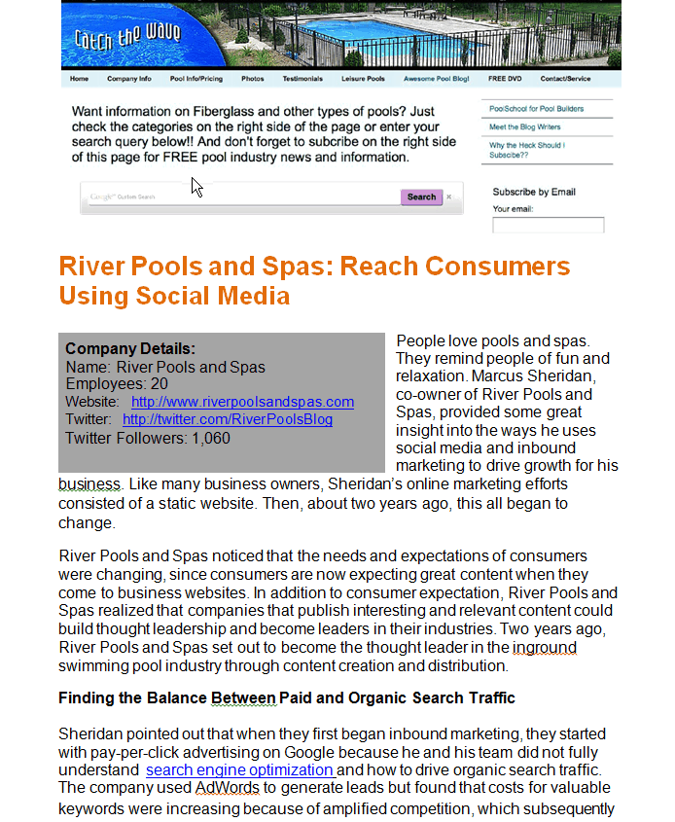
River Pools and Spas: Reach Consumers Using Social Media

People love pools and spas. They remind people of fun and relaxation. Marcus Sheridan, co-owner of River Pools and Spas, provided some great insight into the ways he uses social media and inbound marketing to drive growth for his business. Like many business owners, Sheridan’s online marketing efforts consisted of a static website. Then, about two years ago, this all began to change.
Company Details:
Name: River Pools and Spas
Employees: 20
Website: http://www.riverpoolsandspas.com
Twitter: http://twitter.com/RiverPoolsBlog
Twitter Followers: 1,060

River Pools and Spas noticed that the needs and expectations of consumers were changing, since consumers are now expecting great content when they come to business websites. In addition to consumer expectation, River Pools and Spas realized that companies that publish interesting and relevant content could build thought leadership and become leaders in their industries. Two years ago, River Pools and Spas set out to become the thought leader in the inground swimming pool industry through content creation and distribution.

Finding the Balance Between Paid and Organic Search Traffic

Sheridan pointed out that when they first began inbound marketing, they started with pay-per-click advertising on Google because he and his team did not fully understand search engine optimization and how to drive organic search traffic. The company used AdWords to generate leads but found that costs for valuable keywords were increasing because of amplified competition, which subsequently drove up cost-per-lead. Due to this increased competition, Sheridan saw the need to learn organic search engine optimization as a way to drive free search engine traffic and allow River Pools and Spas to reduce search engine spending.

It can often take a few months to start driving traffic from organic search marketing efforts, so many companies spend more on pay-per-click advertising in those months and reduce spending as organic search traffic begins to increase. During the past year, River Pools and Spas began to drive organic search traffic and lead results with business blogging and a long tail keyword strategy. Sheridan said it has blown away any traffic and branding expectations they ever would have had. He also explained that the company’s blogging strategy has been to answer common consumer questions related to swimming pools.
Quick Tip:
Use social media to help build links and improve organic search traffic quality and volume.

The strategy is a simple one, but Sheridan pointed out that the real challenge is for businesses to put themselves in the heads of their customers. Business owners often talk in jargon and industry terms, instead of terms their customers understand and are using to search for products and services. Sheridan emphasized that, in online content they create, business owners need to answer the basic and essential questions customers ask. Answering these simple questions has been essential in River Pools and Spas organic search traffic success.
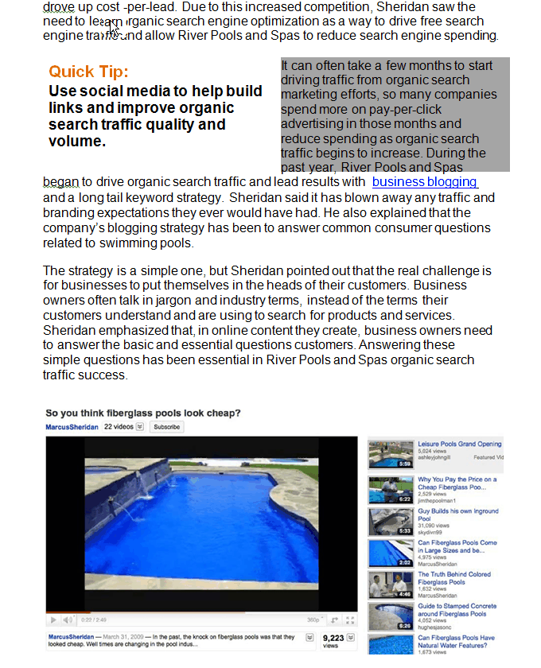

Online Video for Small Business Marketing Success

Some businesses are more visual than others. When you think of pools and spas, your mind is instantly filled with many images. It is a visual industry. It is important for industries that are particularly visual to use images and online video to help tell stories. River Pools and Spas uses YouTube as a component of its overall marketing plan. The goal of video for River Pools and Spas has been to let potential customers see everything that goes into building and owning a swimming pool.
Quick Tip:
Leverage YouTube to tell visual stories about your industry knowledge and expand the reach of your content.

Sheridan said these videos have worked wonders in terms of establishing his company as consumer advocates and thought leaders in the inground swimming pool industry. Sheridan uses these videos in blog posts and on his company website.

Marketing Costs: Inbound vs. Outbound

As part of our discussion with Sheridan, he compared his marketing costs between inbound and outbound marketing. A few years ago, when his budget was only dedicated to outbound marketing, his business was spending more than $150,000 on radio ads, yellow page ads, direct mail, etc. Last year, after River Pools and Spas had fully established its inbound marketing methodologies, the company spent less than $50,000. Despite a major decrease in the budget, River Pools and Spas had its best year ever for new business leads, during a poor economic year. While many swimming pool companies were going out of business and suffering huge losses in sales, River Pools and Spas experienced growth and success.

To summarize, in the course of one year, the following occurred:

- Advertising dollars were reduced by 70%
- Website traffic increased 300-400% on average
- Leads, especially organic, increased over 400%

Building a Competition Barrier Using Social Media

Blogging and building a robust organic search engine strategy can build critical barriers to competition. If your business holds top search positions for important ________ keywords, it will be difficult for competitors to position themselves as long as you continue to create relevant content. Inbound marketing rewards companies that take action first in an industry. Sheridan says many of his customers don’t even consider the competition because they are overwhelmed by and impressed with his desire to teach, inform and educate. He attributes these factors to helping River Pools and Spas close the majority of their sales during the first in-home visit, which traditionally hasn't happened in the swimming pool industry.

Social Media Marketing Advice for All Industries

Sheridan, who has become a passionate advocate for social media and inbound marketing, has three pieces of advice for other small business owners looking to grow their business.

- Start blogging today. He says, "If you're not blogging, you're dying." He indicated that blogging is such a powerful driver for improving organic search traffic and leads.

- Focus on what works for your business. Sheridan believes that small business owners shouldn't try to do everything when it comes to social media marketing. Although his company uses Twitter and Facebook, those channels are not a major focus because they have found more business value in blogging and search engine marketing.

- Use a content management system (CMS). As a small business owner, Sheridan believes that having control over your website is critical. He calls content management systems "Web Design for Dummies." Not having to rely on a webmaster to make changes to his website has allowed him to take control and quickly and easily publish new content.

Part V: Conclusion

Small business owners have many important activities to juggle each day. Through this eBook, you've hopefully gained perspective for how other small business owners have been able to grow their businesses using social media and inbound marketing while managing the time commitments of content creation and customer engagement.

Now take some time to determine which of these strategies could drive the best result for your business!

On-Line Marketing Strategy #7
Your Blog By Using Wordpress

Why Wordpress?

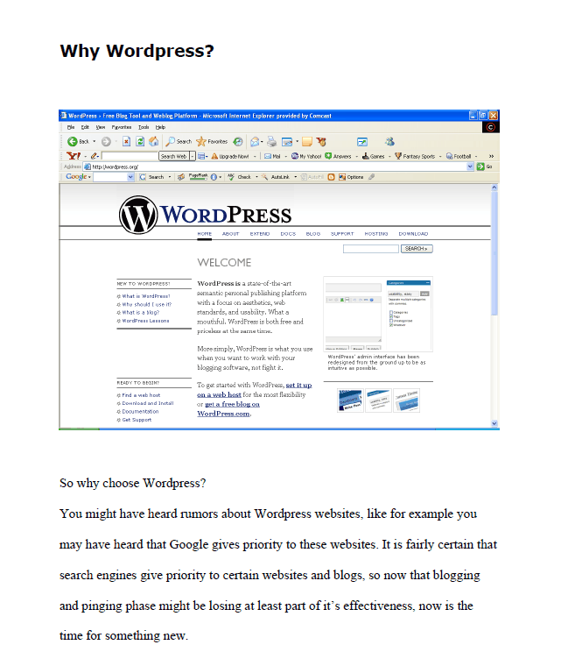
So why choose Wordpress?

You might have heard rumors about Wordpress websites, like, for example, you may have heard that Google gives priority to these websites. It is fairly certain that search engines give priority to certain websites and blogs, so now that blogging and pinging phrase might be losing at least part of its effectiveness, now is the time for something new.

There's strong evidence that Wordpress blogs get better search rankings than other sites. We will explore that in more detail later, but for now just know that there are some search engine advantages to using Wordpress tools.

In some ways this tool is only good for those who understand the importance and advantages of blogging. Blogging is a form of website promotion and information sharing that can have very strong business implications.

Wordpress Blogging

What is so special about Wordpress? Wordpress is your simple and easy way to set up a blog with minimal programming requirements. Wordpress gives you a plethora of themes, theme resources, and the ability to use images and various blog designs and layouts. I can elaborate all day about the basic features and benefits of Wordpress, but I have to admit that most of us use Wordpress for one simple reason. We use Wordpress to make money.

Here's a quick example of how Wordpress can change the way you blog forever:

You have a few websites and already are earning some decent money from them so you have a full-time programmer on retainer. You've heard about Wordpress and how it would allow you to set up your blogs with little or no effort.

You like the idea but don't want to pay the programmer so you decide to tackle it yourself. It's easy to download the pages and open an FTP connection to your website. You then uploaded the documents and set up the database connection. Within minutes, you are working with a Wordpress setup on your website. It was that easy.

You can now set up all the theme, feeds, and template tags you need. All done within an hour. After this, you would simply copy this setup to other websites and change the header information to the match requirements at your other websites. You accomplish all this in less than 30 minutes.

Best of all you didn't need to take up your programmer's valuable time.

You can then go on to embed Google Adsense ads and other advertising in the blogs. A few strategically placed links on pages that are already indexed and your blogs are up and running!

Wordpress and high-end blogging tools like it can simplify the arduous process of setting up a blog or blogging system. Wordpress is VERY easy. Below is a Wordpress blog I set up in 30 minutes:

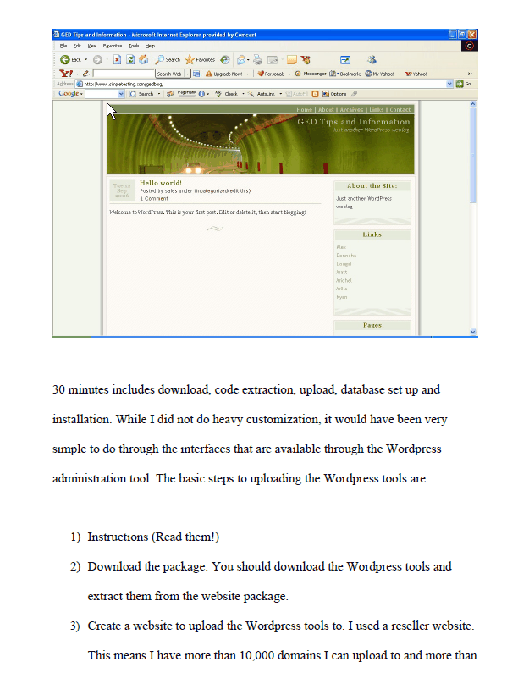

30 minutes includes download, code extraction, upload, database set up and installation. While I did not do heavy customization, it would have been very simple to do through the interfaces that are available through the Wordpress administration tool. The basic steps to uploading the Wordpress tools are:

- Instructions (Read them!)
- Download the package. You should download the Wordpress tools and extract them from the website package.
- Create a website to upload the Wordpress tools to. I used a reseller website. This means I have more than 10,000 domains I can upload to and more than 1000 sub-domains I can use for every top-level domain. I get all this for $33.00 USD per month (www.redfoxhosting.com).
- Upload the Wordpress files.
- Go to your website www.yourwebsite.com (index.php is the default page that Wordpress opens to).
- Go to your website and pull the MySQL database information (a) Username, (b) Password, (c) Server Information [This information will be available in your database control panel.]
- Go to the website and answer the questions on your database (When you start Wordpress on your website, it will ask you to answer several questions, answer those questions with the database information from #6).
- Input your set up information and set up the links and layouts of the website.

Why Wordpress Instead of Blogger?

Have you ever used blogger? I am referring to www.blogger.com. Blogger.com and LiveJournal.com are some of the best-known blogging websites on the internet. Unfortunately there is one MAJOR drawback -- you don't own the website. At any time blogger can delete your username and profile. Lots of work and effort poured into someone else's websites is not what you want to do. It is not in your best interest. This is the perfect example of how no business built on Blogger or LiveJournal.com is actually yours. These blogs generated income in the order of about $500 - $3350 per month. This income included a collection of Adsense and Commission Junction revenue. Unfortunately, both Blogger.com and LiveJournal.com reserve the right to kick you off. Only a website put together with your own pages affords you a viable business that you own. You should never put your business and hours and hours of your work into a website you do not own and cannot control.

Features and Benefits of Wordpress

There are also not a million other files for you to upload. This system is easy to download and easy to upload to your own personal websites. Wordpress is built to W3C standards for XHTML and CSS. These features make Wordpress code easier to manage and easier to render in standards-compliant browsers. Non-compliant browsers are made compliant with only a few changes.

Wordpress websites also have some very positive features like themes, non-compiling changes to the website and the ability to utilize plugins. The most positive factor in the Wordpress utility is that you do not need to know php. With many blogging systems you often need to know how to program. With Blogger, I spent hours embedding Google ads in the pages. Also, when I made changes, I had to recompile the script or "rebuild" it. This took time while I waited. Imagine how much time you can spend "rebuilding" dozens of blogs! In each blog, I modified each blog and linked it to my central website. Linking blogs that get regular traffic is a technique called "hub and spoke" theory.
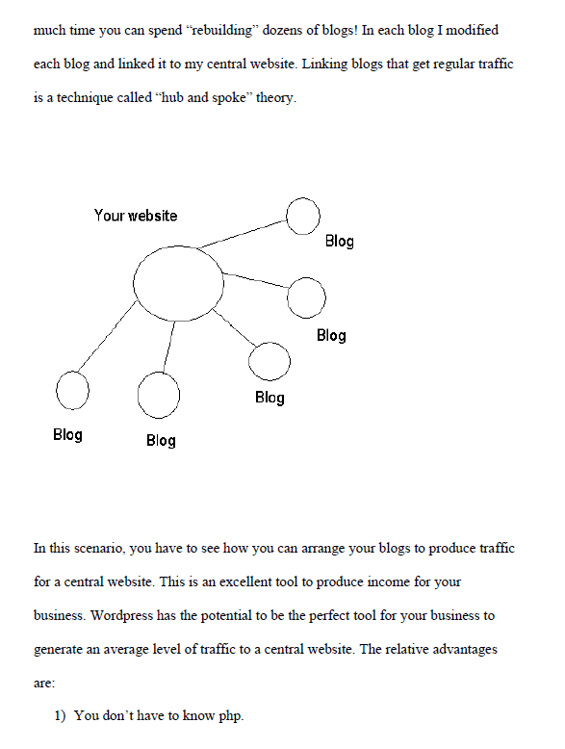

In this scenario, you have to see how you can arrange your blogs to produce traffic for a central website. This is an excellent tool to produce income for your business. Wordpress has the potential to be the perfect tool for your business to generate an average level of traffic to a central website. The relative advantages are:

- You don't have to know php.
- You don't have to know how to program at all.
- You don't need to use the Wordpress hosting service. Although this is offered, it is not necessary.
- Wordpress has aggregator support for standard RSS configurations. This has already been done with Atom.
- Wordpress automatically connects and configures with MySQL with virtually no effort.
- Being built to standards increases Wordpress's longevity and future internet adoption.
- Wordpress automatically imports images.
- The Wordpress template has built-in links added in the template.
- Wordpress allows for the customization of metadata.
- Wordpress allows customized styling for printing.
- Wordpress allows the administrator to design headlines.
- Wordpress allows for categories.
- Wordpress allows for customization of the sidebar.
- Wordpress allows for customized RSS feeds.
- Wordpress allows for customized forms.
- Wordpress allows for basic blogging posts.
- Wordpress allows archiving for posts.
- Wordpress allows for contacts in the template.
- Wordpress allows for an "about" page.

How to Install a Wordpress Blog (Step-by-Step)

Presented here for you is a more detailed explanation of how to install a Wordpress blog.

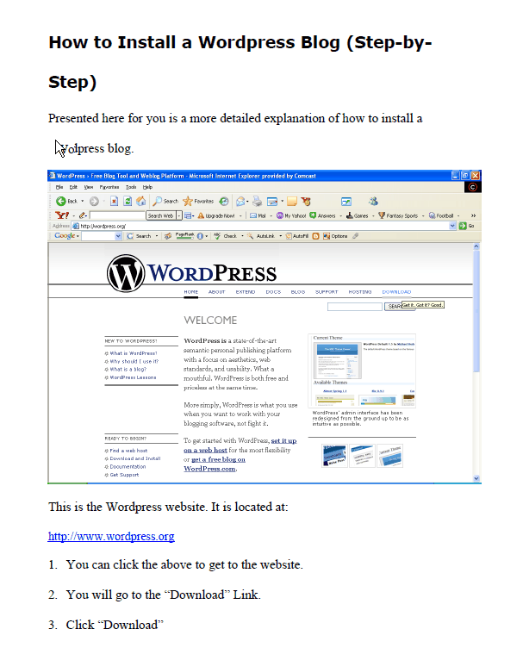

This is the Wordpress website. It is located at:

http://www.wordpress.org

- You can click the above to get to the website.
- You will go to the "Download" link.
- Click "Download."
*Please note we assume you have already read the instructions.

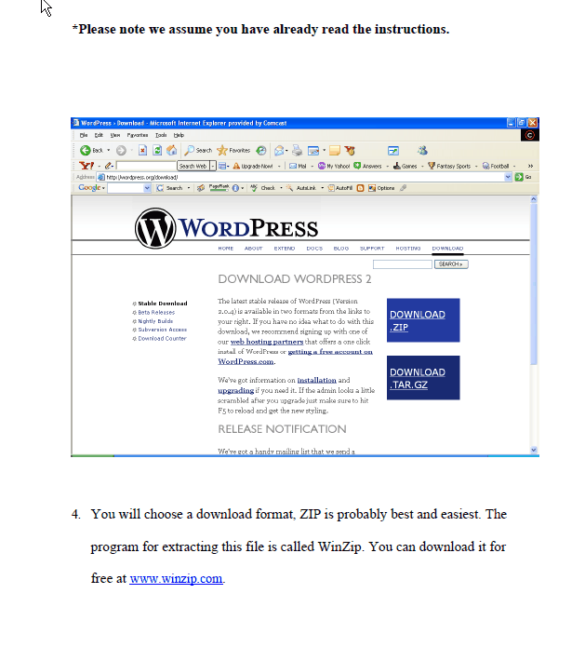
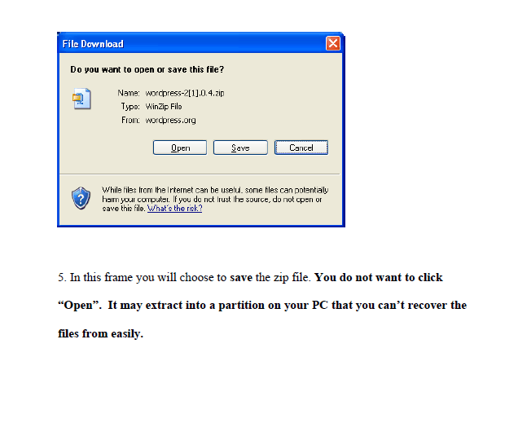
- You will choose a download format. ZIP is probably the best easiest. The program for extracting this file is called WinZip. You can download it for free at www.winzip.com.

- In this frame you will choose to save the zip file. You do not want to click "Open." It may extract into a partition on your PC that you can't recover the files from easily.
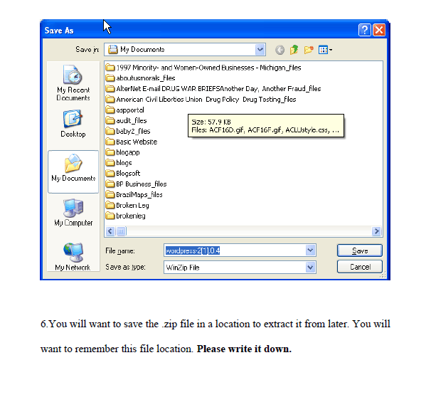

- You will want to save the .zip file in a location to extract it from later. You will want to remember this file location. Please write it down.

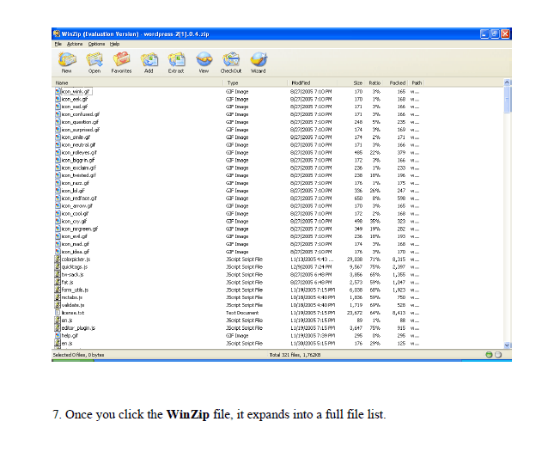

- Once you click the WinZip file, it expands into a full file list.

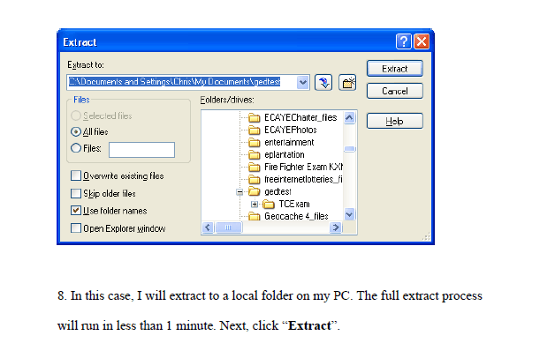

- In this case, I will extract to a local folder on my PC. The full extract process will run in less than 1 minute. Next, click "Extract."

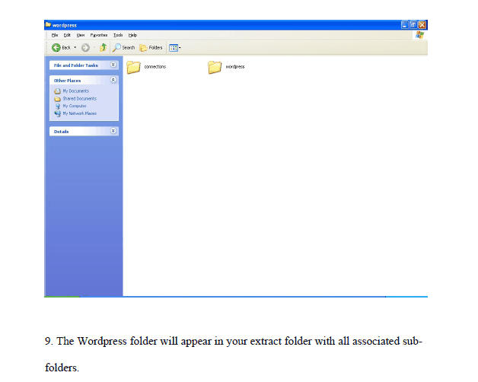

- The Wordpress folder will appear in your extract folder with all associated sub-folders.

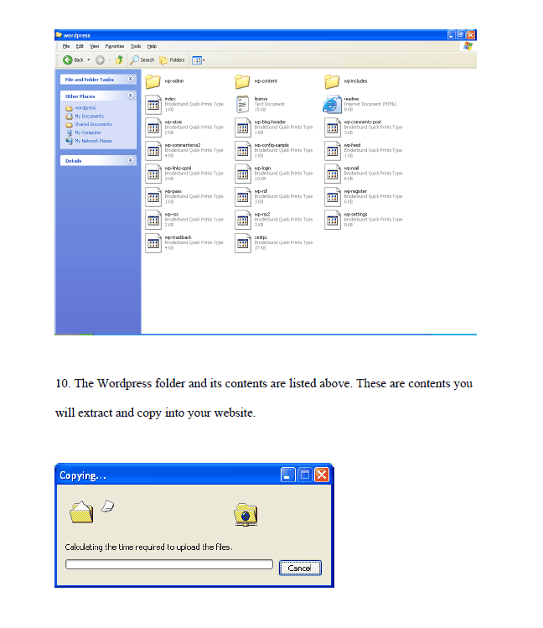
- The Wordpress folder and its contents are listed above. These are contents you will extract and copy into your website.

- Next you will copy and paste these contents into your on-line FTP directory. If this is done from within Windows, this is a "drag and drop" or "copy and paste."

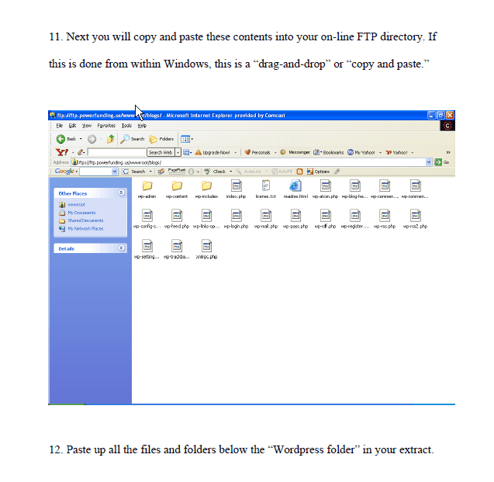
- Paste up all the files and folders below the "Wordpress folder" in your extract.

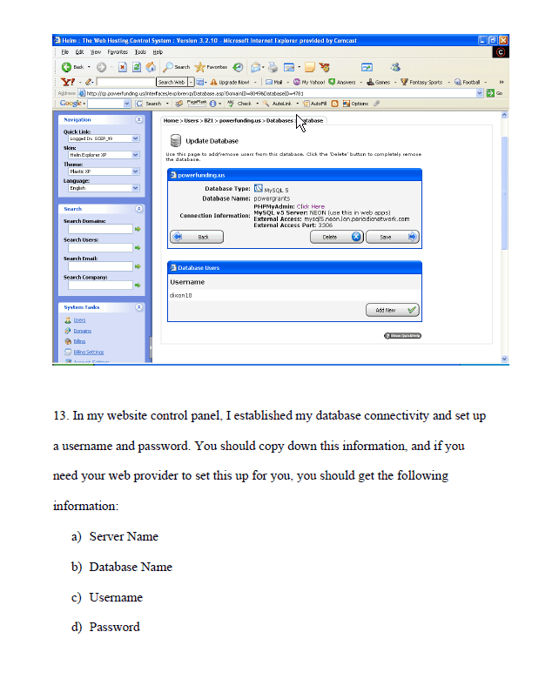

- In my website control panel, I established my database connectivity and set up a username and password. You should copy down this information, and if you need your web provider to set this up for you, you should get the following information:
  - Server Name
  - Database Name
  - Username
  - Password

- After that, you will go to the main website and finish your set up.

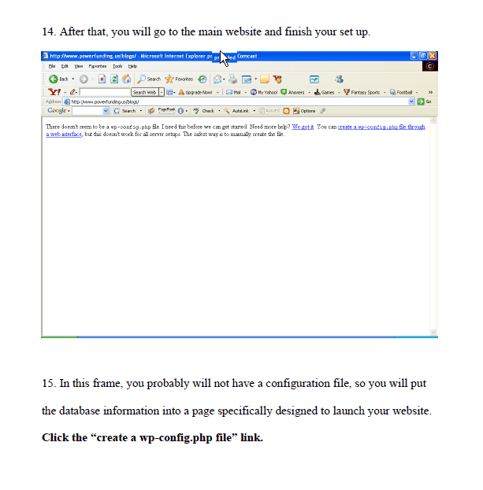
- In this frame, you probably will not have a configuration file, so you will put the database information into a page specifically designed to launch your website. Click the "create a wp-config.php file" link.

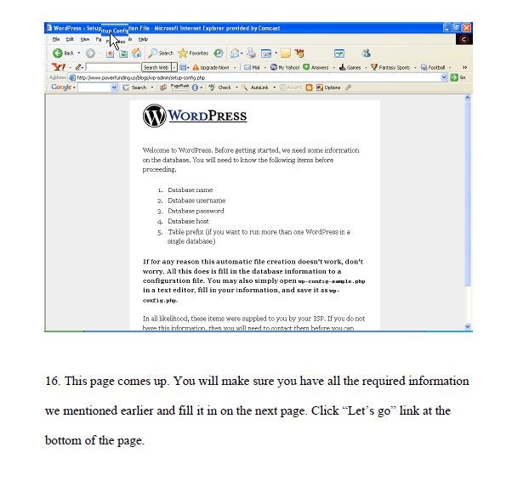
- This page comes up. You will make sure you have all the required information we mentioned earlier and fill it in on the next page. Click "Let's go" link at the bottom of the page.

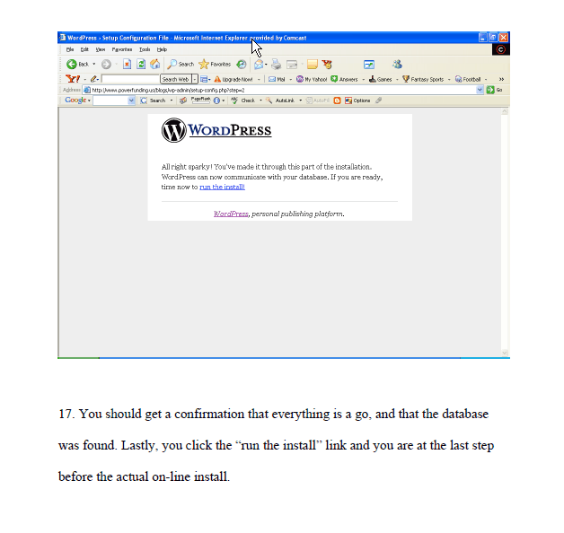
- You should get a confirmation that everything is a go, and that the database was found. Lastly, you click the "run the install" link and you are at the last step before the actual on-line install.

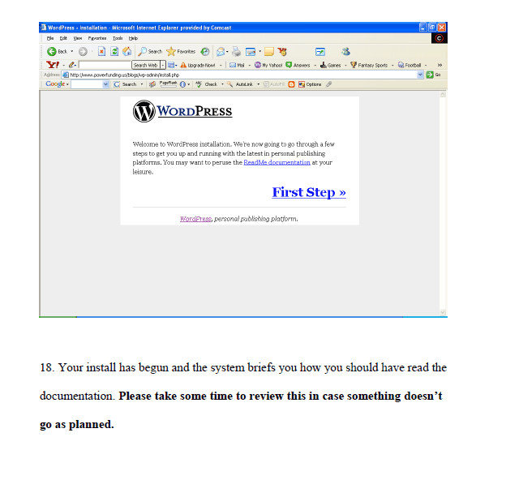
- Your install has begun and the system briefs you how you should have read the documentation. Please take some time to review this in case something doesn't go as planned.

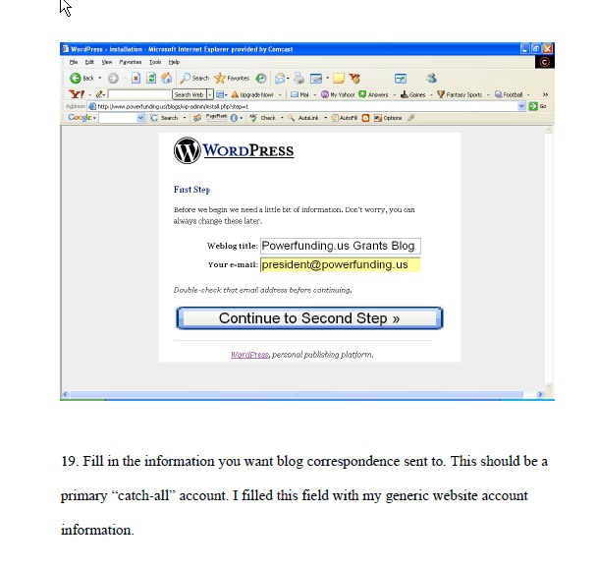
- Fill in the information you want blog correspondence sent to. This should be a primary "catch-all" account. I filled this field with my generic website account information.

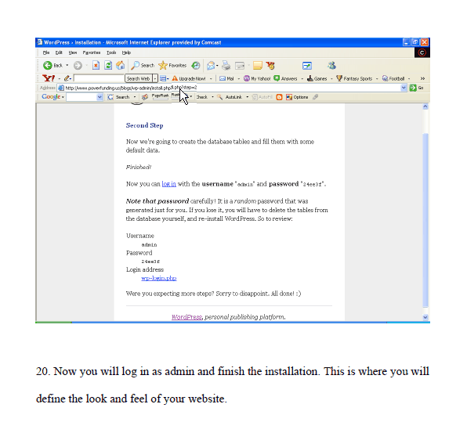
- Now you will log in as admin and finish the installation. This is where you will define the look and feel of your website.

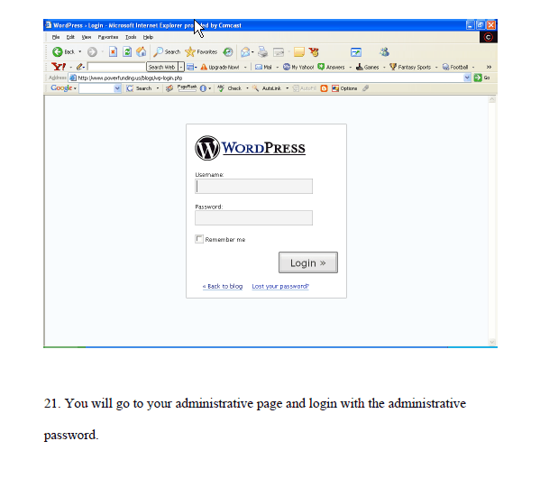
- You will go to your administrative page and login with the administrative password.

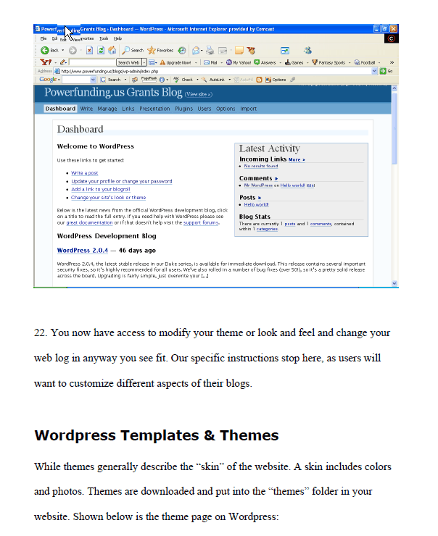
- You now have access to modify your theme or look and feel and change your web log in any way you see fit. Our specific instruction stop here, as users will want to customize different aspects of their blogs.

Wordpress Templates & Themes

While themes generally describe the "skin" of the website, a skin includes colors and photos. Themes are downloaded and put into the "themes" folder in your website. Show below is the theme page on Wordpress:

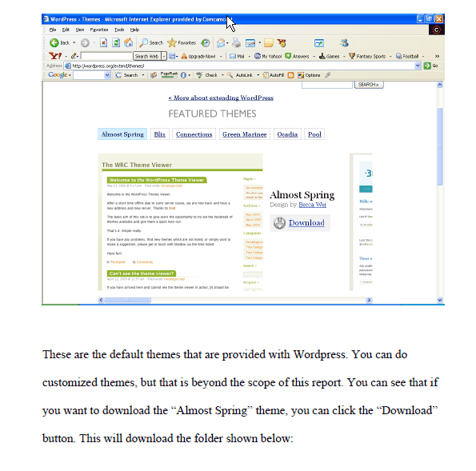
There are the default themes that are provided with Wordpress. You can do customized themes, but that is beyond the scope of this report. You can see that if you want to download the "Almost Spring" theme, you can click the "Download" button. This will download the folder shown below:

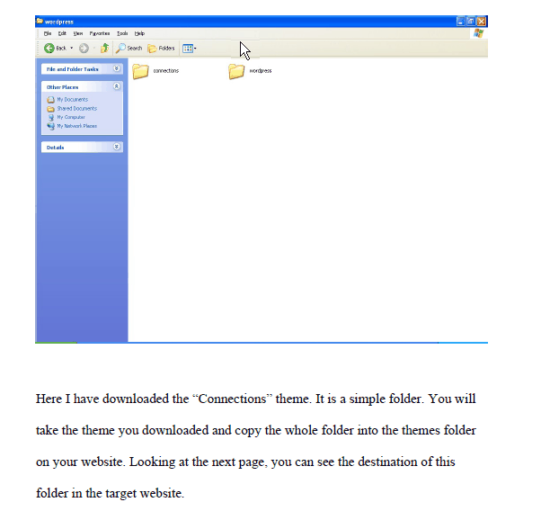
Here I have downloaded the "Connections" theme. It is a simple folder. You will take the theme you downloaded and copy the whole folder into the themes folder on your website. Looking at the next page, you can see the destination of this folder in the target website.

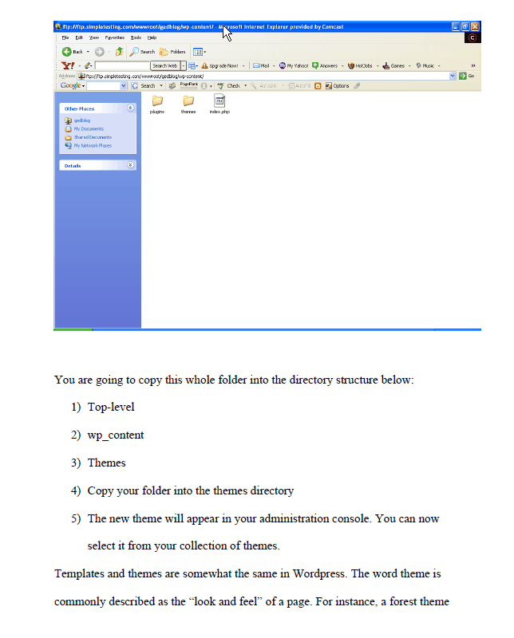

You are going to copy this whole folder into the directory structure below:

- Top-level
- wp_content
- Themes
- Copy your folder into the themes directory
- The new theme will appear in your administration console. You can now select it from your collection of themes.

Templates and themes are somewhat the same in Wordpress. The word theme is commonly described as the "look and feel" of a page. For instance, a forest theme would probably entail images of leaves and greenery somewhere on the page. The actual "template" for the page would be the layout of the webpage itself. The best way to differentiate these two concepts is that the theme is the "look and feel" and the "template" is the page that provides the layout. We will briefly describe what capabilities you have within the use of templates. We won't kill you with a mountain of technical information but we will let you know the capabilities you have inside Wordpress. You can:

- Modify Themes
- Modify template pages
- Modify images in the themes
- Import a "theme within a theme"
- Change page header information
- Embed forms in templates
- Embed plugins in templates
- Add feeds and RSS
- Administer over SSL
- Add filters
- Create custom error pages
- Modify the arrangement of template tags, thusly rebuilding composition of the template

Wordpress templates use custom template tags that populate from the database at run-time. It is an advanced topic, but you can rearrange and play with these tags. This is actual programming and is not part of this book. You should know that this is possible, but in no way required to make every change you could possibly want.

Free Wordpress Template & Theme Resources

Listed below is a list of free Wordpress Template resources:

- www.tastystock.com
- www.lifehacker.com
- chris.lineages.co.uk
- www.andreasviklund.com
- themes.wordpress.net
- blogging.typepad.com
- www.entheosweb.com
- www.freewebsitetemplates.com
- www.freelayouts.com
- http://redalt.com/External/plugins.php
- www.wp-plugins.net
- www.bloggingpro.com
- www.johntp.com/2006/04/06/wordpress-plugins/

Best Paid-For Wordpress Template Resources

- www.clantemplates.com
- www.adesdesign.net
- www.tammyhartdesigns.com
- www.perfectory.com
- www.finerdesign.com
- www.spidean.com
- www.templatefolio.com

Wordpress Plugin Basics

What is a plugin? A plugin is a software addition that adds extra benefits and features to your website. Some plugins add advertising, and monetizing to your website. Others add links and feeds and other special features. Listed below are the plugin categories that Wordpress allows:

- Administration
- Business and Monetizing
- Design, Layout and Styles
- Graphics, Video and Sound
- Links
- Odds and Ends
- Outside Information
- Posts

Here's a few examples from these general categories showing plugins that serve each purpose.

Administration Plugins -- These plugins help you administer your website more effectively. These include spell check, crawl page generation for posts and a host of other capabilities.

Business and Monetizing Plugins -- These plugins have the ability to build in a shopping cart, sell items from CafePress, and create surveys that give you financial credit.

Design, Layout and Styles -- These plugins include customizable post listings, auto-archiving, recent comments, most recent updates are showcased on the website, and recent posts.

Graphics, Video and Sound -- Coolplayer will allow multimedia content to play, and user audio on-line.

Odds and Ends (Miscellaneous) -- These plugins include financial information, weather, geomapping data, user forums, data and time information.

Links -- These plugins include Blog links, link checker, Google Pics, Incoming Links, and random linking system.

Outside Information -- These plugins import external data from outside the Wordpress website. Data like Amazon.com, Media Press, and Blog It information.

Posts -- These allow for cellphone-based blog posts, Bible posts, browser blog and exceptions, and many other types of posts.

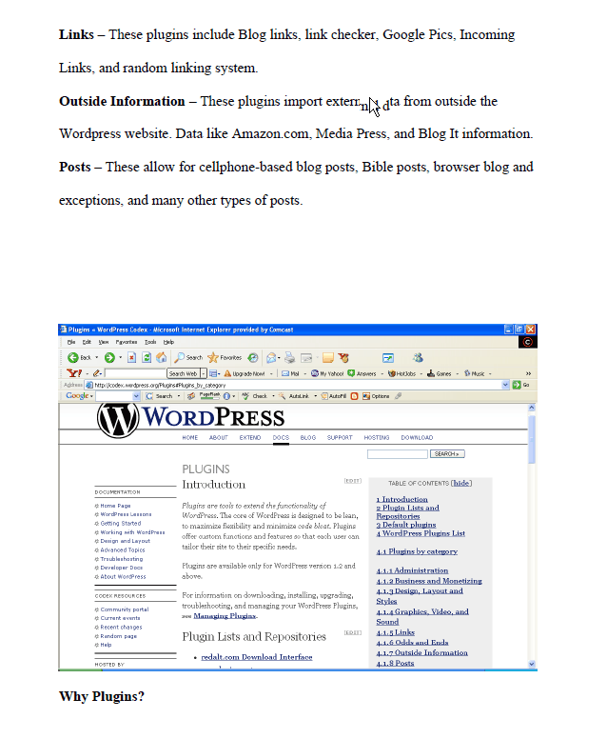

Why Plugins?

Plugins are very important. You need to understand that monetizing the blog is critical. Plugins function to increase interest in your pages and provide extended functionality. The ability to leave messages via cellphone or do podcasts may increase the traffic to your blogs. The actual attraction to Blogger.com is the ease of monetization. You need to decide how you will generate income in your Wordpress page. You have a few options like:

- Shopping cart
- CafePress
- On-line surveys
- Google Adsense
- Commission Junction

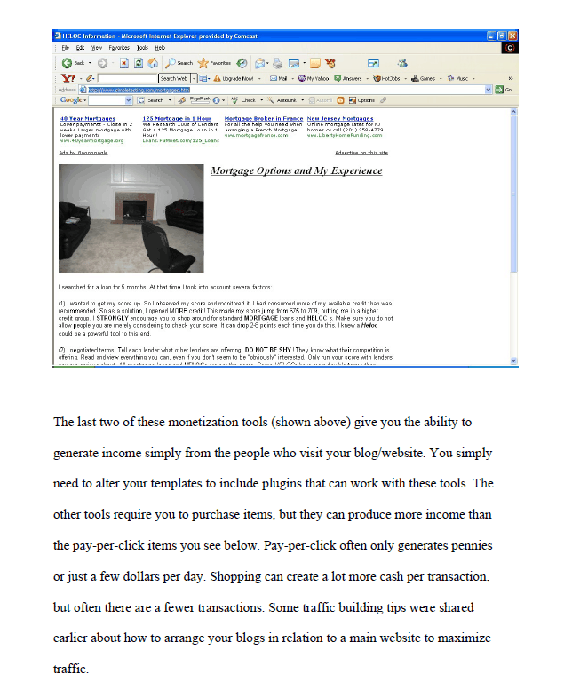

The last two of these monetization tools (shown above) give you the ability to generate income simply from the people who visit your blog/website. You simply need to alter your templates to include plugins that can work with these tools. The other tools require you to purchase items, but they can produce more income than the pay-per-click items you see below. Pay-per-click often only generates pennies or just a few dollars per day. Shopping can create a lot more cash per transaction, but often there are fewer transactions. Some traffic building tips were shared earlier about how to arrange your blogs in relation to a main website to maximize traffic.

How to Install Plugins

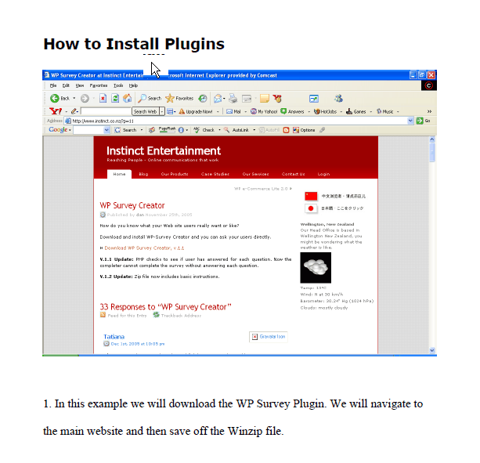

- In this example we will download the WP Survey Plugin. We will navigate to the main website and then save off the Winzip file.

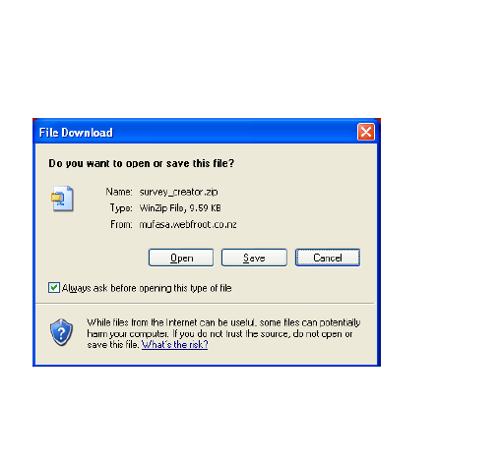

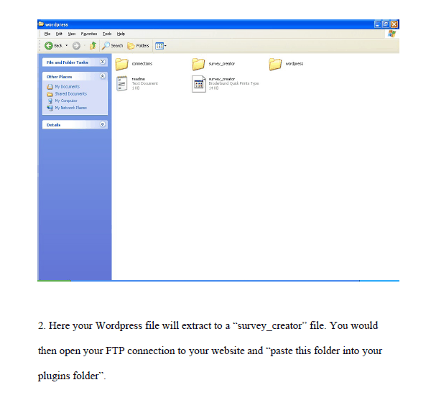
- Here your Wordpress file will extract to a "survey_creator" file. You would then open your FTP connection to your website and "paste this folder into your plugins folder."

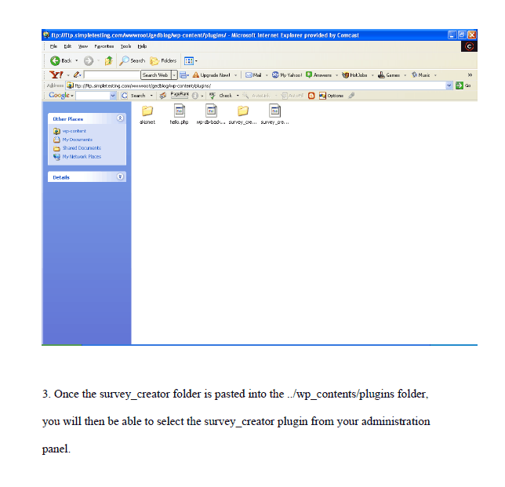
- Once the survey_creator folder is pasted into the ../wp_contents/plugins folder, you will then be able to select the survey_creator plugin from your administration panel.

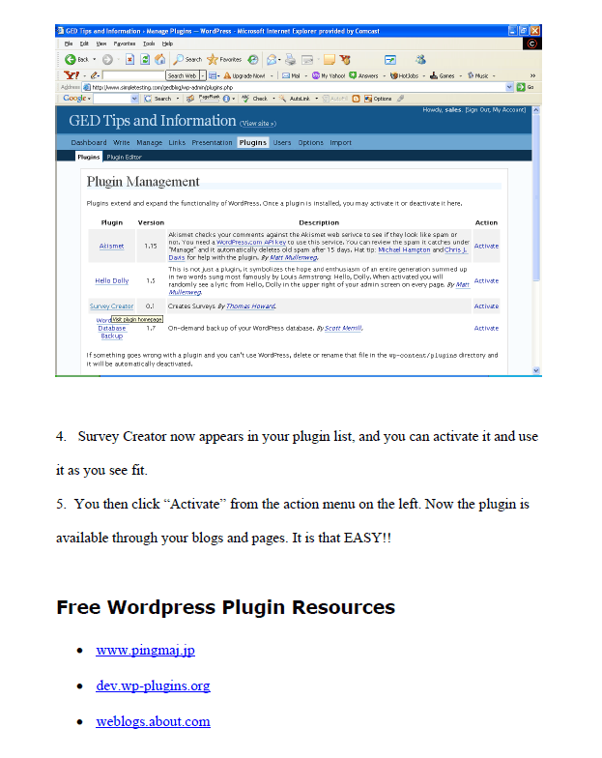
- Survey Creator now appears in your plugin list, and you can activate it and use it as you see fit.

- You then click "Activate" from the action menu on the left. Now the plugin is available through your blogs and pages. It is that EASY!!

Free Wordpress Plugin Resources

- www.pingmaj.jp
- dev.wp-plugins.org
- weblogs.about.com
- www.skipy.net
- www.adesblog.com
- www.theblog.cc
- www.siteground.com
- www.johntp.com

Conclusion

Wordpress continues to release quality version of their already stable product as well as extend users' capability to produce quality websites. Wordpress also has a community theme viewer that allows you to view hundreds of new themes produced by other programmers. This gives the user the ability to see what others have dreamed up.

Wordpress is a quality product that allows you, with very little knowledge, to assemble and deploy a beautifully complex website with little technical knowledge and experience. The user gets the ability to use various themes and templates to make a professional impact on his/her user community. Wordpress is an awesome tool. If you are not using Wordpress to build your websites then you are spending a lot of time doing work you don't have to do.

On-Line Marketing Strategy #8
Mobile Marketing

Marketing your small business isn't easy. It's hard to know where to spend your limited budget and it's even harder to know if you've made the right choices.

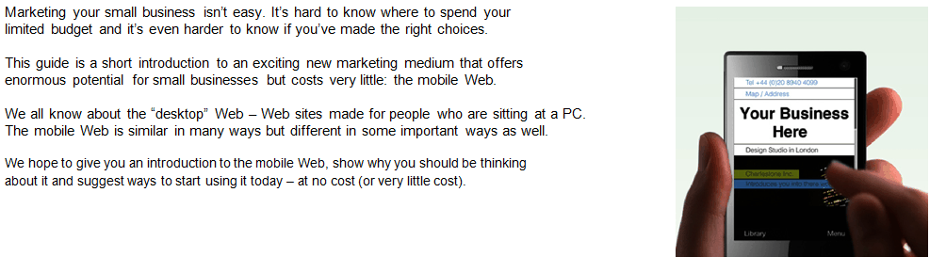
This guide is a short introduction to an exciting new marketing medium that offers enormous potential for small businesses buy costs very little: the mobile Web.

We all know about the "desktop" Web -- Web sites made for people who are sitting at a PC. The mobile Web is similar in many ways but different in some important ways as well.

We hope to give you an introduction to the mobile Web, show you why you should be thinking about it and suggest ways to start using it today -- at no cost (or very little).

What is the mobile Web?

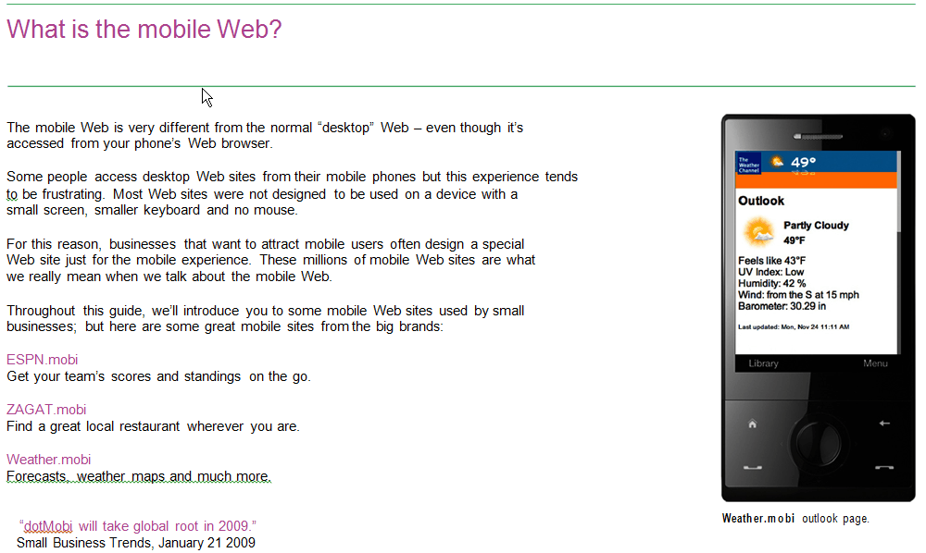
The mobile Web is very different from the normal "desktop" Web -- even though it's accessed from your phone's Web browser.

Some people access desktop Web sites from their mobile phones but this experience tends to be frustrating. Most Web sites were not designed to be used on a device with a small screen, smaller keyboard and no mouse.

For this reason, businesses that want to attract mobile users often design a special Web site just for the mobile experience. These millions of mobile Web sites are what we really mean when we talk about the mobile Web.

Throughout this guide, we'll introduce you to some mobile Web sites used by small businesses, but here are some great mobile sites from the big brands:

ESPN.mobi
Get your team's scores and standings on the go.

ZAGAT.mobi
Find a great local restaurant wherever you are.

Weather.mobi
Forecasts, weather, maps, and much more

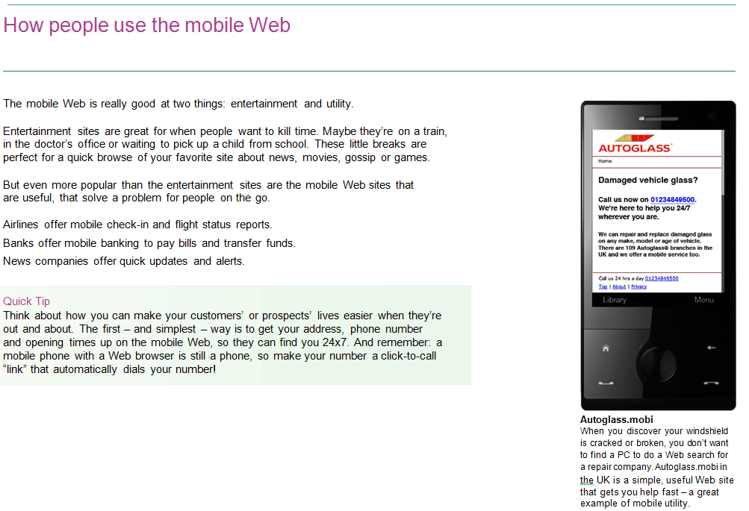
"dotMobi will take global root in 2009"
Small Business Trends, January 21, 2009

How people use the mobile Web

The mobile Web is really good at two things: entertainment and utility.

Entertainment sites are great for when people want to kill time. Maybe they're on a train, in the doctor's office or waiting to pick up a child from school. These little breaks are perfect for a quick browse of your favorite site about news, movies, gossip or games.

But even more popular than the entertainment sites are the mobile Web sites that are useful, that solve a problem for people on the go.

Airlines offer mobile check-in and flight status reports.

Banks offer mobile banking to pay bills and transfer funds.

News companies offer quick updates and alerts.

Why you should market your business on the mobile Web

For an increasing number of small businesses, the answer is: because it's a low-cost way to help people find you and your products. Here's why it's growing so fast:

The mobile Web is huge
If you thought the World Wide Web was big, consider there are nearly four billion mobile phones in the world -- about four times more the number of PCs.

There are over 40 million mobile Web users in the USA and more than 42 million in Europe.

That's a lot of consumers.

The mobile Web is growing fast
Every day, more and more people are using their mobile phones to access Web sites.

A new generation of phones with Web browsers (including the popular iPhone and many more) has made it easy. New mobile networks have made it fast. New "flat rate" data plans make it affordable.

As new phones replace old ones, millions more people will be using the mobile Web.

The mobile Web is branded
The explosion of mobile Web use has not eluded the big brands. Nearly everyone has some kind of mobile Web presence already or is planning to launch one in the next twelve months.

And many smaller businesses -- everything from a one-office real estate agent to the local pizza restaurant -- are following in their footsteps.

How your business can use the mobile Web today

Anything you might put on your normal Web site could be useful on your mobile Web site.

Essentials

Contact details
An essential for any business

Directions or a map
Make it easy to find you

The basics
Who you are, what you do and why they should choose you -- in as few words as possible

- A fitness club might post class schedules on its .mobi site
- A restaurant could post its seasonal menus
- A locksmith could list after-hours contact numbers
- A plumber could list rates and hot line numbers
- A bookshop could list the latest readings it's hosting
- A theatre could post its schedule
- A nightclub might promote theme nights and new cocktails
- A hairdresser could post the latest looks
- A gift shop could run weekly coupons
- A local newspaper could offer a sponsored news digest

Whatever business you're in, there's a good way to put the mobile Web to work.

Ten tips for making a great mobile Web site

- Think about the mobile device - Recognize its limitations (small screen, no mouse), but also think about its extra capabilities (it's a phone, a camera, a text device).
- Think about the mobile user - Think "fast access to short bits of content."
- Keep it simple - Use short, direct sentences. Make navigation easy. Don't expect people to fill out long forms. Let people find things with as few clicks as possible.
- Keep it fast - Lots of video, animation or large image files slow down your site. Keep them to a minimum (Instant Mobilizer can help -- see page seven).
- Make it useful - Don't just think about your business and your goals -- think about your audience and what they really need, especially when they're on the go.
- Make sure it works on all phones - Mobile devices are incredible diverse. Your site may look great on one phone and look terrible (or stop working) on another.
- Choose your domain name carefully - To make your site easy to find, use yourname.mobi. More on this on page six.
- Promote your site - Make sure your customers and prospects know about it. See page nine for advice.
Quick Tip:
Make sure you let users easily switch between your .com and .mobi sites. You can use simple switching icons like these:

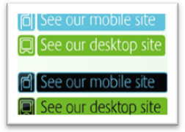

This way, if people accidentally hit your .com Web site from their mobile phones (or your mobile site from a PC) they can easily switch to the site they want.
- Never stop learning - Everything you do on your mobile Web site is testable. See what works and keep improving things. Services like Google Analytics can help you analyze your traffic (and it's free).
- Don't overspend - The mobile Web site should make you money, not drain away your profits. Start simply and your payback will come more quickly.

Promoting your mobile Website

There's no sense making a mobile Web site if nobody knows about it. Here are some easy ways to promote your site and start to build traffic.

Put the address on your business cards, just like you'd do with your "desktop" Web site.

Include it on all promotions - From free handouts to directory listings, e-mail shots, door drops and local ads, make sure they know about your .mobi.

Run a mobile-only promotion - Make a special offer to people who use your mobile site.

Run a contest. Your customers can get a secret code from your site and use it to enter a prize draw -- or answer a few questions on the site.

Throw a launch event. Have a cocktail party and tell your best customers.

Put it on your .com Web site. Show your Web visitors you've got a .mobi too.

Put it in all e-mails. Make your .mobi part of your e-mail signature.

Do some public relations. A local business launching a mobile Web site is still new -- tell the local press!

Put your .mobi address on give-aways, like free branded pens, coffee mugs or USB keys.

Text your best customers. You can send them a direct link to your site in the body of the text message -- just make sure they'll be happy to receive it (nobody likes spam).

Choosing the right name for your mobile Web site

You can choose any domain name for your mobile Web site but one of them works better than all the others .mobi. Here's why:

A .mobi name tells consumers to expect a mobile experience. Using .mobi tells people that your site is optimized for a mobile device and a mobile user. Using a variation of .com says "expect a desktop Web site."

It makes your site memorable. Users are more likely to remember yourname.mobi -- it's clear, simple and fast becoming the most popular option for mobile Web sites.

It makes your site search-engine friendly. The .mobi domain is found in the Internet zone files -- the files that search engines use to start every crawl. Your .com site is already indexed, so you don't get an extra entry if you use any variation of .com.

It's short and sweet. It's the perfect complement for your business name -- and there's no need for www. A .mobi domain will keep your URL concise and tidy, which is good for users.

It's the only mobile domain that's actively promoted - .mobi is supported and promoted by dotMobi, a company backed by 14 of the biggest names in the mobile Web. This powerful backing gives .mobi staying power that no other mobile address has.

It's easy and inexpensive. Many of the top domain name registrars offer excellent value on .mobi names and make it easy to find and register the best available name.

Getting started

The mobile Web is a powerful marketing opportunity for businesses of every size. Many experts predict that it will become bigger than the desktop Web.

For small businesses looking to jump out of the pack, serve their customers in new ways and attract new business, it's an extremely attractive medium.

Section 5 – Bonus Strategies

Strategy #1 Don’t Be a Human Lobster 275
Strategy #2 Educate Employees 276

Strategy #3 Parkinson’s Law 277

Strategy #4 Zero-Based Thinking 279

Strategy #5 Always Use Exact Numbers 282

Strategy #6 Stay Plugged In 285
Bonus Strategy #1
Don’t Be A Human Lobster

Did you know……

A Lobster when left high and dry among the rocks, has not the instinct and energy enough to work her/his way back to the sea, but waits for the sea to come to her/him. If it does not come, she/he remains where she/he is and dies, although the slightest effort would enable her/him to reach the waves, which are perhaps within a yard of her/him.

The world is FULL of Human Lobsters: Men and women stranded on the rocks of indecision and procrastination who, instead of putting forth their own energies, are waiting for some Grand Billow of good fortune to set them afloat.

We know what it takes to get your small business making BIG profits, gaining total control over all your employees, reducing your stress, and cut the amount of hours you are working.

The number one reason people fail in small business marketing is because they never do a darn thing. They learn all these money making marketing strategies and then they don’t use them.

It is better to do something which isn’t quite perfect then to not do anything at all.

Don’t worry if you don’t have every little thing you need. For instance if you do a letter giving away a free product, don’t worry if you only have two in stock. Test the method, if you get a huge response just tell your clients that you were overwhelmed with the response and are currently out of the product. As soon as you get more in, you’ll get it to them. This is a much, much better idea than not doing anything at all.

Once you try something then you have a place to go from. Even if your method didn’t work as well as you’d like, you’ll be able to improve it and get more response.

Stop worrying about all the little details and just do something!

Bonus Strategy #2
Educate Employees

Employees can be a wonderful source of referrals. In order for a business to be extremely successful, the employees have to believe in it too. Employee education is key.

Once you educate your employees why you deliver such a great service, you’ll be surprised at the rewards.

This is what will happen:

- Your employees will start up selling a lot more. If they don’t know how certain products or services benefit their clients they can’t sell them. But if you educate your employees they’ll know and be much more likely to try to sell.

- Your employees can be a wealth of referrals. If they don’t think your business is exceptional, they won’t refer anyone. But if you’ve taught them why and they truly believe it, they will tell lots and lots of people.

- An educated employee is much better suited to help or answer questions from a client. Clients get annoyed when employees don’t know anything.

Educate your employees on a regular basis. Get them excited about working for such a wonderful business. Education and motivation are the keys to super great employees.

Bonus Strategy #3
PARKINSON’S LAW

We need to tell you about this topic now because we DON’T want you to fall into the trap MOST people fall into.

Why People Succeed or Fail
Parkinson’s Law is one of the best known and the most important laws of money and wealth accumulation. It was developed by English writer C. Northcote Parkinson many years ago and it explains why most people retire poor.
The Way the Law Works
This law says that, no matter how much money people earn, they tend to spend the entire amount and a little bit more besides. Their expenses rise in lockstep with their earnings. Many people are earning today several times what they were earning at their first jobs. But somehow, they seem to need every single penny to maintain their current lifestyles. No matter how much they make, there never seems to be enough.
The Key to Financial Success
The first corollary of Parkinson’s Law says: “Financial Independence comes from violating Parkinson’s Law.”
Parkinson’s Law explains the trap that most people fall into. This is the reason for debt, money worries and financial frustration. It is only when you develop sufficient willpower to resist the powerful urge to spend everything you make that you begin to accumulate money and move ahead of the crowd.
Slow Down Your Spending
The second corollary of Parkinson’s Law is: “If you allow your expenses to increase at a slower rate than your earnings, and you save or invest the difference, you will become financially independent in your working lifetime.”

This is the key. we call it the “wedge.” If you can drive a wedge between your increasing earnings and the increasing costs of your lifestyle, and then save and invest the difference, you can continue to improve your lifestyle as you make more money. By consciously violating Parkinson’s Law, you will eventually become financially independent.
Action Exercises
Here are two things you can do to apply this law immediately:

First, imagine that your financial life is like a failing company that you have taken over. Institute an immediate financial freeze. Halt all non-essential expenses. Draw up a budget of your fixed, unavoidable costs per month and resolve to limit your expenditures temporarily to these amounts.

Carefully examine every expense. Question it as though you were analyzing someone else’s expenses. Look for ways to economize or cut back. Aim for a minimum of a 10 percent reduction in your living costs over the next three months.

Second, resolve to save and invest 50 percent of any increase you receive in your earnings from any source. Learn to live on the rest. This still leaves you the other 50 percent to do with as you desire. Do this for the rest of your career.
Bonus Strategy #4
Zero-Based Thinking

This is a more of a “LIFE” strategy that we know if you apply it, you WILL reduce your stress, money WILL flow to YOU from unexpected places, you WILL at least double your productivity, and you WILL ultimately be much happier person.
Are you wondering what the heck I am talking about?
It is so important and has helped us so much over the years that we just have to tell you about it so you can put it to use to help you.
OK?
It is so simple and so easy to do you will wonder why everyone doesn’t do this at least once per month.
We have found over the years that it is the SIMPLE principals that work best for me. It seems that every time something gets complicated or too many people get involved or there are too many moving parts it turns out to be just a big pile of useless crap that doesn’t work.
Is it like this for you?
Good, we have one more thing in common.
This strategy was personally taught to us 13 years ago on a tele-seminar with Brian Tracy.

You’re thinking who the heck is Brian Tracy and why would anyone listen to him. Right?

Brian Tracy is the leading authority in the WORLD on personal achievement. He has written over 20 books and recorded over 100 audio tape programs. His programs are sold in just about every county in the world. There is NOT another human being on the planet who knows more about success and achievement. Go to his web site at BrianTracy.com and you will see for yourself everything he does.

Trust me, he is the real deal.

Anyway on the tele-seminar (which cost me $79 bucks) Mark was explaining to Brian all the stuff going on in his life at that time. All the business projects, friend and family commitments, recreational stuff…everything!

Some of the stuff was working but most of it was NOT. It was all intertwined together. He was getting pulled in all directions. I was just about at the breaking point.

This is what he told me to do. And we still do this 13 years later about every two weeks.

He said get two large pieces of paper; you know the kind they use in meetings on the big pad.

He said tape the two pieces to the wall in your office.

At the top of one paper write

“WHATS WORKING”

At the top of the other paper write

“WHATS NOT WORKING”

He then said list everything that is working in your life under “What’s Working”. Everything in business, relationships, finances, fitness, etc.

Everything.

And then he said list everything that is NOT working in your life under “What’s Not Working”.

Now if you are like Mark when he started this exercise, you WILL have a lot more stuff under “What’s Not Working”.

A lot more.

And then he said something to we will never forget.

He said if something can be fixed immediately under “What’s Not Working”, fix it or STOP it and get out of it as fast as you can.

Ask yourself this question….

“If I knew what I know now about (your item) would I have gotten into it in the first place?” (this is called zero-based thinking)

If your answer is NO then get out of it as fast as you can.

He called it creative abandonment.

STOP doing what is not working in your life. End a relationship that is not working. Stop an advertisement that is no longer working. Fire an employee that is no longer pulling their weight. Etc.

Get out of ALL the energy sucking, time consuming, high stress activities you have gotten yourself into as FAST as you can.

And then he said look at the list of “What Is Working” in your life and
Do More Of It

A lot more of it as fast as you can.
If a marketing method is working - expand it. If you have a good relationship going - make it better. If you fitness program is working – get more fit. Etc.

You get the idea right?

We told you that this was simple but it also brilliant isn’t it?

After you start doing this, you will see the headaches in your life disappear, money will start flowing to you from unexpected sources, you will laugh at stress and you will feel much, much happier.

A few cautions:

1. Don’t tell people what you are doing they will think you lost your marbles.

2. Learn to say NO to new opportunities a lot more (be very selective) so that you don’t keep piling more stuff to your “What’s Not Working” list.

3. The grass is NOT greener someone else. It’s greener where you water it. We talk to people all the time who want to get out of the business they are in and get into another totally unrelated business because they think another business will be better or easier. Every business has its own set of problems. Stay with what you know and get good at marketing and you will make all the money you want.

So we challenge you to do this exercise right now.
Just getting all this crap out of your head will be a stress reliever in and of itself.

After you do this for a while you’re “What’s Working” list will be much longer than you’re “What’s Not Working” list.

And you will be very selective what you will now say YES to.

Bonus Strategy #5
Always Use Exact Numbers

“5% Gas Savings When You Inflate
Your Tires With Nitrogen”

The above headline was the exact words on a sign we saw behind the counter of a Dunn tire store.

Do you believe what they are saying here?

When we see numbers like this we always say to ourselves….

“Figures Lie and Liars Figure”

How about you?

Why don’t we believe this statement?

Before I answer this question in detail I want you to know that I asked the store manager, Gary - “How many customers take them up on their nitrogen offer?”

He said very few.

I was NOT surprised.

So it is not just you and us who don’t believe the statement - it is most of their customers coming in their store.

So why don’t WE believe the nitrogen statement and what does this have to do with your IT business?

First, we don’t believe it because the statement is to GENERAL.

When a round number (5% in this case) is used it kind of tells the reader….. We don’t really know what the gas saving is but we think it’s around 5%, we know its not 10% and it can’t be zero so on average we think its 5%.

Using round numbers DESTROYS the power in the number because it is not SPECIFIC.

Now we’re not chemists or physicists but they must have measured this nitrogen thing to even come up with the idea to sell it to people unless the entire idea of inflating your tires with nitrogen is just a big scam.

For now we will assume it is NOT and that some guy with a white lab coat figured out through experiments that there is a gas savings. And lets also assume that there are many variables (size of tire, weight of car, etc., etc.). So this white lab coat guy came up with a range of gas savings of lets say 4.3% to 6.1% in his experiments.

By-the-way this is how the marketing people came up with 5% because it’s nice clean number and it is between 4.3 and 6.1. It is a safe number in case we ever get sued. (from the legal department).

Our recommendation to them would be to rip down the silly ineffective sign they have up now and replace it with this.

“Ask Us How You Will Save 4.3% to 6.1% On Gas, Every Time
You Fill Up Your Tank…. Forever”

Then all they need to do is train their people to explain to their customers all the real, true details and the benefits to them.

For example (we am making this up because we don’t know the details).

Mr. Smith (customer) asks employee “How can I save 4.3% to 6.1% on my gas bill?

Employee - Mr. Smith a comprehensive 2008 study headed up by Dr. Peabody the head of the physics department at MIT determined that Nitrogen will reduce the amount of fuel used by an automobile by 4.3% to 6.1%. Because nitrogen is a larger molecule it will not seep out of your tires like regular air so your tire will always be inflated properly. And nitrogen does not retain water like air so your tires will be lighter. And there are other factors that determine the exact amount of savings but you will save at least 4.3%.

Employee says - How much do you spend on gas per month Mr. Smith?

Mr. Smith - says around $300.

Employee- pulls out a pre-done chart that has the amount of yearly gas expenditure and the corresponding 4.3% savings in dollars and shows it to Mr. Smith.

Employee - Mr. Smith you will save at least $154.80 and maybe more each year by having nitrogen in your tires. ($300 per month times 12 months is $3,600 times .043 is $154.80)

Employee - Its only $2.50 per tire for the nitrogen so I’ll have it added for you - OK?

Mr. Smith says OK.

Now this may not seem like much but I can bet that the $10 is almost pure profit. And EVERYTIME the customer’s tires need to be rotated or are low they are coming back to Dunn tire. And Dunn Tire will sell them a lot of over the years, won’t they.

SO HOW DOES THIS APPLY TO YOUR SALON OR SPA BUSINESS?

1. Always use exact numbers and details when you write or talk about how long something takes, how long something lasts, explaining fees, and etc.

2. The nitrogen air was an up sell. YOU need to be UP-SELLING in your business at EVERY opportunity. And teach your employees how to do it.

The lesson here is this - If your clients and potential clients don’t believe you they won’t give you their hard-earned money. Use as much detail as you can and use EXACT numbers.

Your get the idea, right?

Bonus Strategy #6
Stay Plugged In

You are NOT alone on this journey. We are here to help you.

Make sure and read this entire manual.

Make sure and listen to the CD’s that came with this manual.

Make sure and read, listen to and implement all the separate system modules that are in the program.

Make sure and read all the emails we send you.

Make sure and get on and listen to the tele-seminars.

Make sure you set up your coaching calls.

And please send us an email if you have any questions.

You now have the knowledge to take your business to any level of success you want to be at. BUT you MUST now put this information into ACTION.

Like you have heard us say before, “There is no difference between knowing and not doing than not knowing in the first place.” Nothing happens without ACTION and it is YOUR responsibility and totally up to you to put these strategies into ACTION.

