Salon News

***HAPPY NEW YEAR*  January 2025**

***WINTER HAIR CARE***

When winter hits, a bad hair day can seem to last the whole winter season. Call it what you like, hat hair, static electricity, split ends, or simply dry frizz.  The ongoing winter environment can have some of the most damaging effect on our hair. People may not take precautions on their hair in the winter as much as they do in the summer time.

In the winter, you will still have sun exposure combined with blustery winds, rain, snow, and cold. You can take protective steps against any winter woes your hair may encounter. At the top of the list for most people is a good thick, rich, moisturizing conditioner. The product must contain essential fatty acids and humectants. Those are best for moisturizing hair helping to attract and hold moisture in the hair, which can be challenging in the winter.

If you have thick or curly hair, you should use a thick, heavy conditioner hair pack, deep treatment.  Leave it in your hair for a half an hour, once or twice a week. If your hair is fine or thin, avoid the conditioning pack. It will be too heavy for your hair.  Instead, use a regular conditioner every time you wash your hair, supplement with a light leave-in spray conditioner.  If it is not light, it will weigh your hair down.

To remove static cling, use a fabric softening dryer sheet.  Lightly rub it on your hair and it will remove the static. Or rub it on your hands and smooth your hands over those stray fly-aways.

Avoid using heat appliance as much as possible.  Using a blow dryer or flat iron will dry out your hair even more in the winter. If your hair is especially vulnerable, avoid using chemicals in the winter.  Try lowlights or highlights with no peroxide color.

To avoid hat hair in the cold weather, put a silk scarf on under your hat to help prevent squishing and reducing static cling.

 Talk to your stylist about your specific hair condition and products that will help.





Though we travel the world over to find the beautiful, we must carry it with us or we find 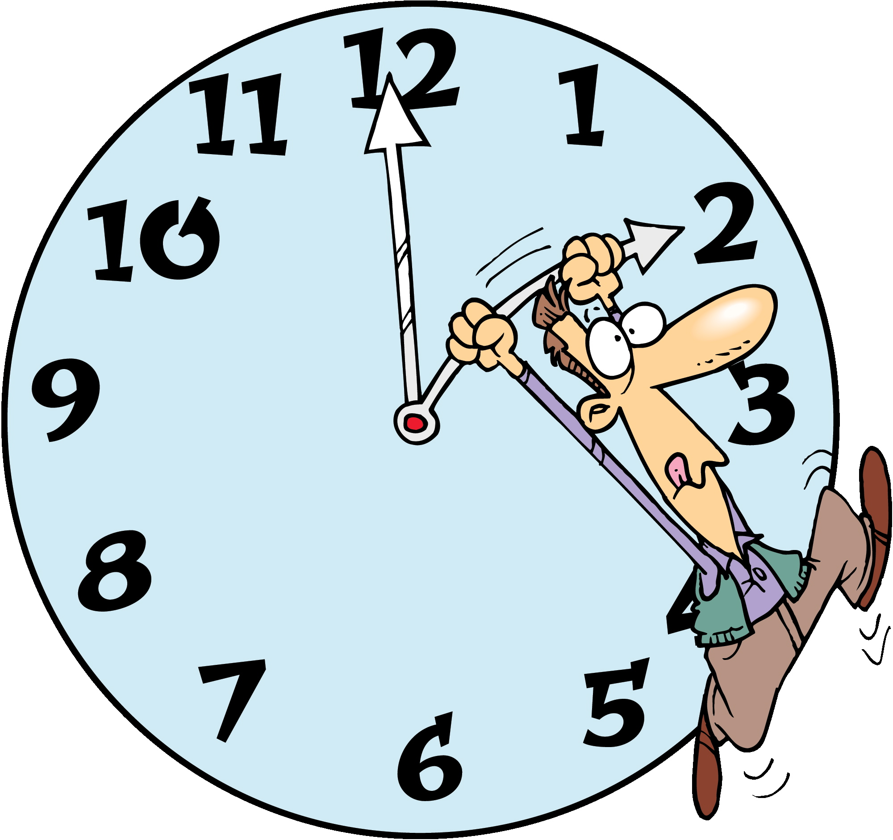it not. ~Ralph Waldo Emerson

**"Never underestimate the power you have to take your life in a new direction."** "Every moment is a fresh beginning." "Life's not about expecting, hoping and wishing, it's about doing, being and becoming." "I like the dreams of the future better than the history of the past."





***January Events***

1 - New Year's Day   
4 - Trivia Day   
5 - Feast of the Epiphany-   
5 - National Bird Day   
10 – House Plant Appreciation Day

20 - Martin Luther King's Birthday - third Monday   
25 – Opposite Day

26 – Australia Day   
29 – Chinese New Year’s, It’s The Year 4719!



***TURKEY MEAT LOAF***

**Ingredients**

1 pound sliced button mushrooms

2 cups finely chopped onion

1 cup grated Parmesan cheese

3/4 cup Italian breadcrumbs

1 tablespoon minced fresh garlic

2 large eggs, lightly beaten

1 (7-oz.) container refrigerated basil pesto

2 tablespoons tomato paste

1 1/2 teaspoons table salt

1 teaspoon freshly ground black pepper

2 (8-oz.) cans tomato sauce

2 (20-oz.) packages lean ground turkey

**Preparation**

1. Preheat oven to 400°. Process mushrooms in a food processor until finely ground. Stir together onion, next 5 ingredients, and mushrooms in a large bowl. Combine tomato paste, salt, pepper, and 1 (8-oz.) can tomato sauce; stir into mushroom mixture.

2. Add turkey to mushroom mixture, and combine, using hands, until well blended. Line 2 (9- x 5-inch) loaf pans with heavy-duty aluminum foil; coat lightly with cooking spray. Divide turkey mixture between prepared pans. Place pans on a foil-lined baking sheet.

3. Bake at 400° for 30 minutes. Spread remaining 8-oz. can tomato sauce over meatloaves. Bake 30 more minutes or until a thermometer inserted in center of meatloaf registers 165°.

4. Let meatloaves stand 10 minutes. Slice and serve.



**Time Management**

These days we all feel like we could use an extra hour in our day. Since 25 hours a day isn’t coming any time soon, here are a few strategies for the over-scheduled person:

1. Do one thing at a time. Doing too many things at once is actually less productive. Set aside time to focus on one project at a time. Multi-tasking is a myth.

2. Delegate. Do not hesitate to get people to help you get projects done.

3. The easiest way to keep things off your “to do” list is not put it there in the first place. Learn to say no.

4. Block websites for a few hours. If you are working on the Internet, it is easy to go to social media websites, such as Facebook or Instagram. Use an app that will block websites for a certain period of time. Check out: selfcontrolapp.com.

5. Review how you do things. Are you doing them an old-fashioned way or is there a faster and better way to handle paying bills, etc.?

6. Make a list at the end of the day so you are ready to dive in first thing in the next morning.

# *TWO BY TWO*

# *NICHOLAS SPARKS*





Russell Green has it all: a beautiful wife, an adorable six year-old daughter, a successful career as an advertising executive and a big home in Charlotte. He is living the dream, and his marriage to the bewitching Vivian is the center of that. But underneath the shiny surface of this perfect existence, fault lines are beginning to appear...and no one is more surprised than Russ when he finds every aspect of the life he took for granted turned upside down. In a matter of months, Russ finds himself without a job or wife, caring for his young daughter while struggling to adapt to a new and baffling reality. Throwing himself into the wilderness of single parenting, Russ embarks on a journey at once terrifying and rewarding; one that will test his abilities and his emotional resources beyond anything he ever imagined.



***Did You Know***

***That Sleep Can***

***Help With***

***Weight Loss?***

Studies have shown a link between sleep deprivation and a propensity to gain weight.  people who experience sleep deprivation have been shown to be more likely to consume high carb and high calorie foods.

Sleep deprivation increases a hormone called Ghrelin, which triggers appetite and decreases one called Leptin which signals that you are full.

People who sleep less tend to eat more.

Skimping on sleep can also set your brain up to make bad decisions.  When you are tired your brain is looking for something to rev it up. That could include a second bowl of ice cream. Here are some steps to getting better sleep.

***Continued…***

**1.**  Figure Out How Much Sleep Your Body Needs. Sleep cycles are 90 minutes long and most adults average five cycles per night.  That means that about 7 ½ hours of sleep would be needed for some people.  There may be differences for others.  Some people need more and some need less. Experiment with what your needs are.

**2.**  Keep Your Bedtime and Wake Up Time Consistent. Try not to vary when you go to bed or wake up by more than half an hour.  This will keep your internal clock functioning more efficiently.

**3.** Cut Back on Caffeine. Try not to consume caffeine after 2 p.m.

**4.** Cut Back on Drinking Alcohol. When alcohol metabolizes out of your system, you will wake up more frequently later in the night.

678-786-3281



BD18216_ MCj03226580000[1]

This area can be used either for the address of your customers. All you have to do is to print labels, paste them here after you’ve put in your return address.

The Newsletter can then be folded in thirds, stapled or adhered with special round stickers available at an office supply store to allow the letter to go through the postal machines with a minimum of effort. A two page newsletter will require postage of a first class letter.

If you do not wish to mail this, then this space can be used for additional information specific to your salon.