Salon News

**March 2025**

**HEALTY SKIN CARE TIPS**

*Most of us do not have time to do intensive skin care. There are ways to pamper yourself by using a few healthy lifestyle choices that don’t take much time. By making some healthy choices, it can help prevent common skin problems and even delay the natural aging process. Get started with a few of the following easy tips:*

1. *Protection from the sun. This cannot be emphasized enough. Sun exposure throughout your life can produce wrinkles, age spots, skin cancer, and many other skin problems.*

* *Use sunscreen with at least 15 SPF. Apply generously and reapply every two hours.*
* *Avoid the sun between 10 a.m. and 2 p.m.*
* *Wear sun protective clothing. Many flattering styles are now available.*

1. *Do not smoke, or if you do, make a plan to stop this year. Smoking makes your skin look older and adds wrinkles. Smoking damages collagen and elastin. Smoking also depletes the skin of oxygen and other nutrients that are important to healthy skin.*
2. *Be gentle with your skin.*

* *Cleaning can be rough on your skin. Do not use strong soap as it can strip oil from your skin, causing excessive dryness. Use a mild cleanser instead.*
* *When shaving, use shaving cream or lotion and shave in the direction the hair grows.*
* *Use moisturizer that best fits your skin type.*
* *Limit time in baths/showers. Hot water will remove oils from your skin.*

*4. Eat a healthy diet. By eating proper foods, you will look and feel your best. Eat*

*plenty of vegetables fruitsand lean proteins.*

1. *Control stress in your life. Uncontrolled stress is harsh on your skin. It can*

*trigger acne outbreaks and other skin problems. Take steps to manage your stress levels; not only your skin will thank you, but the rest of your body as well.*

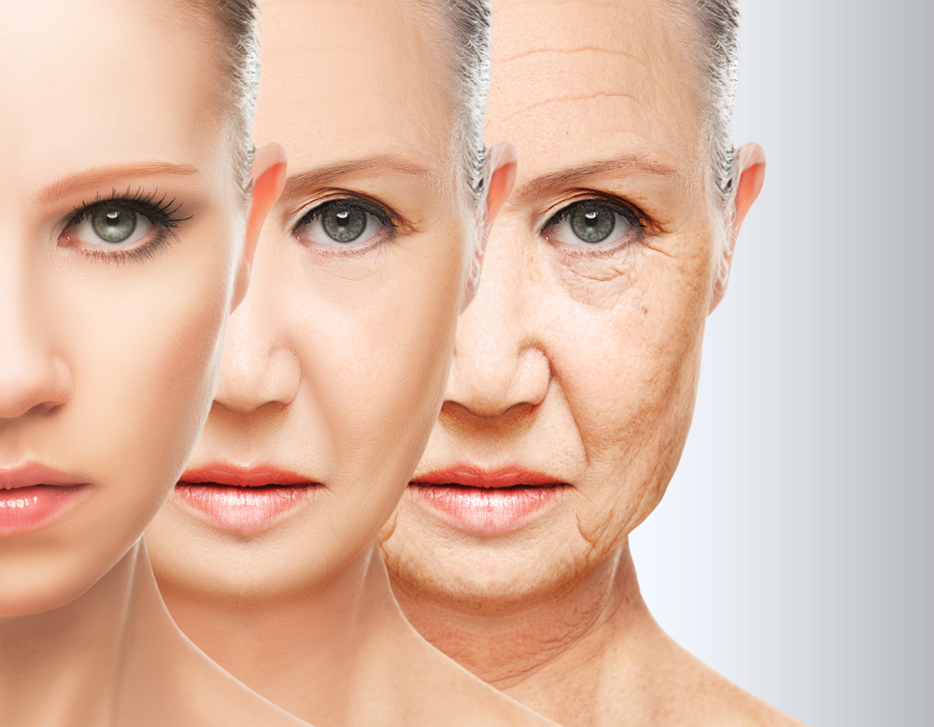

Though we travel the world over to find the beautiful, we must carry it with us or we find it not. ~Ralph Waldo Emerson

"**Spring is when life's alive in everything**." "Spring flowers are nature's most fragrant charms." "When spring came, even the false spring, there were no problems except where to be happiest." "You can cut all the flowers but you cannot keep spring from coming."



***March Events***

1 - Ramadan begins   
2 - Oscar Night 2025     
4 - Mardi Gras (Fat Tuesday)     
5 - Ash Wednesday – the date varies7 Ides of March   
8 - International Women’s Day   
9 - Daylight Savings begins at 2:00 a.m.    
14 - Purim begins at sundown   
17 - St. Patrick’s Day   
20 - International Earth Day – also called Sun-Earth Day   
20 - Spring (Vernal) Equinox    
25 - Feast of the Annunciation

Did You Know Facts – St. Patrick’s Day

Shamrocks are the national flower/emblem of Ireland.

The Chicago River is dyed green with a secret recipe for St. Patrick’s Day.

In Ireland, St. Patrick's Day is a national holiday with banks, stores, and businesses closed for the day.

***Green Chili and Egg Casserole***

***Ingredients***

10 eggs

½ cup flour

1-teaspoon baking powder

½ teaspoon salt

16 ounces Monterey Jack cheese (shredded)

2 cups (16 ounces) cottage cheese (blended to smooth)

1 4 oz. can chopped green chilies

***Directions***

In a bowl, beat the eggs until light. Combine flour, baking powder and salt; add to eggs and mix well. Stir in cheeses and chilies.

Pour into 9” x 13” baking dish. Bake uncovered for 35 minutes or until knife comes out clean.

Let it sit for 5 minutes before serving.

Serves 12

**International Women's Day 2025:**

***"Accelerate Action"***

The theme "Accelerate Action" calls for increased efforts to remove the barriers that prevent women from achieving equality. The campaign aims to speed up progress towards gender parity.

**TIPS TO MAKING FAST AND HEALTHY MEALS**

**With the busy schedules we all keep, it can be challenging to get a healthy dinner on the table. Here are a few tips that can make week night dinners a bit easier and enjoyable to eat:**

**Plan ahead. Write down daily meal plans at the start of the week or over the weekend. Shop for all of the ingredients. Pick up lean entrees such as chicken, ground turkey or whole-wheat pasta. Add vegetables and fruit to each meal plan.**

**Prepare vegetables for quick snacks through the week.**

**Stock healthy dips like hummus and Greek yogurt based dips.**

**Limit foods high in fat.**

**Stock up your pantry with quick and easy staples such as beans, brown rice, and whole-wheat pasta.**

1. **Prepare more than one meal at a time. Cook twice as much and freeze for another meal.**

# The Nest

# By

# Cynthia ’Prix Sweeney









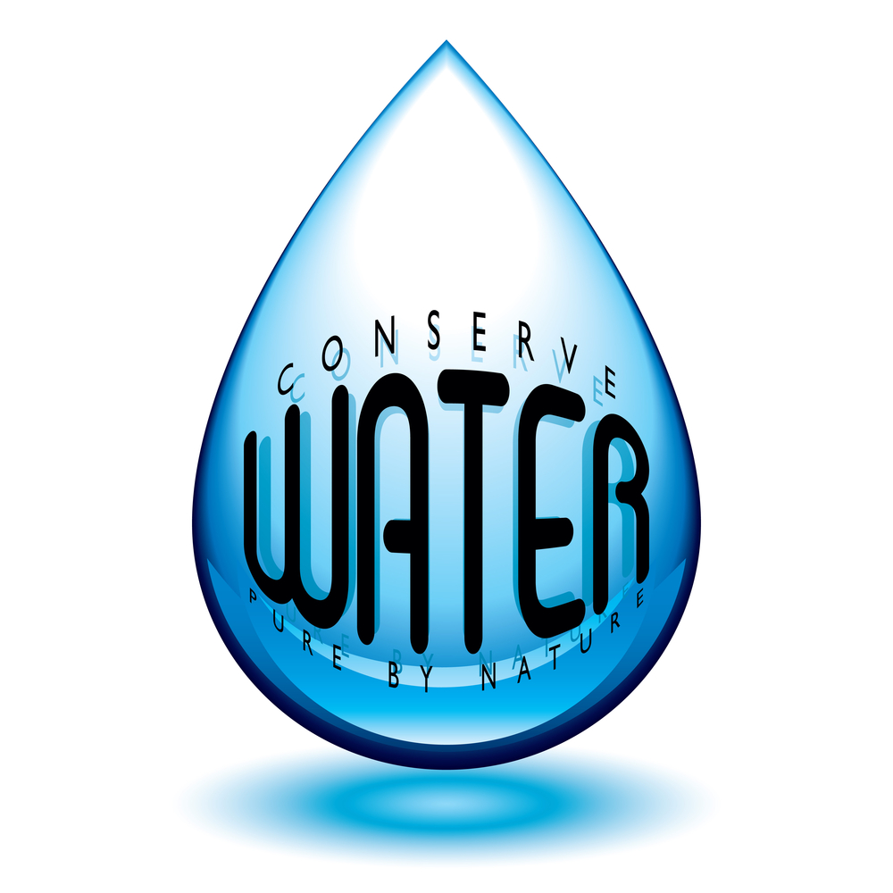

***Maintain a Youthful Look***

**Did you know that one of the top causes of age related appearance is the gradual loss of muscle? The loss of muscle occurs over a period of time. You can help yourself by adding a few items to your diet.**

1. **Apple. Eating an apple a day, with the peel can help. The apple peel is loaded with ursolic acid, a natural chemical that blocks protein that wears muscle tissue away.**
2. **Egg Whites. Egg whites contain leucine, an essential amino acid that helps regulate your body’s muscles.**

1. **Check out other foods that contain leucine, such as soybeans, peanuts and lentils.**

**TIPS FOR**

**WATER**

**CONSERVATION**

***WHEN IT COMES TO CONSERVING WATER, SMALL STEPS CAN MAKE A BIG IMPACT. HERE ARE A FEW SIMPLE WATER CONSERVATION TIPS:***

***in your bathroom:***

***Check your bathroom on a regular basis for leaks to the toilet, facets and shower. by fixing leaks, it can save you hundreds of gallons of water per day.***

***Install low flow showerheads and faucets.***

***Replace the toilet with a high efficiency toilet. this can save five gallons every time you flush.***

***Take a shower instead of a bath and shorten also your shower, saving you gallons per shower.***

***in the laundry room:***

***Only run full loads of laundry.***

***Buy a water saving model that can save up to 40 gallons per load.***

***kitchen:***

***RiNSE dishes as little as possible before putting them into the washer***

***Only run full loads.***



BD18216_ MCj03226580000[1]

This area can be used either for the address of your customers. All you have to do is to print labels, paste them here after you’ve put in your return address.

The Newsletter can then be folded in thirds, stapled or adhered with special round stickers available at an office supply store to allow the letter to go through the postal machines with a minimum of effort. A two page newsletter will require postage of a first class letter.

If you do not wish to mail this, then this space can be used for additional information specific to your salon.