Salon News

**April 2025**

**"Bend the Pain Away:**

**How Yoga Can Soothe Your Chronic Back Woes"**

Through conversations with others, I have noticed that people tend to have strong feelings about yoga—they either adore it or can’t stand it. Some even form opinions without ever giving it a try. Wherever you stand on yoga, stick with me here to discover how it might just ease your back pain, especially if it’s the chronic kind that lingers. Adding just a few yoga poses and breathing techniques to your routine could make a surprising difference.

Yoga enthusiasts, as a group, tend to be a healthy bunch. They often prioritize good nutrition, and with regular practice, they seem deeply connected to their bodies. One such practitioner, Cameron Alborzian, even authored a book called The One Plan, where he outlines his yoga-based approach to managing back pain.

Back pain often stems from obvious culprits like injuries, but it can also sneak up due to life’s stresses or habits like sitting too long, overdoing it with aggressive movements, or other excesses. Easing stress and tweaking those problem habits can go a long way toward soothing lower back discomfort.

One proven stress-buster is mastering yoga’s deep breathing techniques. Try this: sit quietly, tune out distractions, and focus solely on your breath. Take a slow, deep inhale—fill your lungs completely—pause for a moment, then release it gradually. This simple exercise, often taught in beginner yoga classes, can leave you feeling calmer, lower your heart rate and blood pressure, and dial down stress hormones.

If you are curious about yoga for stress relief or gentle stretching, seek out a restorative yoga class. Before it starts, let the instructor know you are new and dealing with back issues—they will likely offer extra guidance to keep you comfortable and safe. Yoga’s beauty lies in its flexibility; it’s not a race or a competition—you move at your own pace.

Unlike faster-paced yoga flow classes that glide through a variety of poses, restorative yoga zeroes in on just a handful of positions, holding each stretch for longer. It’s a perfect starting point for anyone aiming to unwind and boost flexibility while tackling back pain.

Though we travel the world over to find the beautiful, we must carry it with us or we find it not. ~Ralph Waldo Emerson

I don’t need a hair stylist; my pillow gives me a new hairstyle every morning!

~Anonymous

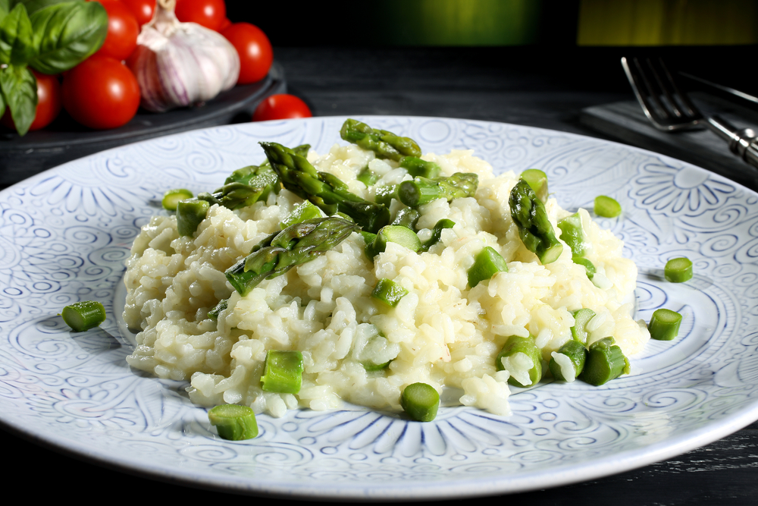



***April Events***

1 - April Fool’s Day   
1 - International Tatting Day   
4 - National Walk to Work Day 1st Friday

12 - Passover begins at sundown, lasts 8 days.   
13 - Palm Sunday  
15 - Income taxes due (most years it is due on the 15th)

18 - Good Friday

20 - Easter Sunday  
21 - Patriot’s Day Third Monday   
22 - Earth Day (U.S.)   
23 - Administrative Professionals Day formerly “Secretaries Day” – date varies   
24 - Take Your Daughter to Work Day 4th Thursday   
25 - Arbor Day always the last Friday in April

Did You Know Facts – Great Lakes

**L**

Lake Superior contains three quadrillion gallons of water.

All of the other four Great Lakes, plus a few more lakes the size of Lake Erie would fit inside of Lake Superior.

Lake Huron is the second largest of the Great Lakes.

If not for the Straights of Mackinac, Lake Michigan and Lake Huron might be considered a single lake.

Lake Michigan is the only Great Lake that is entirely within the borders of the United States.

The largest fresh water sand dunes line the shores of Lake Michigan.

**Asparagus Risotto**

**Ingredients**

4 cups chicken broth

2 tablespoons olive oil

4 green onions, chopped

1 cup Arborio rice

2 pounds asparagus, ends trimmed and cut into 2-in. pieces

2 tablespoons butter

1-cup cream

1/2 cup grated Parmesan cheese

**Preparation**

1. In a small saucepan, bring broth to a simmer.
2. Heat oil in a large pot. Add onions and rice and cook, stirring, until rice is browned, about 5 minutes.
3. Stir in broth, 1/2 cup at a time, and cook, stirring constantly until almost all the broth is absorbed before adding more, until rice is al dente, about 20 minutes; add hot water if you need more liquid. About 5 minutes before rice is done, add asparagus, butter, cream and Parmesan and cook until asparagus is tender-crisp. Serve immediately.

**"Ignite the Game:**

**Why Enthusiasm Is Your Team’s Secret Weapon"**

One of the standout qualities of sportsmanship is enthusiasm.

When you show enthusiasm, it’s like a neon sign announcing you’re thrilled to be part of the action. That energy doesn’t just stay with you—it lifts your teammates, firing them up too.

But the magic doesn’t stop there. Enthusiasm has a way of sparking inspiration in yourself as well. It’s a burst of vitality that refreshes, motivates, and spreads like wildfire, igniting everyone around you with its contagious vibe.

Bring that same enthusiasm into your daily life, and watch it ripple out to encourage others.

At its heart, enthusiasm is a mindset—a deliberate choice. It’s the fuel for passion and the spark behind achievements, pushing you to turn ideas into action.

As the philosopher Ralph Waldo Emerson put it, “Nothing great was ever achieved without enthusiasm.”

Here is how to let your enthusiasm shine:

* Always give your all, no matter the task.
* Cheer on your teammates with genuine support.
* Dive in eagerly to participate and pick up new skills.
* Seek out the positives in your team, your coach, and your fellow players.

**"Glow Like You Mean It:**

**8 Simple Beauty Tricks for Everyday Radiance"**

Who doesn’t love a good beauty tip? Below, you will find practical ideas and easy-to-follow guides to weave into your daily routine for that extra glow.

**1. Hair Goals Start with Clear Communication.**   
When it comes to your hair, don’t leave your stylist guessing. Be upfront about what you want and bring along magazine clippings or photos of styles that catch your eye.

**2. Nightly Brushing for Luscious Locks.**   
Each evening, brush your hair from roots to tips. This spreads your scalp’s natural oils along the strands, leaving your hair with a healthy, glossy shine.

**3. Perfect Brows Made Easy.**   
Before tweezing your brows, soften the skin by gently dabbing the area with a cotton ball soaked in warm water or a bit of cream—plucking will be a breeze.

**4. Banish Puffy Eyes**   
To tame puffiness, splash your face with cold water or grab a washcloth for a cold compress. Try 15 seconds on, 15 seconds off for a quick refresh.

**5. Long-Lasting Eye Makeup.**   
Keep your eye shadow in place by prepping your lids with a light layer of moisturizer, and use a primer under your foundation to lock it in all day.

**6. Silky Smooth Lips.**   
At bedtime, gently exfoliate flaky lips with a warm, damp washcloth, then seal in the softness with a swipe of lip balm.

**7. Lipstick That Stays Put.**   
For enduring lip color, apply your lipstick, let it settle, blot with a tissue, dust lightly with powder, and finish with a second coat—voilà, it’s set!

**8. Moisturize, Always.**   
Never skip moisturizing! A quality product keeps your skin’s oil and water levels balanced for a hydrated, radiant look.

# *Conspiracy of Silence*

# *by*

# *Martha Powers*



**Is Multitasking really efficient?**

Our society is so busy that we all feel the need to do several things at one time. Constant demands with work, school, sports and home have our brains switching from one task to another. Is it really good for you? The truth is, many of us confuse multitasking with distractions. According to studies done by cognitive psychologist David Strayer, 98% of us lack the cognitive abilities to juggle simultaneously two demanding tasks without errors.

Research conducted at Stanford University found that multitasking is less productive than doing a single thing at a time. People who are regularly flooded with several different tasks or information, cannot pay attention, recall information, or switch from one job to another as well as those who complete one task at a time. Multitasking reduces your efficiency and performance because your brain can only focus on one thing at a time. When you try to do two things at once, your brain lacks the capacity to perform both tasks successfully. Multitasking is really only task switching: moving back and forth between tasks and wasting productivity.

What do you do? The most important thing you can do is to focus on one thing at a time until the task it is completed. Then move on to the next task. Believe it or not, this can lead to being more productive.

***Chemical Free***

***Cleaning Fruit and Vegetables***

When you pick up your fruit and vegetables from the market, they will most like still contain pesticides on them. You want to be careful and get that off the fruit and vegetables before you eat them.

There is a simple and cheap way to clean your fruit and vegetables. Fill the sink with water. Add one cup of distilled white vinegar and stir. Add the fruit and/or vegetables, and soak for 10 minutes. The dirt and wax will come off. You will notice the water become dirty and there will be gunk in the bowl. Your fruit will be clean.

With more delicate fruits, like berries and strawberries, you might soak for a shorter period of time. You don’t want to damage your fruit by sitting in the vinegar too long. This cleaning process can help the berries last for weeks.

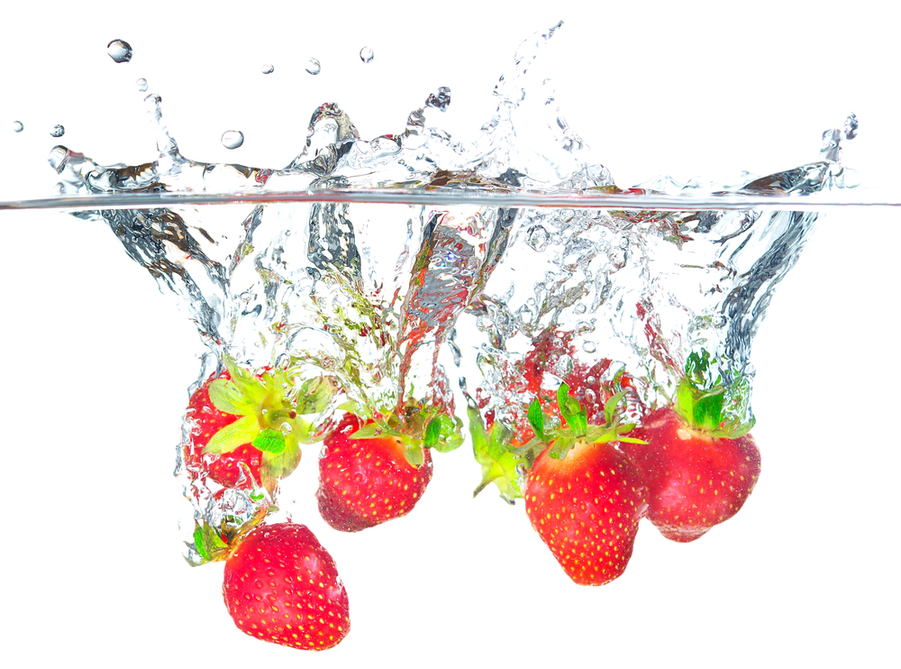

BD18216_ MCj03226580000[1]

This area can be used either for the address of your customers. All you have to do is to print labels, paste them here after you’ve put in your return address.

The Newsletter can then be folded in thirds, stapled or adhered with special round stickers available at an office supply store to allow the letter to go through the postal machines with a minimum of effort. A two page newsletter will require postage of a first class letter.

If you do not wish to mail this, then this space can be used for additional information specific to your salon.