Salon News

**June 2025**

***SUMMER HAIR***

***Preventing Split Ends***

Summertime is a battle against damaging your hair. Split ends are the result of fraying the hair shaft due to excessive heat, dryness, stress and excessive use of chemicals. Split ends can make your hair look dull, damaged and even frizzy. To win the battle against damaged hair, you need to know how to prevent split ends.

The best way to prevent split ends is to learn healthy daily habits to ensure the best care for our hair. By using proper hair care, you can also strengthen your hair.

1. Brushing your hair correctly is very important. Do not use a harsh brush on your hair. Use a cushioned paddle with flexible bristles. Use a brush on your hair *only* when it is dry.
2. Don’t wash your hair every day. Washing every other day allows the natural oils to help protect your hair.
3. Apply shampoo to the crown of your head and lather downward keeping your hair straight.
4. Condition your ends. Apply conditioner directly to the ends of your hair and leave it on for a few minutes. Use a leave-in conditioner afterwards.
5. Do not bunch your hair in a towel. Wrap a towel around your hair and squeeze different areas to pull out the excess water.
6. Brushing wet hair will make it more susceptible to tearing. Only use a wide toothcomb on wet hair. This will help manage your hair without causing breakage to the ends.
7. Anything that uses heat to style your hair can damage it. Try to style with as few of products and let it air dry. If you must use a hair dryer avoid placing direct heat on the ends of your hair until absolutely necessary.
8. Get regular haircuts. When getting your hair trimmed, cut about an inch to an inch and a half above the split end. Split ends will continue to grow if you don’t take care of the damaged hair.
9. Use high quality hair care products. Consult your hair dress for recommendations.
10. Always, always, always be gentle with your hair. Treat it like it is a delicate fabric.



Though we travel the world over to find the beautiful, we must carry it with us or we find 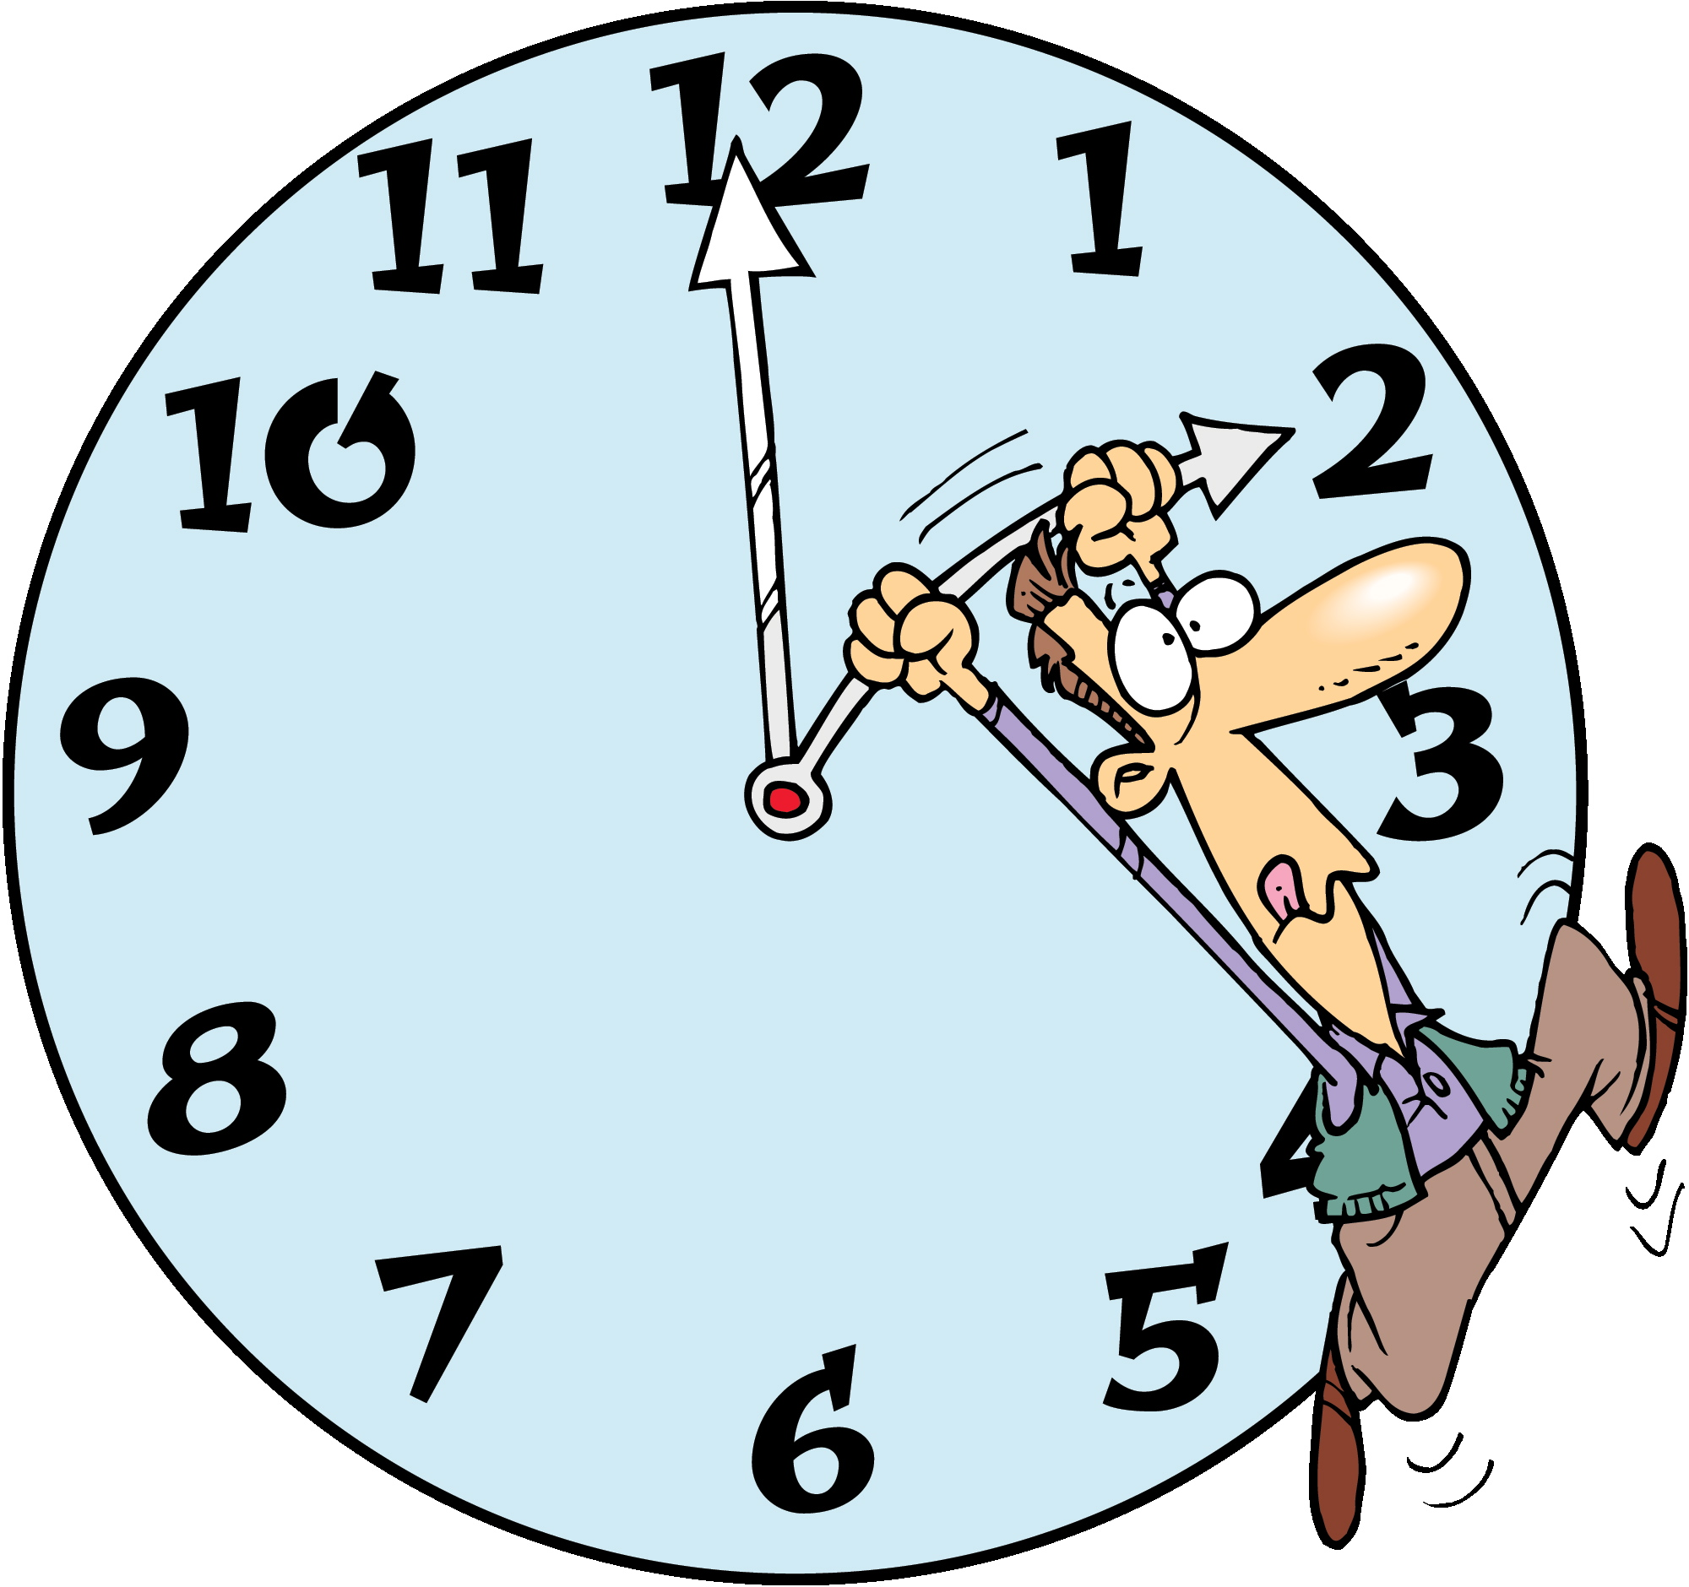it not. ~Ralph Waldo Emerson

***"June’s here, so ditch the winter fuzz and let your summer sparkle steal the show!"***

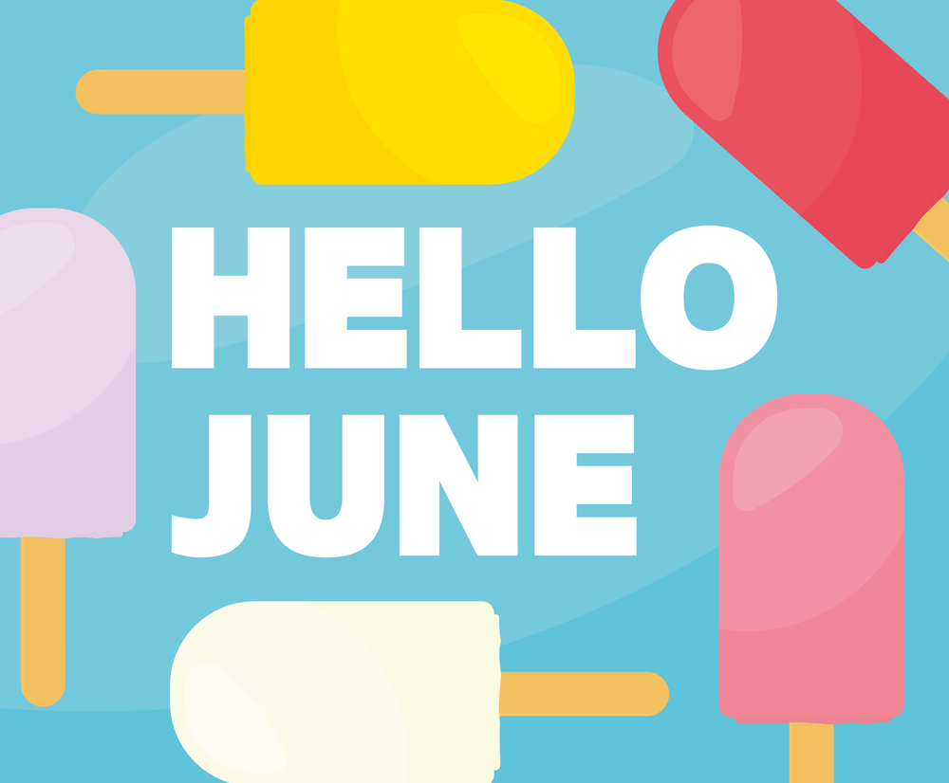

***June Events***

##### **June 6 – D-Day, WWII** Commemorating the Allied invasion of Normandy in 1944, fixed on June 6.

##### **June 14 – Flag Day** Celebrating the adoption of the U.S. flag, always on June 14.

##### **June 15 – Father’s Day** Observed on the third Sunday, which is June 15 in 2025, honoring dads everywhere.

##### **June 19 – Juneteenth** Marking the end of slavery in the U.S., fixed on June 19.

##### **June 20 – Summer Solstice** The longest day of the year in the Northern Hemisphere, falling on June 20 in 2025 (based on astronomical calculations for the sun’s position).

Did You Know Facts – Father’s Day

**L**

There are more than 214,000 men whom are stay-at-home dads.

Father’s Day was declared a national holiday 58 years after Mother's Day became official in the U.S.

Father's Day was introduced to compliment Mother's Day.

***MAC AND CHEESE BAKE***

**Ingredients**

* 1 lb. large elbow macaroni
* salt and pepper (to taste)
* 8 oz. shredded Monterey jack cheese
* 8 oz. extra-sharp Cheddar cheese
* 6 tbsp. butter
* 6 tbsp. all-purpose flour
* 4 c. milk
* 2 can diced tomatoes with green chilies
* 1 can mild green chilies
* 1 c. finely crushed tortilla chips

½ tsp. chili powder

**Directions**

Preheat oven to 425 degrees F. Cook pasta in boiling salted water according to package directions; drain.

Toss together Monterey Jack and Cheddar cheese in a bowl. Melt butter in a large pan over medium heat. Gradually whisk in flour and cook, whisking constantly, 1 minute. Gradually whisk in milk and cook, whisking constantly, until thickened, 8 minutes. Stir in tomatoes with chilies and cook, 2 minutes. Remove from heat and whisk in 3 cups of cheese mixture until smooth. Stir in pasta. Season with salt and pepper. Transfer to a lightly buttered 3-quart baking dish.

Add crushed chips and chili powder to bowl with remaining cup cheese mixture and toss to combine. Sprinkle over pasta. Bake until golden brown, 12 to 15 minutes.

# A bag with sunglasses and bottles on sand AI-generated content may be incorrect.Are You Beach Ready?

In the summertime many people flock to the beach for their summer vacation. If you plan on hitting the beach this summer here are a few tips before you go:

1. Go to the beach early. It is usually less crowded and the sun is not as intense as it will be later in the day.
2. Always bring sunscreen. Sunscreen is essential. Know the difference in the types of sunscreen that is available. Experts recommend nothing less than SPF 30. Apply 15 minutes before going outdoors and every two hours thereafter. If going in the water, reapply each time you get out of the water. (Remember the sun’s rays are hottest between 10 a.m. and 2 p.m.)
3. Sunglasses. Your eyes are sensitive to the sun as well. Do not forget to bring sunglasses. Be sure to bring sunglasses with UVA/UVB protection.
4. Electronics. Protection your cell phone and other electronics from sand and water by placing it in a ziplock bag. You can still use it in the ziplock bag.
5. Hide your valuables. Use a Chap Stick container or a diaper to hid your money.
6. Water. Stay hydrated while at the beach. Bring and drink a lot of water.
7. Shaving with baby oil before heading to the beach. It will help keep your skin smooth.
8. Bring apple cider vinegar. Spray it on sunburn for instant relief.
9. Bring baby powder. When you are done with the beach, sprinkle baby powder on your skin and the sand will wipe off.
10. Put aloe vera gel in ice cube trays and place in your freezer. When you get home put it on your warm body and it will help sooth your skin.

# *L.S. HILTON*

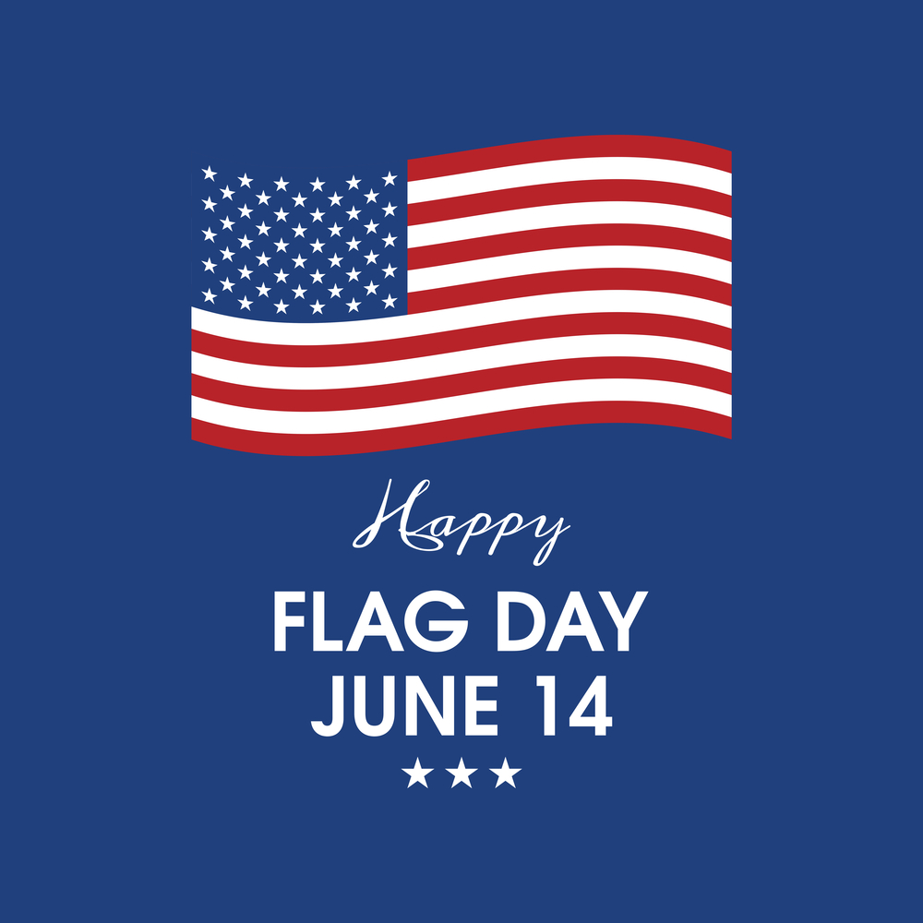

On June 15, 2025, we are taking a moment to honor the incredible fathers who make our world stronger and sweeter. Dads are the ones who fix broken toys, share life’s toughest lessons with a gentle word, and always have a smile ready to light up our day.

Their steady hands and open hearts guide us, whether they are grilling in the backyard or cheering from the sidelines. This Father’s Day, let’s say thank you for the countless ways they show up—big and small.

Here’s to every dad, for being our anchor and our inspiration. Happy Father’s Day!

Technology also impacts our ability to effectively handle person-to-person activity. We’ve all said it, “No cell phones at the dinner table.” But now you’re finding yourself saying it at all meals, even when you’re all just sitting around relaxing, chances are good everyone present has some kind of screen in front of them. Try to have “technology free” portions of the day when everyone goes out for a walk, a hike, to the park to play soccer, or gather around and break out those puzzles, board games, or cards. This is an essential skill for your kids to have in their future, so use their time off from school to help them develop this life skill.

How many of us notice that our kids seem to have a shortened attention span? Studies have proven that too much screen time has a direct correlation to this problem. Try teaching your kids to use their imagination instead of having everything figured out for them. One way is to read to your children. It doesn’t matter if they’re in kindergarten or eleventh grade, they all benefit from being read to. But have them close their eyes while you read and try to see the “movie” of the story you’re reading to them in their head. Share those experiences. Too many children today have an aversion to reading because there are so many words and no illustrations or videos to go along with it. Today’s kids need to be taught to use their imagination.

Try using time limits, but decide on them as a family. When everyone has a say on what changes are being made, they may not resist it as much.  The benefits definitely outweigh the negatives.  You may find that everyone is in a better mood as a result, better sleep, better exercise, and better family relationships.

****

**Limiting Technology**

Summer’s here and for many of us that means more time with our kids. It’s the time of summer camp, sleepy mornings, and more time outside, right?

Not always.

Having the kids underfoot now that school’s out might mean you have less time to do the things you want to do during the summer, and with all that’s available, it’s easy to turn to electronic devices to keep our kiddos entertained. But be sure you know the cost of that kind of childcare.

Yes, technology for kids is a great learning tool as well as a form of entertainment. But try not to turn to it full time.  It has some disadvantages that can have long-lasting effects.

Too much technology means added “blue light” which interferes with sleep. Both adults and kids are susceptible to this. Getting enough sleep can be challenging at the best of times, but when you add extra hours of blue light exposure from cell phones, tablets, computers, and television, it becomes a recipe for sleep deprivation. And kids, even more than adults, need those valuable hours of sleep.

678-786-3281

BD18216_ MCj03226580000[1]

This area can be used either for the address of your customers. All you have to do is to print labels, paste them here after you’ve put in your return address.

The Newsletter can then be folded in thirds, stapled or adhered with special round stickers available at an office supply store to allow the letter to go through the postal machines with a minimum of effort. A two page newsletter will require postage of a first class letter.

If you do not wish to mail this, then this space can be used for additional information specific to your salon.