Salon News

**August 2025**

***NAIL POLISH FINISHES***

Do you get overwhelmed with trying to pick a nail polish? Nail polish comes in every possible color and style.  There are a variety of finishes you can choose from, with each creating a different look for you. Your manicurist will be able to give you suggestions, but the following information will help you to be prepared for your next appointment.

1. ***Matte*** finishhasa flat color with a subtle shine. There are other formulas made to have extra shine, so that your nails look as if they are still wet.
2. ***Cream*** finishes have a shimmer look to them.
3. ***Metallic or Chrome*** finish is a very popular type of polish. You might try this type of you are looking for a trendy look.
4. ***Enhancing finish*** can help your nails, especially if you have weak or brittle nails. Ask your manicurist for a strengthening formula that will promote nail growth. This type of nail polish can help prevent nails from splitting or chipping, so you can have longer nails. Typical growth enhancing nail polish contains strengthening fibers and proteins to promote healthy nail growth.
5. ***Long Lasting*** nail polish canensure your manicure lasts longer, a week or more. To enhance the effectiveness of this type of polish, your manicurist will apply the polish to the tips of your nails as well as the tops and will then finish with a topcoat.
6. ***Quick Drying*** nail polish will be dry to the touch by the time your manicurist is finished painting your other hand. You should still wait about 15 minutes for it to dry completely before leaving the salon.
7. ***All In One Nail Polish.*** Sometimes we can be in a hurry, and might even encourage our manicurist to use an all-in-one nail polish, a formulation that contains both a base and a topcoat so that it can be painted right on your bare nails and you can be on your way. However, listen to your manicurist and get the best service for your nails and your needs.



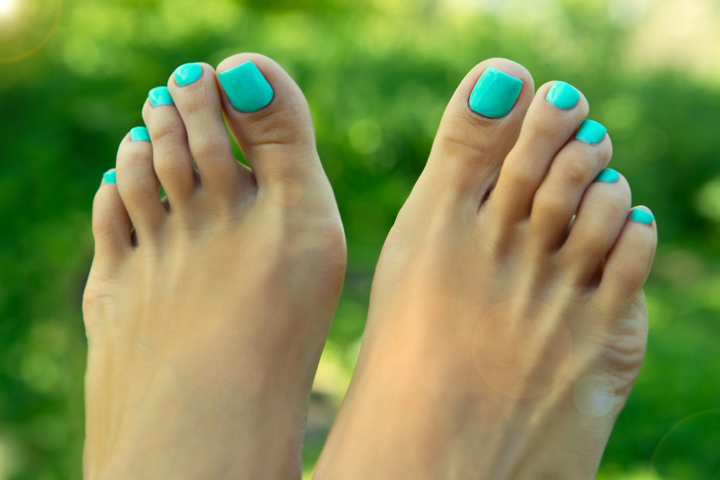

Though we travel the world over to find the beautiful, we must carry it with us or we find 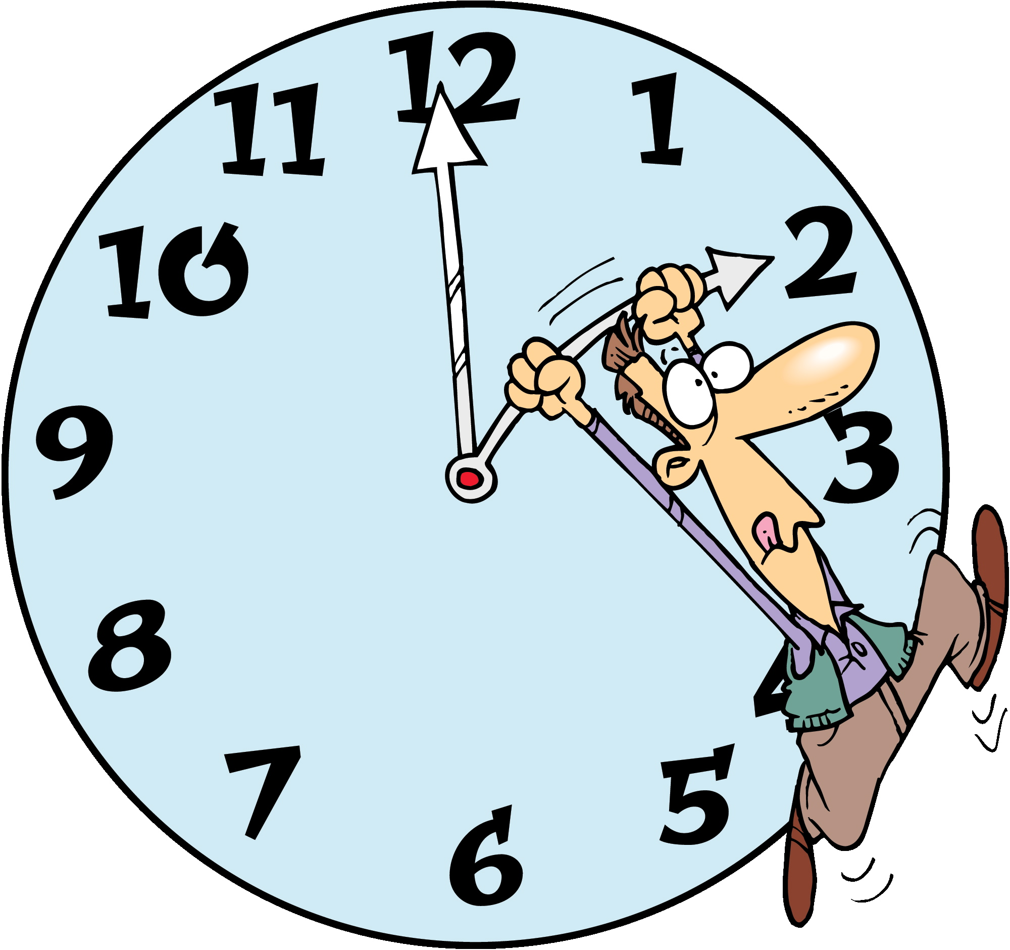it not. ~Ralph Waldo Emerson

Jimmy Carter legalized home-brewing of beer.

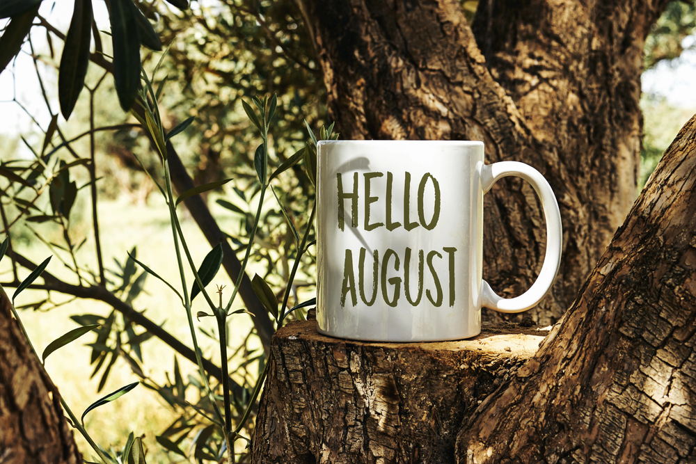

***In August, feed your soul with the beauty of late summer.***

***August Events***

1 - National Mountain Climbing Day

3 - National Watermelon Day

10 - National S'mores Day

11 & 12 - Perseid Meteor Shower - peak dates vary

13 - Left Hander's Day

14 - V-J Day

28 - Stuffed Green Bell Peppers Day

30 - National Marshmallow Toasting Day

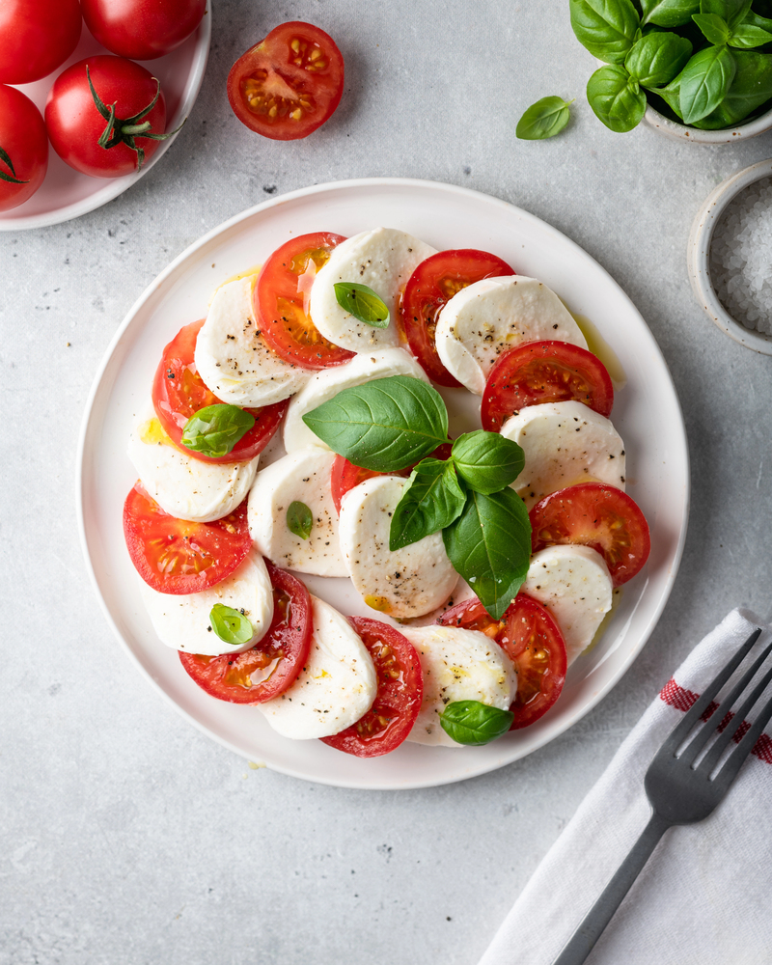

Evidence of brewing goes back about 5,000 years.

**L**

The fear of having an empty beer glass is called cenosillicaphobia.

**Recipe**

Caprese Salad

Ingredients:

1 lb. fresh mozzarella

10 fresh basil leaves

¼ cup olive oil

¼ cup balsamic vinegar (use the BEST balsamic you can find, it WILL make a difference!)

Salt and pepper to taste

Directions:

Place tomato slices, alternating with mozzarella and basil leaves on a large serving platter.

Mix together olive oil, balsamic vinegar and salt and pepper. Drizzle over tomatoes, mozzarella and basil leaves. Ready to serve.

Did You Know Facts – BEER

**WHAT IS SELF-IMAGE?**

*We don’t see people as they are, we see them as we are. ~ Anais Nin*

Your self-image is a mirror of your beliefs—both the ones you hold about yourself and those others project onto you. Once you accept these beliefs, true or not, they weave into the fabric of who you think you are.

Self-image is shaped by your experiences: the words others say, the way they treat you, and the stories you tell yourself. It is reflected in your choices—the car you drive, the job you do, the clothes you wear, the relationships you nurture, and the lifestyle you embrace. It’s the version of yourself you show the world.

Think about today’s outfit, your hairstyle, or even your shoes. These choices stem from your inner beliefs about yourself—whether they are true or just an idealized version you think the world expects.

A belief is something you hold as true, even if it’s not. Most beliefs take root in childhood, shaped by family, friends, teachers, or other trusted figures. We absorb their words as truth, making them our own without questioning. But is it really your truth?

Over time, these beliefs solidify into core convictions, shaping your attitudes and life experiences. They can become so ingrained that changing them feels impossible. To understand your self-image, you may need to challenge its accuracy.

Imagine being told you would never be a good singer, so you never tried. What if you took a chance, joined a choir, and discovered you have a voice? Many people have defied others’ limiting projections by questioning those beliefs and proving them wrong.

When you recognize beliefs that hold you back, you gain the power to rewrite them—and transform your life. Is your self-image truly yours, or is it keeping you from who you could be? Take a moment to reflect and dare to challenge what is holding you back.

**TIPS TO KEEP YOUR ENERGY SOARING ALL DAY  
LONG**

With a packed schedule, staying energized can feel like a challenge. If you are struggling to maintain your spark from morning to night, these simple tips will help you stay vibrant and focused:

**Hydrate Often**

Water is your body’s best friend. Feeling sluggish? Dehydration might be the culprit. Sip water throughout the day to recharge and stay sharp.

**Eat Smart**

Opt for smaller meals and healthy snacks like nuts or fruit to keep energy steady. Cut back on sugar to avoid crashes that zap your vitality.

**Boost with Vitamins**

Add a daily vitamin routine to support your energy levels. Check with your doctor to find the right regimen for your needs.

**Stay Active**

Keep your blood flowing with light movement—think a quick walk or stretching. It refreshes your body and clears your mind.

**Prioritize Sleep**

Quality rest is key to recharging. Aim for 7–8 hours of sleep to wake up ready to tackle the day.

**Take Mini Breaks**

Pause for short stretch sessions and deep breaths during the day. These quick resets boost energy and keep you grounded.





Our personal histories shape how words hit us—some wound, others uplift, coloring how we see the world.

Now think about the words you aim at yourself. Are they kind, or do you criticize endlessly? Those words sink deep, affecting you on a cellular level. Energy healers say it’s not just the words—it’s their vibration. Like a bee’s buzz coaxing a flower to open, kind words and thoughts can heal and nurture us.

Choose your words wisely. Speak with love—to others and yourself—and let their positive energy shape a brighter, healthier you.

***WORDS CARRY POWER: CHOOSE THEM WITH CARE***

We’ve all felt the sting of harsh words from someone we love. Remember how your body reacted—maybe a tightness in your chest or a sinking feeling? It was not just your imagination. Even now, recalling those moments can spark a physical response, proof that words hold energy that lingers.

In college, my relationship with my mom was rocky. The distance helped, but one heated phone call left us both raw. Then came her letter. Holding it, I hesitated, bracing for more hurt. When I opened it, her angry words hit like punches, sending adrenaline surging through me. The pain lingered for hours.

The next day, another letter arrived. I nearly tossed it, fearing more of the same. But something felt different. Curiosity won, and I peeked at the first line: “My darling daughter, please forgive me.” Those words washed over me like a warm wave, easing the ache. Her letter poured out love, hope, and regret, mending my heart.

That experience opened my eyes to the power of words. Science backs it up: words carry energy, not just emotion. Compare “inch” to “mile” or “light” to “dark.” Feel the difference?

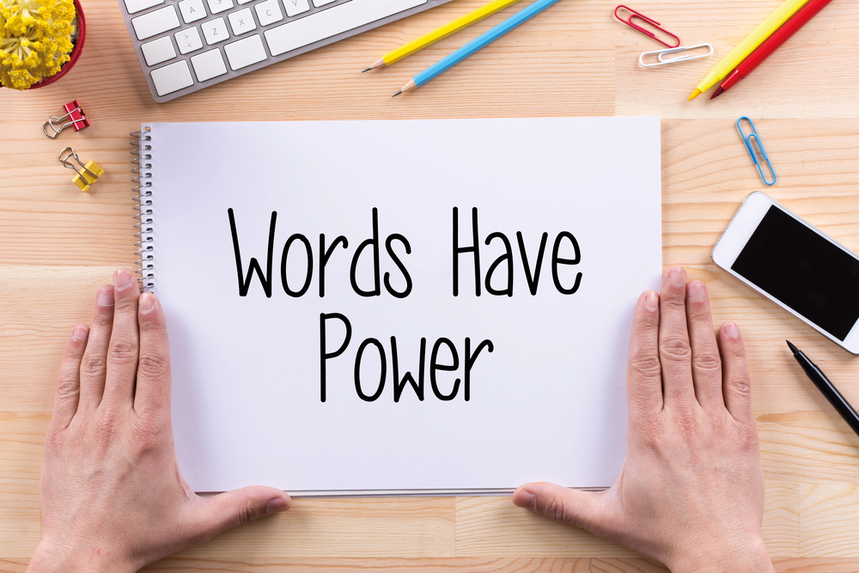

678-786-3281

BD18216_ MCj03226580000[1]

This area can be used either for the address of your customers. All you have to do is to print labels, paste them here after you’ve put in your return address.

The Newsletter can then be folded in thirds, stapled or adhered with special round stickers available at an office supply store to allow the letter to go through the postal machines with a minimum of effort. A two page newsletter will require postage of a first class letter.

If you do not wish to mail this, then this space can be used for additional information specific to your salon.