Salon News
November 2025

UNLOCK A YOUNGER LOOK WITH A PERFECT HAIRCUT

Did you know a fresh haircut can instantly shave years off your appearance? Skip the search for a fountain of youth—your stylist holds the key, and the results are immediate! We often fall into the “same old” routine at appointments, but as time moves on, it’s worth chatting with your stylist about a new, flattering cut.
Understand Your Hair Type:

- Coarse hair. Go for a cropped cut to avoid damaging treatments, revealing healthier, youthful locks.

- Thick hair. Shoulder-length styles, thinned and layered strategically, offer a polished, youthful vibe.
- Thinning hair. A chin-length cut adds fullness and lift or try a shorter style for a height illusion.

- Straight, limp hair. Short, layered cuts counteract weight that ages limp hair. Use lightweight products for extra bounce.
- Oily hair. An asymmetrical cut lifts roots and adds fullness. Ask your stylist for oil-absorbing products.

- Frizzy hair. Opt for a style just past the shoulders to tame frizz as hair becomes harder to manage with age.
- Curly hair. Long layers shape curls for a lively, youthful appearance.

- Wavy hair. Natural waves soften your look—request perimeter layers cut straight for extra charm (you’re in luck!).
- Gray hair. Embrace gray with a trendy, face-flattering style crafted by your stylist


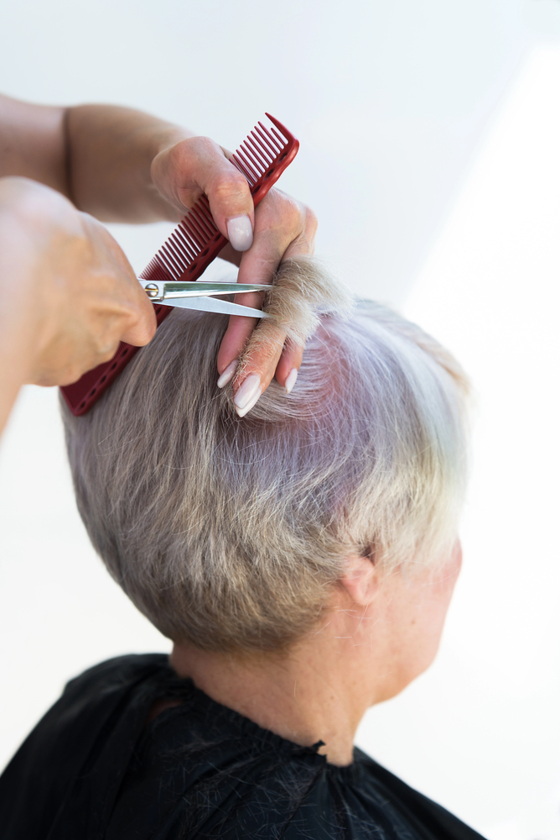

Though we travel the world over to find the beautiful, we must carry it with us or we find 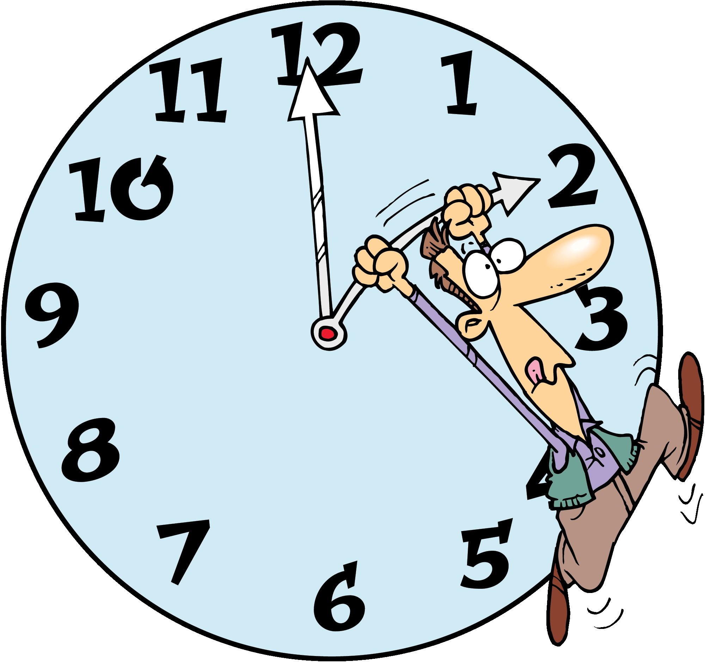it not. ~Ralph Waldo Emerson
"As November 2025 wraps us in cozy stillness, let gratitude light your path—nurture your spirit and shine through the season’s quiet beauty!"
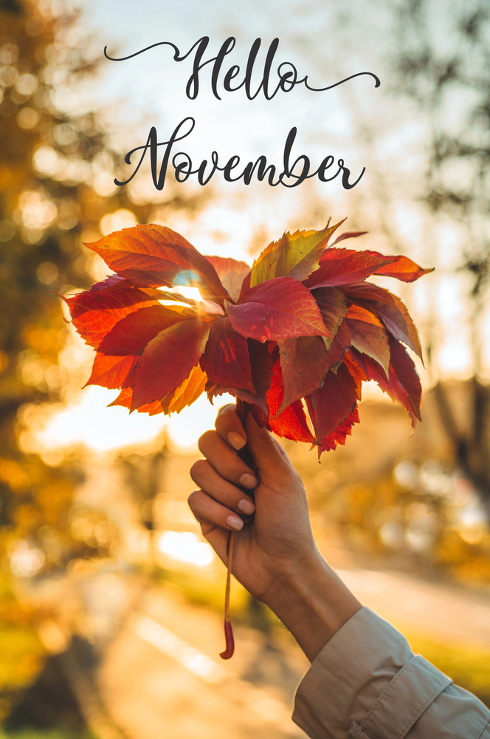
Did You Know Facts – Thanksgiving

November Events

1 - All Saint's Day
1-2 Dia de los Muertos (Day of the Dead)
2 - All Soul's Day - usually on the 2nd
2 - Daylight Savings time ends gain 1 hour of sleep - date varies
7 - U.S. General Election Day - please exercise your right to vote
11 - Veteran's Day
13 - Caregiver Appreciation Day
13 - Sadie Hawkins Day
20 - Great American Smokeout - third Thursday
20 - Universal Children's Day
27 - Thanksgiving Day - fourth Thursday
28 - Black Friday - day after Thanksgiving
29 – Small Business Saturday
30 – Cyber Monday

Plumbers are the busiest the day after Thanksgiving for all those people who overwhelmed the system from dinner.
L

1941 is when congress declared Thanksgiving a national holiday, to be set for the fourth Thursday in November.

CREAM CORN PUDDING
1 can creamed corn
2 Tablespoons sugar
½ cup cream
2 Tablespoons butter, melted
3 Tablespoons flour

Combine all ingredients, slightly mixing. Pour into baking dish. Bake 450°F for 20 minutes

Sweet potatoes

Potatoes
6 medium (about 3 ¹/₂ pounds) orange sweet potatoes cut into 2-inch chunks
3 Tablespoons butter
1-¹/₂ tablespoons firmly packed brown sugar
1-¹/₂ teaspoons ground cinnamon
³/₄ teaspoon salt
¹/₄ teaspoon Pepper

Pecans
1 Tablespoon butter
¹/₃ cup chopped pecans
2 Tablespoons sugar
¹/₄ cup sliced green onions

Combine sweet potatoes and enough water to cover in 4-quart saucepan. Cook over high heat 5-6 minutes or until water comes to a boil. Reduce heat to medium-high. Cook 30-35 minutes or until potatoes are tender. Drain. Cool slightly. Peel potatoes.
- Heat oven to 375°F. Place sweet potatoes and all remaining potato ingredients into bowl. Beat at medium speed, scraping bowl often, until smooth. Spoon potato mixture into lightly greased 2-quart casserole. Cover; bake 20-25 minutes or until heated through.
- Melt 1-tablespoon butter in small nonstick skillet until sizzling; add pecans and sugar. Cook over medium-low heat, stirring constantly, 2-3 minutes or until pecans are golden. Remove from heat.
- Sprinkle potatoes with pecans and green onion, just before serving.

Benjamin Franklin wanted our national bird to be a turkey!

A HEARTWARMING THANKSGIVING IN 2025

As November 2025 unfolds, Thanksgiving Day on November 27 brings a cherished opportunity to pause and reflect. This year, with the crisp air and golden hues of fall, the fourth Thursday of the month invites us to gather with loved ones, share gratitude, and create lasting memories. Rooted in traditions of abundance and togetherness, Thanksgiving is more than a feast—it is a celebration of connection and care.

This holiday, set against the backdrop of a bustling season, offers a perfect moment for self-care amidst the joy. Whether you are hosting a table full of laughter or joining a cozy gathering, take time to nurture yourself. A warm bath, a quiet walk among autumn leaves, or a moment of gratitude journaling can recharge your spirit. For many, the kitchen becomes a haven—preparing that perfect turkey or pumpkin pie can be a soothing ritual.

Let’s make Thanksgiving 2025 a blend of giving and receiving. Share a kind word, lend a hand, or simply savor the company around you. As the day winds down with Black Friday’s excitement looming on November 28, hold onto the peace this holiday brings. Here’s to a season of thanks, health, and harmony!
STRESS AND YOU IN 2025

Stress is a universal reality—and sometimes a helpful one. It sharpens our focus, primes us for action, and sets us apart when we manage it well. But when stress takes over, it becomes an unwelcome force, disrupting our body chemistry, spiking cortisol, and stealing our peace, sleep, and clarity.

Physically, stress can lead to weight gain, sleeplessness, daytime fatigue, cravings for sweets, salts, and fats, and visible signs on our skin and hair. It robs skin of suppleness, inviting wrinkles, while hair may turn gray or thin—changes that can sometimes be irreversible for both men and women.

How can we fight back? Start by tackling the root cause. Identify what’s stressing you and, if possible, address it step by step.

If that is not an option, focus on managing your response. Prioritize self-care: get ample sleep, exercise regularly, eat nutritiously, and take necessary supplements. Then, go deeper—step away from our instant-everything world. Spend time in nature, whether a long wilderness hike or a quiet walk among trees or by water, leaving electronics behind.

Research confirms daily nature time is a proven stress reliever. In 2025, make it a priority—find your spot, be it a backyard or park. Your well-being—and your hair—will thank you.

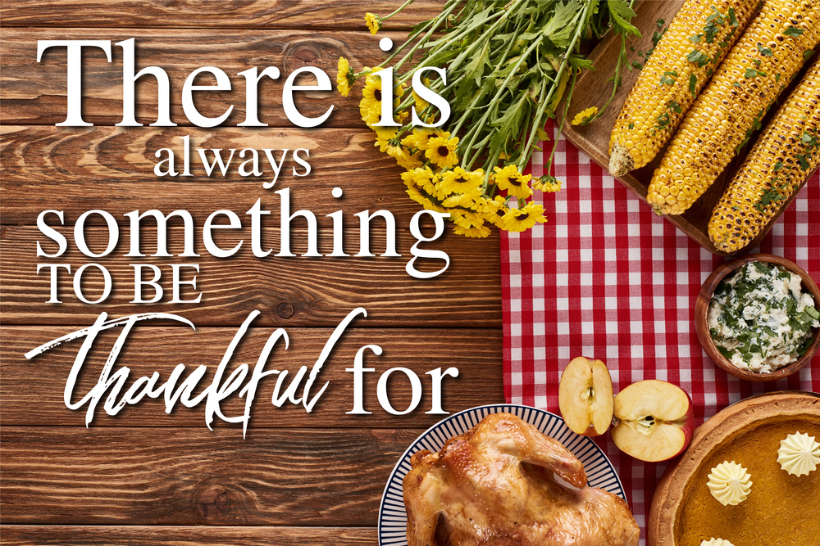



GROCERY
SHOPPING
TIPS FOR
2025
Shop on a Tight Schedule
Hit the store when time is short—focus sharpens, and you will avoid lingering and overspending.
Compare Unit Prices
Look beyond sale tags; the cost per unit reveals the real deal, guiding smarter choices.
Use Cash Only
Leave debit and credit cards at home in 2025 to stick to your list and curb impulse buys.
Opt for Frozen Options
Frozen fruits, veggies, and seafood often match fresh nutrition, offering better flavor and price when out of season—fresh fish might even be frozen anyway.
continued

Choose Store Brands
Save money with store-label items, often as quality as name brands at a lower cost.

Go Solo
Shop alone to avoid kid-driven extras that inflate your 2025 grocery bill.

Scan Top and Bottom Shelves
Eye-level items are priciest—check higher and lower for budget-friendly finds.

Maximize Your Loyalty Card
Leverage rewards to stretch your dollars further this year.

Ask the Butcher for Sale Days
Inquire about quick-sale items to snag deals now or freeze for later.

Preview Weekly Specials
Review the ad before shopping—know that not all circled items are on sale, so track your prices!

678-786-3281



This area can be used either for the address of your customers. All you have to do is to print labels, paste them here after you’ve put in your return address.

The Newsletter can then be folded in thirds, stapled or adhered with special round stickers available at an office supply store to allow the letter to go through the postal machines with a minimum of effort. A two page newsletter will require postage of a first class letter.

If you do not wish to mail this, then this space can be used for additional information specific to your salon.

