Salon News
December 2025

SAY GOODBYE TO DRY SKIN AND HAIR

Winter weather can make your skin and hair look and feel like an alligator. Cold temperatures and winds, along with outdoor activities, contribute to uncomfortable flakey and dry skin. It can also really damage your hair. Here are some tips on what you can do...
1. A hot shower on a cold morning sounds great, but that is not the best idea. In fact, hot water will dry out your skin and hair, leaving skin dry and scaly and hair looking dull. Instead, take a shorter warm shower, no more than ten minutes.
2. When done with the shower or washing your hands, apply cream or lotion to your freshly dried skin. Your hands will dry out with all the soap and/or alcohol-based hand sanitizer too. Have your stylist help you choose a hair conditioner for the winter months.
3. When choosing a skin lotion, read the ingredients. Look for creams or lotions with ingredients such as ceramides, urea, lactic acid and dimethicone.
4. Having the heat on will dry out your skin and hair as well. Use a humidifier in your office or home to add moisture to the air.
5. What you wear actually matters. Cotton is a soft natural fabric that will not irritate your skin. You can wear a thin cotton layer under your clothes. Protect your hair from wind.
6. Always use sunscreen. You can find moistures that include sunscreen with an SPF 15 or higher for daily use and SPF 30 for recreational use. This is true even during the winter.
7. Remember that your scalp is part of your skin. Dry scalp problems sometimes require a different shampoo or conditioning treatment. Talk with your stylist about the best solution for your situation.
8. Your skin is your largest and most protective organ. Take good care of it.




Though we travel the world over to find the beautiful, we must carry it with us or we find 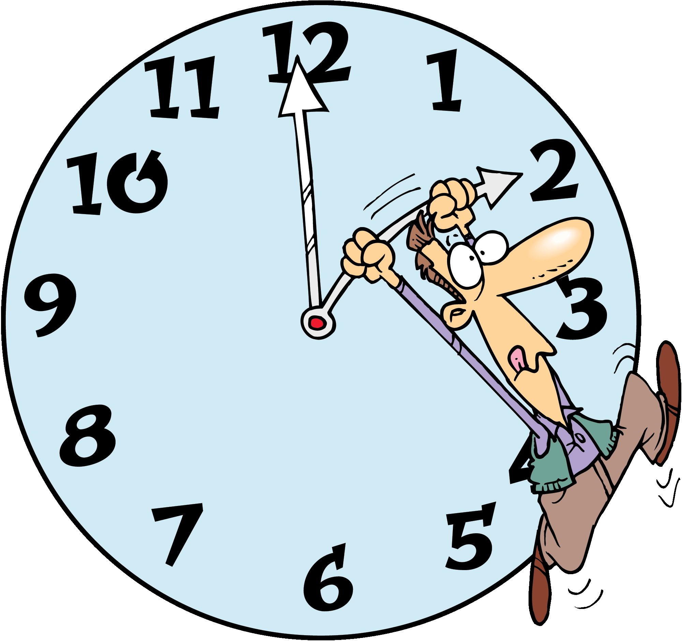it not. ~Ralph Waldo Emerson

"As December 2025 wraps the world in twinkling lights and cozy nights, let gratitude and self-care light your path—shine bright through the season’s magic!"
Did You Know Fun Facts – New Year’s Eve

December Events

7 - Pearl Harbor Day
14 - Chanukah lasts 8 days
12 - Poinsettia Day
21 - Winter Solstice (shortest day of the year)
23 - Festivus – for the rest of us!
25 - Christmas
26 - Boxing Day – date can vary
26 - Kwanzaa
27 - National Fruitcake Day
31 - New Year’s Eve



The First New Year’s Eve celebration was over 4,000 years ago. Julius Caesar was the first to declare Jan. 1 a national holiday.
L

About 1 million people gather in New York City’s Times Square to watch the ball drop.

Salmon Cheese Log Recipe

Ingredients

16 oz. salmon (drained and flaked)
8 oz. cream cheese, soften
1 TBL lemon juice
1 tsp. prepared horseradish
2 tsp. grated onions
¼ tsp. salt
¼ tsp. Worcestershire sauce
½ cup chopped pecans
3 TBL fresh parsley
Crackers

Preparation

Place all ingredients except pecans, parsley and crackers in a medium bowl. Mix completely. Form into a log or ball.

Place pecans and parsley on wax paper, roll log in mixture until coated.
Cover and chill 2 hours.
Serve with crackers.


Top Resolutions are: to lose weight, get organized spend less money, save more money, stay fit and healthy and quit smoking.

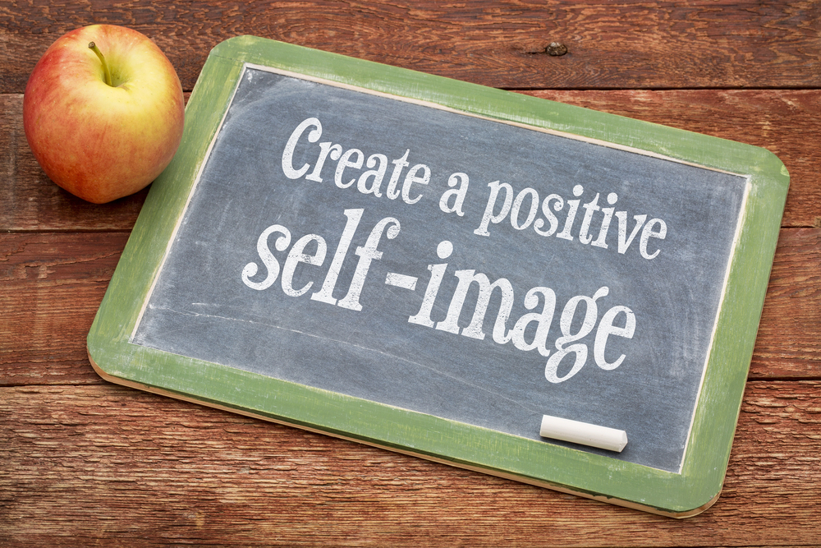

WHAT IS SELF-IMAGE?

Self-image is the mental picture we hold of ourselves, shaped by our own beliefs and those projected onto us by others. Once accepted, these ideas—true or not—become woven into our identity.

It is a mosaic of experiences: how we interpret words, actions, and our inner dialogue. Everything from the car we drive, the job we hold, the clothes we wear, to the relationships and lifestyle we choose reflects this image we present to the world.

Notice what you wore today, how you styled your hair, or whether your shoes shine. These choices stem from a deep-seated belief about who you are—whether authentic or an idealized version you think the world demands.

A belief is simply something we accept as true, even if it is not.

Most beliefs form in childhood, absorbed from family, friends, teachers, and authority figures we trust.

We adopt their words as truth, letting them root deeply, shaping attitudes and life experiences. Over time, they harden into core beliefs—resistant to change.

But are they your truth?

Imagine being told you would never be a good dancer.

Many carry that label lifelong. Yet what if you took a class? Challenged the story?

Countless people have become exactly what others said they couldn’t—by questioning the belief.

Awareness is power.

When you recognize limiting beliefs, you can rewrite them—and transform your life.

Is your self-image accurate? Or is it quietly holding you back?






FINANCIAL TIPS FOR 2026

A recent study shows the average U.S. college student answers only about a third of basic financial questions correctly. Even if you are not paying bills or working full-time yet, building financial knowledge and good credit now sets you up for life. Here are smart habits to start today:
Build Credit Responsibly.
Use credit to create a strong history—open a basic card in college and pay it off monthly to boost your score.
Create a Budget.
Track discretionary spending (clothes, food, fun) with a spreadsheet or app to curb impulse buys and stay in control.
Understand Student Loans.
Know subsidized (interest-free while in school) vs. unsubsidized loans. Research forgiveness programs for public service roles like teaching or military.

Guard Against Identity Theft.
Lock devices with passwords or biometrics, especially on public Wi-Fi. Change email passwords regularly.
Avoid Bank Fees.
Choose accounts matching your habits—big banks may charge $4+ for out-of-network ATMs. Read the fine print.
Leverage Tech for Savings.
Apps like Acorns round up purchases to invest spare change; Digit analyzes spending and saves small amounts automatically in an FDIC-insured account.
Curate Your Social Media.
Posts last forever—recruiters check profiles. Avoid content involving alcohol, drugs, or profanity to protect future job prospects.
Financial independence grows with patience and practice. Start now!



678-786-3281

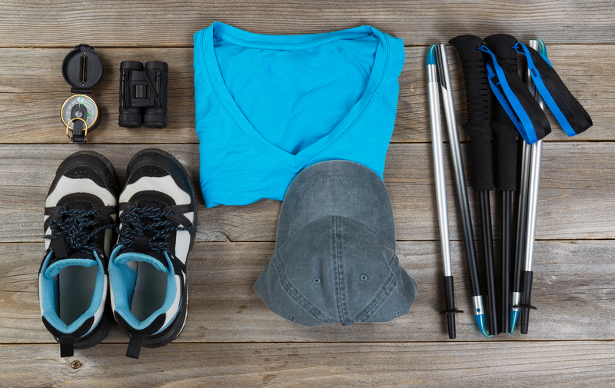

This area can be used either for the address of your customers. All you have to do is to print labels, paste them here after you’ve put in your return address.

The Newsletter can then be folded in thirds, stapled or adhered with special round stickers available at an office supply store to allow the letter to go through the postal machines with a minimum of effort. A two page newsletter will require postage of a first class letter.

If you do not wish to mail this, then this space can be used for additional information specific to your salon.

