Salon News
January 2026

Trouble with Fine, Thin Hair?
Some of us are born with fine, thin hair. Some of us discover that our hair seems to be thinning for no apparent reason. The truth about human hair is that as we age, our hair goes through three stages of growth. Number one is a transition phase, the next is transition phase, and finally the resting phase. In our youth, all phases are well balanced. As we age, however, we spend more time in the resting phase.
What does this mean for us? That as we age, we shed hair faster than it is growing back in. For women, unlike men, this means that we see a gradual thinning of our hair all over our scalp. In addition, women experience fluctuating hormones throughout their lives, which means that our hair can become lush and full, and other times it seems dull, thin, and lifeless. The good news is that you don’t have to put up with that.
The hair industry constantly researches the needs of their clients and come up with a variety of products that help hide thinning hair problems. The very best place to get advice is to talk to your stylist. You may notice that each time you visit, your stylist will try different products to give you the best result for your current cut. Not all stylists push the products. If you are particularly happy with how your hair behaves right after an appointment, be sure to talk to your stylist and ask about the products used on your hair and how to use them.
Typically, the products will create either a bit of friction, or even more dimension on the shaft of the hair. You might see things like “beach look” or “salt/sea water” which is one of the first products you might consider using. Depending on the product you select, you may use it either before or after drying the hair. These products provide a lot of lift, and as mentioned, friction. This means that when you do a little “teasing” of the hair, your hair retains the lift you envision.
Another choice is a styling powder. This is applied after the hair is dried, at the roots of the hair. Be sure to gently rub it into your scalp so no tell-tale white powder remains. Some people don’t like this as it gives your hair a “cotton-candy” feel. But your style has the holding power you just can’t beat!
Talk to your stylist about your current issues. Our hair changes throughout our lives. Keep looking smart and groomed by knowing what your hair currently needs today.




Though we travel the world over to find the beautiful, we must carry it with us or we find 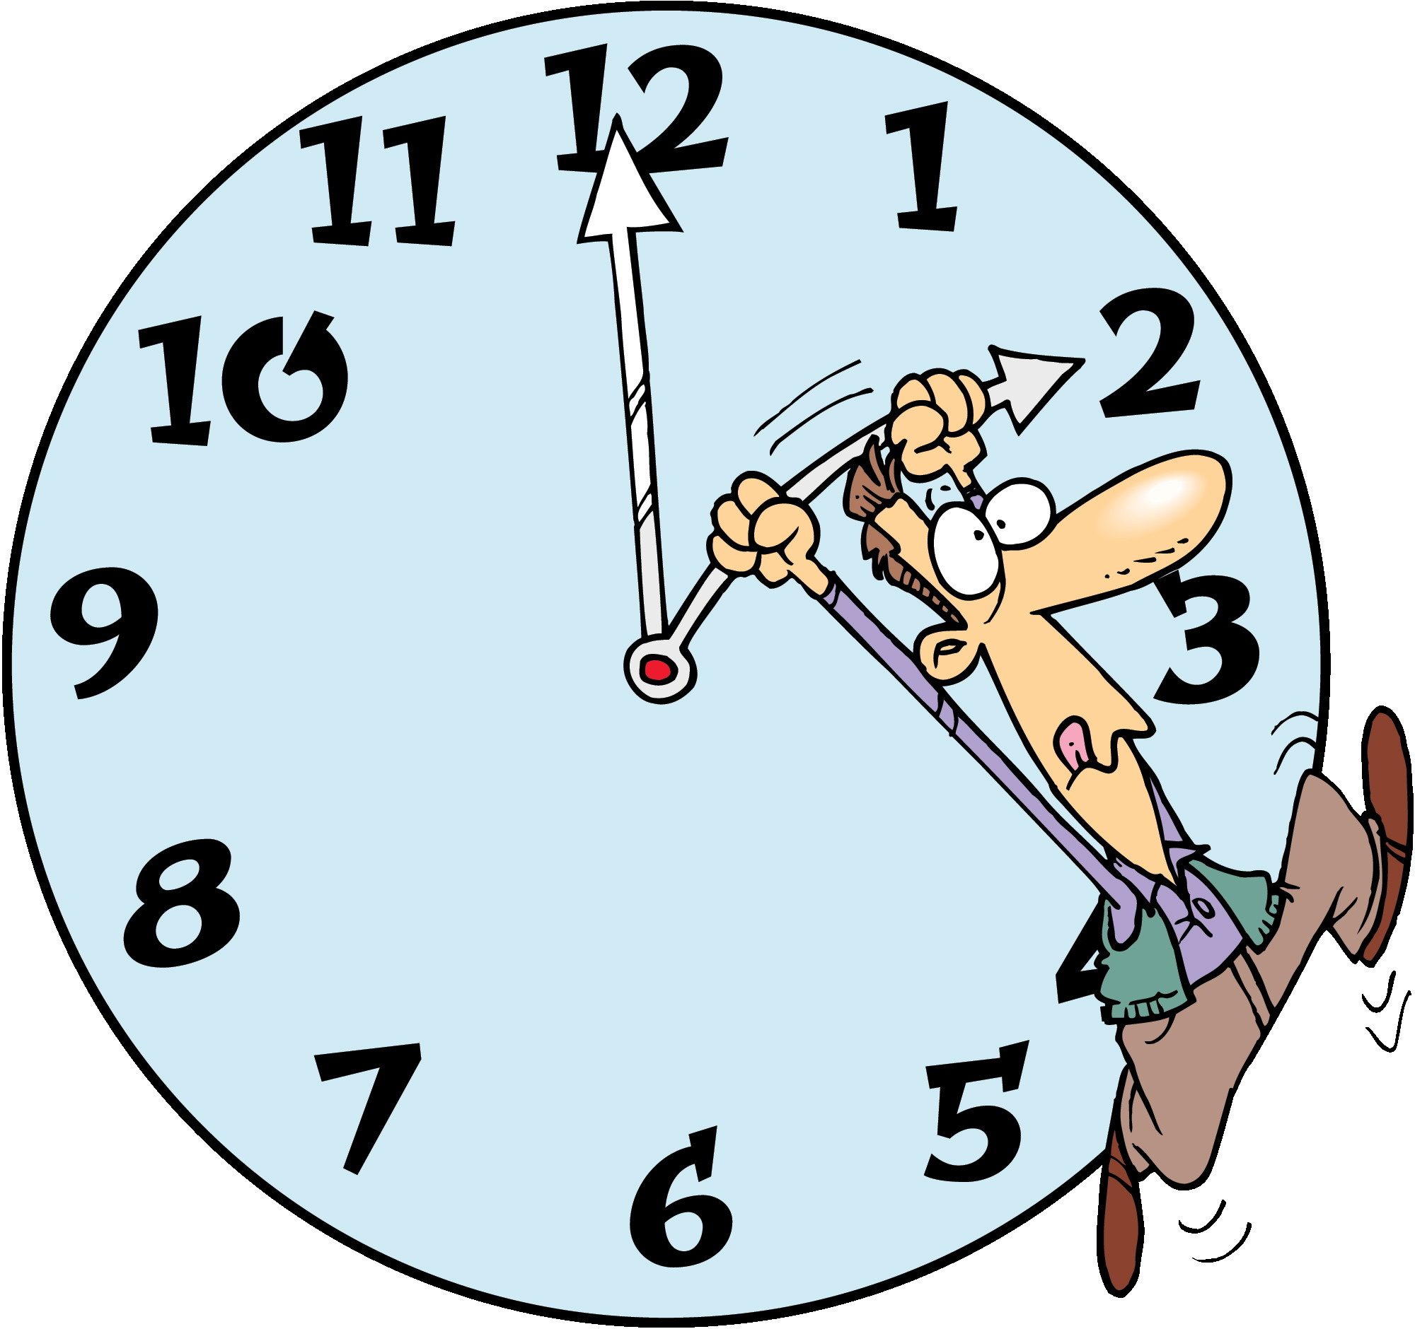it not. ~Ralph Waldo Emerson
`

RECIPE OF THE MONTH

EGG NOG FRENCH TOAST

INGREDIENTS:
8 eggs
2 cups eggnog
1/4 cup brown sugar
1/2 teaspoon vanilla or rum extract
20 to 26 slices bread
Confectioners' sugar, optional
Maple syrup

DIRECTIONS:
In a bowl, beat eggs, eggnog, sugar and extract; soak bread for 2 minutes per side. Cook on a greased hot griddle until golden brown on both sides and cooked through. Dust with confectioners' sugar if desired. Serve with syrup.

TOTAL TIME: Prep: 10 min. cook: 30 min.
Serves: 8-10.
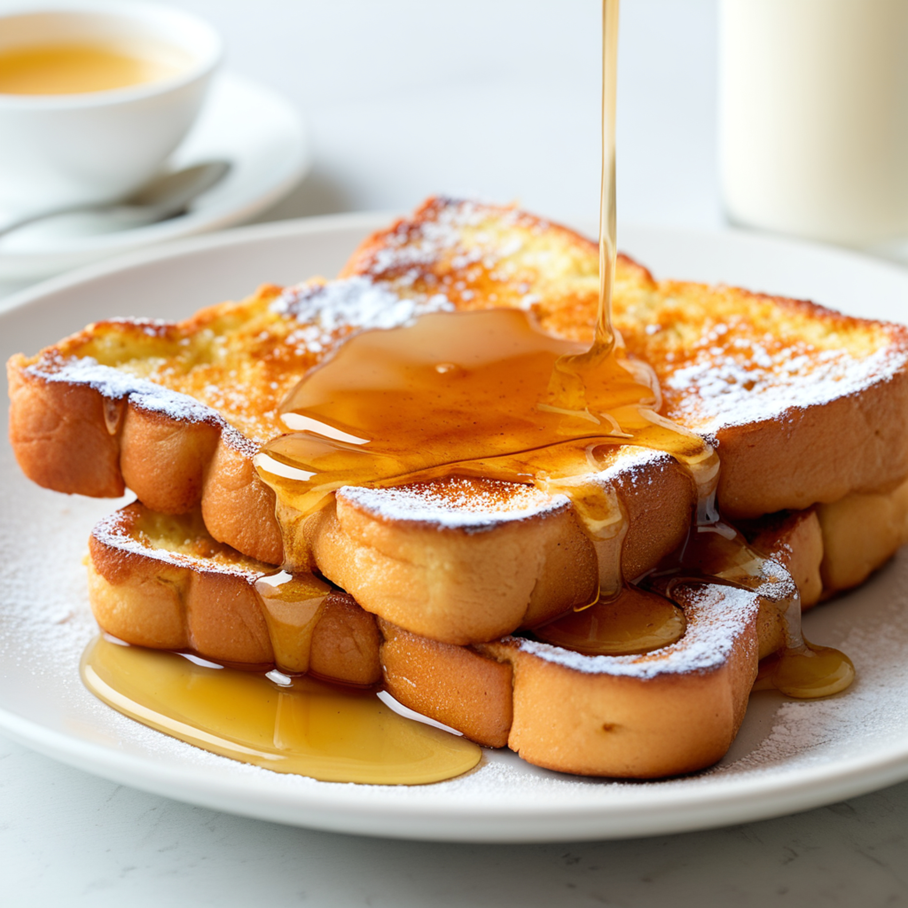

January Events

1 - New Year’s Day: Welcome 2026 with fresh beginnings and celebration!

4 - Trivia Day: Test your knowledge and have fun with fascinating facts.

5 – National Bird Day: Celebrate our feathered friends and raise awareness about birds.

6 – Feast of the Epiphany / Three Kings Day: Marks the traditional end of the Christmas season with gift-giving and reflection.

10 – Houseplant Appreciation Day: Give your green companions some love—perfect for brightening winter days.

19 – Martin Luther King Jr. Day: Celebrated on the third Monday in January (January 19 in 2026), honoring the legacy of equality and justice.

25 – Opposite Day: Say one thing and mean another—just for fun!

26 – Australia Day: A national day of celebration Down Under—perfect for summer vibes in the Southern Hemisphere.
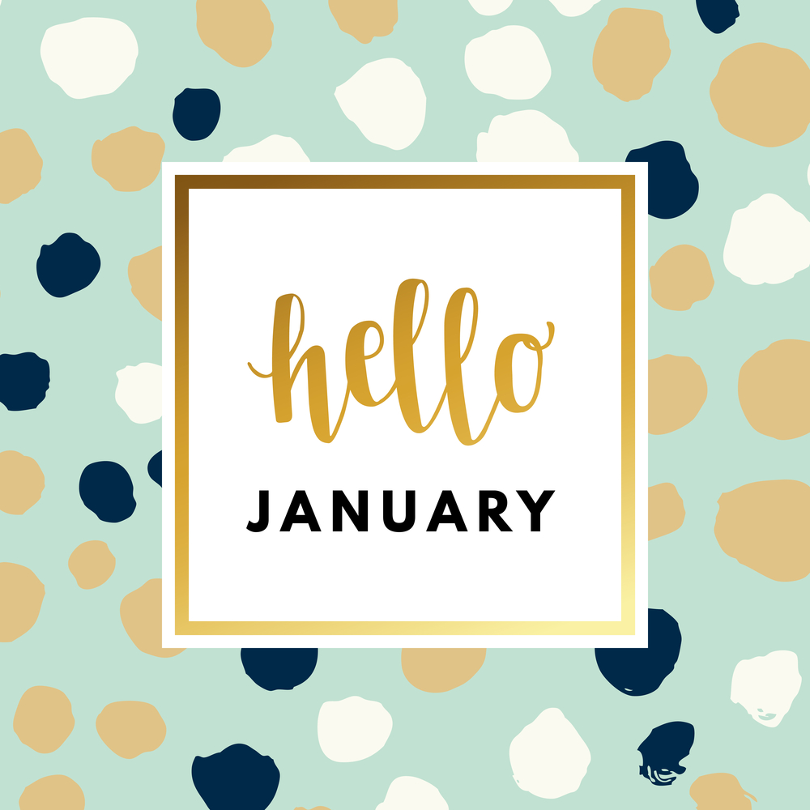
L

"January 2026 whispers fresh beginnings—let the new year renew your spirit and light up your glow like the first sunrise of the year."

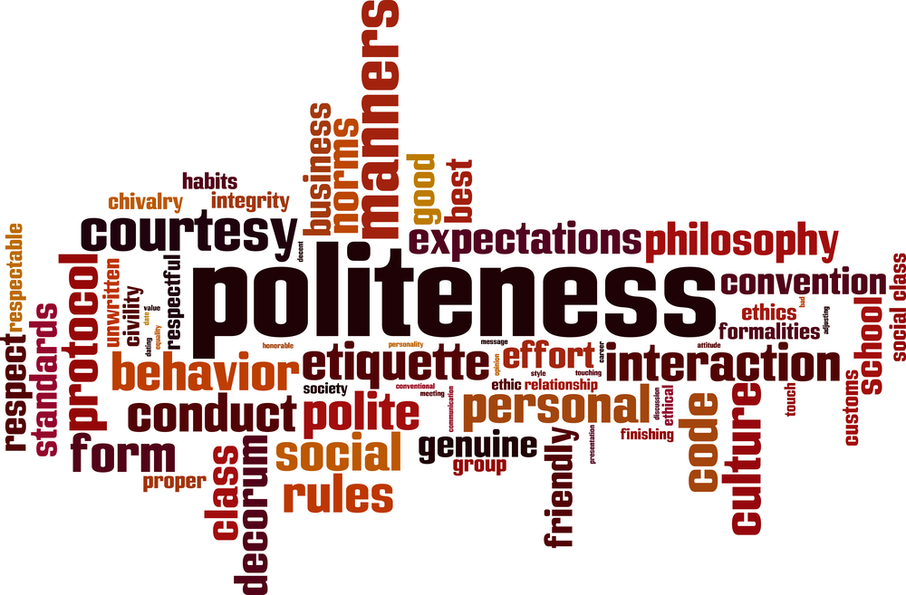

The Power of Relationships

“No man is an island.” – John Donne.

We might fantasize about hiding away in a cave sometimes, but life doesn’t work that way. From the grocery line to the highway, every day we depend on others to follow the same basic rules of courtesy.

Yet things fall apart fast: someone cuts you off, grabs the last checkout spot with one item while you’re juggling a full cart. The instinct is to fire back. It feels good for a second—until you realize you might need that very person someday.

Picture this: a family racing to Disney World gets cut off at the gate. Horn blaring, rude gesture flying. Days later, the dad discovers the driver was the hiring manager for his dream job. Spoiler: he didn’t get it.

In 2026, connections still open doors. Jobs, favors, kindness—they all travel through relationships. Basic manners aren’t just polite; they’re smart. The next time frustration rises, pause. That stranger might be a future colleague, neighbor, or friend. Choose grace. Your network—and your peace of mind—will thank you.

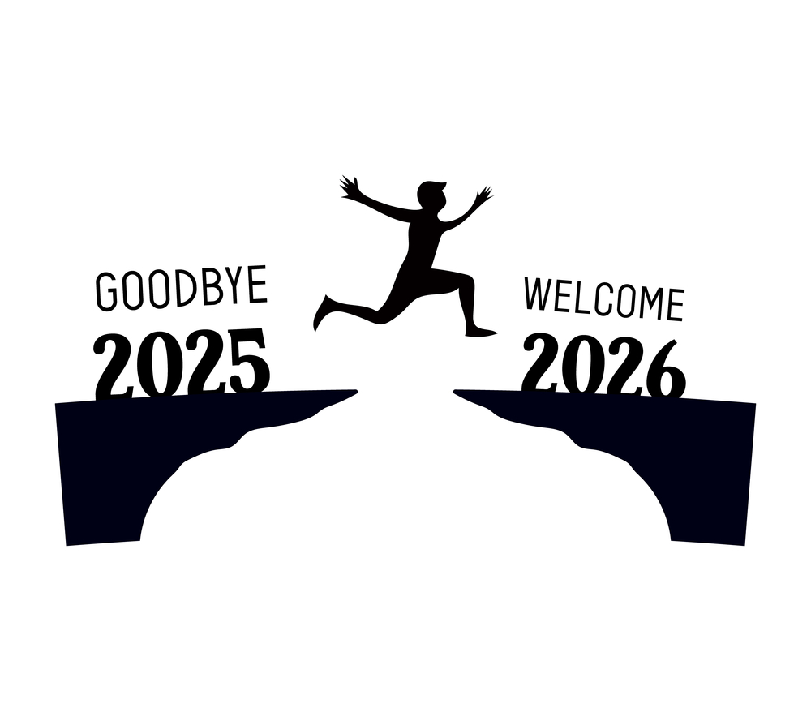


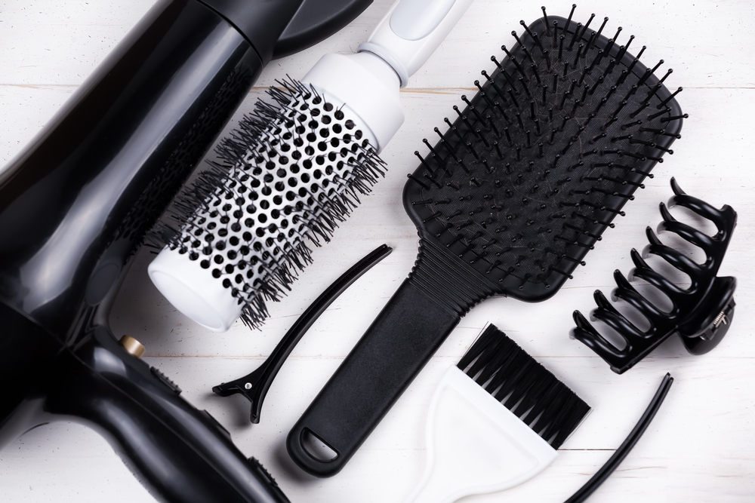

NEW YEARS RESOLUTIONS
This year, be kinder to yourself when you set resolutions. Big, dramatic overhauls rarely stick. Tiny, gentle changes do.
Pick ONE small habit you can keep every single day. Something so easy it almost feels silly:
* Drink an extra glass of water.
* Take three deep breaths when you wake up.
* Stand up and stretch every hour.
* Smile at yourself in the mirror each morning.
The secret? Make it enjoyable. Add a dash of fun or humor—turn it into a little game. When you smile at your reflection and think “Hey, gorgeous,” you’re already winning.
Small steps + daily joy = real, lasting change.
Here’s to a lighter, brighter 2026—one gentle habit at a time.

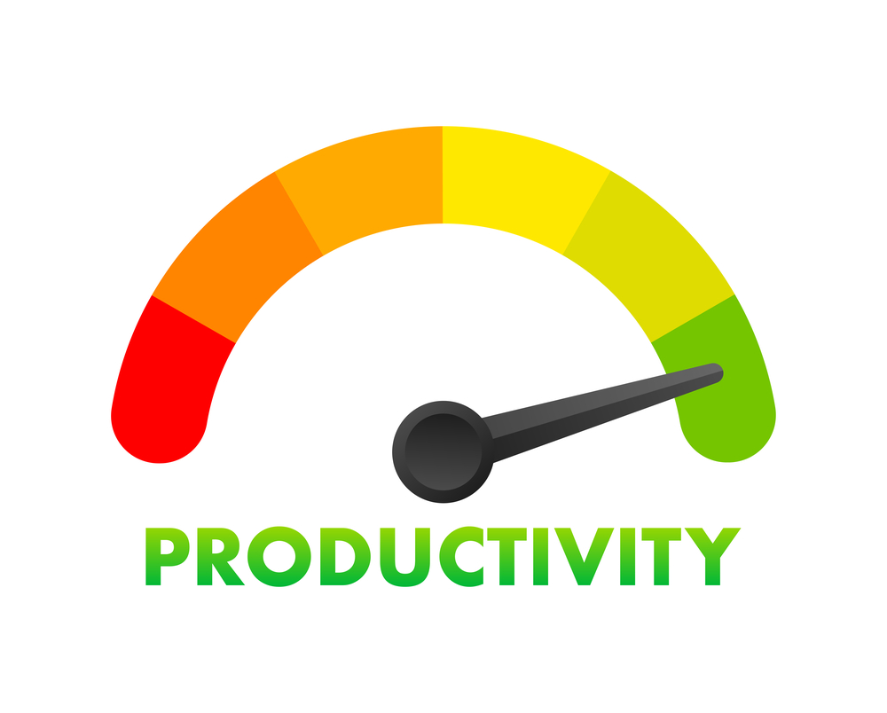

Double Up on Workouts – 30 minutes in the morning + a quick evening session = unstoppable momentum.

Hydrate – Dehydration drains energy and focus. Keep water close all day.

Beat the Crowds – Shop, run errands, or schedule appointments during off-peak times.

Maximize Commute Time – Listen to audiobooks, podcasts, or return calls—turn “lost” time into growth time.

Do It Right the First Time – Stay focused and minimize rework.

Protect Your Creative Time – Block uninterrupted moments for yourself daily—zero distractions, maximum results.

Here’s to a powerful, productive 2026!

TIPS TO BOOST PRODUCTIVITY

Ready to make 2026 your most productive year yet? These simple, proven strategies will help you work smarter and achieve more:

De-clutter Everything – Clear physical and digital mess (desk, inbox, phone). A tidy space = a calm, focused mind.

Batch Email Checks – Limit to twice daily (morning + afternoon). Protect your peak energy hours for deep work.

Knock Out Small Tasks Fast – If it takes under 5 minutes, do it now. Clear the little stuff and free your mental bandwidth.

Distance from Negativity – Surround yourself with positive, supportive people who lift you up.

Stick to a Daily Routine – Consistency beats luck every time.

Start Early – The quiet morning hours are pure gold for high-impact work.

Learn to Say No – Protect your time and energy—every “yes” to something unimportant is a “no” to your priorities.

Single-Task – Multitasking kills efficiency. Focus on one thing at a time and watch your output soar.

Move Your Body – Exercise fuels energy, sharpens focus, and sparks creativity.

678-786-3281

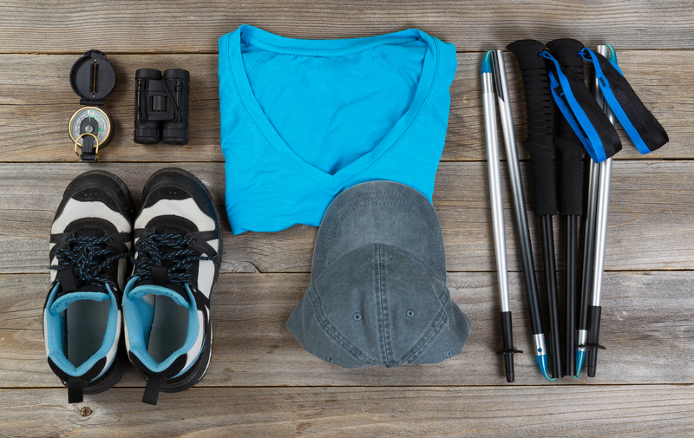

This area can be used either for the address of your customers. All you have to do is to print labels, paste them here after you’ve put in your return address.

The Newsletter can then be folded in thirds, stapled or adhered with special round stickers available at an office supply store to allow the letter to go through the postal machines with a minimum of effort. A two page newsletter will require postage of a first class letter.

If you do not wish to mail this, then this space can be used for additional information specific to your salon.

