Salon News
March 2026

BEAUTY IDEAS

We all love beauty tips. Here you will find useful beauty ideas and guides that you can implement in your everyday life.

For your hair, be sure to communicate with your hairstylist. Be direct when telling your hairstylist what you want and bring photos from magazines of styles you like.

- Brush hair from roots to ends nightly. This distributes natural oils throughout the shaft and gives hair a healthy sheen.

3. For beautiful brows, soften skin before tweezing by dabbing with a cotton ball soaked in warm water or cream.

4. Reduce puffy eyes by splashing with cold water or applying a cold compress in a wash cloth 15 seconds on, 15 seconds off.

5. To get eye shadow to stay on your lids by priming your lids with moisturizer. Also use a primer to keep your foundation from fading.

6. Get lips soft and smooth by using a damp, warm washcloth at night to rub off the flaky dry bits and then follow up with a coat of lip balm.

7. For lipstick to last longer, after applying it to your lips, let it set, then blot lips with a tissue and the dust your lips with powder and they apply another layer.

8. Don’t forget to moisturize. Use a good moisturizer to balance out water and oil levels.

Small habits, big results—pick one or two to start today!

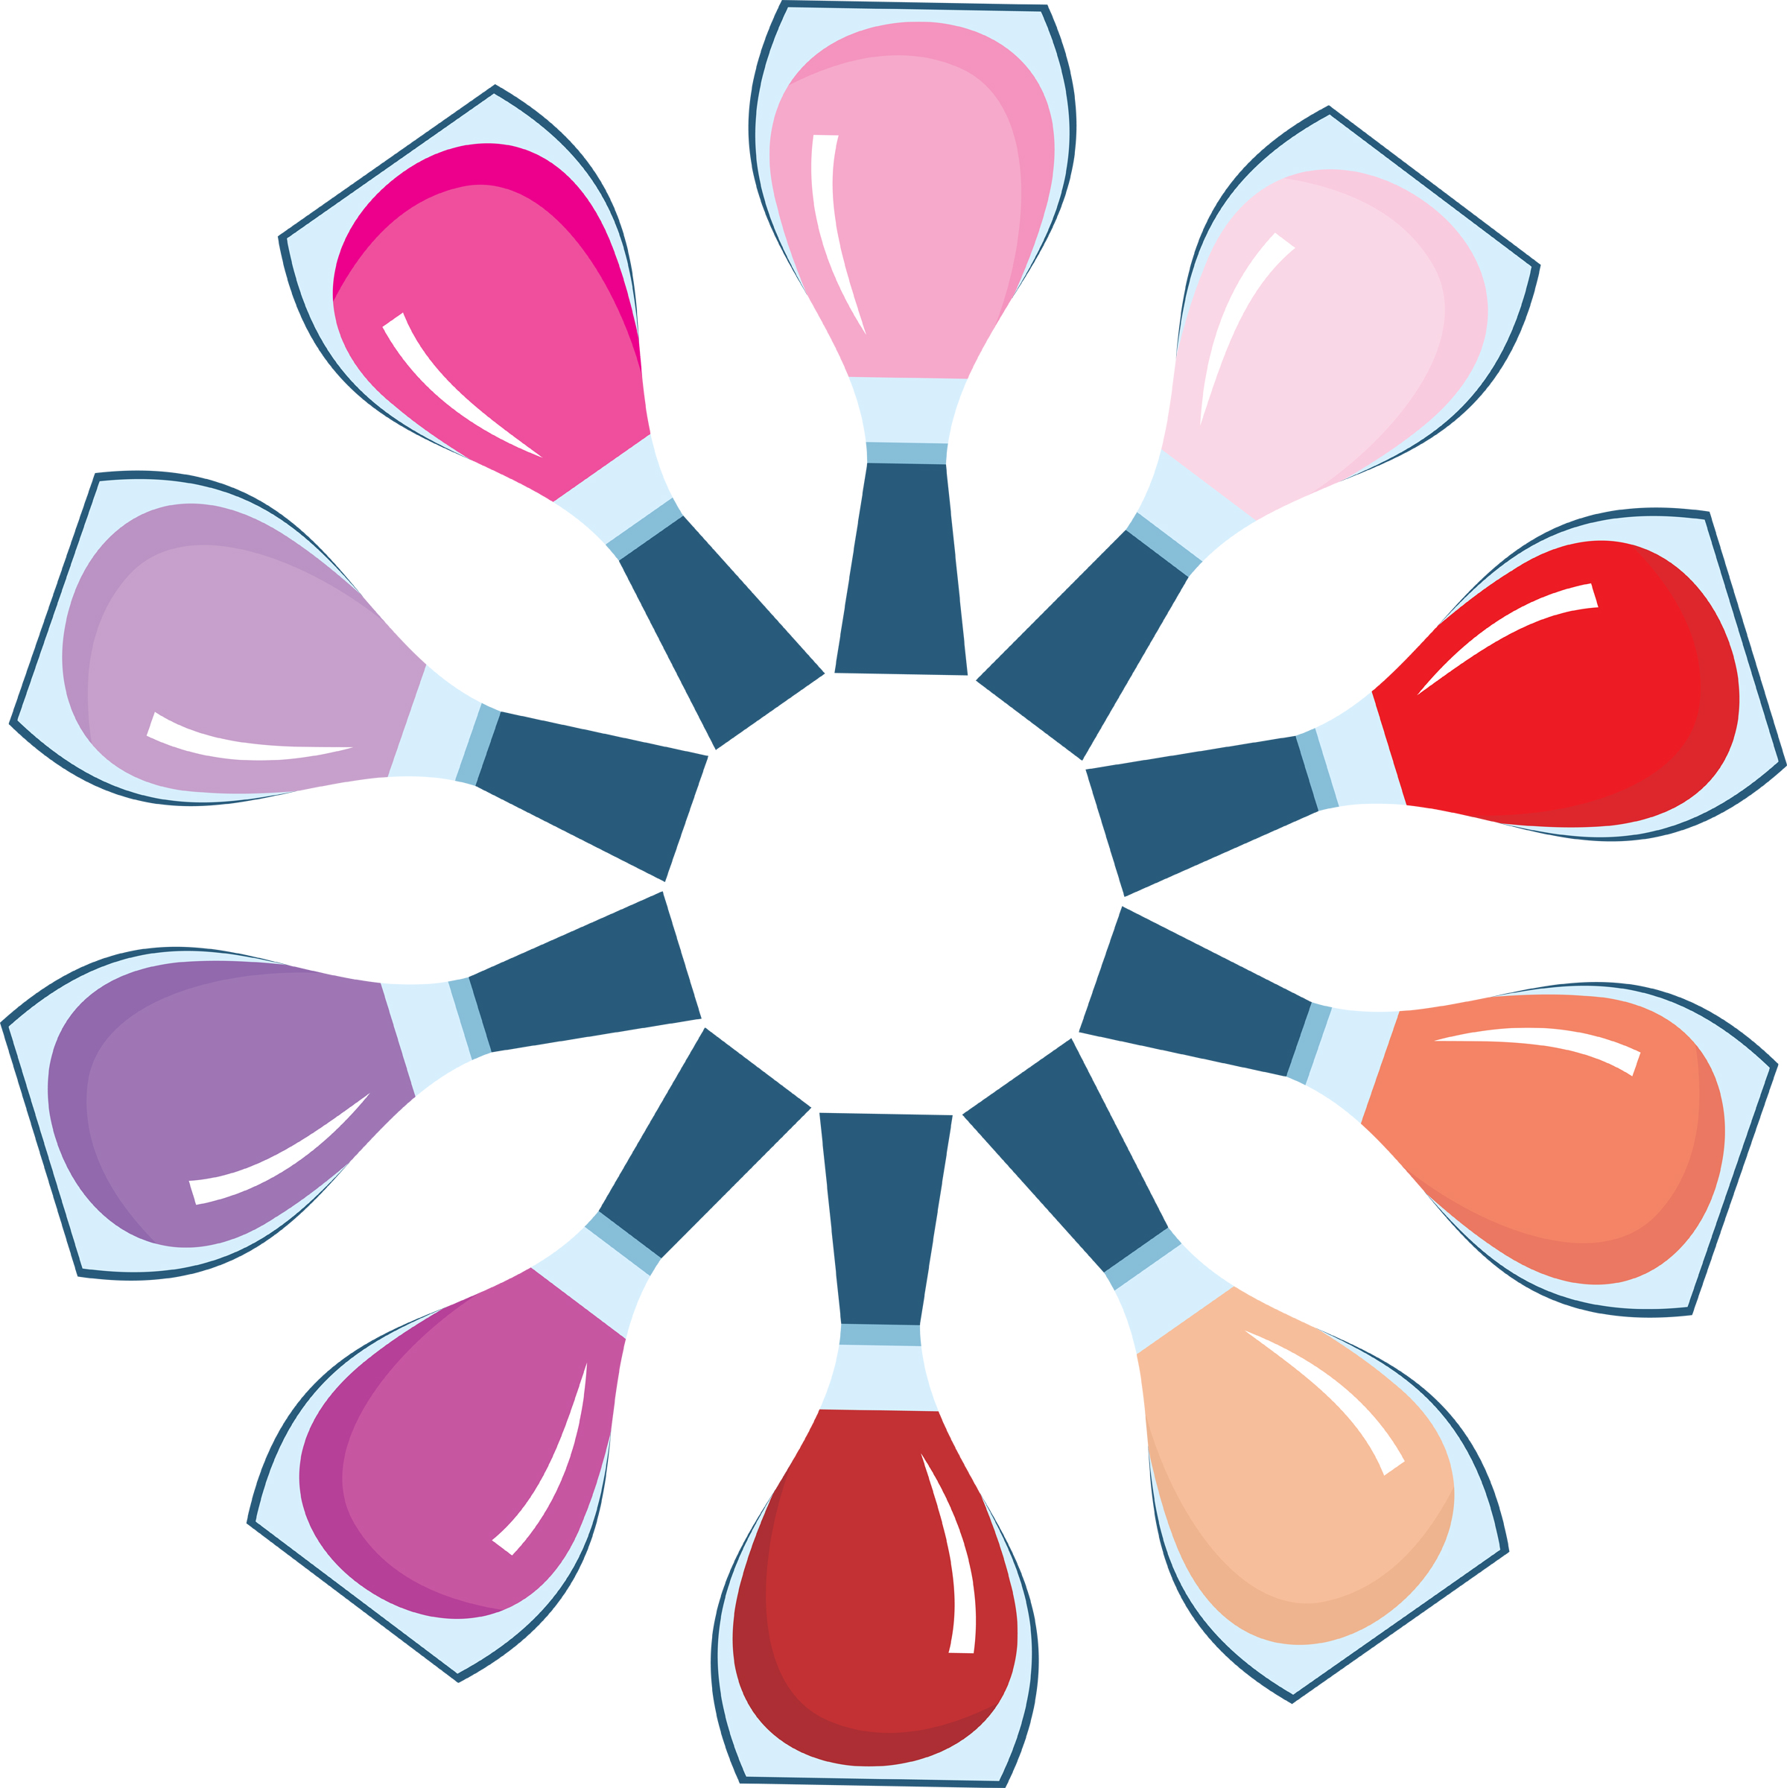


Though we travel the world over to find the beautiful, we must carry it with us or we find 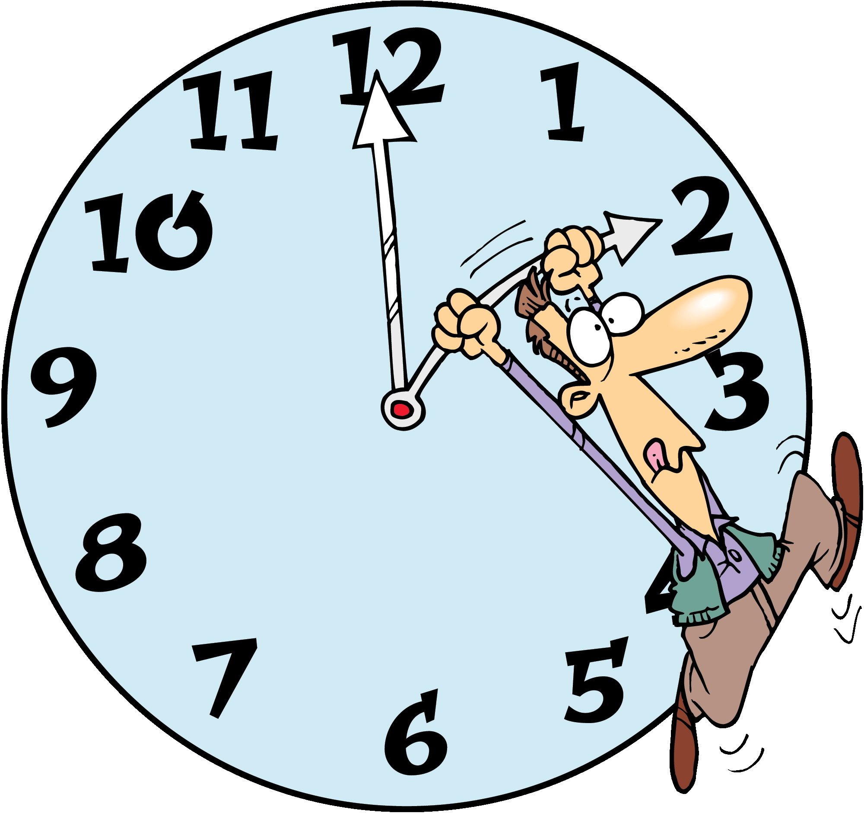it not. ~Ralph Waldo Emerson

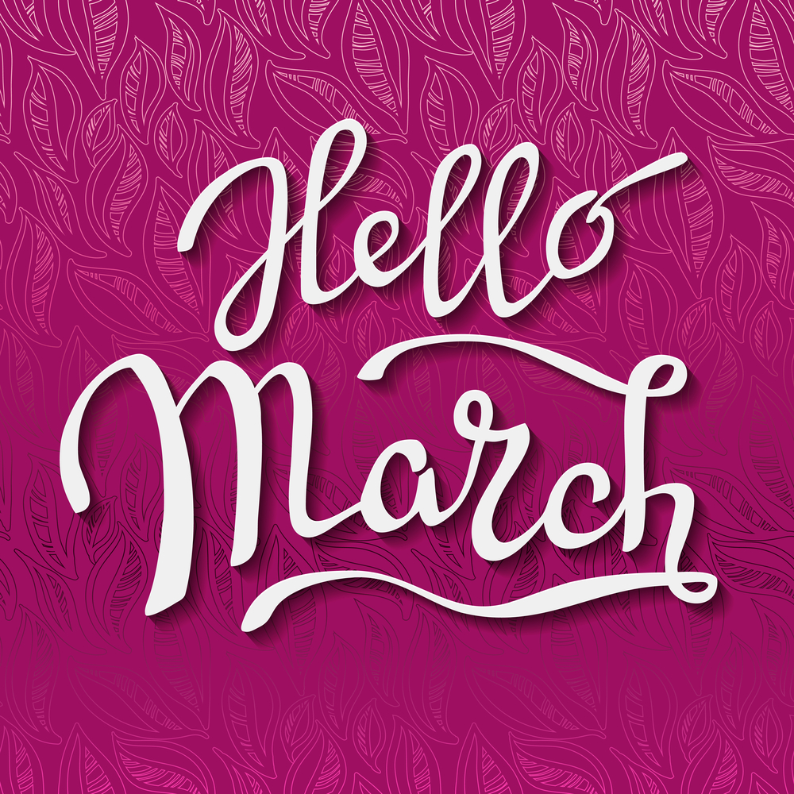
March Events

7 - Ides of March
8 - International Women’s Day
8 - Daylight Savings begins at 2:00 a.m. – date varies
8 - Oscar Night 2024 – the date varies
11 - Ramadan begins
17 - St. Patrick’s Day
20 - Spring (Vernal) Equinox – the date varies
20 - International Earth Day – also called Sun-Earth Day
24 - Palm Sunday – the date varies
24 - Purim begins at sundown
25 - Feast of the Annunciation
27 - Good Friday – the date varies
29 - Easter Sunday – the date varies
"March 2026 arrives like a quiet promise—spring whispers beneath the last of winter’s frost. Let renewal begin within: breathe deeply, care gently, and allow your own beauty to bloom again."
Did You Know Random Fun Facts – St. Patrick’s Day

St. Patrick was not Irish. He was from Wales.
L

The Shamrock and the Harp are both symbols of Ireland.

Irish Soda Bread

4 cups flour

4 tablespoons white sugar

1 teaspoon baking soda

½ teaspoon salt

½ cup butter, melted

1 cup buttermilk

1 egg

(top)

¼ cups butter

¼ cup buttermilk

Preheat oven 375°. Grease large baking sheet.

In a large bowl, mix together flour, sugar, baking soda, baking powder, salt, and ½ cup melted butter. Stir in egg and one cup of buttermilk. Turn dough onto a floured surface and knead. Form dough into a round and place on prepared baking sheet. In a small bowl, combine the ¼ cup butter and ¼ cup buttermilk. Brush loaf with this mixture. Mark an X on the top of the loaf with a knife.

Bake in preheated oven for about 45 to 50 minutes. After 30 minutes, insert toothpick into center of the loaf and see if it comes out clean. Continue brushing loaf with the butter mixture while it bakes.

For many years blue was the color associated with St. Patrick’s Day. Green was considered unlucky.

INTERNATIONAL WOMAN'S DAY 2026: CELEBRATING STRENGTH, PROGRESS & SELF-CARE
Every year on March 8, the world pauses to honor International Women’s Day—a global celebration of women’s achievements, resilience, equality, and contributions across every field. In 2026, the official theme continues to evolve around “Accelerate Action,” urging faster progress toward gender parity in workplaces, leadership, health, education, and beyond.
The day originated over a century ago, rooted in labor rights, suffrage, and equality movements. Today it’s both a joyful tribute and a powerful reminder: while we’ve made strides, women still face unequal pay, underrepresentation in leadership, disproportionate caregiving burdens, and safety challenges in many parts of the world.
For those of us in the beauty and wellness space, International Women’s Day is also a perfect moment to celebrate self-care as an act of empowerment. When a woman feels good in her skin, her hair, her body—it radiates confidence. A fresh cut that frames her face just right, a hydrating facial that brings back her glow, a manicure that makes her smile every time she looks down—these small rituals are quiet affirmations: “I am worth the time and care.”
This March 8, whether you are raising a glass with friends, attending a local event, posting words of encouragement, or simply treating yourself to something that makes you feel beautiful and strong—do it unapologetically.
Because lifting women up (including the one in the mirror) is how real change keeps moving forward.
Happy International Women’s Day.
Here’s to every woman who’s ever dared to take up space, speak her truth, and keep shining.

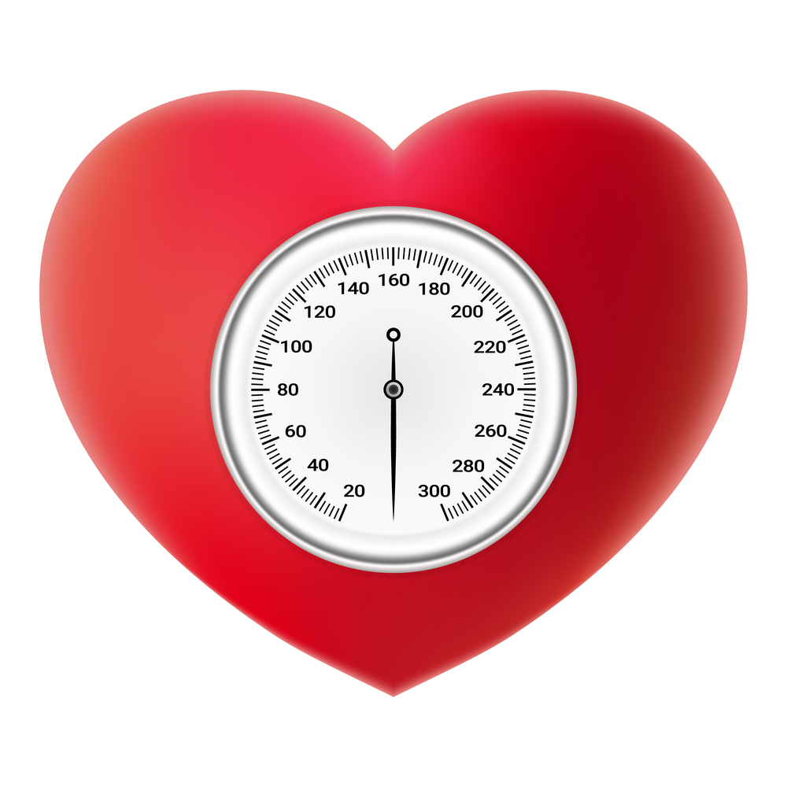

BLOOD PRESSURE MAINTENANCE

According to the Center for Disease Control and Prevention, about one in three U.S. adults have high blood pressure. Most high blood pressure happens when arteries get plugged up by a waxy plaque.

Many factors impact high blood pressure: too much salt, stress, smoking, processed foods, obesity, and other factors. High blood pressure can lead to strokes, eye and kidney damage, and heart disease.

Here are a few ways to help lower your blood pressure.

- Lose weight.
- Exercise more.
- Eat less salt. Read labels and don’t add extra salt.
- Eat fruits, vegetables and low fat dairy.
- Reduce alcohol intake.
- Quit smoking.
- Cut down on caffeine.
- Reduce stress.
- Monitor blood pressure and discuss the results with your doctor.
- Meditative practices such as biofeedback, breathing techniques, yoga, and mindfulness practices.

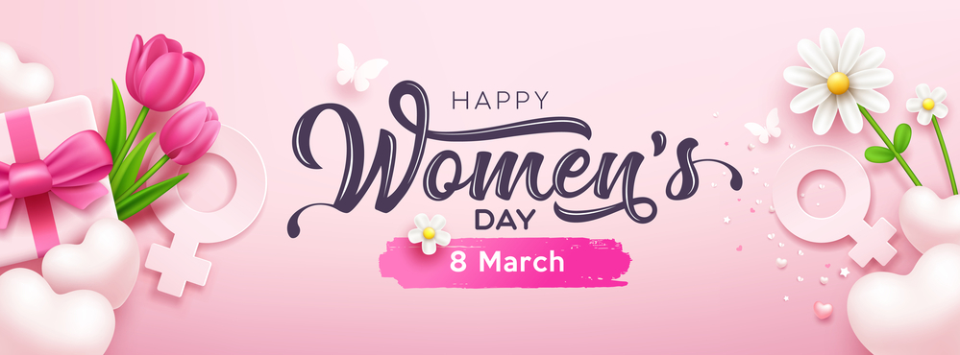

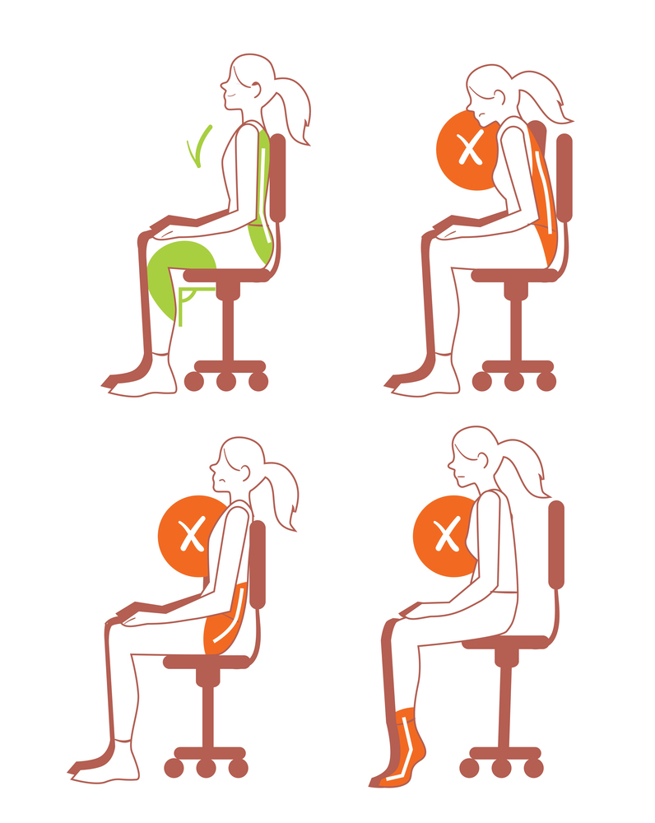

WATCH YOUR POSTURE

We’ve all had someone, mom, dad, ballet instructor, tell us, “Stand up straight!” But have you ever wondered WHY it is important? Good posture is more important than just looking good by standing up straight. For one thing, you immediately look about ten pounds lighter. And while slouching seems to “feel” good, it puts a lot more stress on our muscles, tendons, bones, and internal organs.
By slouching or hunching one of the first problems we experience is reduced respiration. Sure, you can still breathe enough to stay alive, but by slouching, we compress our lung area making it impossible to take deep inhalations, to properly inflate our lungs all the way to the very bottom of the organs. This causes symptoms of fear and stress because we become used to a very shallow breathing habit that usually only happens when we are faced with a “fight or flight” response. By slouching, we are training our bodies to breathe in a stressed manner, which in turn raises our normal cortisol levels.

Increased cortisol is a sign of a stressed body. Increased cortisol leads to increased belly fat deposits, increased blood pressure, and increased heart rate. We have enough stress in our lives as it is without adding to it by something as easy to fix as standing or sitting up straight.

If you’ve never experienced true lung expansion, try attending a yin/nidra yoga class where they teach you how to focus on deep breathing. Once you notice how good it feels to fully expand your lungs, you will never forget that feeling of almost euphoria that follows. In yoga, controlled breathing is called pranayama, which literally means “control of the life force.” You can influence not only your everyday stress reaction, but you can also impact diseases such as asthma, chronic pulmonary diseases, even heart failure.

Do you stand or sit up straight? An easy test is to back up against a wall to see if your shoulders and back touch the wall. if only parts of your spine touch the wall, you need to focus on slowly straightening your spine until your shoulders drop and slide back. At first, this may seem very uncomfortable. That’s because we’ve spent so many years in a perpetual slouch. This is especially true for people who work in offices. Sitting at a desk for hours has predisposed people to an earlier death, unless they consciously sit up straight, breathe from the bottom of their lungs, and get up and walk around periodically.

It would seem that Mom was right after all, wasn’t she?

678-786-3281

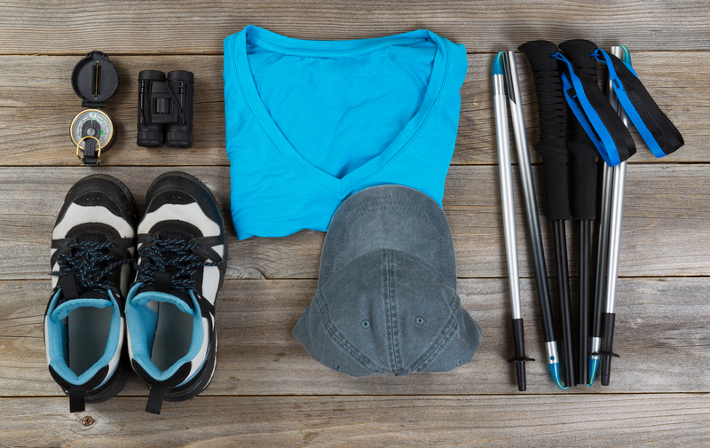

This area can be used either for the address of your customers. All you have to do is to print labels, paste them here after you’ve put in your return address.

The Newsletter can then be folded in thirds, stapled or adhered with special round stickers available at an office supply store to allow the letter to go through the postal machines with a minimum of effort. A two page newsletter will require postage of a first class letter.

If you do not wish to mail this, then this space can be used for additional information specific to your salon.

