Salon News
April 2026

Salon Shampoos – Are They REALLY Better?

It’s a question hair stylists are often asked, and when they recommend their salon brand, or other professional brand, they often face skeptical eyes in the mirror. It’s shampoo, it cleans hair, right? How can a professional brand be any different than what you can buy at your neighborhood drugstore?
One way to look at it is this; wine is made from grapes. Some bottles of wine are only a few dollars, while others go for hundreds of dollars. Anyone who has trained their palate can usually tell the difference. So can a professional hairdresser.
Basically shampoo is intended to clean your hair and scalp. They contain some of the same essential ingredients. But if you really pay attention to how your hair feels after using certain shampoos, there is still a significant difference. Recently I stayed with my mother and forgot to pack my usual salon shampoo. I used the bottle she had in her shower. My mother is very frugal, but I didn’t realize just how frugal until I dried and styled my hair.
I looked in the mirror and felt shocked. Despite being freshly washed, gone was the sheen and healthy look I’d come to expect. Instead, my hair looked and felt dry and brittle.
Looking further into this issue, it soon became clear a shampoo that costs far less than the salon products often uses fillers like water and sulfates and little to no vitamins, minerals, or oils designed to keep your hair shiny and healthy. Even brand name shampoos sold at discount stores might not be exactly the same as what you purchase at the salon.
In addition, shampoos are formulated for a variety of hair and scalp conditions. When you discuss your specific needs with your stylist, they can recommend and actually use a selected shampoo at each visit to see which one best suits your needs. This eliminates the need to purchase full bottles of a product you may only use once.
Sure, your friend or neighbor might swear by a certain shampoo, but that doesn’t guarantee that it will do the same for your hair. Your professional hairdresser spends hours a week dealing with hair and scalp issues. I recommend using their expertise to your advantage.

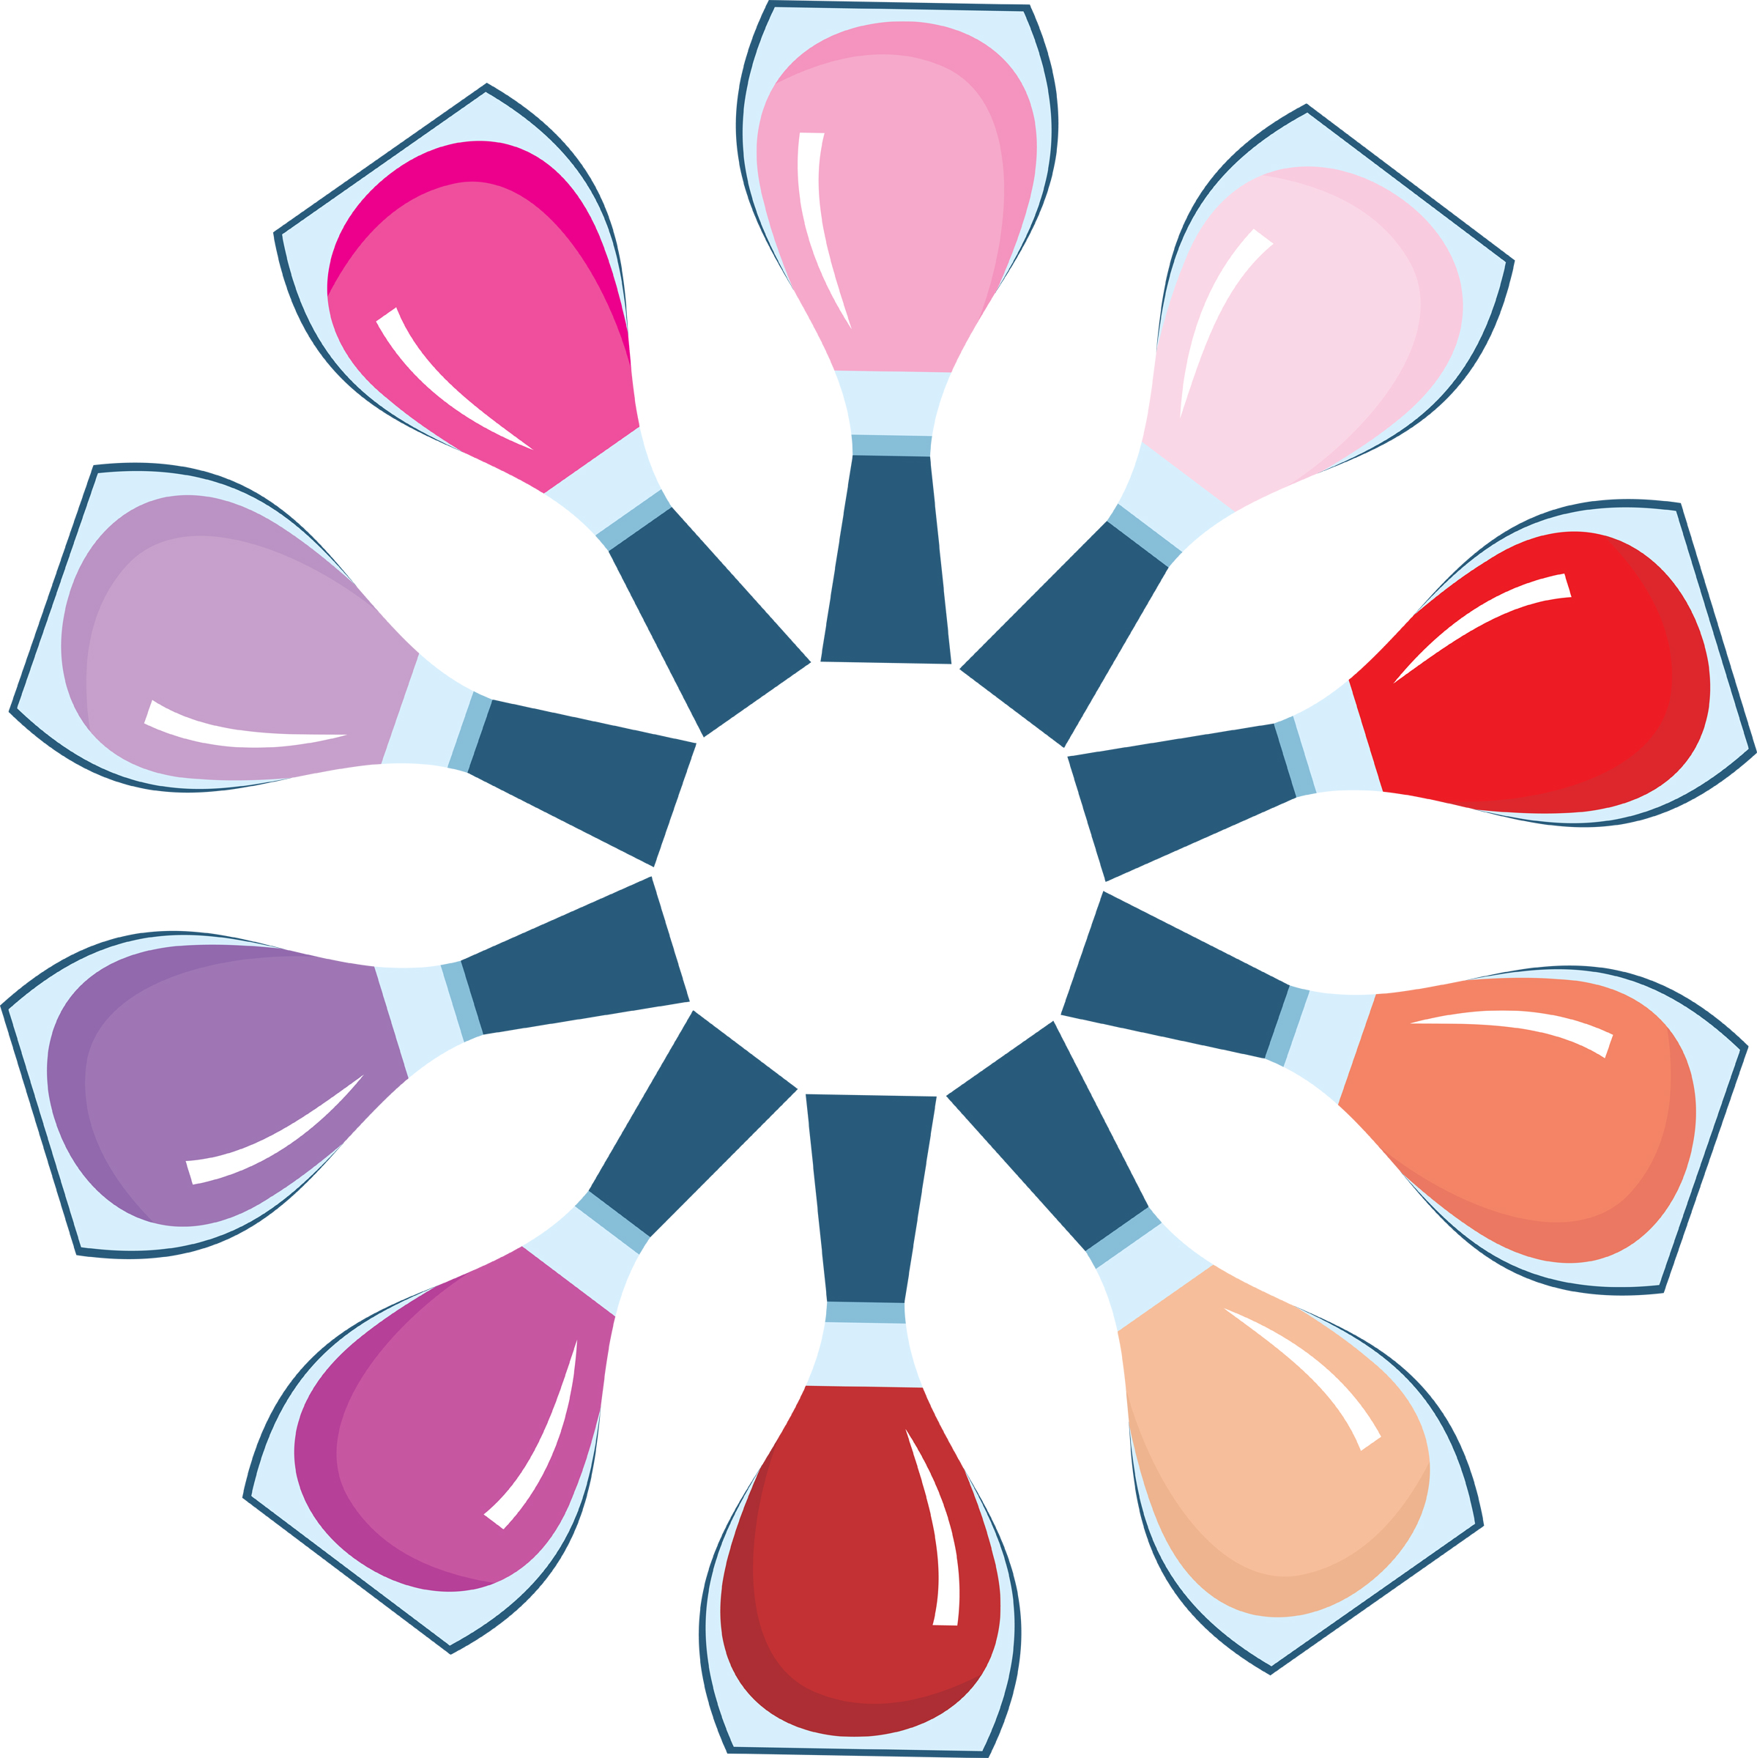
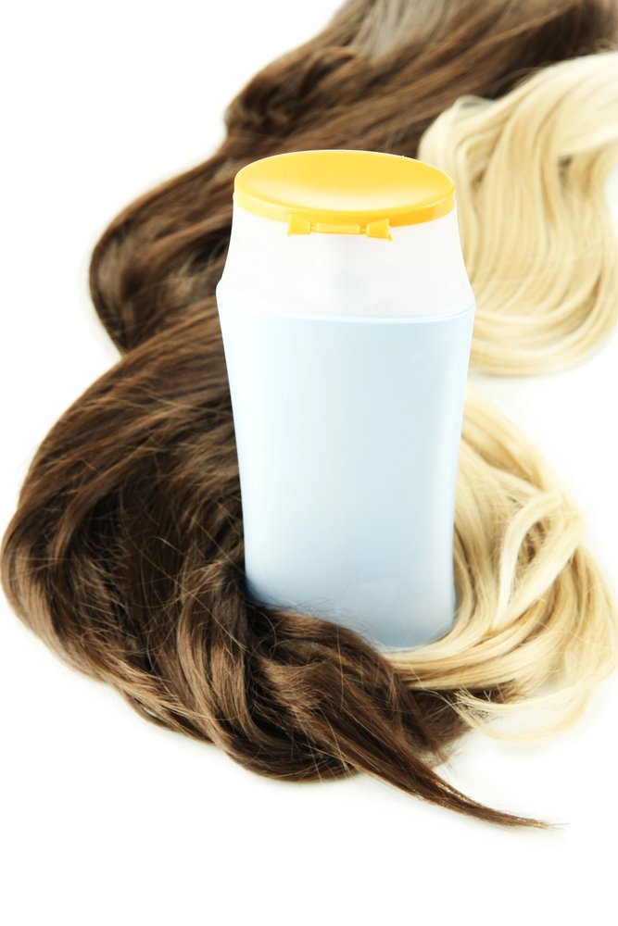

Though we travel the world over to find the beautiful, we must carry it with us or we find 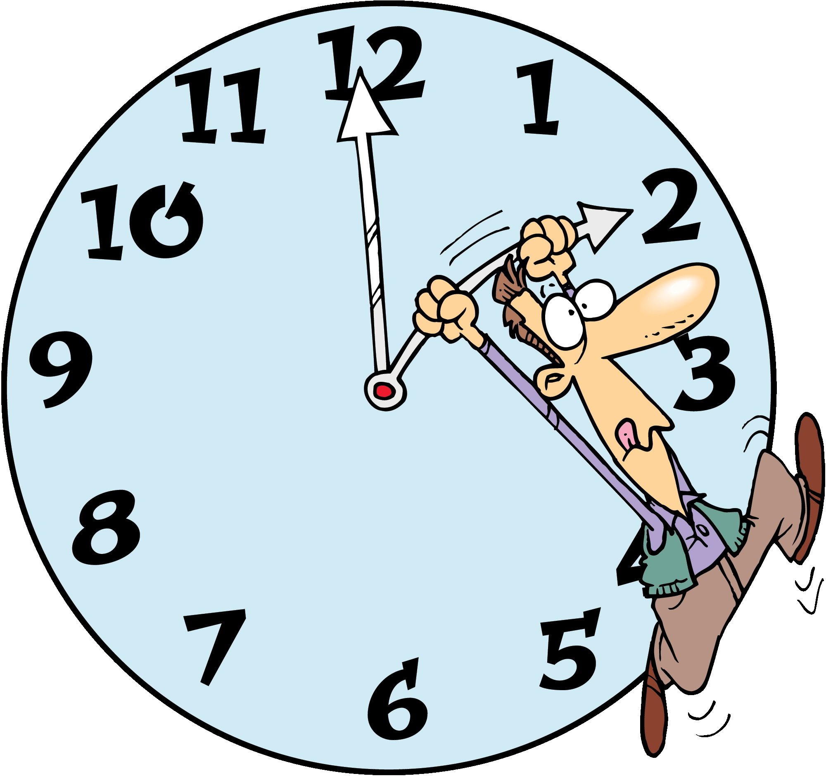it not. ~Ralph Waldo Emerson
April Events

1 - April Fool’s Day
1 - International Tatting Day
3 - National Walk to Work Day 1st Friday
5 – Easter Sunday
15 - Income taxes due (most years it is due on the 15th)
20 - Patriot’s Day Third Monday
22 - Earth Day (U.S.)
22 - Passover begins at sundown, and lasts 8 days.
22 - Administrative Professionals Day formerly “Secretaries Day” – date varies
23 - Take Your Daughter to Work Day – The 4th Thursday of the month.
24 - Arbor Day – always the last Friday in April

"April 2026 arrives like a soft exhale after winter—fresh, hopeful, and full of possibility. Let this month be your gentle reminder to bloom where you are, care for yourself with kindness, and trust that even the smallest steps toward beauty and confidence will carry you into a brighter season."
L

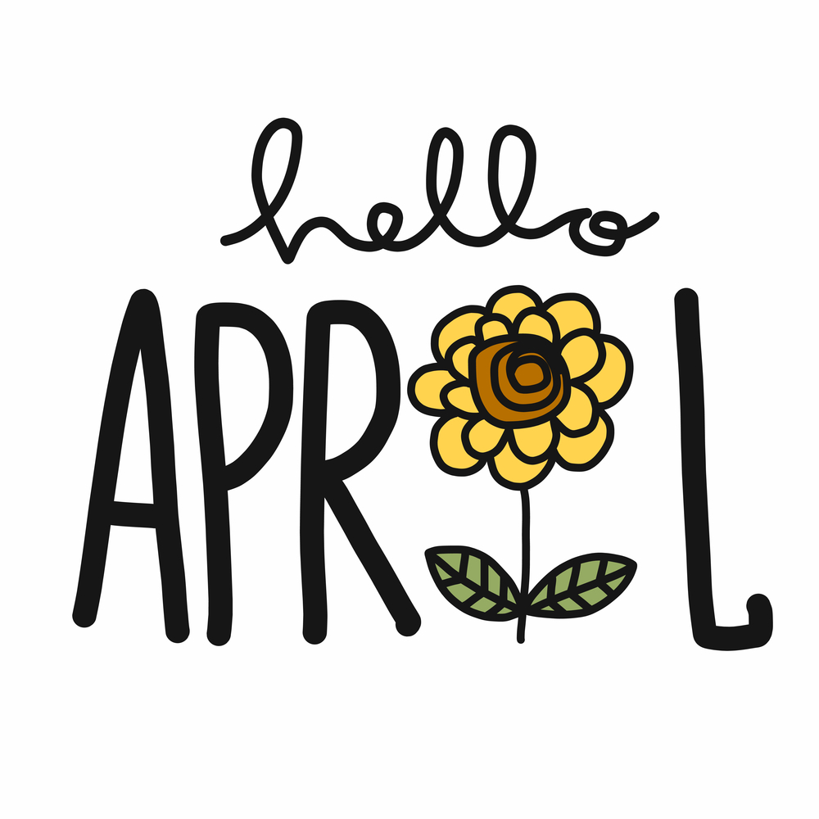

Strawberry Spinach Salad

2 tablespoons sesame seeds

1 tablespoon poppy seeds

½ cup white sugar

½ cup olive oil

¼ cup distilled white vinegar

¼ teaspoon paprika

¼ teaspoon Worcestershire sauce

1 tablespoon minced onion

10 ounces fresh spinach. Rinse and dry.

1 quarter strawberries, sliced

¼ cup almonds, slivered

- In a medium bowl, whisk together the sesame seeds, poppy seeds, sugar, olive oil, vinegar, paprika, Worcestershire sauce and onion. Cover, and chill for one hour.

- In a large bowl, combine the spinach, strawberries and almonds. Pour dressing over salad, and toss. Refrigerate 10 to 15 minutes before serving


7. Swing your arms – Bend elbows ~90°, pump arms forward and back (not across your body) to add momentum and burn extra calories.

8. Maintain posture on hills – Stay upright; avoid leaning forward (strains lower back) or backward (overworks quads).

9. Focus on form – Pay attention to your gait—smooth, even steps reduce injury risk and improve efficiency.

10. Listen to your body – If something feels off, slow down or adjust. Good walking should feel energizing, not painful.

Happy walking! Put on those shoes, step outside, and let each stride bring you closer to a stronger, calmer, healthier you.

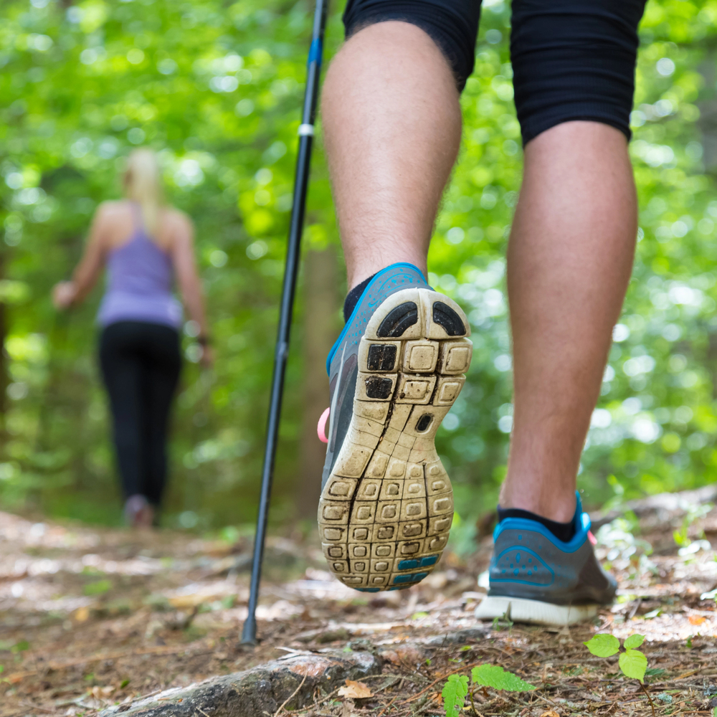
WALK YOUR WAY TO BETTER HEALTH IN 2026

Walking is one of the simplest, most accessible ways to stay active—no gym, no equipment, just you and a good pair of shoes. Step out almost anywhere and start moving. The benefits add up quickly:

* Strengthens your heart and helps lower blood pressure.
* Reduces stress and improves mood.
* Promotes deeper, more restful sleep.
* Supports weight management and joint health.

Aim for a brisk 30-minute walk (or more) most days. Go solo for quiet reflection or invite a friend for conversation—it’s flexible and fun.

Proper Walking Technique – 10 Key Tips.

1. Warm up first – Do a few gentle stretches to loosen hips, hamstrings, calves, and shoulders

2. Stand tall – Chin parallel to the ground, shoulders relaxed and back, eyes looking ahead (not down at your feet).

3. Foot position – Keep feet hip-bone width apart for natural balance.

4. Heel-to-toe roll – Land on your heel first, then roll smoothly through the mid-foot to push off with your toes.

5. Engage your core – Lightly tighten your abdomen to support your lower back and maintain alignment.

6. Take natural strides – Aim for longer (not forced) steps—let your legs swing comfortably.

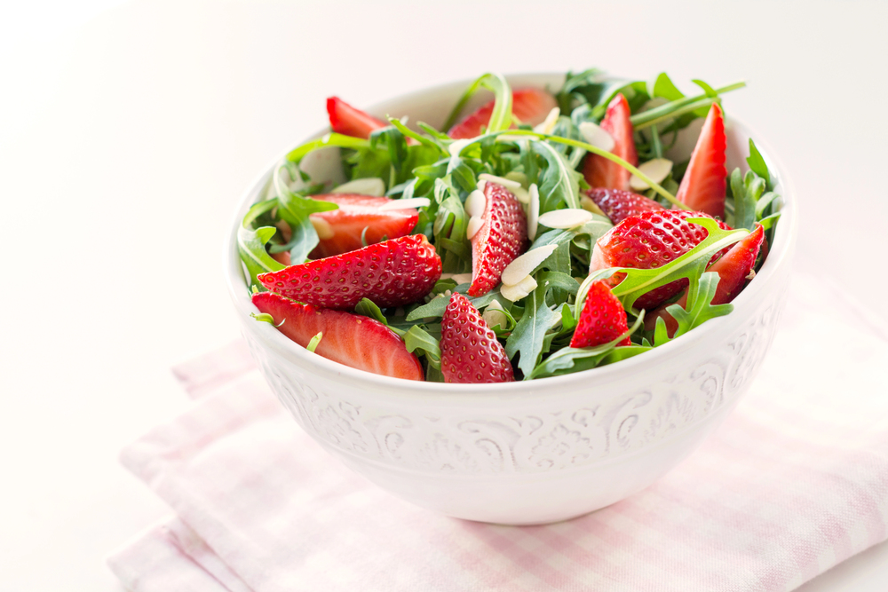

- Make balanced choices. Healthy eating can be difficult. Some foods have more sugar and fat in them, while others have more fiber and vitamins in them.
- Make better choices when eating out.
- Eat everything in moderation. Stop eating when you are full.
- Make sure you are getting good fats by eating more fish, nuts and seeds.
- Check labels on food products.
- Avoid frying. Instead, steam, bake, poach, or grill.
- Eat smaller portions.

Don’t give up. If you fail at one meal, take advantage of eating right at the next meal.

Eating Right

To stay at a healthy weight and keep the balance between the calories in what you eat and drink, and calories you burn when moving, it is important to eat right. Here are a few tips to help:

- Choose foods that are lower in fat and fewer calories.
- Always start your day with breakfast.
- Snack throughout the day. Snacks help you refuel your body. Choose healthy snacks: low-fat milk and a few graham crackers, an apple with peanut butter or a hand full of almonds.
- Eat more fruits, vegetables and grains. These foods give you more vitamins, minerals; and fiber will give your body more energy.

678-786-3281

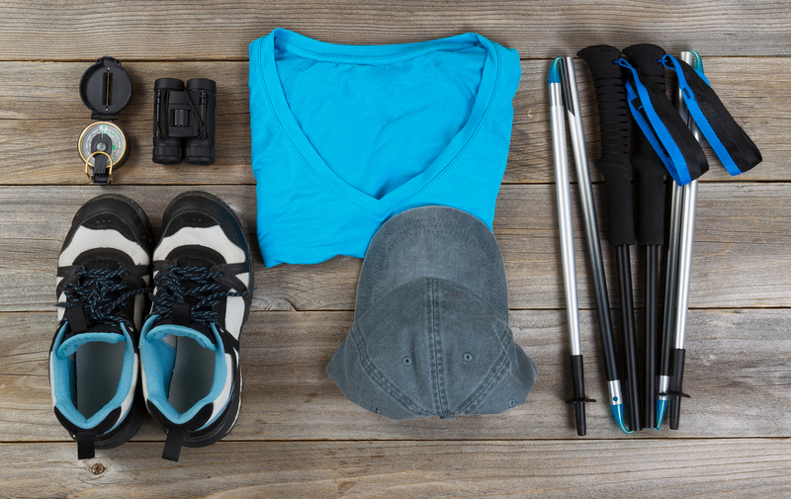


This area can be used either for the address of your customers. All you have to do is to print labels, paste them here after you’ve put in your return address.

The Newsletter can then be folded in thirds, stapled or adhered with special round stickers available at an office supply store to allow the letter to go through the postal machines with a minimum of effort. A two page newsletter will require postage of a first class letter.

If you do not wish to mail this, then this space can be used for additional information specific to your salon.

