Salon News
June 2026

Health and Beauty Benefits of a Scalp Massage

One of the best things about getting your hair done at a salon is the scalp massage. It is a simple technique where you knead soft tissues in the body, which can create a calming effect and remove tension. The scalp is filled with nerve endings and a majority of the nervous system is located inside the skull. A good scalp massage will stimulate your nervous system. A scalp massage is a way to reduce stress.

Additional Benefits to a scalp massage:
- A soothing scalp massage boosts your mood and sense of well-being by working on three hormones, serotonin, dopamine, both of which enhance those “feel good” emotions, and reducing cortisol, that stress-related hormone that makes us feel down, and adds to belly-fat weight gain. So, yes, a scalp massage can help manage your weight too.
- It stimulates blood flow to and from the skin, increasing the oxygen supply to your scalp and hair roots.
- It cleanses the hair and scalp of oils, dirt, and bacteria, while also lubricating the scalp, making it healthier and promoting hair growth.
- When rubbing the hair from roots to tip, it can stimulate growth and vitality.
- It soothes a dry, itchy scalp by conditioning it, preventing dry cells.
- It leaves your hair softer and more radiant by spreading natural oils, making it easier to style.
- It prevents hair follicle damage from the sun or chemical treatments by improving resiliency over time.
- It just feels good and relaxing.

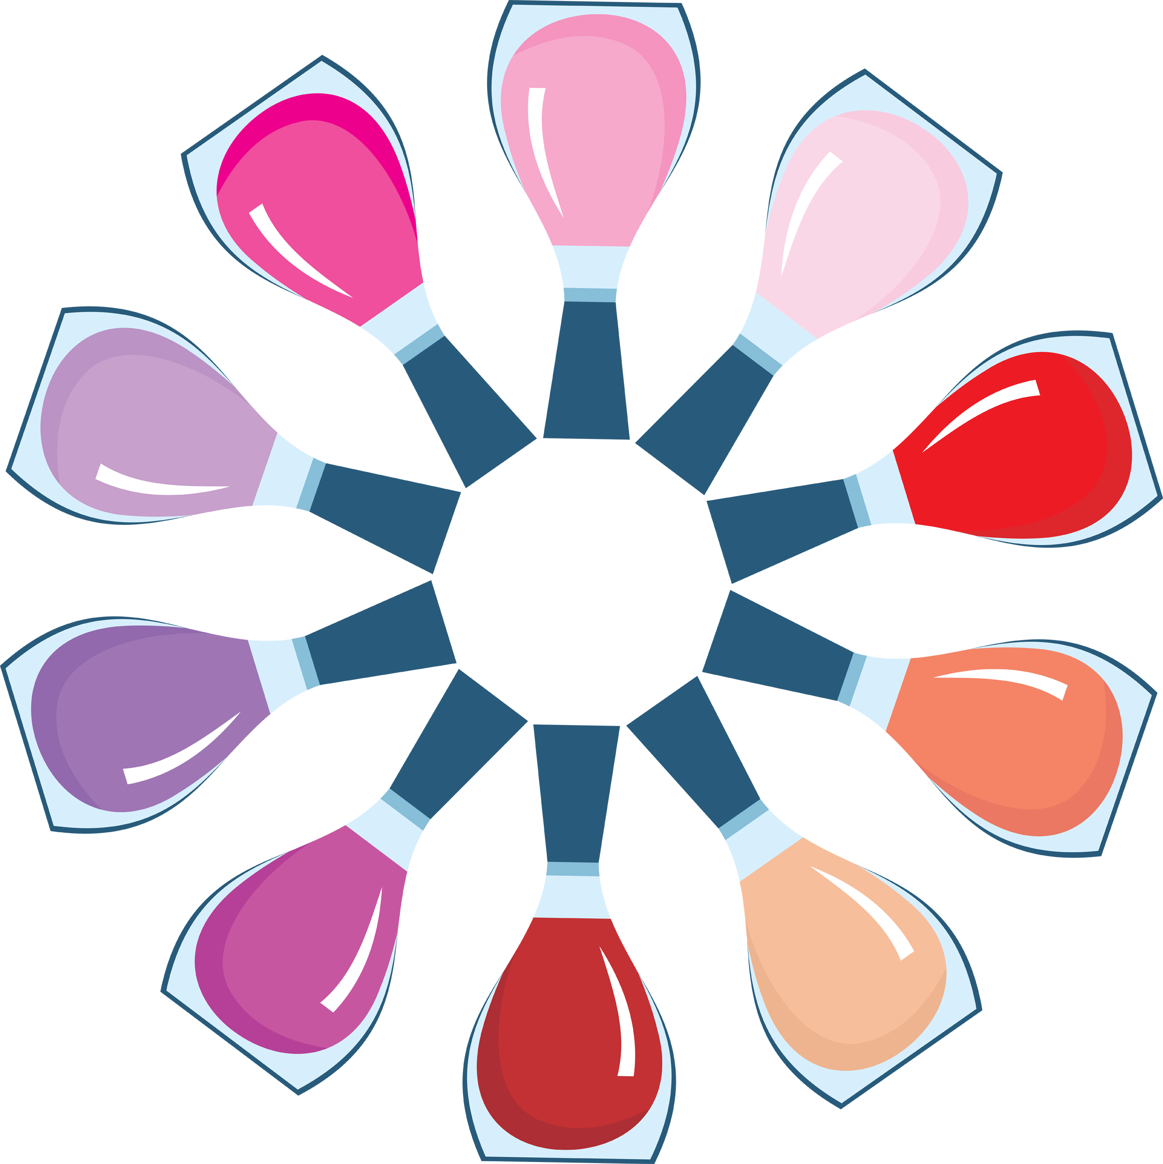
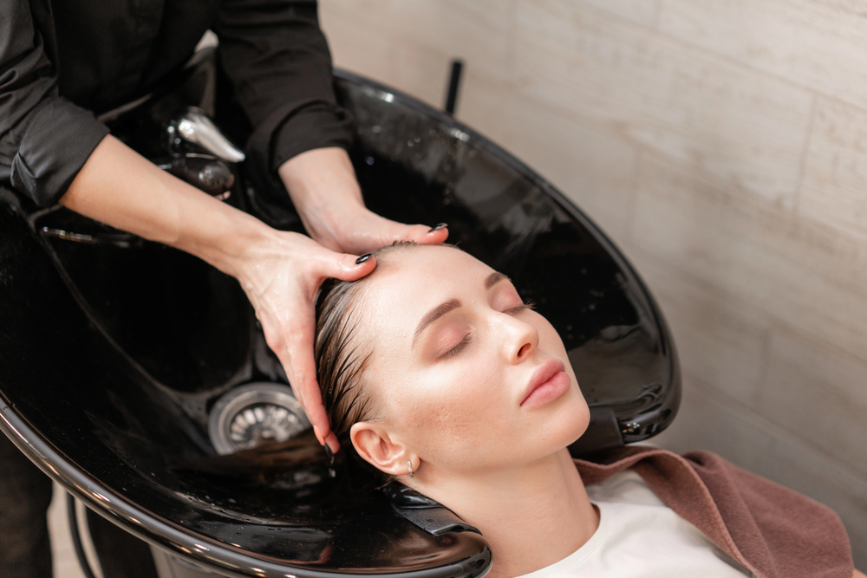

Though we travel the world over to find the beautiful, we must carry it with us or we find 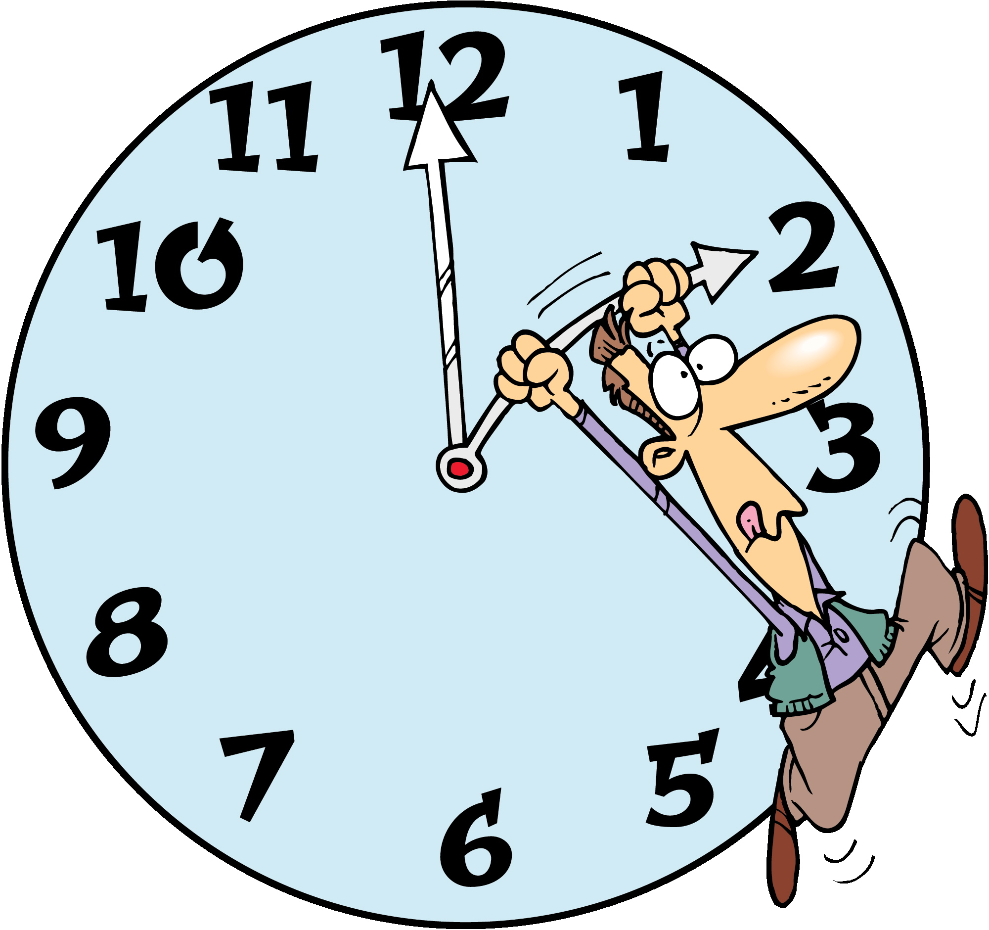it not. ~Ralph Waldo Emerson
June Events

June 6 – D-Day (WWII)
Commemorating the Allied invasion of Normandy in 1944.

June 14 – Flag Day
Celebrating the adoption of the U.S. flag.

June 19 – Juneteenth
Federal holiday commemorating the end of slavery in the United States.

June 21 – Father’s Day (Third Sunday)
A special day to honor fathers and father figures.

June 21 – Summer Solstice
The longest day of the year and the official first day of summer in the Northern Hemisphere.

Summer solstice occurs when the earth’s semi-axis inclines more towards the sun.
Did You Know Interesting Facts – Summer Solstice
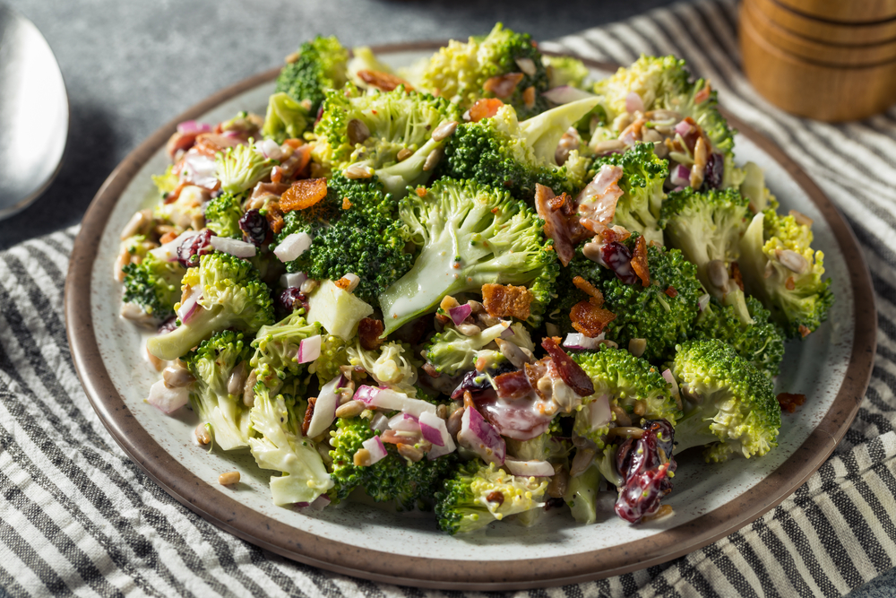
"June 2026 arrives wrapped in golden sunlight and endless possibility. Let this month be your invitation to slow down, soak in the warmth, and bloom boldly into the woman you’re meant to be. May your days be filled with laughter, your hair with shine, and your heart with peace."
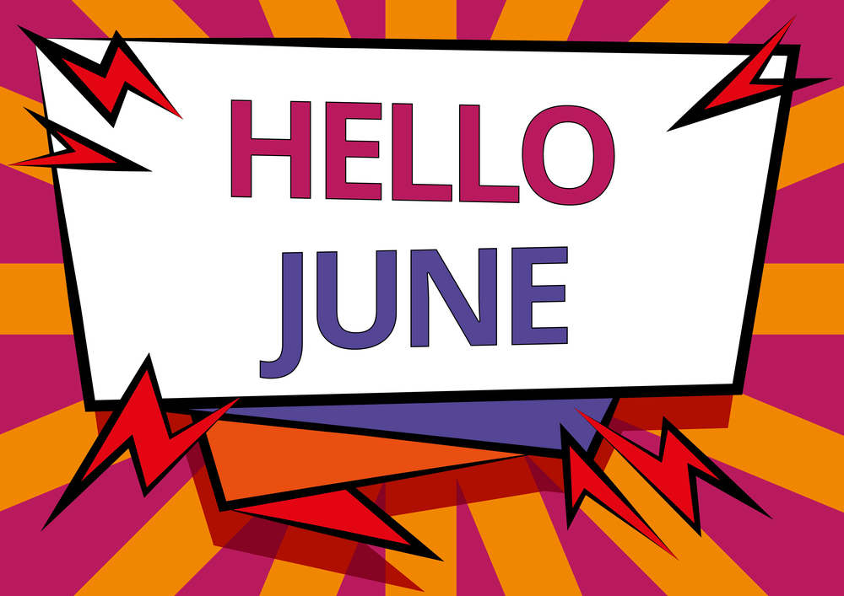
L

When summer solstice occurs in the northern hemisphere, it experiences its longest day and shortest night of the year.
Broccoli Bacon Salad

Ingredients:
Salad:
5 cups broccoli florets, cut into small pieces
1/2 cup finely chopped red onion
1 cup shredded cheddar cheese
1/2 pound cooked, crumbled bacon
1/2 cup sunflower seeds
1 cup dried cranberries or raisins

Dressing:
1 cup mayonnaise
2 tablespoons sugar
2 tablespoons red wine vinegar
1/2 teaspoon salt
1/4 teaspoon black pepper

Directions:

Combine all salad ingredients in a large mixing bowl; mix well. Combine dressing ingredients in a small mixing bowl. Mix until thoroughly combined using a fork or wire whisk. Add dressing to salad and mix well. Refrigerate 1 hour.

Makes 8 servings

Some people confuse the solstice with an equinox.

Words Have Power, Use them wisely
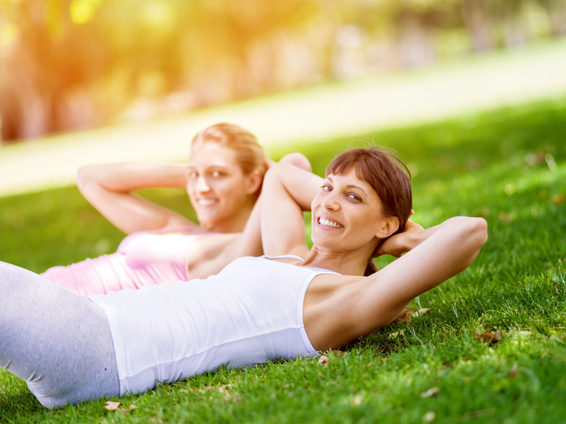

Energy Boosting Ideas
One thing for certain about summer heat, it zaps your energy. Once the sun beats down on you, your energy level will likely take a nose dive. Here are some ways to boost your energy and feel better.
- Make breakfast a priority. Aim for 15-20 grams of protein for breakfast.
- Drink lots of water. One sign of dehydration is fatigue. Even mild dehydration can slow metabolism and zap your energy. Anytime you feel exhausted, try drinking water.
- Move around. When you are feeling tired, you don’t want to exercise. However, just by increasing your activity, will increase your energy level. A mere 20-30 minutes of walking, five days a week, will increase your energy level.
- Listening to music can amp up your sensory input, increasing your level of energy.
- Stay away from sugary snacks. They will give you quick energy, but you will crash even faster.
- As energy levels change throughout the day, here are several foods that can increase them:

A. Almonds. Protein enriched nuts can give you a boost. However, magnesium in almonds will give you an added boost. Magnesium plays a vital role in converting sugar into energy. A deficiency in magnesium can leave you feeling sluggish.
B. Blueberries. Your blood sugar can drop during the afternoon. A cup of blueberries can nourish the pancreas and strengthen its ability to keep the blood sugar under control.
C. Banana with peanut butter. The natural sweetness in fruit takes longer to metabolize and protein in the peanut butter will extend that higher level of energy.
D. Whole grain, high protein bars. Choose bars with at least five grams of protein and fiber, but with fewer than 15 grams of sugar.

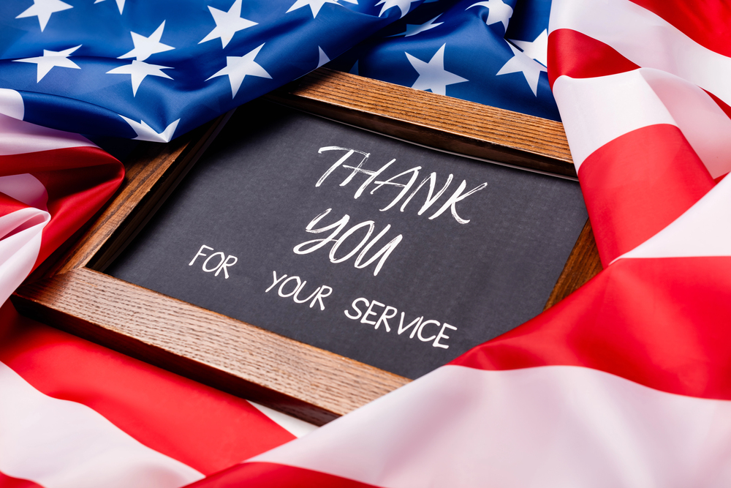
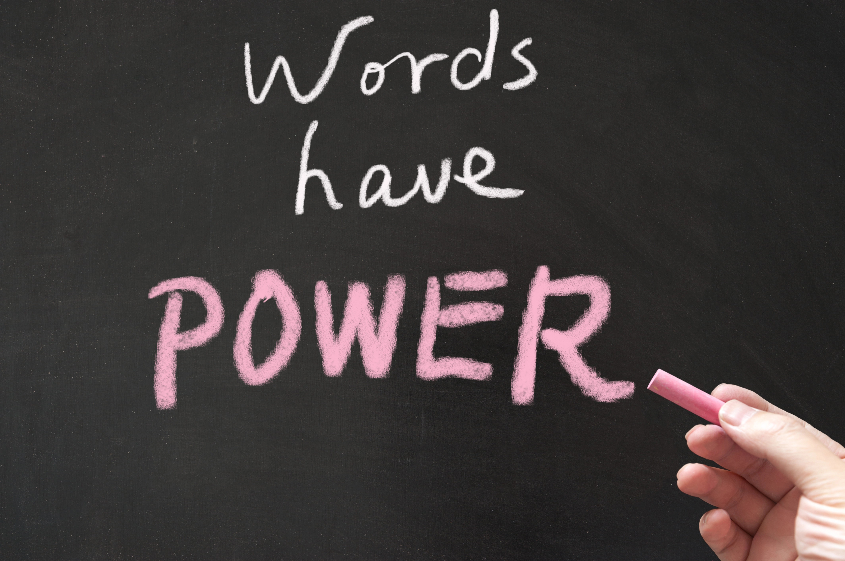
We’ve all felt it — the sting of harsh words from someone we love. That heavy feeling in your chest. The way your body tenses even at the memory. Words don’t just pass through us; they leave an imprint.

A few years ago, my relationship with my mom was strained. After one particularly painful phone call, I received a letter from her. The moment I started reading, her words hit me like physical blows. My heart raced. My body felt heavy. The anger and hurt lingered for hours.

The very next day, another letter arrived. This time, I almost didn’t open it. But something felt different. The first line read: “My darling daughter, please forgive me.”

In that instant, my entire body relaxed. A wave of warmth and relief washed over me. The same person, the same pen, but completely different energy. That experience changed how I view words forever.

Words carry energy. They can wound or they can heal. Think about it: say the word “inch”… then say “mile.” Feel the difference? Or try “light” versus “dark,” “gentle” versus “harsh.” Our bodies instinctively respond to the vibration behind the words we hear — and especially the words we speak to ourselves.

This is why self-talk matters so much. The way you speak to yourself in the mirror each morning has real power. Kind, loving words nourish your spirit and even influence your physical well-being. Harsh, critical words do the opposite.

Energy healers have long understood this truth: it’s not just the words themselves, but the emotion and intention behind them that creates the impact.

Just like a bee’s specific buzz can signal a flower to open, your words can open hearts — including your own.

Today, choose kindness. Speak gently to yourself and to others. Use your words as tools to uplift, encourage, and heal.

Because the words you choose don’t just describe your world — they help create it.

If you’re looking for a meaningful way to show your appreciation, consider giving him something that helps him feel his best:

* A sharp, fresh haircut that makes him feel confident.

* Time to unwind with a service just for him.

Sometimes the best gift isn’t a thing — it’s helping someone you love feel good in their own skin.

To every dad reading this: Thank you for all the ways — big and small — that you show up and love your families. You are appreciated more than you know.

Happy Father’s Day!

We hope your day is filled with joy, relaxation, and the love you so richly deserve.

FATHER’S DAY 2026; Celebrating the Quiet Strength of Dads

Behind every strong family is often a dad who shows up — sometimes loudly, sometimes quietly — but always with love.
Whether he’s the one fixing things around the house, offering advice you didn’t know you needed, cracking jokes to lighten the mood, or simply being a steady, reliable presence, fathers play a powerful role in our lives. They teach us resilience, humor, responsibility, and how to love through actions as much as words.

This Father’s Day, we want to celebrate all the incredible dads, stepdads, grandpas, and father figures who make life better just by being themselves.

678-786-3281

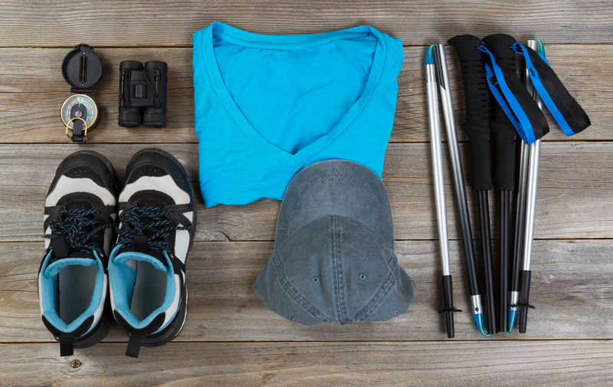
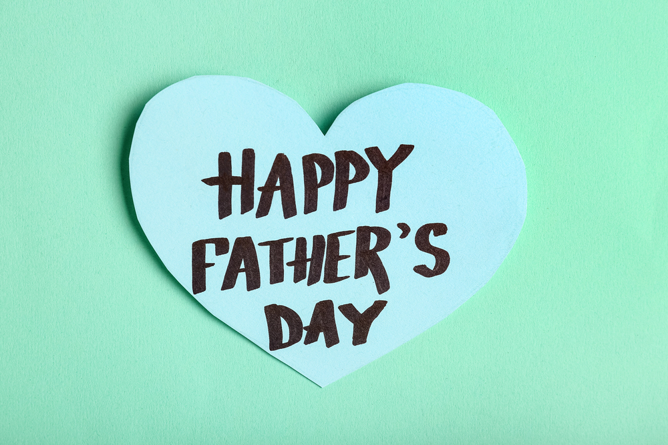
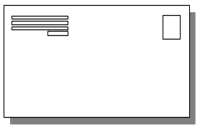

This area can be used either for the address of your customers. All you have to do is to print labels, paste them here after you’ve put in your return address.

The Newsletter can then be folded in thirds, stapled or adhered with special round stickers available at an office supply store to allow the letter to go through the postal machines with a minimum of effort. A two page newsletter will require postage of a first class letter.

If you do not wish to mail this, then this space can be used for additional information specific to your salon.

