Salon News
September 2026

TRICKS TO KEEP HAIR FROM THINNING
Noticed your hair looking a little thinner lately? You’re not alone—and the good news is there are simple, effective steps you can take to help it look thicker, glossier, and more vibrant. Healthy hair starts from within and is supported by the daily care you give it. Here are practical tips to help keep thinning at bay:
1. Boost Your Protein: Hair is primarily made of protein, so adding quality protein to your diet can make a real difference in strength and growth.
2. Give Your Hair a Break: Tight ponytails, frequent extensions, and excessive heat styling put strain on the follicles and can lead to traction alopecia. Choose looser styles, skip extensions when you can, and ease up on the blow-dryer to give your hair and scalp a break.
3. Listen to Your Body: Thinning can sometimes signal an underlying issue such as a thyroid imbalance (especially hypothyroidism, which becomes more common after menopause). If you’re concerned, a conversation with your doctor is the best next step.
4. Check Your Vitamins: Deficiencies in B12 and Vitamin D can slow growth and contribute to thinning. Enjoy more meat, fish, eggs, and dairy—or consider a high-quality B-complex to help fill any gaps.
5. Top Up Your Iron: Low iron is one of the most common culprits behind thinning hair. Include lean red meat in your meals or speak with a professional about a suitable iron supplement to support stronger growth from within.
6. Nourish Your Scalp: A healthy scalp is the foundation of healthy hair. Ask your stylist about targeted treatments and products designed to keep the scalp in top condition and encourage fuller-looking results.
7. Never Skip Conditioner: Skipping conditioner can leave hair dehydrated, brittle, and more prone to breakage. Choose a lightweight formula with panthenol and glycerin to moisturize without weighing fine or fragile hair down.
Your hair reflects your overall wellbeing—small, consistent changes can make a noticeable difference. Stop in for a consultation anytime. We’re always happy to help you find the right products and styles for healthier, fuller-looking hair.


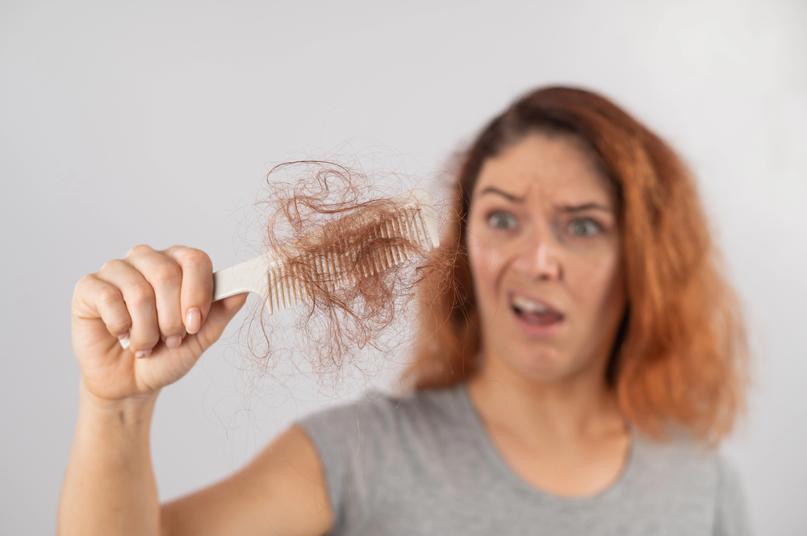

Though we travel the world over to find the beautiful, we must carry it with us or we find it not. 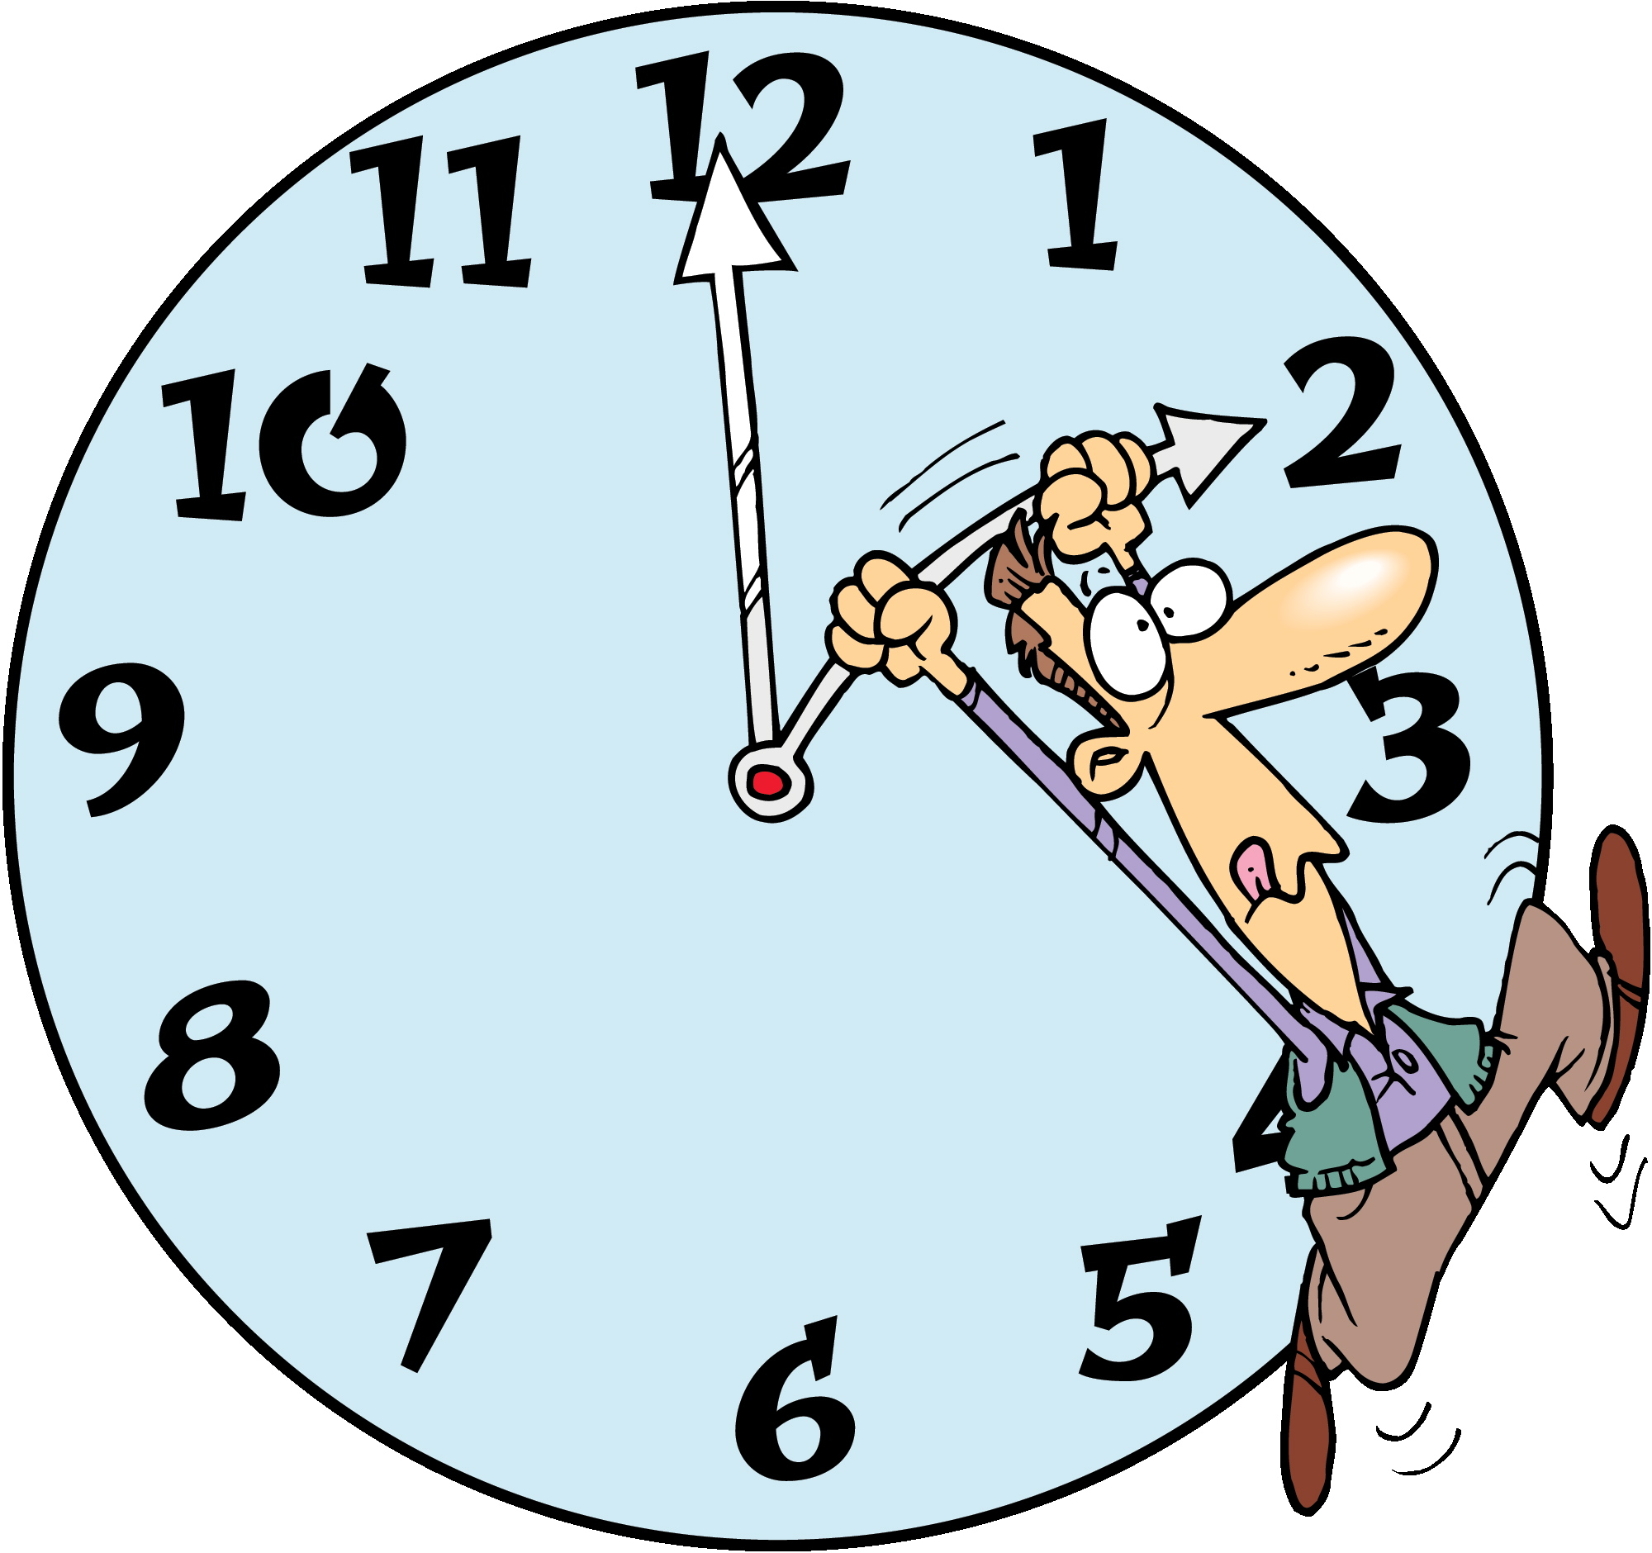 Oregon was the first state to make Labor Day a holiday in 1887.

“September is nature’s reminder that change can be beautiful. Embrace the new season with healthy, confident hair that shines as brightly as you do.”

In the United States, Labor Day is celebrated annually on the first Monday in September.
Did You Know Interesting Facts – Labor Day

Slow Cook Balsamic Pot Roast

Ingredients
- Olive oil
- 1 1/2 lb. boneless chuck roast, trimmed
- kosher salt
- Freshly ground black pepper
- 5 cloves garlic, minced
- 1 large onion, cut into 1" cubes
- 1/4 c. balsamic vinegar
- 3 tbsp. brown sugar
- 3 carrots, peeled and chopped into 1" pieces
- 3 gold potatoes, peeled and cut into 1" chunks
- 5 sprigs of fresh thyme
- 1 bay leaf
- 2 c. chicken stock
- 1 c. dry red wine
- 2 tbsp. chopped fresh parsley

Directions
- In a large sauté pan over high heat, warm 1 tablespoon oil. Dry meat with paper towels and season generously with salt and pepper all over. Sear on all sides until a deep golden crust forms, 2 to 3 minutes per side. Transfer meat to the slow cooker bowl.
- Return pan to medium heat and add 1 teaspoon oil. Sauté garlic and onions for 2 minutes. Deglaze with balsamic vinegar. Simmer on low until slightly reduced, about 5 minutes. Scrape bottom with a wooden spoon to remove all bits of meat. Add brown sugar and stir until dissolved. Pour mixture over meat in slow cooker.
- Add carrots, potatoes, thyme, bay leaf, chicken stock and red wine. Cook on low for 6 to 8 hours.
- Remove bay leaf and thyme branches. Garnish with parsley and serve immediately.

The first labor Day was celebrated on Tuesday, September 5, 1882 in New York City.
~ Ralph Waldo Emerson
September Events

2 – V-J Day (Victory over Japan Day, WWII)
7 – Labor Day (first Monday of the month)
11 – 9/11 Remembrance
13 – Grandparents Day (first Sunday after Labor Day)
17 – Constitution Day
19 – Oktoberfest begins in Munich, Germany (runs through October 4)
21 – International Day of Peace (United Nations)
22 – Autumnal Equinox
25 – Native American Day (fourth Friday of the month)


Colorado was the last state to make Labor Day a holiday before it became a federal holiday in 1894.
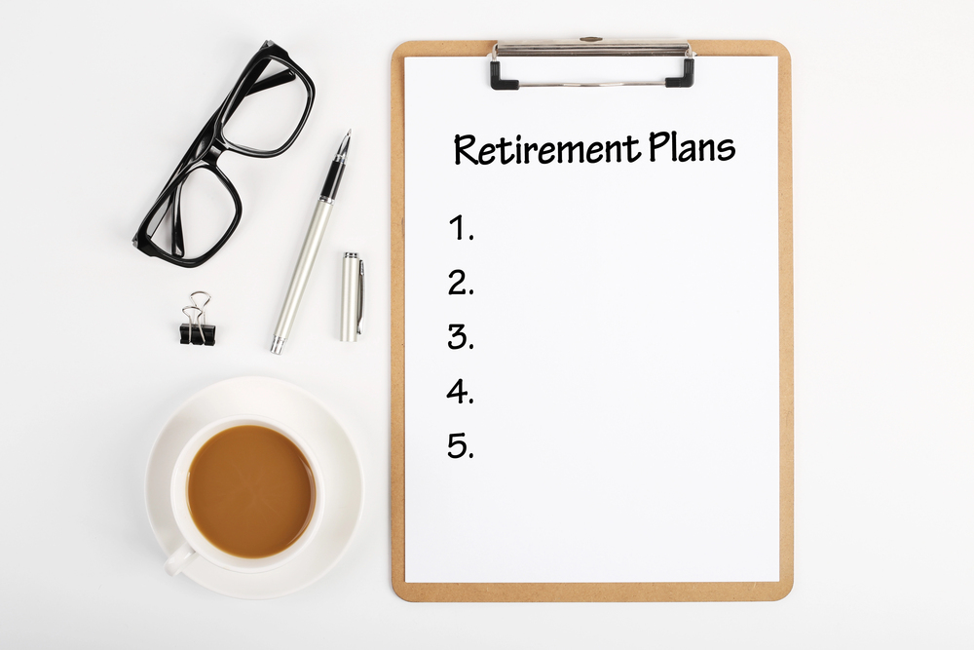



Are You Prepared For Retirement?

No matter your age, now is a smart time to prepare for retirement. You may still be years away from that day when you can sleep in and set your own schedule. Saving enough money is only part of the plan. Social Security will likely remain an important piece, though the full retirement age continues to rise. Research your options now and consider working with a financial advisor you trust. Good health is never guaranteed, and neither is economic stability—so building other interests and staying active can make the later years far more enjoyable. The happiest retirees tend to stay busy with hobbies, volunteering, or even part-time work they enjoy. Take care of your health and that retirement day will arrive on a much stronger foundation.

If you are not prepared, here are a few strategies to consider:
- Work longer.
- Free up home equity.
- Pay down debt.
- Invest in staying healthy.
- Delay Social Security.
- Cut spending today and add more to savings.
- Explore whether a self-directed 401(k) option could help you seek stronger long-term returns.


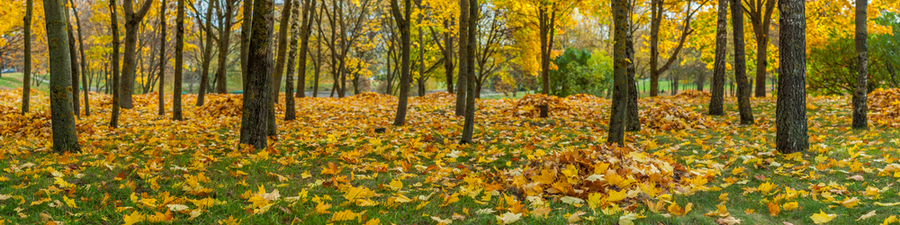



WHAT TO DRINK AFTER WORKOUT?
After a workout, what do you reach for? Water? A sports drink? Research suggests that milk—especially chocolate milk—can be an excellent recovery choice. Milk delivers hydrating fluid, high-quality protein, carbohydrates, and electrolytes all in one package. These nutrients work together to support muscle recovery and replenish what you’ve used.

A study from Indiana University found that chocolate milk performs especially well. It offers a higher carbohydrate and protein content than plain milk, making it well-suited for replenishing tired muscles. It also provides fluid for rehydration, calcium for bone health, and a moderate amount of natural sugar to help restore energy.

The carbohydrates and protein in chocolate milk give your body something useful to work with—something plain water alone cannot provide.

Next time you finish a workout, consider reaching for a glass of milk.

THOSE AUTUMN LEAVES

Instead of cursing the leaves as they fall, then cursing them again as you bag them, consider a better use. Those same leaves can improve your garden and help keep unnecessary waste out of the landfill.
Most people don’t realize that fallen leaves make up one of the largest contributions to landfills by volume. A study from several years ago estimated that more than eight million tons of leaves were sent to landfills across the country each year.

It doesn’t have to be that way. Treat leaves as a resource instead of waste and you’ll be feeding your lawn, roses, trees, and vegetable garden a rich natural compost that improves soil and reduces the need for store-bought amendments.
Some communities and HOAs require prompt leaf removal, which leaves many homeowners feeling they have no choice but to bag them. With a few exceptions—Black Walnut, Eucalyptus, and Oleander—most leaves will actually benefit your garden.

It does take a little more effort than simply piling them up or leaving them on the lawn all winter (where they lose much of their mineral value to leaching). A better approach is to use them directly as mulch under trees or in areas where you want to suppress weeds next spring.

You can also mulch leaves right into the lawn by running the mower over them and shredding them in place.
Alternatively, pile the leaves, enclose them with wire fencing, and turn the pile occasionally with a hoe or pitchfork. In about six months you’ll have rich leaf mold ready for the garden. Leaf mold can hold up to five times its weight in water and, when worked into heavy clay soil, creates a much more plant-friendly growing medium. Extra leaf mold can go straight into the compost pile where worms and microbes will finish the job.

By next spring you may even find yourself looking forward to next fall’s leaves.

678-786-3281

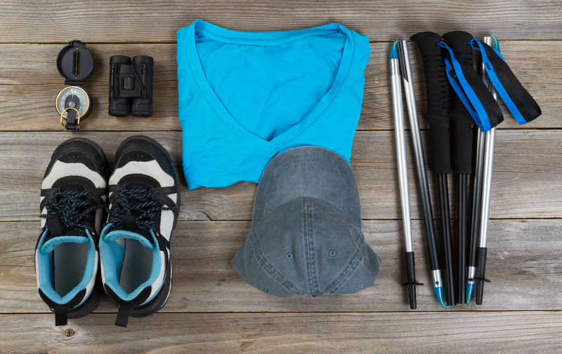

This area can be used either for the address of your customers. All you have to do is to print labels, paste them here after you’ve put in your return address.

The Newsletter can then be folded in thirds, stapled or adhered with special round stickers available at an office supply store to allow the letter to go through the postal machines with a minimum of effort. A two page newsletter will require postage of a first class letter.

If you do not wish to mail this, then this space can be used for additional information specific to your salon.

