Salon News
October 2026

NIGHTTIME BEAUTY ROUTINE TIPS

After enduring makeup, weather, and pollution all day, your body needs tender loving care overnight. It is worth it to take a few minutes to follow a nighttime regime. Here are a few overnight tips.

- Wash your face. Do not go to bed until you have washed your make up off of your face. If you leave it on, your makeup grinds into your skin and can cause breakouts and can stretch your pores.

2. Boost Collagen. As you get older your skin makes less collagen, which helps keep your skin firm. To stimulate collagen production, apply Vitamin A on your face. A formulation that has retinoid in it can also help lighten brown spots. Apply directly to brown spots on hands and arms.

3. Foot care. A few times a week, rub your heels and toes with lotion containing 12% lactic acid which helps with dry skin. Top that off with a heavier cream, one with shea butter. Then put on socks before you go to bed. You will wake up with soft smooth feet.

4. Cuticles and Soft hands. Use heavy duty hand cream at night. Slather on your hands and cuticles before going to bed.

5. Moisturize. If you have dry skin, use a humidifier. Turn one on before you go to sleep. It fills the air with moisture, which will help hydrate your skin. Be sure you drink enough water too.

6. Spot treatment. Use a purifying mask to target acne and rosacea pimples and leave it on overnight. The extended skin contact brings better results to your face. Be sure to read instructions before leaving on overnight.

7. Hair. Your hair contains oils and dirt that can get on your face and pillowcase and can cause breakouts. Braid it or pin it up to keep it off of your face. Change your pillowcase every other night if possible.

8. Exfoliate. While you are sleeping, your skin is working hard to repair itself. Nighttime is the best time to apply and leave on exfoliators to give your face time to absorb and correct daily damage.

9. Sleep. Get at least eight hours of sleep at night. Lack of sleep can really impact the way you look. Sleep can reduce dark circles as well. Lack of sleep compromises your body’s circulatory system. Sleep will help repair damage.


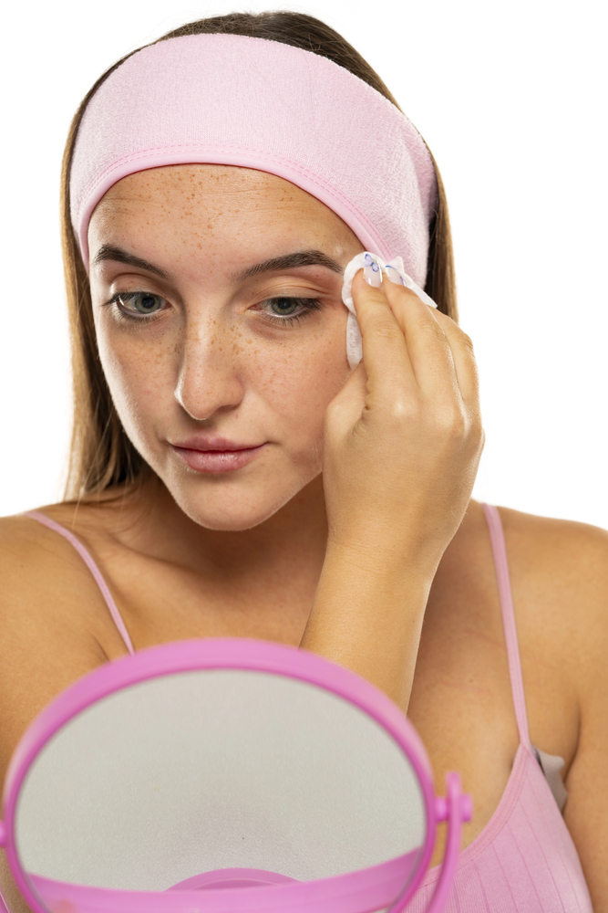

Though we travel the world over to find the beautiful, we must carry it with us or we find 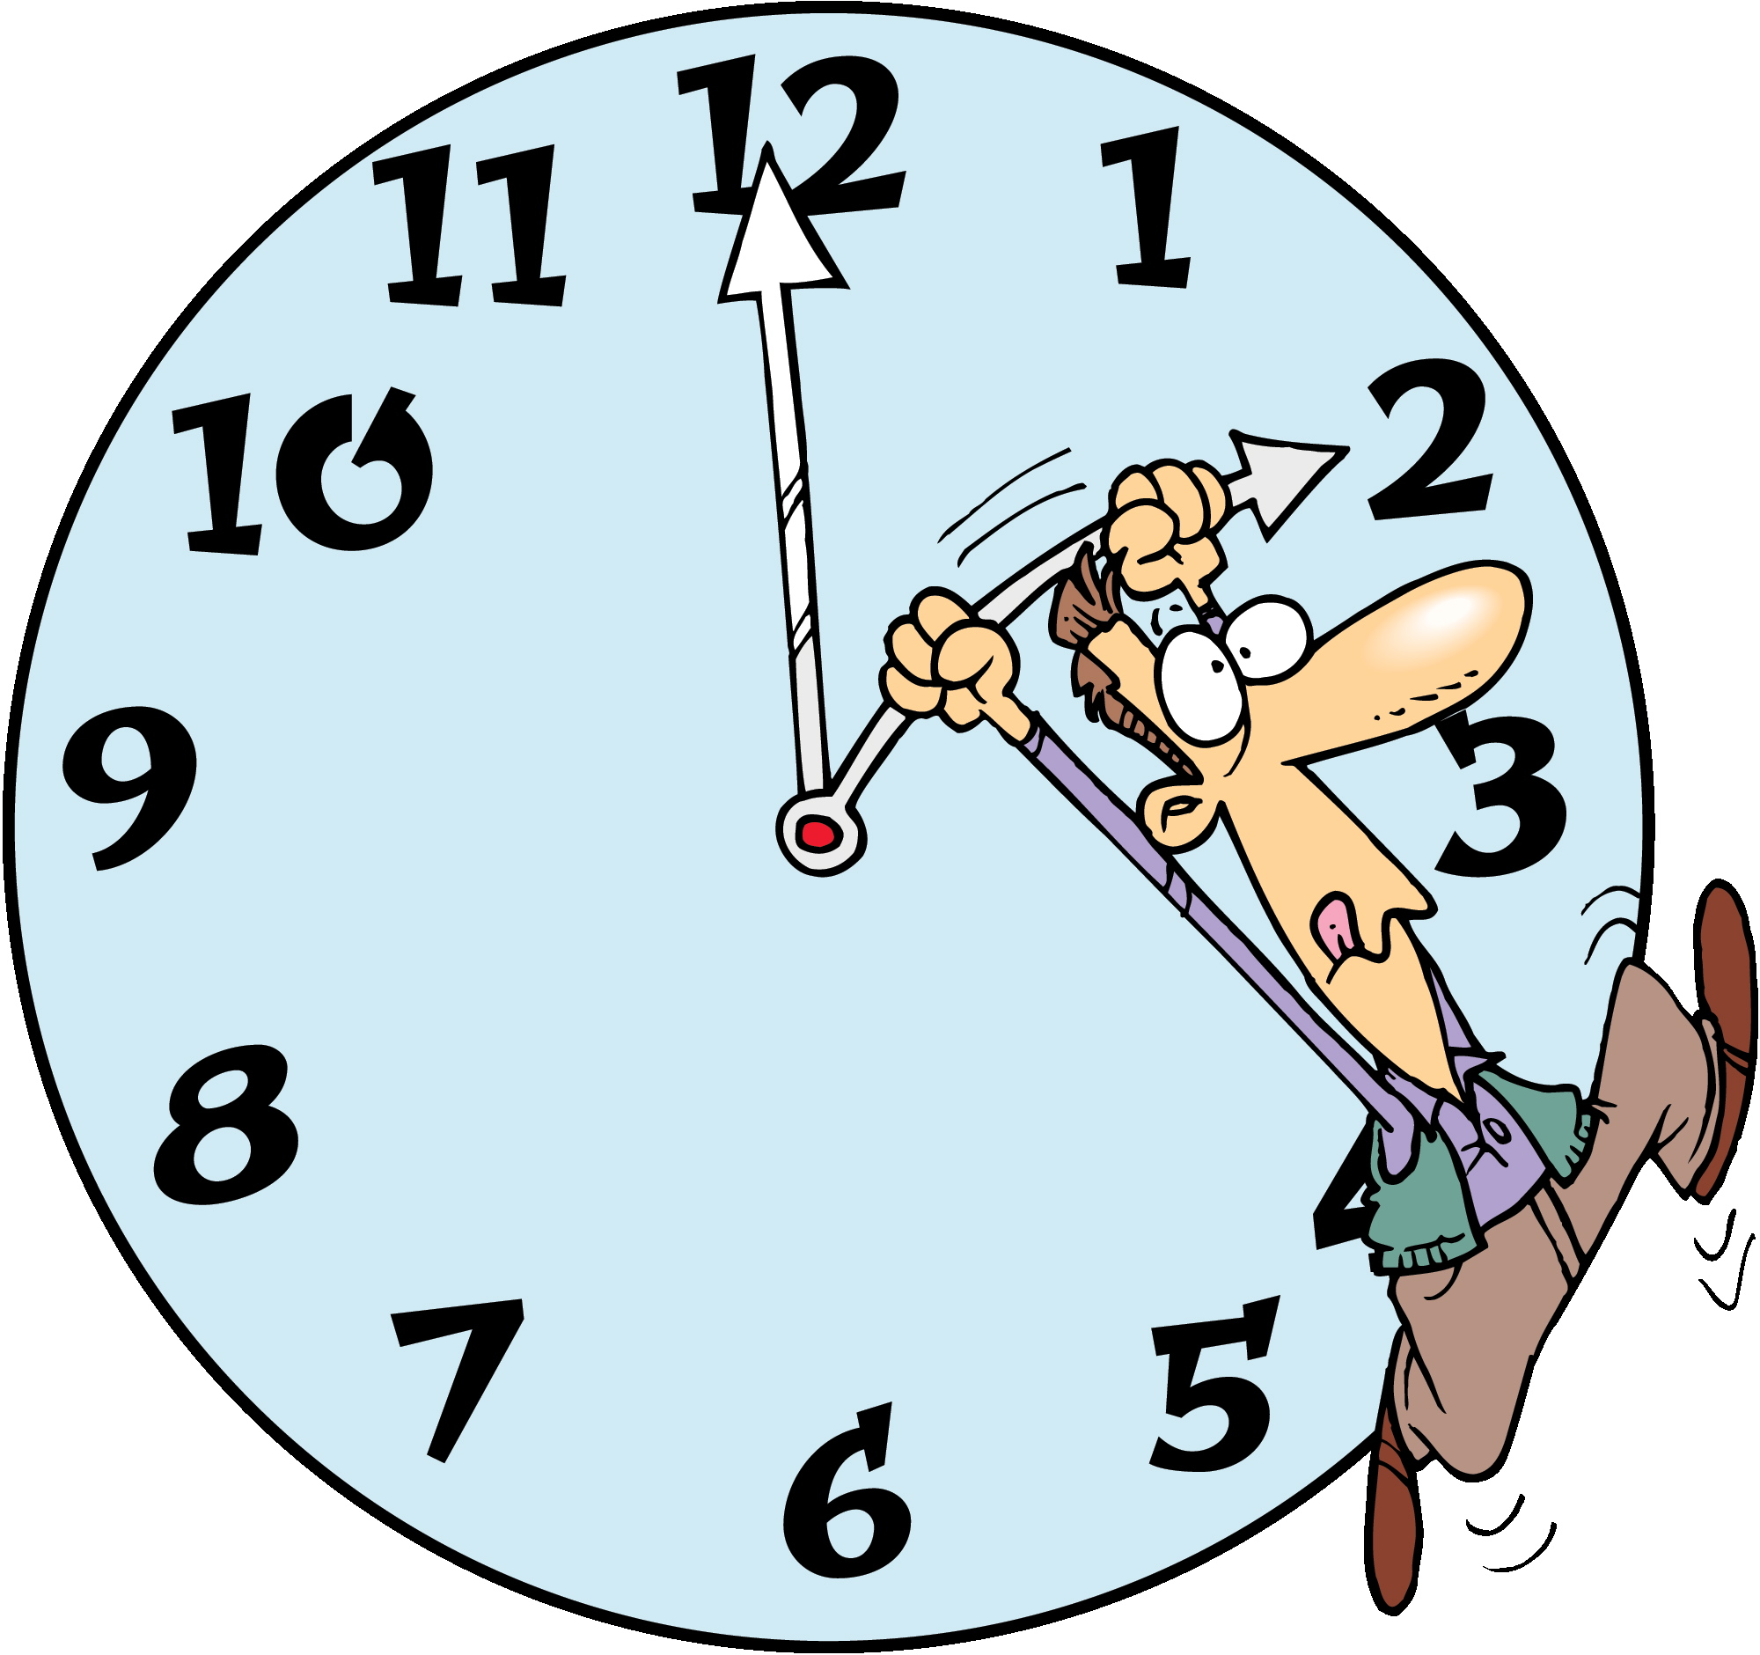it not. ~Ralph Waldo Emerson

October Events

October 1 - International Day of Older Persons

October 2 - World Smile Day (first Friday of the month)

October 4 - Oktoberfest in Munich typically wraps up on the first Sunday in October

October 12 - Columbus Day (observed, second Monday)
Indigenous Peoples’ Day (second Monday)
Thanksgiving Day in Canada (second Monday)

October 16 - Boss’s Day

October 17 - Sweetest Day (third Saturday)
National Mammography Day

October 24 - United Nations Day
Make a Difference Day (fourth Saturday)

October 31 - Halloween

Originally, you had to dance for your Halloween treats.
“Take care of yourself the way you take care of everyone else. The glow people notice usually starts there.”
Did You Know Interesting Facts – Halloween
L

In earlier Halloween celebrations, people wore animal skins and heads.
.

Carmel Dip
1 package (14 oz.) caramels
20 large marshmallows
½ cup melted butter
1/3 cup heavy whipping cream
Apple Slices
Place caramels in a microwave-safe bowl. Microwave uncovered on high for one minute. Add marshmallows; microwave for one minute or until marshmallows are melted. Stir occasionally. Whip in melted butter and cream until mixed. Serve with apple slices.
Refrigerator leftovers.
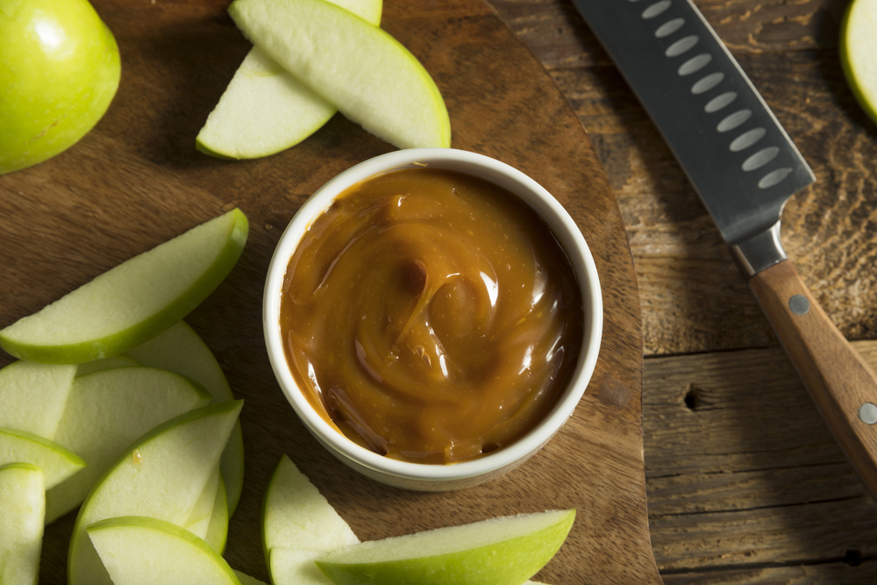

Halloween is more Irish than St. Patrick’s Day. Its origin comes from a Celtic festival for the dead called “Samhain.”



Better Food Choices Without the Overwhelm

Eating well doesn’t have to mean a strict diet or giving up everything you like. It usually comes down to a few steady habits: knowing what your body needs, slowing down enough to notice when you’re full, and making the easier choice more often than the hard one. These tips keep it practical.

1. Know your calorie needs
“Eat less” only works if you know what enough looks like for you. A quick look at a trusted calorie guide — or a conversation with your doctor or a dietitian — is a better starting point than guessing.

2. Eat mindfully
Enjoy the meal. Put the phone down when you can. Pause halfway through and notice whether you’re still hungry. That pause is often the difference between satisfied and stuffed.

3. Use a smaller plate
Same food, smaller plate, less automatic overeating. It sounds too simple. It works more often than people expect.

4. Save the heavy stuff for sometimes
Cakes, cookies, pizza, and other high-fat, high-sugar, high-salt foods don’t have to disappear. They work better as occasional treats than everyday staples.

5. Fill half the plate with produce
Fruits and vegetables take up space, add nutrients, and make the rest of the meal feel complete. Cut some up ahead of time so the easy snack is the good one.

6. Watch the sodium
A lot of salt hides in packaged food. Flip the label. Lower-sodium swaps add up across a week.

7. Choose lower-fat dairy
Skim or 1% milk, and similar lower-fat options, give you the benefits with less saturated fat.

8. Shop with a list
Write it before you go and stick to it. The list is there to protect you from the chips-and-cookies aisle when you’re tired or hungry.

9. Use better fats, in smaller amounts
Olive oil is a solid everyday choice. Skip oils and shortenings made with hydrogenated fats when you can.

10. Drink more water
Thirst often masquerades as hunger. Keep water close and make it the default drink.

11. Put yourself on the list
Better food choices stick when you treat them as care, not punishment. You are allowed to take time for that.

Start with one change this week — water, a smaller plate, or a produce-heavy dinner. The rest gets easier once the first habit feels normal.
October 2026: Breast Cancer Awareness That Goes Beyond Pink

October is Breast Cancer Awareness Month — a reminder that early detection still saves lives, and that awareness only matters if it turns into action. Pink ribbons are a symbol. Knowing your body, keeping screening appointments, and supporting the people around you is the real work.

Breast cancer remains the most common cancer in women in the U.S. after skin cancer. The American Cancer Society estimates about 321,910 new invasive cases in women in 2026, plus about 60,730 cases of DCIS. About 1 in 8 women will be diagnosed in their lifetime. Men can get it too — roughly 2,670 cases are expected this year. Death rates have fallen about 44% since 1989 because of better screening and better treatment. That progress is real. So is the work still left to do.

Know what is normal for you Look and feel matters all year, not just in October. Tell a doctor about changes such as:
- A new lump or thickening
- Skin dimpling, puckering, or redness
- Nipple changes or unusual discharge
- Swelling or pain that is new for you

Most changes are not cancer. Checking them promptly is still the right move.

Don’t skip screening
Guidelines differ slightly by organization, so the best plan is the one you and your doctor choose for your risk. For many people at average risk, mammograms begin around age 40 and continue on a regular schedule. Higher risk — family history, certain gene changes, or other factors — may mean starting earlier or adding other tests. October 17 is National Mammography Day. If you are due, this is a good month to book it.

Remember the whole community
October 13 is Metastatic Breast Cancer Awareness Day, for people living with cancer that has spread. October 17–23 is Men’s Breast Cancer Awareness Week. Survivors, caregivers, and families deserve more than a color campaign. They deserve check-ins, rides to appointments, meals, and ordinary kindness that lasts after the ribbons come down.

What you can do this month
Schedule the mammogram you have been putting off. Learn your family history. Offer to go with a friend. Support a trusted local or national organization. At the salon, we can make space for the conversation — quietly, respectfully, and without turning someone’s story into a slogan.

Awareness is useful. Follow-through is better. If October prompts one appointment, one honest talk, or one act of support, the month did its job.

Ways to Control Blood Pressure

High blood pressure can increase the risk of heart attacks, strokes or other health problems. Lifestyle plays an important role in treating your high blood pressure. If you can control your blood pressure, you might avoid, delay, or reduce the need for medication. Regular visits to our doctor are a key in controlling your blood pressure. Here are a few lifestyle changes to help keep your blood pressure down.

- Lose Extra pounds. Even just losing 5 to 10 pounds can help lower your blood pressure. Carrying too much weight around your waistline can put you at greater risk of high blood pressure.
- Exercise regularly. 30 minutes of regular exercise daily can lower your blood pressure. Be consistent with your exercise.
- Reduce stress. Stress definitely can affect our bodies and increase blood pressure.

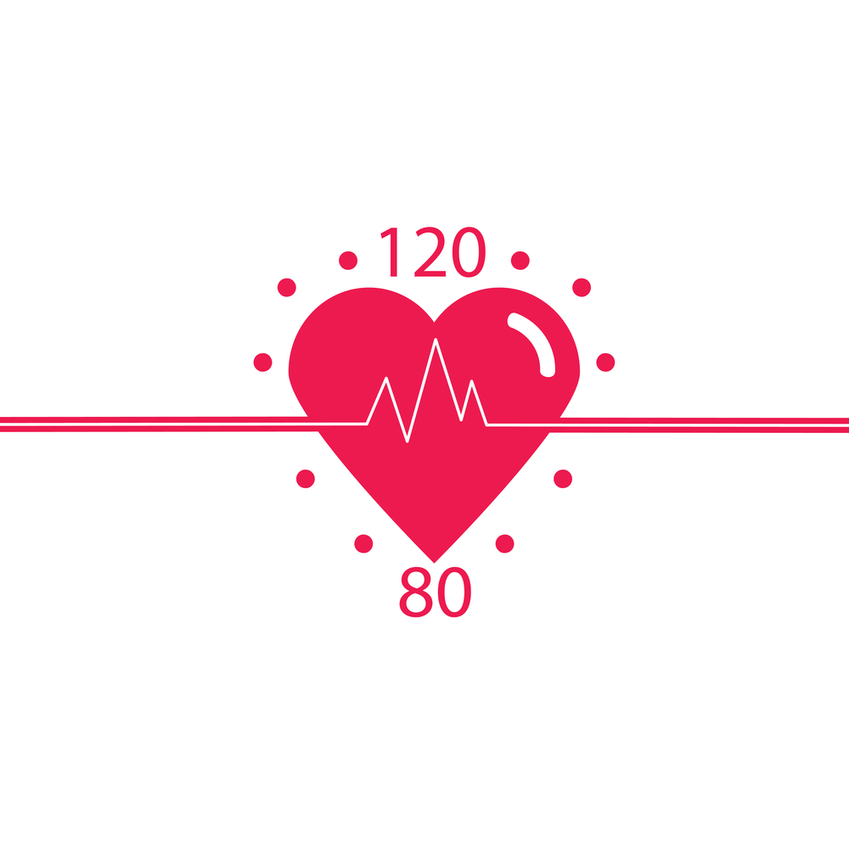

- Quit smoking. It may be difficult, but the health results are worth it.
- Reduce sodium. Many processed foods have a lot of sodium added to them. Check the amount of sodium on the labels.
- Eat a healthy diet. Include whole grains, fruits, vegetables, and low fat dairy products.
- Limit alcohol. Too much alcohol can raise your blood pressure.
- Cut back on caffeine. Caffeine can increase your blood pressure. Check with your doctor to see if you are sensitive to caffeine.
- Medication. If prescribed, take blood pressure medication.

678-786-3281

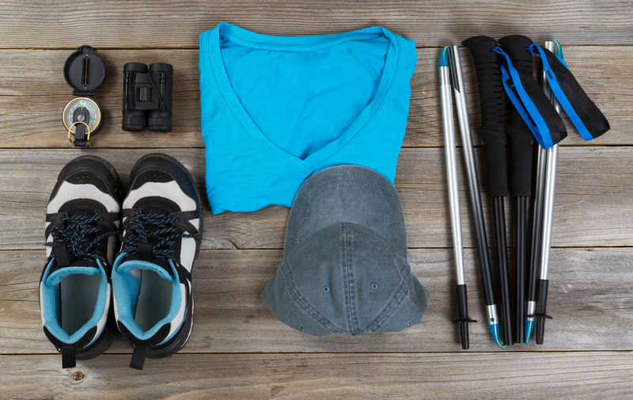
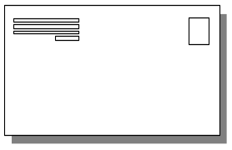

This area can be used either for the address of your customers. All you have to do is to print labels, paste them here after you’ve put in your return address.

The Newsletter can then be folded in thirds, stapled or adhered with special round stickers available at an office supply store to allow the letter to go through the postal machines with a minimum of effort. A two page newsletter will require postage of a first class letter.

If you do not wish to mail this, then this space can be used for additional information specific to your salon.
